

**200132703494**

**Moose Bandarawela**

**H.P.K THARINDU CHANAKA**

**E-Commerce Web Application**

**Project Documentation**



**H.P.K. Tharindu Chanaka**

200132703494

Bandarawela Branch

Moose Batch



**Tap on it**

Table of Contents

**Customer Side Interfaces 4**

Signup UI & Process 4

Sign in UI & process 8

Password Resetting Model and Process 12

Sign Out process 16

User Profile Interface and Process 16

Home Page and Basic Searching Process 27

Headers & Footers 39

Wish list User Interface & Process 49

Cart User Interface & Process 67

Check-out User Interface 91

Single Product View and Process 97

Invoice Page & Process 108

Add Feedback Process 112

Purchasing History and Process 115

Chat Service (Chat With Admin) 125

**Admin Side Interfaces 126**

Admin Sign in UI & Process 126

Admin Dashboard 132

User Reports 146

User Address Report 149

Product Report 152

Invoice Report 155

Recent Product Report 157

Feedback Report 159

Happy Customer Report 164

Report Printing function167

User Blocking process 167

Prodcut Blocking process 168

All Charts 169

Selling History UI & Advanced Process 176

My Products UI and Processes 188

Update Product UI & Process 203

Add Product UI & Process 210

Recent Product Page 218

Completed and Removed items from Purchasing history 225

Manage Users UI & Process 230

Manage Products UI & Process 236

Mange Categories & add Category Images UI & Process244

Chatapp (Chat with Customers) 252

**Business Charts 258**

Doughnet Charts 259

Pie Charts 261

Bar Charts 263

Line Charts265

Polar Area Charts 266

Radar Charts 269

Chart processes271

**ER Diagram 273**

**Mobile View (Responsive Proofs) 274**

**E-commerce web application Customer side**

1. Signup UI & process associated with it

**Signup User Interface**

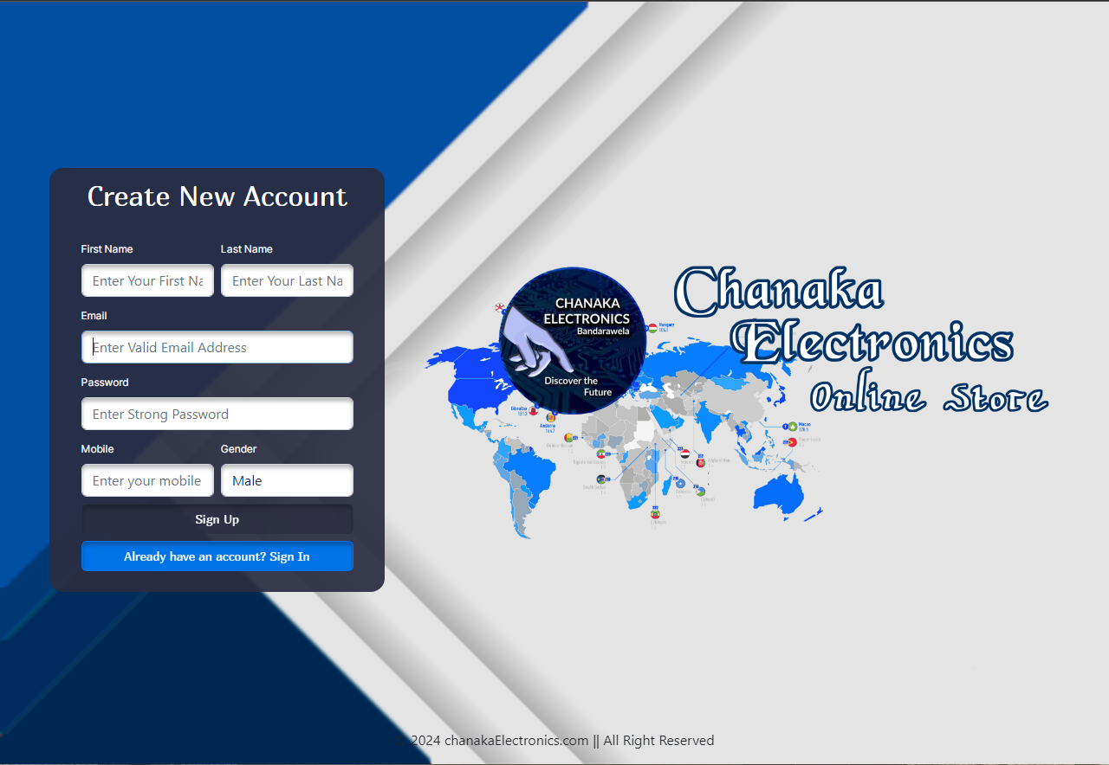

This is the user Sign Up interface. Users can enter the required details here and sign up for the web application. If they are already signed up before they can redirect into the signin interface using the ‘Already have an account? Sign In’ button.

<!DOCTYPE html>

<?php include "connection.php"; ?>

<html>

<head>

<meta charset="utf-8">

<meta name="viewport" content="width=device-width, initial-scale=1">

<title> Chanaka Electronics Store </title>

<link rel="stylesheet" href="bootstrap.css" />

<link rel="stylesheet" href="https://cdn.jsdelivr.net/npm/bootstrap-icons@1.9.1/font/bootstrap-icons.css">

<link rel="stylesheet" href="style.css" />

<link rel="icon" href="resources/logo.png" />

</head>

<div class="col-10 col-lg-4" id="signUpBox">

<div class="row g-2 d-flex justify-content-center mx-2 rounded-4" style="background-color: rgba(43, 45, 66, 0.93);">

<div class="col-10 d-flex justify-content-center">

<p class="title02">Create New Account</p>

</div>

<div class="col-5">

<label class="form-label f1" style="color: white;">First Name</label>

<input type="text" class="form-control" placeholder="Enter Your First Name" id="fname" style="box-shadow: 0px 4px 4px 0px rgba(0, 0, 0, 0.25) inset;" />

</div>

<div class="col-5">

<label class="form-label f1" style="color: white;">Last Name</label>

<input type="text" class="form-control" placeholder="Enter Your Last Name" id="lname" style="box-shadow: 0px 4px 4px 0px rgba(0, 0, 0, 0.25) inset;" />

</div>

<div class="col-10">

<label class="form-label f1" style="color: white;">Email</label>

<input type="email" class="form-control" placeholder="Enter Valid Email Address" id="email" style="box-shadow: 0px 4px 4px 0px rgba(0, 0, 0, 0.25) inset;" />

</div>

<div class="col-10">

<label class="form-label f1" style="color: white;">Password</label>

<input type="password" class="form-control" placeholder="Enter Strong Password" id="pass" style="box-shadow: 0px 4px 4px 0px rgba(0, 0, 0, 0.25) inset;" />

</div>

<div class="col-5 ">

<label class="form-label f1" style="color: white;">Mobile</label>

<input type="text" class="form-control" placeholder="Enter your mobile" id="mobile" style="box-shadow: 0px 4px 4px 0px rgba(0, 0, 0, 0.25) inset;" />

</div>

<div class="col-5 ">

<label class="form-label f1" style="color: white;">Gender</label>

<select class="form-control" id="gender" style="box-shadow: 0px 4px 4px 0px rgba(0, 0, 0, 0.25) inset;">

<?php

$rs = Database::search("SELECT * FROM `gender`");

$num = $rs->num_rows;

for ($x = 0; $x < $num; $x++) {

$data = $rs->fetch_assoc();

?>

<option value="<?php echo $data["id"]; ?>">

<?php echo $data["gender_name"]; ?>

</option>

<?php

} ?>

</select>

</div>

<div class="col-10 d-grid mt-2">

<button class="btn f2" style="background-color: rgba(43, 45, 66, 0.68); box-shadow: 0px 4px 4px 0px rgba(0, 0, 0, 0.25) inset;" onclick="signUp();">Sign Up</button>

</div>

<div class="col-10 d-grid mt-2 mb-4">

<button class="btn f2" style="background-color: #0073e6; box-shadow: 0px 4px 4px 0px rgba(0, 0, 0, 0.25) inset; " onclick="changeView();">Already have an account? Sign In</button> </div>

<div class="col-10 d-none f1" id="msgdiv">

<div class="alert alert-danger fs-6 f1 text-danger" role=" alert" id="alertdiv">

<i class="bi bi-x-octagon-fill fs-6" id="msg"> </i>

</div>

</div>

</div>

</div>

<div class="col-12 fixed-bottom d-none d-lg-block">

<p class="text-center">&copy; 2024 chanakaElectronics.com || All Right Reserved</p>

</div>

**Signup process**

<?php

require "connection.php";

$fname = $_POST["firstname"];

$lname = $_POST["lastname"];

$email = $_POST["em"];

$password = $_POST["pw"];

$mobile = $_POST["mob"];

$gender = $_POST["gender"];

if(empty($fname)){

echo (" Please enter your First Name !");

}else if(strlen($fname) > 50){

echo ("First Name must have less than 50 characters");

}else if(empty($lname)){

echo (" Please enter your Last Name!");

}else if(strlen($lname) > 50){

echo (" Last Name must have less than 50 characters");

}else if (empty($email)){

echo (" Please enter your Email !!!");

}else if(strlen($email) >= 100){

echo (" Email must have less than 100 characters");

}else if(!filter_var($email,FILTER_VALIDATE_EMAIL)){

echo (" Invalid Email !!!");

}else if (empty($password)){

echo (" Please enter your Password !!!");

}else if(strlen($password) < 5 || strlen($password) > 20){

echo (" Password must be between 5 - 20 charcters");

}else if(empty($mobile)){

echo (" Please enter your Mobile !!!");

}else if(strlen($mobile) != 10){

echo (" Mobile must have 10 characters");

}else if(!preg_match("/07[0,1,2,4,5,6,7,8][0-9]/",$mobile)){

echo (" Invalid Mobile !!!");

}else{

$resultSet = Database::search("SELECT * FROM `user` WHERE `email`='".$email."' OR `mobile`='".$mobile."'");

$num = $resultSet->num_rows;

if($num > 0){

echo (" User with the same Email or Mobile already exists.");

}else{

$d = new DateTime();

$timezone = new DateTimeZone("Asia/Colombo");

$d->setTimezone($timezone);

$date = $d->format("Y-m-d H:i:s");

Database::insUpdelete("INSERT INTO `user`

(`fname`,`lname`,`email`,`mobile`,`password`,`gender_id`,`join_date`,`status`) VALUES

('".$fname."','".$lname."','".$email."','".$mobile."','".$password."','".$gender."','".$date."','1')");

echo "  success";

}

}

**JavaScript code**

function changeView() {

var signUpBox = document.getElementById("signUpBox");

var signInBox = document.getElementById("signInBox");

signUpBox.classList.toggle("d-none");

signInBox.classList.toggle("d-none");

}

function signUp() {

var firstName = document.getElementById("fname");

var lastName = document.getElementById("lname");

var email = document.getElementById("email");

var password = document.getElementById("pass");

var mobile = document.getElementById("mobile");

var gender = document.getElementById("gender");

var form = new FormData();

form.append("firstname", firstName.value);

form.append("lastname", lastName.value);

form.append("em", email.value);

form.append("pw", password.value);

form.append("mob", mobile.value);

form.append("gender", gender.value);

var request = new XMLHttpRequest();

request.onreadystatechange = function () {

if ((request.readyState == 4) & (request.status == 200)) {

var text = request.responseText;

if (text == "success") {

document.getElementById("msg").innerHTML = text;

document.getElementById("msg").className = "bi bi-check2-circle fs-5";

document.getElementById("alertdiv").className = "alert alert-success";

document.getElementById("msgdiv").className = "d-block";

} else {

document.getElementById("msg").innerHTML = text;

document.getElementById("msgdiv").className = "d-block";

}

}

};

request.open("POST", "signUpProcess.php", true);

request.send(form);

}

1. Sign in UI & process associated with it

**Sign in User Interface**

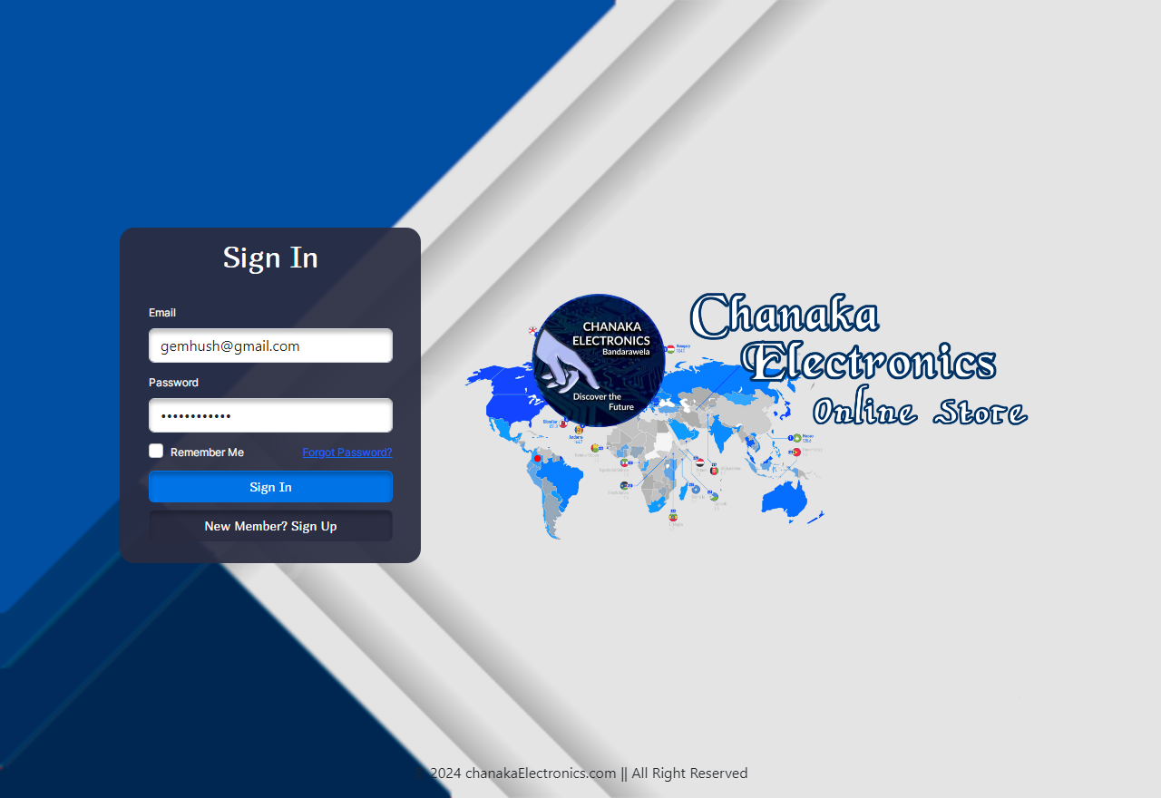

This is the user Sign In interface. Users who are already registered to the web application, can enter their email and password here and login to the application. If the user is an admin he can use the ‘Go to Admin Login’ button and redirect into the admin signin interface. User can use the ‘Remember Me’ option to keep their password and email saved in the next login. Also if any user has forgotten their password, they can use the forgot password option to reset the password.

<div class="col-10 col-lg-4 d-none" id="signInBox">

<div class="row g-2 d-flex justify-content-center mx-2 rounded-4" style="background-color: rgba(43, 45, 66, 0.93);">

<div class="col-10 d-flex justify-content-center">

<p class="title02">Sign In</p>

</div>

<?php

$email = "";

$password = "";

if (isset($_COOKIE["email"])) {

$email = $_COOKIE["email"];

}

if (isset($_COOKIE["password"])) {

$password = $_COOKIE["password"];

}

?>

<div class="col-10">

<label class="form-label rounded-4 f1" style="color: white; ">Email</label>

<input type="email f1" class="form-control" id="email2" style="box-shadow: 0px 4px 4px 0px rgba(0, 0, 0, 0.25) inset;" value="<?php echo $email; ?>" />

</div>

<div class="col-10">

<label class="form-label f1" style="color: white;">Password</label>

<input type="password" class="form-control" id="password2" style="box-shadow: 0px 4px 4px 0px rgba(0, 0, 0, 0.25) inset;" value="<?php echo $password; ?>"/>

</div>

<div class="col-5">

<div class="form-check">

<input class="form-check-input" type="checkbox" id="rememberme" />

<label class="form-check-label f1" style="color: white;">Remember Me</label>

</div>

</div>

<div class="col-5 text-end">

<a href="#" class="link-primary f1" onclick="forgotPassword();">Forgot Password?</a>

</div>

<div class="col-10 d-grid mt-2">

<button class="btn f2" style="background-color: #0073e6; color: white; box-shadow: 0px 4px 4px 0px rgba(0, 0, 0, 0.25) inset;" onclick="signIn();">Sign In</button>

</div>

<div class="col-10 d-grid mt-2">

<button class="btn f2" style="background-color: rgba(43, 45, 66, 0.83); color: white; box-shadow: 0px 4px 4px 0px rgba(0, 0, 0, 0.25) inset;" onclick="changeView();">New Member? Sign Up</button>

</div>

<div class="col-10 d-grid mt-2 mb-4">

<a href="adminSignin.php" class="btn f2" style="background-color: rgba(18, 64, 118, 0.83); color: white; box-shadow: 0px 4px 4px 0px rgba(0, 0, 0, 0.25) inset;">Go

to Admin Login</a>

</div>

<div class="col-10 d-none" id="msgdiv2">

<div class="alert alert-danger" role="alert" id="alertdiv2">

<i class="bi bi-x-octagon-fill fs-5" id="msg2">

</i>

</div>

</div>

</div>

</div>

<div class="col-lg-7 mx-3 d-lg-block logo"></div>

**Sign in Process**

<?php

session_start();

require "connection.php";

$email = $_POST["email2"];

$password = $_POST["pass2"];

$rememberme = $_POST["remember"];

if (empty($email)) {

echo (" Please enter your Email");

} else if (strlen($email) > 100) {

echo (" Email must have less than 100 characters");

} else if (!filter_var($email, FILTER_VALIDATE_EMAIL)) {

echo (" Invalid Email");

} else if (empty($password)) {

echo (" Please enter your Password");

} else if (strlen($password) < 5 || strlen($password) > 20) {

echo (" Password must have between 5-20 charaters");

} else {

$resultSet = Database::search("SELECT * FROM `user` WHERE `email`='" . $email . "'

AND `password`='" . $password . "'");

$num = $resultSet->num_rows;

if ($num == 1) {

$data = $resultSet->fetch_assoc();

if($data["status"] == 1){

echo ("success");

$_SESSION["user"] = $data;

if ($rememberme == "true") {

setcookie("email", $email, time() + (60 * 60 * 24 * 365));

setcookie("password", $password, time() + (60 * 60 * 24 * 365));

} else {

setcookie("email", "", -1);

setcookie("password", "", -1);

}

}else{

echo(" Sorry Admin has deactivated this user.");

}

} else {

echo (" Invalid Username or Password");

} } ?>

**JavaScript Code**

function signIn() {

var email = document.getElementById("email2");

var password = document.getElementById("password2");

var rememberme = document.getElementById("rememberme");

var form = new FormData();

form.append("email2", email.value);

form.append("pass2", password.value);

form.append("remember", rememberme.checked);

var request = new XMLHttpRequest();

request.onreadystatechange = function () {

if (request.readyState == 4) {

var text2 = request.responseText;

if (text2 == "success") {

window.location = "home.php";

document.getElementById("msg2").innerHTML = text2;

document.getElementById("msg2").className =

"bi bi-check2-circle fs-5 ";

document.getElementById("alertdiv2").className = "alert alert-success";

document.getElementById("msgdiv2").className = "d-block";

} else {

document.getElementById("msg2").innerHTML = text2;

document.getElementById("msg2").className = "bi bi-x-octagon-fill fs-5";

document.getElementById("alertdiv2").className = "alert alert-danger";

document.getElementById("msgdiv2").className = "d-block";

} } };

request.open("POST", "signInProcess.php", true);

request.send(form);

}

1. Password Resetting model & Process associated with it

**Password Resetting Model UI**

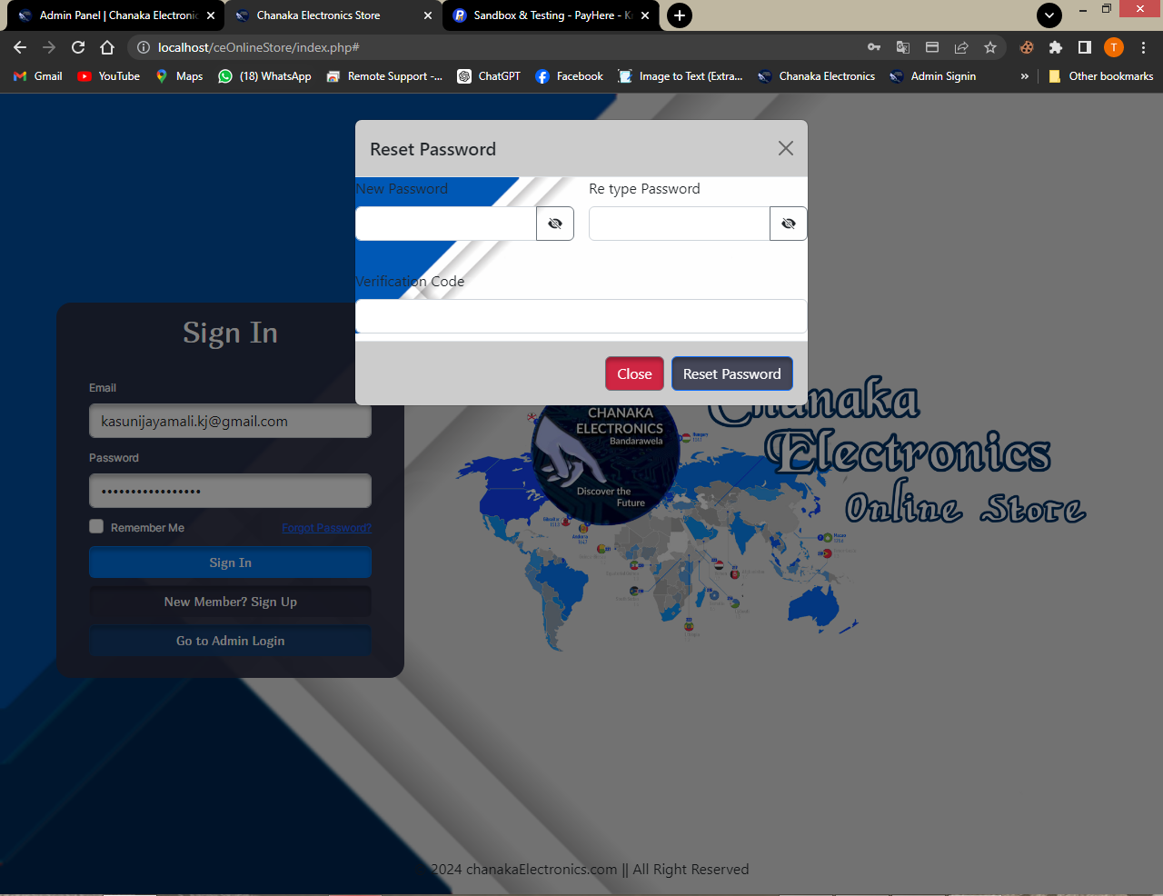

This is the password resetting model. After clicking on the ‘Forgot Password’ option given in the Sign In interface, this model views and if the user has forgotten the password and he need to reset the password he can create a new password and enter the verification code sent to his email and reset the password.

<div class="modal" tabindex="-1" id="forgotPasswordModal">

<div class="modal-dialog">

<div class="modal-content">

<div class="modal-header" style="background-color: rgba(0, 0, 0, 0.20);">

<h5 class="modal-title">Reset Password</h5>

<button type="button" class="btn-close" data-bs-dismiss="modal" aria-label="Close"></button>

</div>

<div class="body1">

<div class="row g-3">

<div class="col-6">

<label class="form-label">New Password</label>

<div class="input-group mb-3">

<input type="password" class="form-control" id="newpassinput" />

<button class="btn btn-outline-secondary" type="button" id="newpassbtn" onclick="ShowPass();">

<i id="eye1" class="bi bi-eye-slash-fill text-dark">

</i>

</button>

</div>

</div>

<div class="col-6">

<label class="form-label">Re type Password</label>

<div class="input-group mb-3">

<input type="password" class="form-control" id="retypepassinput" />

<button class="btn btn-outline-secondary" type="button" id="retypepassbtn" onclick="ShowRetypePass();">

<i id="eye2" class="bi bi-eye-slash-fill text-dark"></i>

</button>

</div>

</div>

<div class="col-12">

<label class="form-label">Verification Code</label>

<input type="text" class="form-control" id="verifycode" />

</div>

</div>

</div>

<div class="modal-footer mt-2" style="background-color: rgba(0, 0, 0, 0.20);">

<button type="button" class="btn btn-secondary" data-bs-dismiss="modal" style="background-color: rgba(209, 0, 36, 0.81); box-shadow: 0px 4px 4px 0px rgba(0, 0, 0, 0.25) inset; ">Close</button>

<button type="button" class="btn btn-primary" style="background-color: rgba(43, 45, 66, 0.83); color: white; box-shadow: 0px 4px 4px 0px rgba(0, 0, 0, 0.25) inset;" onclick="resetpass();">Reset Password</button>

</div> </div>

</div> </div>

**Password Resetting Process**

**forgotPass.php**

<?php

require "connection.php";

require "SMTP.php";

require "PHPMailer.php";

require "Exception.php";

use PHPMailer\PHPMailer\PHPMailer;

if (isset($_GET["email2"])) {

$email = $_GET["email2"];

$resultSet = Database::search("SELECT * FROM `user` WHERE `email` = '" . $email . "';");

$num = $resultSet->num_rows;

if ($num == 1) {

$code = uniqid();

Database::insUpdelete("UPDATE `user` SET `verification_code` = '" . $code . "' WHERE `email` = '" . $email . "';");

// email code

$mail = new PHPMailer;

$mail->IsSMTP();

$mail->Host = 'smtp.gmail.com';

$mail->SMTPAuth = true;

$mail->Username = 'sadeeshanilakshi25@gmail.com';

$mail->Password = 'jpzvibdzhgoqdegt';

$mail->SMTPSecure = 'ssl';

$mail->Port = 465;

$mail->setFrom('sadeeshanilakshi25@gmail.com', 'Reset Password');

$mail->addReplyTo('sadeeshanilakshi25@gmail.com', 'Reset Password');

$mail->addAddress($email);

$mail->isHTML(true);

$mail->Subject = 'Do you Reset your Password in Cute & Cozy online platform';

$bodyContent = '<h1 style="color:#D10024">Here is your Verification Code ' . $code . '</h1>';

$mail->Body = $bodyContent;

if($mail -> send()){

echo "success";

}else{

echo 'Verification code sending failed';

}

} else {

echo ("Invalid Email Address");

} }

**.js code**

var bm;

function forgotPassword() {

var sendEmail = document.getElementById("email2");

var req = new XMLHttpRequest();

req.onreadystatechange = function () {

if (req.readyState == 4) {

var text3 = req.responseText;

if (text3 == "success") {

alert(

"Verification code has sent to your Email. Please check your inbox"

);

var modal = document.getElementById("forgotPasswordModal");

bm = new bootstrap.Modal(modal);

bm.show();

} else {

alert(text3);

} } };

req.open("GET", "forgotPass.php?email2=" + sendEmail.value, true);

req.send();

}

function ShowPass() {

var input = document.getElementById("newpassinput");

var eye = document.getElementById("eye1");

if (input.type == "password") {

input.type = "text";

eye.className = "bi bi-eye-fill";

} else {

input.type = "password";

eye.className = "bi bi-eye-slash-fill";

} }

function ShowRetypePass() {

var input = document.getElementById("retypepassinput");

var eye = document.getElementById("eye2");

if (input.type == "password") {

input.type = "text";

eye.className = "bi bi-eye-fill";

} else {

input.type = "password";

eye.className = "bi bi-eye-slash-fill";

} }

**resetPass.php**

<?php

require "connection.php";

$email = $_POST["em"];

$npw = $_POST["npw"];

$rtpw = $_POST["rtpw"];

$vc = $_POST["vc"];

if (empty($email)) {

echo ("Missing Email Address");

} else if (empty($npw)) {

echo ("Please insert a New password");

} else if (strlen($npw) < 5 || strlen($npw) > 20) {

echo ("Invalid Password");

} else if (empty($rtpw)) {

echo ("Please Re-Type your New Password");

} else if ($npw != $rtpw) {

echo ("Password doesn't matched");

} else if (empty($vc)) {

echo ("Please Enter your Verification Code");

} else {

$resultSet = Database::search("SELECT * FROM `user` WHERE `email` = '" . $email . "' AND `verification_code` = '" . $vc . "';");

$num = $resultSet->num_rows;

if ($num == 1) {

Database::insUpdelete("UPDATE `user` SET `password` = '" . $npw . "' WHERE `email` = '" . $email . "';");

echo ("success");

} else {

echo ("Invalid Email Address or verification Code");

}}

**.js code**

function resetpass() {

var email = document.getElementById("email2");

var newpw = document.getElementById("newpassinput");

var retypepw = document.getElementById("retypepassinput");

var verify = document.getElementById("verifycode");

var form = new FormData();

form.append("em", email.value);

form.append("npw", newpw.value);

form.append("rtpw", retypepw.value);

form.append("vc", verify.value);

var request = new XMLHttpRequest();

request.onreadystatechange = function () {

if (request.readyState == 4) {

var text4 = request.responseText;

if (text4 == "success") {

bm.hide();

alert("Password Reset Success");

} else {

alert(text4);

} } };

request.open("POST", "resetPass.php", true);

request.send(form);

}

1. Sign out Process

<?php

session_start();

if(isset($_SESSION["user"])){

$_SESSION["user"] = null;

session_destroy();

echo("success");

}

?>

**.js code**

function signout() {

var request = new XMLHttpRequest();

request.onreadystatechange = function () {

if (request.readyState == 4) {

var text5 = request.responseText;

if (text5 == "success") {

window.location.reload();

} else {

alert(text5);

} } };

request.open("GET", "SignoutProcess.php", true);

request.send(); }

1. User Profile Interface & process associated with it

**User Profile User Interface**

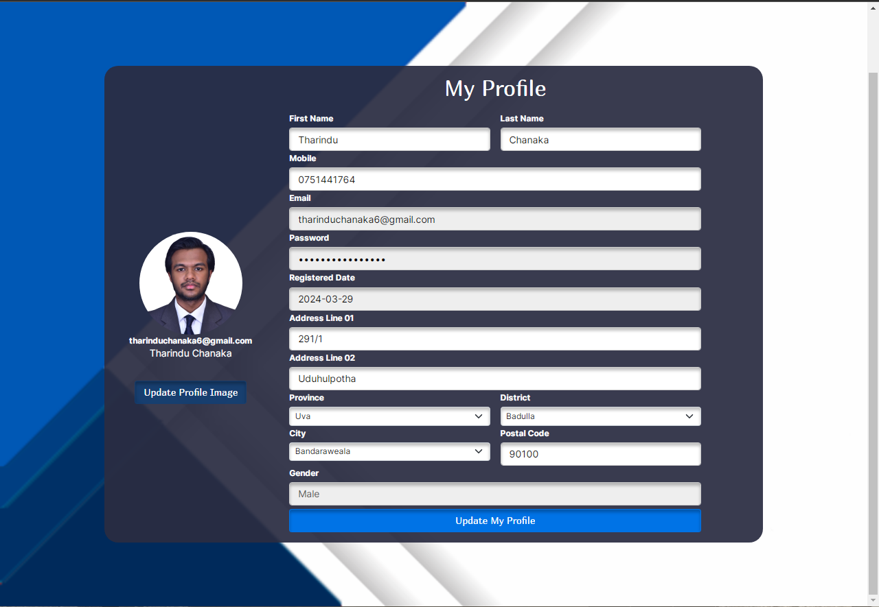

This is the User Profile Interface. User can enter his details and update the profile here. Also he can add a profile picture here. The details that the user has entered when he is getting sign up to the web application are displayed here. User can enter the other required details to update his profile. User can’t change his password, email and the registered date here and those input fields are disabled.

<!DOCTYPE html>

<?php

session_start();

require "connection.php";

if (isset($_SESSION["user"])) {

$email = $_SESSION["user"]["email"];

?>

<html>

<head>

<meta charset="utf-8" />

<meta name="viewport" content="width=device-width, initial-scale=1" />

<title><?php echo $_SESSION["user"]["fname"]; ?>'s Profile</title>

<link rel="stylesheet" href="bootstrap.css" />

<link rel="stylesheet" href="bootstrap-icons.css" />

<link rel="stylesheet" href="style.css" />

<link rel="icon" href="resources/logo.png" />

</head>

<body class="body3">

<?php require "header.php"; ?>

<div class="container-fluid vh-100 mt-5 mb-5">

<div class="row">

<?php

$details_resultSet = Database::search("SELECT * FROM `user` INNER JOIN `gender` ON gender.id=user.gender_id WHERE `email`= '" . $email . "';");

$img_resultSet = Database::search("SELECT * FROM `profile_image` WHERE `user_email`='" . $email . "';");

$addr_resultSet = Database::search("SELECT * FROM `user_has_address`

INNER JOIN `city` ON user_has_address.city_id=city.id

INNER JOIN `district` ON city.district_id=district.id

INNER JOIN `province` ON district.province_id=province.id WHERE `user_email`='" . $email . "';");

$data = $details_resultSet->fetch_assoc();

$imgdata = $img_resultSet->fetch_assoc();

$addrdata = $addr_resultSet->fetch_assoc();

?>

<div class="col-12 d-flex justify-content-center vh-100 mt-5">

<div class="row d-flex align-content-center justify-content-center border-bottom-danger border-5">

<div class="col-9 d-flex justify-content-center align-content-center rounded-5 resp" style="background-color: rgba(43, 45, 66, 0.93); ">

<div class="d-flex flex-column align-items-center text-center justify-content-center mt-3">

<?php

if (empty($imgdata["path"])) {

?>

<img src="resources/user.png" id="viewimg" class="rounded-circle mt-5" style="width:150px ;" />

<?php

} else {

?>

<img src="<?php echo $imgdata["path"]; ?>" id="viewimg" class="rounded-circle mt-5" style="width:150px ;" />

<?php

}

?>

<span class="fw-bold text-white f1"><?php echo $email; ?></span>

<span class=" text-white f1" style="font-size: 14px;"><?php echo $data["fname"] . " " . $data["lname"]; ?></span>

<input type="file" class="d-none" id="profileimg" accept="image/*" />

<label for="profileimg" class="btn mt-5 text-white f3" style="background-color: rgba(18, 64, 118, 0.83); box-shadow: 0px 4px 4px 0px rgba(0, 0, 0, 0.25) inset; " onclick="changeimg();">Update Profile Image</label>

</div>

<div class="col-9 d-flex justify-content-center resp-box" id="updateProfile">

<div class="row d-flex justify-content-center ">

<div class="col-10 d-flex justify-content-center mt-3">

<p class="title02">My Profile</p>

</div>

<div class="col-5">

<label class="form-label f1 text-white">First Name</label>

<input type="text" class="form-control f1 text-black" value="<?php echo $data["fname"]; ?>" id="fname" style="box-shadow: 0px 4px 4px 0px rgba(0, 0, 0, 0.25) inset;" />

</div>

<div class="col-5">

<label class="form-label f1 text-white">Last Name</label>

<input type="text" class="form-control f1 text-black" value="<?php echo $data["lname"]; ?>" id="lname" style="box-shadow: 0px 4px 4px 0px rgba(0, 0, 0, 0.25) inset;" />

</div>

<div class="col-10 ">

<label class="form-label f1 text-white">Mobile</label>

<input type="text" class="form-control f1 text-black" value="<?php echo $data["mobile"]; ?>" id="mob" style="box-shadow: 0px 4px 4px 0px rgba(0, 0, 0, 0.25) inset;" />

</div>

<div class="col-10">

<label class="form-label f1 text-white">Email</label>

<input type="email" class="form-control f1 text-black" readonly value="<?php echo $data["email"]; ?>" style="box-shadow: 0px 4px 4px 0px rgba(0, 0, 0, 0.25) inset;" />

</div>

<div class="col-10">

<label class="form-label f1 text-white">Password</label>

<input type="passwod" class="form-control f1 text-black" readonly value="<?php echo $data["password"]; ?>" style="box-shadow: 0px 4px 4px 0px rgba(0, 0, 0, 0.25) inset;" />

</div>

<div class="col-10">

<label class="form-label f1 text-white">Registered Date</label>

<input type="email" class="form-control f1 text-black" readonly value="<?php echo $data["join_date"]; ?>" style="box-shadow: 0px 4px 4px 0px rgba(0, 0, 0, 0.25) inset;" />

</div>

<?php

if (!empty($addrdata["line1"])) {

?>

<div class="col-10">

<label class="form-label f1 text-white">Address Line 01</label>

<input id="add01" type="text" class="form-control f1 text-black" value="<?php echo $addrdata["line1"]; ?>" style="box-shadow: 0px 4px 4px 0px rgba(0, 0, 0, 0.25) inset;" />

</div>

<?php

} else {

?> <div class="col-10">

<label class="form-label f1 text-white">Address Line 01</label>

<input id="add01" type="text" class="form-control f1 text-black" style="box-shadow: 0px 4px 4px 0px rgba(0, 0, 0, 0.25) inset;" />

</div>

<?php

}

if (!empty($addrdata["line2"])) {

?>

<div class="col-10">

<label class="form-label f1 text-white">Address Line 02</label>

<input id="add02" type="text" value="<?php echo $addrdata["line2"]; ?>" class="form-control f1 text-black" style="box-shadow: 0px 4px 4px 0px rgba(0, 0, 0, 0.25) inset;" />

</div>

<?php

} else {

?>

<div class="col-10">

<label class="form-label f1 text-white">Address Line 02</label>

<input id="add02" type="text" class="form-control f1 text-black" style="box-shadow: 0px 4px 4px 0px rgba(0, 0, 0, 0.25) inset;" />

</div>

<?php

}

$province_resultSet = Database::search("SELECT * FROM `province`");

$district_resultSet = Database::search("SELECT * FROM `district`");

?>

<div class="col-5">

<label class="form-label f1 text-white">Province</label>

<select class="form-select f1 text-black" id="province" style="box-shadow: 0px 4px 4px 0px rgba(0, 0, 0, 0.25) inset;">

<option value="0">Select Province</option>

<?php

$province_num = $province_resultSet->num_rows;

for ($x = 0; $x < $province_num; $x++) {

$province_data = $province_resultSet->fetch_assoc();

?>

<option value="<?php echo $province_data["id"]; ?>" <?php

if (!empty($addrdata["province_id"])) {

if ($province_data["id"] == $addrdata["province_id"]) {

?>selected<?php

}

} ?>>

<?php echo $province_data["province_name"]; ?></option>

<?php

}

?>

</select>

</div>

<div class="col-5">

<label class="form-label f1 ">District</label>

<select class="form-select f1 text-black" id="district" style="box-shadow: 0px 4px 4px 0px rgba(0, 0, 0, 0.25) inset;">

<option value="0">Select District</option>

<?php

$district_num = $district_resultSet->num_rows;

for ($x = 0; $x < $district_num; $x++) {

$district_data = $district_resultSet->fetch_assoc();

?>

<option value="<?php echo $district_data["id"]; ?>" <?php

if (!empty($addrdata["district_id"])) {

if ($district_data["id"] == $addrdata["district_id"]) {

?>selected<?php }

} ?>>

<?php echo $district_data["district_name"]; ?></option>

<?php } ?>

</select>

</div>

<div class="col-5">

<label class="form-label f1 text-white">City</label>

<select class="form-select f1 text-black" id="city" style="box-shadow: 0px 4px 4px 0px rgba(0, 0, 0, 0.25) inset;">

<option value="0">Select City</option>

<?php

$city_resultSet = Database::search("SELECT * FROM `city`");

$city_num = $city_resultSet->num_rows;

for ($x = 0; $x < $city_num; $x++) {

$city_data = $city_resultSet->fetch_assoc();

?>

<option value="<?php echo $city_data["id"]; ?>" <?php

if (!empty($addrdata["city_id"])) {

if ($city_data["id"] == $addrdata["city_id"]) {

?>selected<?php }

} ?>>

<?php echo $city_data["city_name"]; ?></option>

<?php }

?>

</select>

</div>

<?php

if (!empty($addrdata["postal_code"])) {

?>

<div class="col-5">

<label class="form-label f1 text-white">Postal Code</label>

<input id="postal" type="text" class="form-control f1 text-black" value="<?php echo $addrdata["postal_code"]; ?>" style="box-shadow: 0px 4px 4px 0px rgba(0, 0, 0, 0.25) inset;" />

</div>

<?php

} else {

?>

<div class="col-5">

<label class="form-label f1 text-white">Postal Code</label>

<input id="postal" type="text" class="form-control f1 text-black" style="box-shadow: 0px 4px 4px 0px rgba(0, 0, 0, 0.25) inset;" />

</div> <?php

}

if (!empty($data["gender_name"])) {

?>

<div class="col-10 ">

<label class="form-label f1 text-white">Gender</label>

<input class="form-control f1" readonly value="<?php echo $data["gender_name"]; ?>" style="box-shadow: 0px 4px 4px 0px rgba(0, 0, 0, 0.25) inset;" />

</div>

<?php

} else {

?>

<div class="col-10 ">

<label class="form-label f1 text-white">Gender</label>

<input class="form-control f1" readonly style="box-shadow: 0px 4px 4px 0px rgba(0, 0, 0, 0.25) inset;" />

</div>

<?php

}

?>

<div class="col-10 d-grid mt-2 mb-4">

<button class="btn f2" onclick="updatePro();" style="background-color: #0073e6; box-shadow: 0px 4px 4px 0px rgba(0, 0, 0, 0.25) inset;">Update My Profile</button>

</div> </div> </div>

</div> </div> </div>

</div>

</div>

<?php

} else {

header("location:home.php");

}

?>

<script src="bootstrap.bundle.js"></script>

<script src="script.js"></script>

</body>

</html>

**Profile Updating Process**

<?php

session_start();

require "connection.php";

if (isset($_SESSION["user"])) {

$fname = $_POST["fname"];

$lname = $_POST["lname"];

$mobile = $_POST["mob"];

$line1 = $_POST["add01"];

$line2 = $_POST["add02"];

$province = $_POST["province"];

$district = $_POST["district"];

$city = $_POST["city"];

$postal = $_POST["postal"];

if (isset($_FILES["image"])) {

$img = $_FILES["image"];

$allow_img_extensions = array("image/jpeg", "image/jpg", "image/png", "image/svg+xml", "image/ico");

$file_extension = $img["type"];

// echo($file_extension);

if (!in_array($file_extension, $allow_img_extensions)) {

echo ("Please Select a valid Image.");

} else {

$new_file_ex;

if ($file_extension == "image/jpeg") {

$new_file_ex = ".jpeg";

} else if ($file_extension == "image/jpg") {

$new_file_ex = ".jpg";

} else if ($file_extension == "image/png") {

$new_file_ex = ".png";

} else if ($file_extension == "image/svg+xml") {

$new_file_ex = ".svg";

} else if ($file_extension == "image/ico") {

$new_file_ex = ".ico";

}

// echo($new_file_ex);

$file_name = "resources/proimg/" . $_SESSION["user"]["fname"] . "_" . uniqid() . $new_file_ex;

move_uploaded_file($img["tmp_name"], $file_name);

$img_rs = Database::search("SELECT * FROM `profile_image`

WHERE `user_email` = '" . $_SESSION["user"]["email"] . "';");

$img_num = $img_rs->num_rows;

if ($img_num == 1) {

Database::insUpdelete("UPDATE `profile_image` SET `path` = '" . $file_name . "'

WHERE `user_email` = '" . $_SESSION["user"]["email"] . "';");

} else {

Database::insUpdelete("INSERT INTO `profile_image` (`path` , `user_email`)

VALUES ('" . $file_name . "' , '" . $_SESSION["user"]["email"] . "')"); } }

}

Database::insUpdelete("UPDATE `user` SET `fname` = '" . $fname . "', `lname` = '" . $lname . "', `mobile` = '" . $mobile . "'

WHERE `email` = '" . $_SESSION["user"]["email"] . "';");

$address_rs = Database::search("SELECT* FROM `user_has_address`

WHERE `user_email` = '" . $_SESSION["user"]["email"] . "';");

$address_num = $address_rs->num_rows;

if ($address_num == 1) {

Database::insUpdelete("UPDATE `user_has_address` SET `line1` = '" . $line1 . "', `line2` = '" . $line2 . "',

`city_id` = '" . $city . "',`postal_code` = '" . $postal . "'

WHERE `user_email` = '" . $_SESSION["user"]["email"] . "';");

} else {

Database::insUpdelete("INSERT INTO `user_has_address`

(`line1`,`line2`,`user_email`,`city_id`,`postal_code`)

VALUES ('" . $line1 . "' ,'" . $line2 . "' , '" . $_SESSION["user"]["email"] . "','" . $city . "' ,'" . $postal . "')");

}

echo ("success");

} else {

echo ("Please Log in first");

}

**JavaScript function**

function updatePro() {

var fname = document.getElementById("fname");

var lname = document.getElementById("lname");

var mobile = document.getElementById("mob");

var line1 = document.getElementById("add01");

var line2 = document.getElementById("add02");

var province = document.getElementById("province");

var district = document.getElementById("district");

var city = document.getElementById("city");

var postal = document.getElementById("postal");

var image = document.getElementById("profileimg");

var form = new FormData();

form.append("fname", fname.value);

form.append("lname", lname.value);

form.append("mob", mobile.value);

form.append("add01", line1.value);

form.append("add02", line2.value);

form.append("province", province.value);

form.append("district", district.value);

form.append("city", city.value);

form.append("postal", postal.value);

if (image.files.length == 0) {

var confirmation = confirm(

"Are you sure You don't need to update Profile image ??"

);

if (confirmation) {

alert("You haven't selected any image"); }

} else {

form.append("image", image.files[0]);

}

var request = new XMLHttpRequest();

request.onreadystatechange = function () {

if (request.readyState == 4) {

var text6 = request.responseText;

if (text6 == "success") {

window.location.reload();

} else {

alert(text6);

} } };

request.open("POST", "updateProfileProcess.php", true);

request.send(form);

}

**JavaScript Function for profile image updating**

function changeimg() {

var view = document.getElementById("viewimg"); //Get id from profile image

var filechooser = document.getElementById("profileimg"); //Get file chooser

filechooser.onchange = function () {

var file1 = this.files[0];

var url = window.URL.createObjectURL(file1);

view.src = url;

};

}

1. Home Page and Basic searching process associated with it

**Home User Interface**

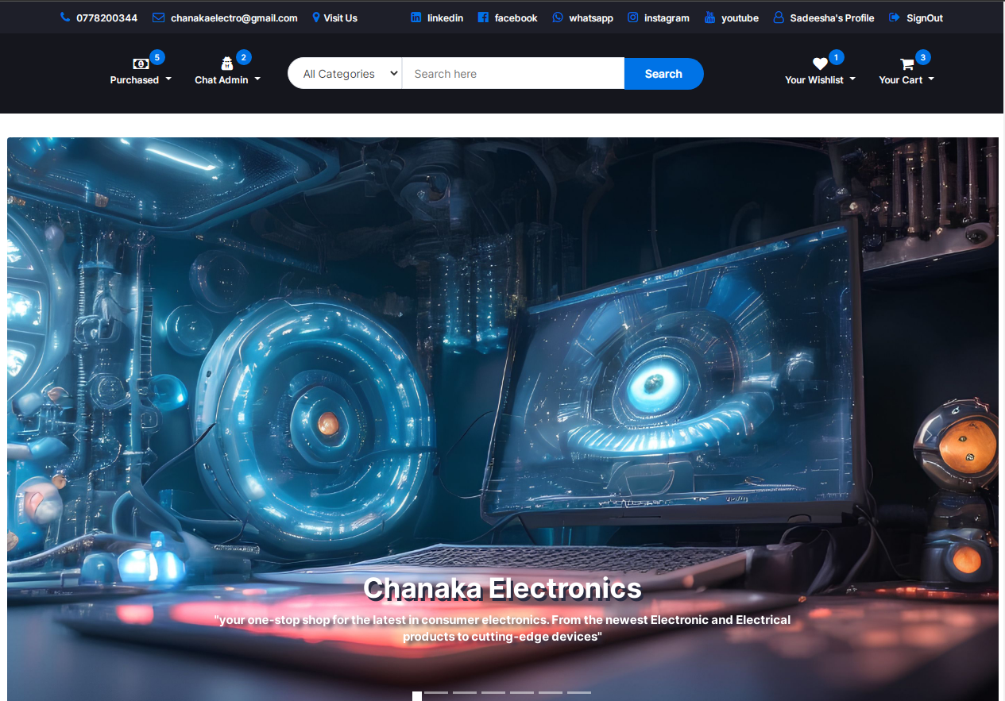

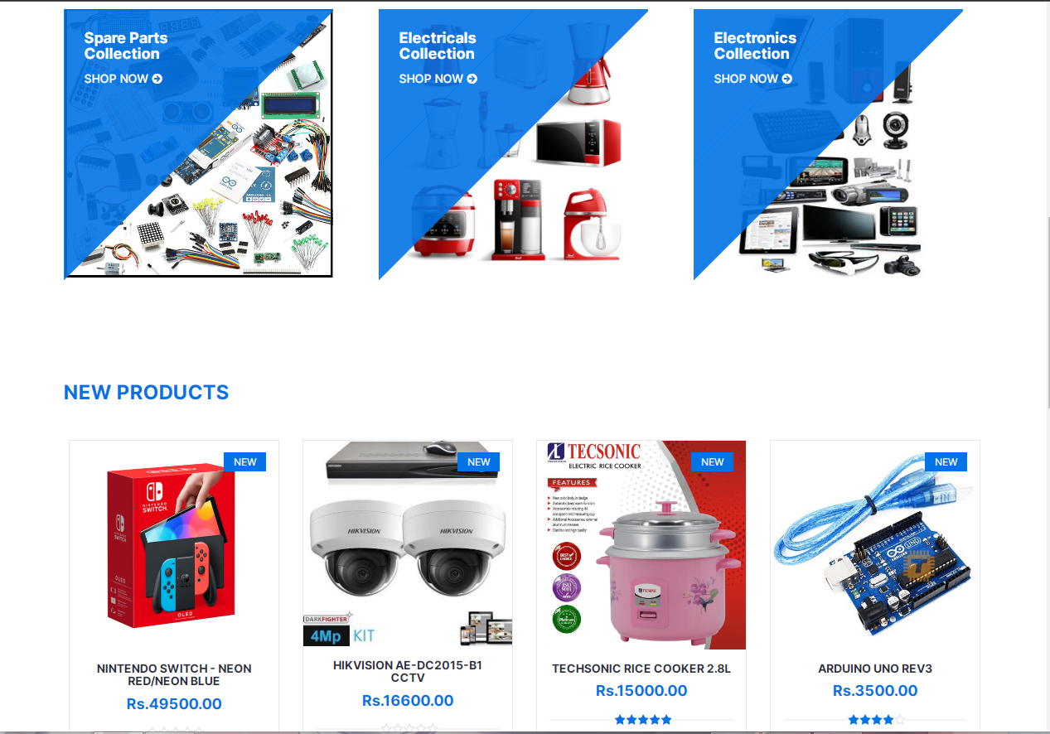

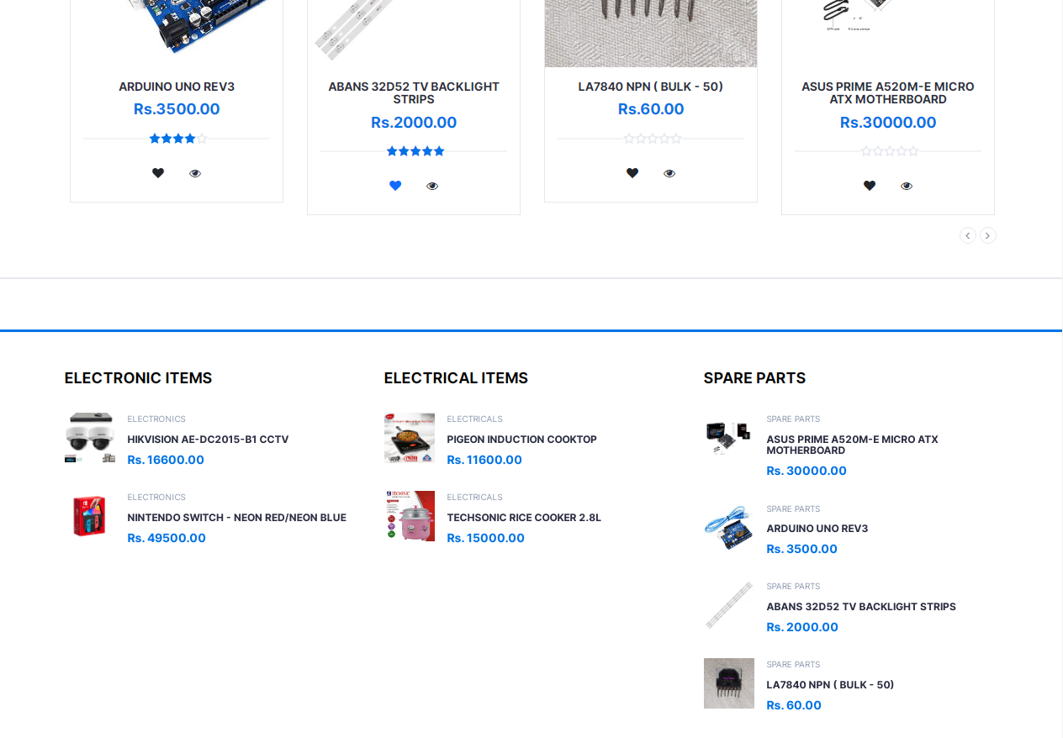

This is the home page interface of the web application.This contains a top header, main header, body, Carousal and a footer. In the body the product categories are displayed and user can navigate into each category page and purchase products related to those categories. The latest products that has been added to the web application are displayed in the body below the categories. User can view product details and add products to the wishlist using options given within the product cards. The condition of the product and the price is also displayed in each product cards. Also the latest products that has been added by the sellers are displayes as category wise in the bottom off the body.

!DOCTYPE html>

<html lang="en">

<head>

<meta charset="utf-8">

<meta http-equiv="X-UA-Compatible" content="IE=edge">

<meta name="viewport" content="width=device-width, initial-scale=1">

<link rel="icon" href="resources/logo.png" />

<title>Welcome | Start Shopping</title>

<link href="https://fonts.googleapis.com/css?family=Montserrat:400,500,700" rel="stylesheet">

<link type="text/css" rel="stylesheet" href="css/bootstrap.min.css" />

<link type="text/css" rel="stylesheet" href="css/slick.css" />

<link type="text/css" rel="stylesheet" href="css/slick-theme.css" />

<link type="text/css" rel="stylesheet" href="css/nouislider.min.css" />

<link rel="stylesheet" href="bootstrap-icons.css" />

<link rel="stylesheet" href="css/font-awesome.min.css">

<link type="text/css" rel="stylesheet" href="css/style.css" />

<link rel="stylesheet" href="style.css" />

</head>

<?php require "header2.php" ?>

<body style="overflow-x: hidden;">

<div class="section">

<div class="container">

<div class="row">

<?php

$category_resultSet = Database::search("SELECT * FROM `category`");

$category_num = $category_resultSet->num_rows;

for ($x = 0; $x < $category_num; $x++) {

$category_data = $category_resultSet->fetch_assoc();

?>

<div class="col-12 col-lg-4 col-xs-12">

<div class="shop">

<div class="shop-img">

<img src="<?php echo $category_data["path"]; ?>" alt="">

</div>

<div class="shop-body">

<h4><?php echo $category_data["name"]; ?><br>Collection</h4>

<a href="#" class="cta-btn">Shop now <i class="fa fa-arrow-circle-right"></i></a>

</div>

</div></div>

<?php

}

?>

</div></div>

</div>

<div class="section" id="basicSearchResult">

<div class="container">

<div class="row">

<div class="col-md-12" data-wow-delay="0.1s">

<div class="section-title">

<h3 class="title" style="color: #0073e6;">New Products</h3>

</div>

</div>

<div class="col-md-12">

<div class="row">

<div class="products-tabs">

<div id="tab1" class="tab-pane active">

<div class="products-slick" data-nav="#slick-nav-1">

<?php

$product_resultSet = Database::search("SELECT * FROM `product` WHERE `status_id` = '1' ORDER BY `datetime_added` DESC");

$product_num = $product_resultSet->num_rows;

for ($z = 0; $z < $product_num; $z++) {

$product_data = $product_resultSet->fetch_assoc();

?>

<div class="product">

<div class="product-img img-fluid">

<?php

$image_resultSet = Database::search("SELECT * FROM `image` WHERE `product_id` = '" . $product_data["id"] . "';");

$image_data = $image_resultSet->fetch_assoc();

?>

<img src="<?php echo $image_data["code"]; ?>" alt="">

<div class="product-label">

<span class="new">NEW</span>

</div>

</div>

<div class="product-body">

<h3 class="product-name"><a href="#"><?php echo $product_data["title"]; ?></a></h3>

<h4 class="product-price">Rs.<?php echo $product_data["price"]; ?>.00</h4>

<?php

$Rf_rs = Database::search("SELECT * FROM `feedback`WHERE `product_id`='" . $product_data["id"] . "' ORDER BY `date` DESC");

$Rf_num = $Rf_rs->num_rows;

$Rf_data = $Rf_rs->fetch_assoc();

?>

<div class="product-rating">

<?php

if ($Rf_num == 0) {

?>

<i class="fa fa-star-o"></i>

<i class="fa fa-star-o"></i>

<i class="fa fa-star-o"></i>

<i class="fa fa-star-o"></i>

<i class="fa fa-star-o"></i>

<?php

} else {

?>

<?php

if ($Rf_data["type"] == 5) {

?>

<i class="fa fa-star"></i>

<i class="fa fa-star"></i>

<i class="fa fa-star"></i>

<i class="fa fa-star"></i>

<i class="fa fa-star"></i>

<?php }

?>

<?php

if ($Rf_data["type"] == 4) {

?>

<i class="fa fa-star"></i>

<i class="fa fa-star"></i>

<i class="fa fa-star"></i>

<i class="fa fa-star"></i>

<i class="fa fa-star-o"></i>

<?php

}

?>

<?php

if ($Rf_data["type"] == 3) {

?>

<i class="fa fa-star"></i>

<i class="fa fa-star"></i>

<i class="fa fa-star"></i>

<i class="fa fa-star-o"></i>

<i class="fa fa-star-o"></i>

<?php } ?>

<?php

if ($Rf_data["type"] == 2) {

?>

<i class="fa fa-star"></i>

<i class="fa fa-star"></i>

<i class="fa fa-star-o"></i>

<i class="fa fa-star-o"></i>

<i class="fa fa-star-o"></i>

<?php } ?>

<?php

if ($Rf_data["type"] == 1) {

?>

<i class="fa fa-star"></i>

<i class="fa fa-star-o"></i>

<i class="fa fa-star-o"></i>

<i class="fa fa-star-o"></i>

<i class="fa fa-star-o"></i>

<?php } ?>

<?php

}

?>

</div>

<div class="product-btns">

<?php

if (isset($_SESSION["user"])) {

$email = $_SESSION["user"]["email"];

$watchlist_Resultset = Database::search("SELECT * FROM `wishlist` WHERE `product_id`='" . $product_data["id"] . "' AND `user_email`= '" . $email . "'");

$watchlist_num = $watchlist_Resultset->num_rows;

if ($watchlist_num == 1) {

?>

<button class="add-to-wishlist" onclick='addWishlist(<?php echo $product_data["id"]; ?>);'>

<i class="fa fa-heart text-primary" id='heart<?php echo $product_data["id"]; ?>'></i>

<span class="tooltipp fs-6">Remove</span>

</button>

<?php

} else {

?>

<button class="add-to-wishlist" onclick='addWishlist(<?php echo $product_data["id"]; ?>);'>

<i class="fa fa-heart text-dark" id='heart<?php echo $product_data["id"]; ?>'></i>

<span class="tooltipp">add to wishlist</span>

</button>

<?php } } ?>

<?php

if (!isset($_SESSION["user"])) {

?>

<button class="d-none">

<a href="#">

<i class="fa fa-eye-slash"></i>

<span class="tooltipp">Log in First</span>

</a>

</button>

<?php

} else {

?>

<button class="quick-view">

<a href="<?php echo "SingleProductView.php?id=" . ($product_data["id"]); ?>">

<i class="fa fa-eye"></i>

<span class="tooltipp">quick view</span>

</a>

</button>

<?php } ?>

</div>

</div>

<?php

if (!isset($_SESSION["user"])) {

?>

<div class="add-to-cart">

<button class="add-to-cart-btn"><i class="fa fa-shopping-cart"></i>Can't add to Cart</button>

</div>

<?php

} else {

?>

<div class="add-to-cart">

<button class="add-to-cart-btn" onclick="AddtoCart(<?php echo $product_data['id']; ?>);"><i class="fa fa-shopping-cart"></i> add to cart</button>

</div>

<?php } ?>

</div>

<?php

}

?>

<!-- /product -->

</div>

<div id="slick-nav-1" class="products-slick-nav"></div>

</div>

<!-- /tab -->

</div>

</div></div>

</div></div>

</div>

<div id="newsletter" class="section"></div>

<div class="section">

<div class="container">

<div class="row">

<div class="col-md-4 col-xs-6">

<div class="section-title">

<h4 class="title" style="color: black;">Electronic Items</h4>

<div class="section-nav">

<div id="slick-nav-3" class="products-slick-nav"></div>

</div>

</div>

<div class="products-widget-slick" data-nav="#slick-nav-3">

<div>

<?php

$product_resultSet = Database::search("SELECT * FROM `product` WHERE `category_id`= '1' AND `status_id` = '1' ORDER BY `qty` ASC LIMIT 4 OFFSET 0");

$product_num = $product_resultSet->num_rows;

for ($z = 0; $z < $product_num; $z++) {

$product_data = $product_resultSet->fetch_assoc();

?>

<div class="product-widget">

<?php

$image_resultSet = Database::search("SELECT * FROM `image` WHERE `product_id` = '" . $product_data["id"] . "';");

$image_data = $image_resultSet->fetch_assoc();

?>

<div class="product-img">

<img src="<?php echo $image_data["code"]; ?>" alt="">

</div>

<div class="product-body">

<p class="product-category">Electronics</p>

<h3 class="product-name"><a href="#"><?php echo $product_data["title"]; ?></a></h3>

<h4 class="product-price">Rs. <?php echo $product_data["price"]; ?>.00</h4>

</div>

</div>

<?php } ?>

</div>

</div></div>

<div class="col-md-4 col-xs-6">

<div class="section-title">

<h4 class="title" style="color: black;">Electrical Items</h4>

<div class="section-nav">

<div id="slick-nav-3" class="products-slick-nav"></div>

</div>

</div>

<div class="products-widget-slick" data-nav="#slick-nav-3">

<div>

<?php

$product_resultSet = Database::search("SELECT * FROM `product` WHERE `category_id`= '2' AND `status_id` = '1' ORDER BY `qty` ASC LIMIT 4 OFFSET 0");

$product_num = $product_resultSet->num_rows;

for ($z = 0; $z < $product_num; $z++) {

$product_data = $product_resultSet->fetch_assoc();

?>

<div class="product-widget">

<?php

$image_resultSet = Database::search("SELECT * FROM `image` WHERE `product_id` = '" . $product_data["id"] . "';");

$image_data = $image_resultSet->fetch_assoc();

?>

<div class="product-img">

<img src="<?php echo $image_data["code"]; ?>" alt="">

</div>

<div class="product-body">

<p class="product-category">Electricals</p>

<h3 class="product-name"><a href="#"><?php echo $product_data["title"]; ?></a></h3>

<h4 class="product-price">Rs. <?php echo $product_data["price"]; ?>.00</h4>

</div></div>

<?php } ?>

</div>

</div></div>

<div class="col-md-4 col-xs-6">

<div class="section-title">

<h4 class="title" style="color: black;">Spare Parts</h4>

<div class="section-nav">

<div id="slick-nav-3" class="products-slick-nav"></div>

</div>

</div>

<div class="products-widget-slick" data-nav="#slick-nav-3">

<div>

<?php

$product_resultSet = Database::search("SELECT * FROM `product` WHERE `category_id`= '3' AND `status_id` = '1' ORDER BY `qty` ASC LIMIT 4 OFFSET 0");

$product_num = $product_resultSet->num_rows;

for ($z = 0; $z < $product_num; $z++) {

$product_data = $product_resultSet->fetch_assoc();

?>

<div class="product-widget">

<?php

$image_resultSet = Database::search("SELECT * FROM `image` WHERE `product_id` = '" . $product_data["id"] . "';");

$image_data = $image_resultSet->fetch_assoc();

?>

<div class="product-img">

<img src="<?php echo $image_data["code"]; ?>" alt="">

</div>

<div class="product-body">

<p class="product-category">Spare Parts</p>

<h3 class="product-name"><a href="#"><?php echo $product_data["title"]; ?></a></h3>

<h4 class="product-price">Rs. <?php echo $product_data["price"]; ?>.00</h4>

</div>

</div>

<?php } ?>

</div> </div>

</div> </div>

</div></div>

<div id="newsletter" class="section"></div>

<?php require "footer.php" ?>

<!-- jQuery Plugins -->

<script src="js/jquery.min.js"></script>

<script src="js/bootstrap.min.js"></script>

<script src="js/slick.min.js"></script>

<script src="js/nouislider.min.js"></script>

<script src="js/jquery.zoom.min.js"></script>

<script src="js/main.js"></script>

<script src="script.js"></script>

</body>

</html>

**Basic Search Process**

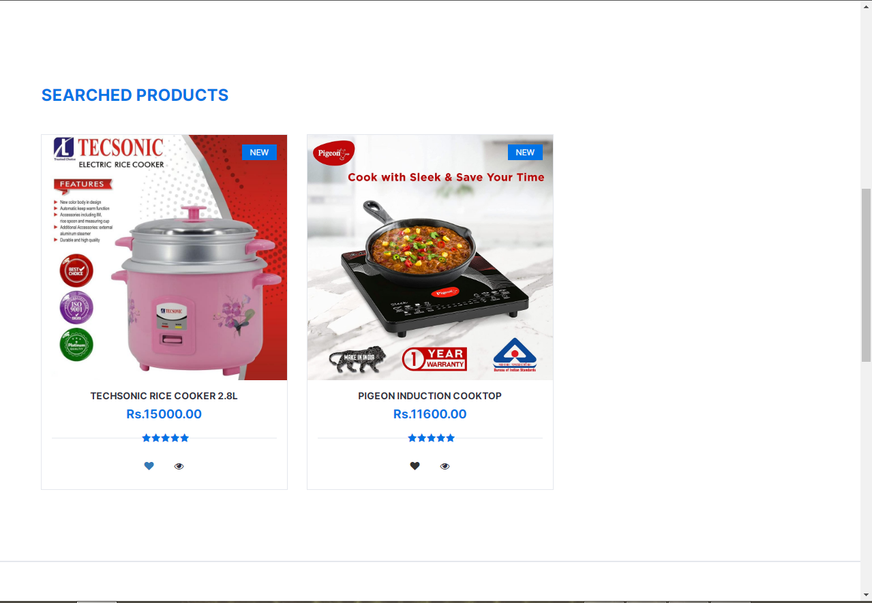

The products that user has searched are displayed like this.

<?php

require "connection.php";

session_start();

$txt = $_POST["text"];

$select = $_POST["search"];

$query = "SELECT * FROM `product`";

if (!empty($txt) && $select == 0) {

$query .= " WHERE `title` LIKE '%" . $txt . "%'";

} else if (empty($txt) && $select != 0) {

$query .= " WHERE `category_id`='" . $select . "'";

} else if (!empty($txt) && $select != 0) {

$query .= " WHERE `title` LIKE '%" . $txt . "%' AND `category_id`='" . $select . "'";

}

?>

<div class="section">

<div class="container">

<div class="row">

<div class="col-md-12" data-wow-delay="0.1s">

<div class="section-title">

<h3 class="title" style="color: #0073e6;">Searched Products</h3>

</div>

</div>

<?php

$selected_rs = Database::search($query);

$selected_num = $selected_rs->num_rows;

for ($x = 0; $x < $selected_num; $x++) {

$selected_data = $selected_rs->fetch_assoc();

?>

<div class="col-lg-4 col-md-4 col-sm-12 mb-4">

<div class="product">

<div class="product-img img-fluid">

<?php

$image_resultSet1 = Database::search("SELECT * FROM `image` WHERE `product_id` = '" . $selected_data["id"] . "';");

$image_data1 = $image_resultSet1->fetch_assoc();

?>

<img src="<?php echo $image_data1["code"]; ?>" alt="" class="img-fluid w-100">

<div class="product-label">

<span class="new">NEW</span>

</div>

</div>

<div class="product-body">

<h3 class="product-name"><a href="#"><?php echo $selected_data["title"]; ?></a></h3>

<h4 class="product-price">Rs.<?php echo $selected_data["price"]; ?>.00</h4>

<?php

$Rf_rs1 = Database::search("SELECT * FROM `feedback`WHERE `product_id`='" . $selected_data["id"] . "' ORDER BY `date` DESC");

$Rf_num1 = $Rf_rs1->num_rows;

$Rf_data1 = $Rf_rs1->fetch_assoc();

?>

<div class="product-rating">

<?php

if ($Rf_num1 == 0) {

?>

<i class="fa fa-star-o"></i>

<i class="fa fa-star-o"></i>

<i class="fa fa-star-o"></i>

<i class="fa fa-star-o"></i>

<i class="fa fa-star-o"></i>

<?php

} else {

for ($i = 1; $i <= 5; $i++) {

if ($i <= $Rf_data1["type"]) {

?>

<i class="fa fa-star"></i>

<?php } else { ?>

<i class="fa fa-star-o"></i>

<?php } } } ?>

</div>

<div class="product-btns">

<?php

if (isset($_SESSION["user"])) {

$email = $_SESSION["user"]["email"];

$watchlist_Resultset3 = Database::search("SELECT * FROM `wishlist` WHERE `product_id`='" . $selected_data["id"] . "' AND `user_email`= '" . $email . "'");

$watchlist_num3 = $watchlist_Resultset3->num_rows;

if ($watchlist_num3 == 1) {

?>

<button class="add-to-wishlist" onclick='addWishlist(<?php echo $selected_data["id"]; ?>);'>

<i class="fa fa-heart text-primary" id='heart<?php echo $selected_data["id"]; ?>'></i>

<span class="tooltipp">Remove</span>

</button>

<?php

} else {

?>

<button class="add-to-wishlist" onclick='addWishlist(<?php echo $selected_data["id"]; ?>);'>

<i class="fa fa-heart text-dark" id='heart<?php echo $selected_data["id"]; ?>'></i>

<span class="tooltipp">Add to wishlist</span>

</button>

<?php } } ?>

<?php

if (isset($_SESSION["user"])) {

?>

<button class="quick-view">

<a href="<?php echo "SingleProductView.php?id=" . ($product_data["id"]); ?>">

<i class="fa fa-eye"></i>

<span class="tooltipp">quick view</span>

</a>

</button>

<?php

} else {

?>

<button class="d-none">

<a href="#">

<i class="fa fa-eye-slash"></i>

<span class="tooltipp">Log in First</span>

</a>

</button>

<?php } ?>

</div></div>

<?php

if (isset($_SESSION["user"])) {

?>

<div class="add-to-cart">

<button class="add-to-cart-btn" onclick="AddtoCart(<?php echo $product_data['id']; ?>);"><i class="fa fa-shopping-cart"></i> add to cart</button>

</div>

<?php

} else {

?>

<div class="add-to-cart">

<button class="add-to-cart-btn"><i class="fa fa-shopping-cart"></i>Can't add to Cart</button>

</div>

<?php } ?>

</div></div>

<?php } ?>

</div></div>

</div>

**JavaScript Code**

function basicSearch() {

var txt = document.getElementById("basic_search_txt");

var Select = document.getElementById("basic_search_select");

var basicform = new FormData();

basicform.append("text", txt.value);

basicform.append("search", Select.value);

var req = new XMLHttpRequest();

req.onreadystatechange = function () {

if (req.readyState == 4) {

var text14 = req.responseText;

document.getElementById("basicSearchResult").innerHTML = text14;

} };

req.open("POST", "basicSearchProcess.php", true);

req.send(basicform);

}

1. Headers & Footers

**Header.php**

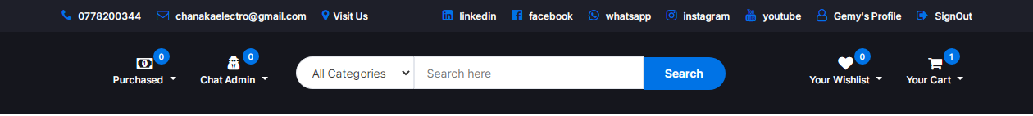

This is the top header and the main header of the web application.The top header is displayed in every page of the web application and the main header is displayed only in the home page.In the top header admin’s contact details and his other social media profile links are displayed. On the right side of the top header logged in user’s name is displayed and he can navigate into update profile page using the profile icon to see or update his details. There is a sign out option next to profile icon and user can sign out from the application and again signin to the application. In the main header there are options given with icons to navigate into purchasing history page to see the items that has been purchased by the user , wishlist page and to the cart page.In the On click of each icon a model is viewd to display item details.On the top of those icons, the number of items that has been added to each pages are displayed. Also there is a search bar and user can search the categories or items he needs to buy.

<!DOCTYPE html>

<html>

<head>

<meta charset="utf-8">

<meta http-equiv="X-UA-Compatible" content="IE=edge">

<meta name="viewport" content="width=device-width, initial-scale=1">

<link href="https://fonts.googleapis.com/css?family=Montserrat:400,500,700" rel="stylesheet">

<link type="text/css" rel="stylesheet" href="css/bootstrap.min.css" />

<link type="text/css" rel="stylesheet" href="bootstrap-icons.css" />

<link type="text/css" rel="stylesheet" href="css/slick.css" />

<link type="text/css" rel="stylesheet" href="css/slick-theme.css" />

<link type="text/css" rel="stylesheet" href="css/nouislider.min.css" />

<link rel="stylesheet" href="css/font-awesome.min.css">

<link type="text/css" rel="stylesheet" href="css/style.css" />

<link rel="icon" href="resources/logo.png" />

</head>

<body class="body">

<div classs="vh-100 w-100 ">

<div class="">

<div class="col-12">

<header>

<div id="top-header">

<div class="container">

<ul class="header-links pull-left">

<li><a href="tel:+94778200344"><i class="fa fa-phone"></i> 0778200344</a></li>

<li><a href="mailto:chanakaelectro@gmail.com"><i class="fa fa-envelope-o"></i> chanakaelectro@gmail.com</a></li>

<li><a href="https://maps.app.goo.gl/1fM9BCFsGSyPkZDT8"><i class="fa fa-map-marker"></i>Visit Us</a></li>

</ul>

<ul class="header-links pull-right">

<li><a href="https://www.linkedin.com/in/chanaka-sanjeewa-175aa728b"><i class="fa fa-linkedin-square"></i> linkedin</a></li>

<li><a href="https://www.facebook.com/50Bandarawela?mibextid=2JQ9oc"><i class="fa fa-facebook-official"></i> facebook</a></li>

<li><a href="https://wa.me/message/CBYLNI2IKXKII1"><i class="fa fa-whatsapp"></i> whatsapp</a></li>

<li><a href="https://instagram.com/chanaka.sanjeewa?igshid=MzRlODBiNWFlZA=="><i class="fa fa-instagram"></i> instagram</a></li>

<li><a href="https://youtube.com/@chanakaElectro?si=ob-OIXZGP6odFKTe"><i class="fa fa-youtube"></i> youtube</a></li>

<?php

session_start();

if (isset($_SESSION["user"])) {

$data = $_SESSION["user"];

?>

<li><a href="userprofile.php"><i class="fa fa-user-o"></i> <?php echo $data["fname"]; ?>'s Profile</a></li>

<li><a href="" onclick="signout();"><i class="fa fa-sign-out"></i> SignOut</a></li>

<?php

} else {

?>

<li><a href="index.php"><i class="fa fa-user-o"></i> Log In</a></li>

<?php } ?>

</div>

</div>

</ul>

<div id="header">

<!-- container -->

<div class="container">

<!-- row -->

<div class="row">

<!-- LOGO -->

<div class="col-md-3 clearfix">

<div class="header-ctn">

<!-- Purchasing History -->

<div class="dropdown" style="cursor: pointer;">

<?php

require "connection.php";

if (!isset($_SESSION["user"]["email"])) {

?>

<a class="dropdown-toggle" data-toggle="" aria-expanded="false">

<i class="fa fa-window-close"></i>

<span>Purchased</span>

<div class="qty">0</div>

</a>

<?php } else { ?>

<a class="dropdown-toggle" data-toggle="dropdown" aria-expanded="true">

<i class="fa fa-money"></i>

<?php

$p_rs = Database::search("SELECT * FROM `invoice`

INNER JOIN `user` ON invoice.user_email=user.email WHERE `user_email`= '" . $_SESSION["user"]["email"] . "' AND `remove_status` ='1'");

$p_num = $p_rs->num_rows;

?>

<span>Purchased</span>

<div class="qty"><?php echo $p_num; ?></div>

</a>

<?php } ?>

<div class="cart-dropdown">

<div class="cart-list">

<?php

for ($x = 0; $x < $p_num; $x++) {

$p_data = $p_rs->fetch_assoc();

$product_rs = Database::search("SELECT* FROM `product` WHERE `id`='" . $p_data["product_id"] . "'");

$product_data = $product_rs->fetch_assoc();

$image_rs = Database::search("SELECT * FROM `image` WHERE `product_id`='" . $p_data["product_id"] . "'");

$image_data = $image_rs->fetch_assoc();

?>

<div class="product-widget">

<div class="product-img">

<img src="<?php echo $image_data['code']; ?>" />

</div>

<div class="product-body">

<h3 class="product-name"><a href="#"><?php echo $product_data["title"] ?></a></h3>

<h4 class="product-price"><span class="qty">1x</span>Rs. <?php echo $product_data["price"]; ?>.00</h4>

</div>

</div>

<?php } ?>

</div>

<div class="cart-btns" style="display: flex; justify-content: center;">

<a href="home.php">Home</a>

<a href="purchasingHistory.php">View Purchasing History <i class="fa fa-arrow-circle-right"></i></a>

</div>

</div>

</div>

<!-- /Purchasing History -->

<!-- Chat -->

<div class="dropdown" style="cursor: pointer;">

<?php

if (!isset($_SESSION["user"]["email"])) {

?>

<a class="dropdown-toggle" data-toggle="" aria-expanded="false">

<i class="fa fa-user-secret"></i>

<span>Chat</span>

<div class="qty">0</div>

</a>

<?php

} else {

$send_rs = Database::search("SELECT * FROM `chat2`

INNER JOIN `user` ON chat2.touser=user.email

WHERE `touser`= '" . $_SESSION["user"]["email"] . "'");

$send_num = $send_rs->num_rows;

$rec_rs = Database::search("SELECT * FROM `chat`

INNER JOIN `user` ON chat.fromuser=user.email

WHERE `fromuser`= '" . $_SESSION["user"]["email"] . "'

AND `toadmin` = 'chanakaelectro@gmail.com'");

$rec_num = $rec_rs->num_rows;

?>

<a class="dropdown-toggle" data-toggle="dropdown" aria-expanded="true">

<i class="fa fa-user-secret"></i>

<span>Chat Admin</span>

<div class="qty"><?php echo $send_num; ?></div>

</a>

<?php } ?>

<div class="cart-dropdown" style="background-image: url('resources/peakpx.jpg');">

<div class="cart-list" style="overflow-x: hidden;">

<?php

for ($x = 0; $x < $rec_num; $x++) {

$rec_data = $rec_rs->fetch_assoc();

?>

<div class="product-widget">

<div class="product-body">

<div class="col-12">

<div class="row">

<div class="col-10 rounded-4" style="background-color: #075E54; width:90%;">

<div class="row">

<div class="col-10 offset-1 pt-3">

<span class="text-white fw-bold fs-5"><?php echo $rec_data["message"]; ?></span>

</div>

<div class="col-10 offset-1 text-end pb-2">

<span class="text-light fs-6"><?php echo $rec_data["datetime"]; ?></span>

</div>

</div> </div>

</div> </div>

</div> </div>

<?php } ?>

<?php

for ($x = 0; $x < $send_num; $x++) {

$send_data = $send_rs->fetch_assoc();

?>

<div class="product-widget">

<div class="product-body">

<div class="col-12">

<div class="row">

<div class="col-10 rounded-4" style="background-color: #444444; width:90%; margin-left:-60px;">

<div class="row">

<div class="col-10 offset-1 pt-3">

<span class="text-white fw-bold fs-5"><?php echo $send_data["message"]; ?></span>

</div>

<div class="col-10 offset-1 text-start pb-2">

<span class="text-light fs-6"><?php echo $send_data["datetime"]; ?></span>

</div> </div>

</div> </div>

</div>

</div> </div>

<?php } ?>

</div>

<div class="cart-btns" style="display: flex; justify-content: center;">

<a href="home.php">Cancel</a>

<a onclick="contactAdmin('<?php echo $_SESSION['user']['email']; ?>');">Leave Quick Text<i class="fa fa-arrow-circle-right"></i></a>

</div>

</div> </div>

</div> </div>

<!-- msg modal -->

<div class="modal" tabindex="-1" id="contactAdmin">

<div class="modal-dialog">

<div class="modal-content">

<div class="modal-header" style="background-color: #075E54;">

<h5 class="modal-title title1 text-uppercase fw-bold fs-4" style="color: #ffffff;">Administrator | Chanaka Electronics</h5>

<button type="button" class="btn-close text-light border border-2 border-warning" data-bs-dismiss="modal" aria-label="Close"></button>

</div>

<div class="modal-footer" style="background-image: url('resources/0a755a111030c39fca13d9fa38931f20.jpg');">

<div class="col-12 ">

<div class="row">

<div class="col-10">

<input type="text" class="form-control text-light border border-0 py-2" style="background-color: #444444;" id="msgtxt" placeholder="Chat with admin......" />

</div>

<div class="col-2 d-grid">

<button type="button" class="btn" onclick="SEndAdminMsg1('<?php echo $_SESSION['user']['email']; ?>');"><i class="bi bi-send-fill fs-2" style="color: #075E54;"></i></button>

</div>

</div></div>

</div></div>

</div>

</div>

<!-- msg modal -->

<div class="col-md-6">

<div class="header-search">

<select class="input-select" id="basic_search_select" style="max-width: 150px;">

<option value="0">All Categories</option>

<?php

$category_resultSet = Database::search("SELECT * FROM `category`");

$category_num = $category_resultSet->num_rows;

for ($x = 0; $x < $category_num; $x++) {

$category_data = $category_resultSet->fetch_assoc();

?>

<option value="<?php echo $category_data["c_id"]; ?>"><?php echo $category_data["name"]; ?></option>

<?php } ?>

</select>

<input class="input" type="text" aria-label="Text input with dropdown button" placeholder="Search here" id="basic_search_txt">

<button class="search-btn" onclick="basicSearch();">Search</button>

</div></div>

<div class="col-md-3 clearfix">

<div class="header-ctn">

<!-- Wishlist -->

<div class="dropdown" style="cursor: pointer;">

<?php

if (!isset($_SESSION["user"]["email"])) {

?>

<a class="dropdown-toggle" data-toggle="" aria-expanded="false">

<i class="fa fa-heart-o"></i>

<span>Your Wishlist</span>

<div class="qty">0</div>

</a>

<?php } else { ?>

<a class="dropdown-toggle" data-toggle="dropdown" aria-expanded="true">

<i class="fa fa-heart"></i>

<?php

$w_rs = Database::search("SELECT * FROM `wishlist`

INNER JOIN `user` ON wishlist.user_email=user.email WHERE `user_email`= '" . $_SESSION["user"]["email"] . "' ");

$w_num = $w_rs->num_rows;

?>

<span>Your Wishlist</span>

<div class="qty"><?php echo $w_num; ?></div>

</a>

<?php } ?>

<div class="cart-dropdown">

<div class="cart-list">

<?php

for ($x = 0; $x < $w_num; $x++) {

$w_data = $w_rs->fetch_assoc();

$product_rs = Database::search("SELECT* FROM `product` WHERE `id`='" . $w_data["product_id"] . "'");

$product_data = $product_rs->fetch_assoc();

$image_rs = Database::search("SELECT * FROM `image` WHERE `product_id`='" . $w_data["product_id"] . "'");

$image_data = $image_rs->fetch_assoc();

?>

<div class="product-widget">

<div class="product-img">

<img src="<?php echo $image_data['code']; ?>" />

</div>

<div class="product-body">

<h3 class="product-name"><a href="#"><?php echo $product_data["title"] ?></a></h3>

<h4 class="product-price"><span class="qty">1x</span>Rs. <?php echo $product_data["price"]; ?>.00</h4>

</div></div>

<?php } ?>

</div>

<div class="cart-btns" style="display: flex; justify-content: center;">

<a href="home.php">Home</a>

<a href="wishlist.php">View Wishlist <i class="fa fa-arrow-circle-right"></i></a>

</div></div>

</div>

<!-- /Wishlist -->

<!-- Cart -->

<div class="dropdown" style="cursor: pointer;">

<?php

if (!isset($_SESSION["user"]["email"])) {

?>

<a class="dropdown-toggle" data-toggle="" aria-expanded="false">

<i class="fa fa-shopping-bag"></i>

<span>Your Cart</span>

<div class="qty">0</div>

</a>

<?php } else { ?>

<a class="dropdown-toggle" data-toggle="dropdown" aria-expanded="true">

<i class="fa fa-shopping-cart"></i>

<?php

$c_rs = Database::search("SELECT * FROM `cart`

INNER JOIN `user` ON cart.user_email=user.email WHERE `user_email`= '" . $data["email"] . "' ");

$c_num = $c_rs->num_rows;

?>

<span>Your Cart</span>

<div class="qty"><?php echo $c_num; ?></div>

</a>

<?php } ?>

<div class="cart-dropdown">

<div class="cart-list">

<?php

for ($y = 0; $y < $c_num; $y++) {

$c_data = $c_rs->fetch_assoc();

$product_rs1 = Database::search("SELECT* FROM `product` WHERE `id`='" . $c_data["product_id"] . "'");

$product_data1 = $product_rs1->fetch_assoc();

$image_rs1 = Database::search("SELECT * FROM `image` WHERE `product_id`='" . $c_data["product_id"] . "'");

$image_data1 = $image_rs1->fetch_assoc();

?>

<div class="product-widget">

<div class="product-img">

<img src="<?php echo $image_data1['code']; ?>" alt="">

</div>

<div class="product-body">

<h3 class="product-name"><a href="#"><?php echo $product_data1["title"] ?></a></h3>

<h4 class="product-price"><span class="qty">1x</span>Rs. <?php echo $product_data1["price"]; ?>.00</h4>

</div></div>

<?php } ?>

</div>

<div class="cart-btns" style="display: flex; justify-content: center;">

<a href="cart.php">View Cart</a>

<a href="#">Checkout <i class="fa fa-arrow-circle-right"></i></a>

</div>

</div></div>

<!-- /Cart -->

</div>

</div></div>

</div></div>

</header>

</div></div>

</div>

<script src="js/jquery.min.js"></script>

<script src="js/bootstrap.min.js"></script>

<script src="js/slick.min.js"></script>

<script src="js/nouislider.min.js"></script>

<script src="js/jquery.zoom.min.js"></script>

<script src="js/main.js"></script>

<Script src="script.js"></Script>

<Script src="bootstrap.bundle.js"></Script>

</body>

</html>

**Footer.php**

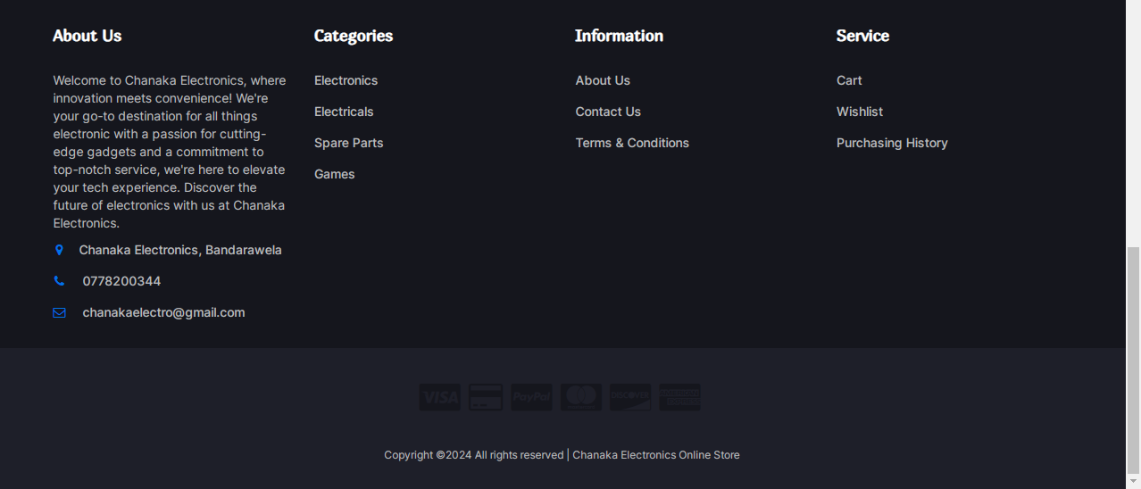

This is the footer of the web application.This footer is displayed at the bottom all the customer side interfaces. In the footer there is a ‘about us’ description and when it get clicked user can connect with the Chanaka Electronics portfolio site. Also the product categories, Information and the service pages links are also added here and users can navigate into those pages. There is a copy right statement that has been added to the bottom of the footer.

<!DOCTYPE html>

<html>

<head>

<meta charset="utf-8">

<meta http-equiv="X-UA-Compatible" content="IE=edge">

<meta name="viewport" content="width=device-width, initial-scale=1">

<link href="https://fonts.googleapis.com/css?family=Montserrat:400,500,700" rel="stylesheet">

<link type="text/css" rel="stylesheet" href="css/bootstrap.min.css" />

<link type="text/css" rel="stylesheet" href="css/slick.css" />

<link type="text/css" rel="stylesheet" href="css/slick-theme.css" />

<link type="text/css" rel="stylesheet" href="css/nouislider.min.css" />

<link rel="stylesheet" href="css/font-awesome.min.css">

<link type="text/css" rel="stylesheet" href="css/style.css" />

<link rel="icon" href="resources/logo.png" />

</head>

<body class="body">

<div class="">

<div class="row">

<div class="col-12 mt-5 foooter">

<!-- FOOTER -->

<footer id="footer">

<!-- top footer -->

<div class="section">

<!-- container -->

<div class="container">

<!-- row -->

<div class="row">

<div class="col-md-3 col-xs-6">

<div class="footer">

<h3 class="footer-title">About Us</h3>

<p class="about">

Welcome to Chanaka Electronics, where innovation meets convenience!

We're your go-to destination for all things electronic with a passion for cutting-edge gadgets and a

commitment to top-notch service, we're here to elevate your tech experience.

Discover the future of electronics with us at Chanaka Electronics.

</p>

<ul class="footer-links">

<li><a href="https://maps.app.goo.gl/1fM9BCFsGSyPkZDT8"><i class="fa fa-map-marker"></i>Chanaka Electronics, Bandarawela</a></li>

<li><a href="tel:+94778200344"><i class="fa fa-phone"></i> 0778200344</a></li>

<li><a href="mailto:chanakaelectro@gmail.com"><i class="fa fa-envelope-o"></i> chanakaelectro@gmail.com</a></li>

</ul>

</div> </div>

<div class="col-md-3 col-xs-6">

<div class="footer">

<h3 class="footer-title">Categories</h3>

<ul class="footer-links">

<?php

$category_resultSet1 = Database::search("SELECT * FROM `category`");

$category_num1 = $category_resultSet1->num_rows;

for ($x = 0; $x < $category_num1; $x++) {

$category_data1 = $category_resultSet1->fetch_assoc();

?>

<li><a href="#"><?php echo $category_data1["name"]; ?></a></li>

<?php } ?>

</ul>

</div>

</div>

<div class="clearfix visible-xs"></div>

<div class="col-md-3 col-xs-6">

<div class="footer">

<h3 class="footer-title ">Information</h3>

<ul class="footer-links">

<li><a href="http://chanakaelectronics.000webhostapp.com/index.php">About Us</a></li>

<li><a href="tel:+94778200344">Contact Us</a></li>

<li><a href="#">Terms & Conditions</a></li>

</ul>

</div>

</div>

<div class="col-md-3 col-xs-6">

<div class="footer">

<h3 class="footer-title">Service</h3>

<ul class="footer-links">

<li><a href="cart.php">Cart</a></li>

<li><a href="wishlist.php">Wishlist</a></li>

<li><a href="purchasingHistory.php">Purchasing History</a></li>

</ul>

</div>

</div></div>

</div></div>

<div id="bottom-footer" class="section">

<div class="container">

<!-- row -->

<div class="row">

<div class="col-md-12 text-center">

<ul class="footer-payments">

<li><a href="#"><i class="fa fa-cc-visa"></i></a></li>

<li><a href="#"><i class="fa fa-credit-card"></i></a></li>

<li><a href="#"><i class="fa fa-cc-paypal"></i></a></li>

<li><a href="#"><i class="fa fa-cc-mastercard"></i></a></li>

<li><a href="#"><i class="fa fa-cc-discover"></i></a></li>

<li><a href="#"><i class="fa fa-cc-amex"></i></a></li>

</ul>

<span class="copyright">

Copyright &copy;<script>

document.write(new Date().getFullYear());

</script> All rights reserved | Chanaka Electronics Online Store </a>

</span>

</div>

</div></div>

</div>

<!-- /bottom footer -->

</footer>

<!-- /FOOTER -->

</div>

</div></div>

<!-- jQuery Plugins -->

<script src="js/jquery.min.js"></script>

<script src="js/bootstrap.min.js"></script>

<script src="js/slick.min.js"></script>

<script src="js/nouislider.min.js"></script>

<script src="js/jquery.zoom.min.js"></script>

<script src="js/main.js"></script>

<script src="bootstrap.bundle.js"></script>

<script src="script.js"></script>

</body>

1. Wishlist User Interface & process associated with it

**Wishlist User Interface**

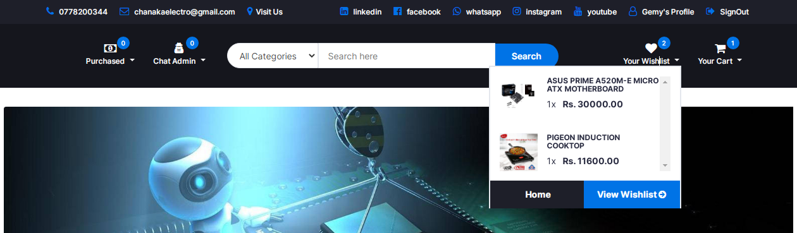

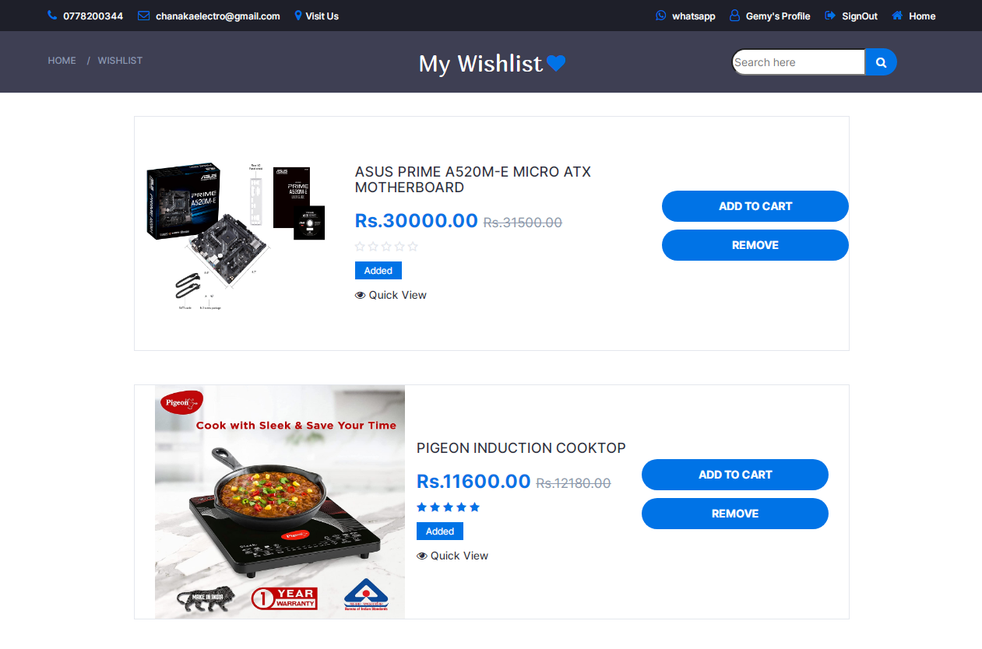

This is the wishlist Interface. The items that has been added by users to buy later as wishlist are displayed here. Users can view product details, add the products to the cart and remove the products from the wishlist here. Also users can search the products that they have been added to the wishlist using the search bar.

<!DOCTYPE html>

<html>

<?php session_start(); ?>

<head>

<meta charset="utf-8" />

<meta name="viewport" content="width=device-width, initial-scale=1" />

<title>Wishlist</title>

<link href="https://fonts.googleapis.com/css?family=Montserrat:400,500,700" rel="stylesheet">

<link type="text/css" rel="stylesheet" href="css/bootstrap.min.css" />

<link type="text/css" rel="stylesheet" href="css/slick.css" />

<link type="text/css" rel="stylesheet" href="css/slick-theme.css" />

<link type="text/css" rel="stylesheet" href="css/nouislider.min.css" />

<link rel="stylesheet" href="css/font-awesome.min.css">

<link type="text/css" rel="stylesheet" href="css/style.css" />

<!-- <link rel="stylesheet" href="bootstrap.css" />

<link rel="stylesheet" href="bootstrap-icons.css" /> -->

<link rel="stylesheet" href="style.css" />

<link rel="stylesheet" href="bootstrap-icons.css" />

<link rel="icon" href="resources/logo.png" />

</head>

<body>

<?php require "header.php";

if (isset($_SESSION["user"])) {

?>

<div class="container-fluid vh-100">

<div class="row">

<div class="col-12 d-flex justify-content-center vh-100">

<!-- BREADCRUMB -->

<div id="breadcrumb" class="section" style="height:80px; background-color: rgba(43, 45, 66, 0.91);">

<div class="container">

<div class="row bread">

<div class="col-md-3 breadcrumb-resp" style="margin-top: 20px;">

<ul class="breadcrumb-tree">

<li><a href="home.php">Home</a></li>

<li><a href="wishlist.php">Wishlist</a></li>

</ul>

</div>

<div class="col-md-6 col-sm-6 col-xs-6 wishlist" style="display: flex; justify-content: center; margin-top: 18px;">

<h2 class="f3" style="font-weight:normal; color: white;">My Wishlist</h2>

<a href="#" style="font-size: 24px; margin-left: 5px; color: #0073e6;"><i class="fa fa-heart" aria-hidden="true"></i></a>

</div>

<div class="col-md-3 col-sm-6 col-xs-6 search-bar">

<div class="header-search">

<input class="input-search" placeholder="Search here" id="s">

<button class="search-icon" style="font-size: 14px;"><i class="fa fa-search" aria-hidden="true" onclick="searchWatchlist();"></i></button>

</div>

</div></div>

</div>

</div></div>

</div>

<?php

require "connection.php";

$user = $_SESSION["user"]["email"];

$watch_rs = Database::search("SELECT * FROM `wishlist` WHERE `user_email` = '" . $user . "'");

$watch_num = $watch_rs->num_rows;

if ($watch_num == 0) {

?>

<!-- empty view -->

<div class="col-12 ">

<div class="row">

<div class="col-12 emptyView"></div><br>

<div class="col-12 text-center">

<label class="form-label f" style="font-size: 22px; font-weight: normal;">You have no items in your Watchlist

yet.</label>

</div><br>

<div class="offset-4 col-12 d-grid mb-3" style="display: flex; justify-content: center;">

<a class="primary-shop-btn cta-btn" href="home.php">Shop now</a>

</div><br>

</div></div>

<?php } else { ?>

<div class="col-12" id="searchresult">

<div class="row " style="display: flex; justify-content: center;">

<?php

$query = "SELECT * FROM `product`";

for ($x = 0; $x < $watch_num; $x++) {

$watch_data = $watch_rs->fetch_assoc();

$product_rs = Database::search("SELECT* FROM `product` WHERE `id`='" . $watch_data["product_id"] . "'");

$product_data = $product_rs->fetch_assoc();

$image_rs = Database::search("SELECT * FROM `image` WHERE `product_id`='" . $watch_data["product_id"] . "'");

$image_data = $image_rs->fetch_assoc();

$Rf_rs1 = Database::search("SELECT * FROM `feedback`WHERE `product_id`='" . $product_data["id"] . "' ORDER BY `date` DESC");

$Rf_num1 = $Rf_rs1->num_rows;

$Rf_data1 = $Rf_rs1->fetch_assoc();

$price = $product_data["price"];

$adding_price = ($price / 100) * 5;

$new_price = $price + $adding_price;

$difference = $new_price - $price;

$percentage = ($difference / $price) * 100;

?>

<div class="wishlist-box1 col-lg-6" style="height:325px; width:58%; margin-bottom: 20px;">

<div class="product-wishlist" style="display:flex; flex-direction:row; display: flex; align-items: center; display: flex; justify-content: center;">

<div class="product-image">

<img src="<?php echo $image_data["code"]; ?>" alt="" class="img">

</div>

<div class="product-details" style="margin-left: 15px;">

<div class="product-body">

<h3 class="product-name" id="t"><a href="#"><?php echo $product_data["title"] ?></a></h3>

<h4 class="product-price">Rs.<?php echo $price; ?>.00 <del class="product-old-price">Rs.<?php echo $new_price; ?>.00</del></h4><br>

<div class="product-rating">

<?php

if ($Rf_num1 == 0) {

?>

<i class="fa fa-star-o"></i>

<i class="fa fa-star-o"></i>

<i class="fa fa-star-o"></i>

<i class="fa fa-star-o"></i>

<i class="fa fa-star-o"></i>

<?php

} else {

?>

<?php

if ($Rf_data1["type"] == 5) {

?>

<i class="fa fa-star"></i>

<i class="fa fa-star"></i>

<i class="fa fa-star"></i>

<i class="fa fa-star"></i>

<i class="fa fa-star"></i>

<?php } ?>

<?php

if ($Rf_data1["type"] == 4) {

?>

<i class="fa fa-star"></i>

<i class="fa fa-star"></i>

<i class="fa fa-star"></i>

<i class="fa fa-star"></i>

<i class="fa fa-star-o"></i>

<?php } ?>

<?php

if ($Rf_data1["type"] == 3) {

?>

<i class="fa fa-star"></i>

<i class="fa fa-star"></i>

<i class="fa fa-star"></i>

<i class="fa fa-star-o"></i>

<i class="fa fa-star-o"></i>

<?php } ?>

<?php

if ($Rf_data1["type"] == 2) {

?>

<i class="fa fa-star"></i>

<i class="fa fa-star"></i>

<i class="fa fa-star-o"></i>

<i class="fa fa-star-o"></i>

<i class="fa fa-star-o"></i>

<?php } ?>

<?php

if ($Rf_data1["type"] == 1) {

?>

<i class="fa fa-star"></i>

<i class="fa fa-star-o"></i>

<i class="fa fa-star-o"></i>

<i class="fa fa-star-o"></i>

<i class="fa fa-star-o"></i>

<?php } ?>

<?php } ?>

</div>

<div class="product-label1">

<span class="new">Added</span>

</div>

<div class="product-btns">

<a href="<?php echo "SingleProductView.php?id=" . $product_data["id"]; ?>"><i class="fa fa-eye" style="margin-top: 15px;"></i>&nbsp;Quick View</a>

</div>

</div></div>

<div class="product-details" style="margin-left: 20px;">

<div class="add-to-cart" style="display: flex; flex-direction: column; ">

<button class="add-to-cart-btn" style="margin-top: 10px; width: 250px;" onclick="AddtoCart(<?php echo $product_data['id']; ?>);"><i class="fa fa-shopping-cart"></i> add to cart</button>

<button class="add-to-cart-btn" style="margin-top: 10px; width: 250px;" onclick='removeFromWatchList(<?php echo $watch_data["id"]; ?>);'><i class="fa fa-trash"></i>remove</button>

</div>

</div></div>

</div></div>

</div>

<!-- <responsive-Large-screen> -->

<!-- <responsive-medium-screen> -->

<div class="col-12" id="searchresult">

<div class="row " style="display: flex; justify-content: center;">

<div class="wishlist-box2 d-lg-none" style="height:325px; width: 80%;">

<div class="product-wishlist" style="display:flex; flex-direction:row; display: flex; align-items: center; display: flex; justify-content: center;">

<div class="product-image">

<img src="<?php echo $image_data["code"]; ?>" alt="" class="img">

</div>

<div class="product-details" style="margin-left: 20px;">

<div class="product-body">

<h3 class="product-name"><a href="#"><?php echo $product_data["title"] ?></a></h3>

<h4 class="product-price">Rs.<?php echo $price; ?>.00 <del class="product-old-price">Rs.<?php echo $new_price; ?>.00 </del></h4><br>

<div class="product-rating">

<?php

if ($Rf_num1 == 0) {

?>

<i class="fa fa-star-o"></i>

<i class="fa fa-star-o"></i>

<i class="fa fa-star-o"></i>

<i class="fa fa-star-o"></i>

<i class="fa fa-star-o"></i>

<?php

} else {

?>

<?php

if ($Rf_data1["type"] == 5) {

?>

<i class="fa fa-star"></i>

<i class="fa fa-star"></i>

<i class="fa fa-star"></i>

<i class="fa fa-star"></i>

<i class="fa fa-star"></i>

<?php } ?>

<?php

if ($Rf_data1["type"] == 4) {

?>

<i class="fa fa-star"></i>

<i class="fa fa-star"></i>

<i class="fa fa-star"></i>

<i class="fa fa-star"></i>

<i class="fa fa-star-o"></i>

<?php } ?>

<?php

if ($Rf_data1["type"] == 3) {

?>

<i class="fa fa-star"></i>

<i class="fa fa-star"></i>

<i class="fa fa-star"></i>

<i class="fa fa-star-o"></i>

<i class="fa fa-star-o"></i>

<?php } ?>

<?php

if ($Rf_data1["type"] == 2) {

?>

<i class="fa fa-star"></i>

<i class="fa fa-star"></i>

<i class="fa fa-star-o"></i>

<i class="fa fa-star-o"></i>

<i class="fa fa-star-o"></i>

<?php } ?>

<?php

if ($Rf_data1["type"] == 1) {

?>

<i class="fa fa-star"></i>

<i class="fa fa-star-o"></i>

<i class="fa fa-star-o"></i>

<i class="fa fa-star-o"></i>

<i class="fa fa-star-o"></i>

<?php } ?>

<?php } ?>

</div>

<div class="product-label1">

<span class="new">NEW</span>

</div>

<div class="product-btns">

<a href="<?php echo "SingleProductView.php?id=" . $product_data["id"]; ?>"><i class="fa fa-eye" style="margin-top: 15px;"></i>&nbsp;Quick View</a>

</div>

</div>

</div>

<div class="product-details" style="margin-right: 8px;">

<div class="add-to-cart" style="display: flex; flex-direction: column; ">

<button class="add-to-cart-btn" style="margin-top: 10px; width: 250px;" onclick="AddtoCart(<?php echo $product_data['id']; ?>);"><i class="fa fa-shopping-cart"></i> add to cart</button>

<!-- <button class="add-to-cart-btn" style="margin-top: 10px; width: 275px;";><i class="fa fa-usd"></i>buy now</button> -->

<button class="add-to-cart-btn" style="margin-top: 10px; width: 250px;" onclick='removeFromWatchList(<?php echo $watch_data["id"]; ?>);'><i class="fa fa-trash"></i>remove</button>

</div>

</div></div>

</div> </div>

</div>

<!-- <responsive-medium-screen> -->

<!-- <responsive-small-screen> -->

<div class="col-12" id="searchresult">

<div class="row " style="display: flex; justify-content: center;">

<div class="wishlist-box3" style="height:520px; width:60%; margin-bottom: 90px;">

<div class="product-wishlist" style="display:flex; flex-direction:column; display: flex; align-items: center; display: flex; justify-content: center;">

<div class="product-image" style="width: 70%; height: 275px;">

<img src="<?php echo $image_data["code"]; ?>" alt="" class="img">

</div>

<div class="product-details" style="margin-left: 20px;">

<div class="product-body">

<h3 class="product-name"><a href="#"><?php echo $product_data["title"] ?></a></h3>

<h4 class="product-price">Rs.<?php echo $price; ?>.00 <del class="product-old-price">Rs.<?php echo $new_price; ?>.00 </del></h4><br>

<div class="product-rating">

<?php

if ($Rf_num1 == 0) {

?>

<i class="fa fa-star-o"></i>

<i class="fa fa-star-o"></i>

<i class="fa fa-star-o"></i>

<i class="fa fa-star-o"></i>

<i class="fa fa-star-o"></i>

<?php

} else {

?>

<?php

if ($Rf_data1["type"] == 5) {

?>

<i class="fa fa-star"></i>

<i class="fa fa-star"></i>

<i class="fa fa-star"></i>

<i class="fa fa-star"></i>

<i class="fa fa-star"></i>

<?php } ?>

<?php

if ($Rf_data1["type"] == 4) {

?>

<i class="fa fa-star"></i>

<i class="fa fa-star"></i>

<i class="fa fa-star"></i>

<i class="fa fa-star"></i>

<i class="fa fa-star-o"></i>

<?php } ?>

<?php

if ($Rf_data1["type"] == 3) {

?>

<i class="fa fa-star"></i>

<i class="fa fa-star"></i>

<i class="fa fa-star"></i>

<i class="fa fa-star-o"></i>

<i class="fa fa-star-o"></i>

<?php } ?>

<?php

if ($Rf_data1["type"] == 2) {

?>

<i class="fa fa-star"></i>

<i class="fa fa-star"></i>

<i class="fa fa-star-o"></i>

<i class="fa fa-star-o"></i>

<i class="fa fa-star-o"></i>

<?php } ?>

<?php

if ($Rf_data1["type"] == 1) {

?>

<i class="fa fa-star"></i>

<i class="fa fa-star-o"></i>

<i class="fa fa-star-o"></i>

<i class="fa fa-star-o"></i>

<i class="fa fa-star-o"></i>

<?php } ?>

<?php } ?>

</div>

<div class="product-label1">

<span class="new">NEW</span>

</div>

<div class="product-btns">

<a href="<?php echo "SingleProductView.php?id=" . $product_data["id"]; ?>"><i class="fa fa-eye" style="margin-top: 15px;"></i>&nbsp;Quick View</a>

</div>

</div>

</div>

<div class="product-details">

<div class="add-to-cart" style="display: flex; flex-direction: column; ">

<button class="add-to-cart-btn" style="margin-top: 10px; width: 250px;" onclick="AddtoCart(<?php echo $product_data['id']; ?>);"><i class="fa fa-shopping-cart"></i> add to cart</button>

<!-- <button class="add-to-cart-btn" style="margin-top: 10px; width: 275px;";><i class="fa fa-usd"></i>buy now</button> -->

<button class="add-to-cart-btn" style="margin-top: 10px; width: 250px;" onclick='removeFromWatchList(<?php echo $watch_data["id"]; ?>);'><i class="fa fa-trash"></i>remove</button>

</div> </div>

</div> </div>

<?php } ?>

</div>

</div>

<!-- <responsive-small-screen> -->

<?php require "footer.php"; ?>

<?php }

} else {

header("location:home.php"); } ?>

<script src="bootstrap.bundle.js"></script>

<script src="script.js"></script>

</body>

</html>

**Add to wishlist process**

<?php

session_start();

require "connection.php";

if (isset($_SESSION["user"])) {

if (isset($_GET["id"])) {

$email = $_SESSION["user"]["email"];

$pid = $_GET["id"];

$watchlist_Resultset = Database::search("SELECT * FROM `wishlist` WHERE `product_id`='" . $pid . "' AND

`user_email`= '" . $email . "'");

$watchlist_num = $watchlist_Resultset->num_rows;

if ($watchlist_num == 1) {

$watchlist_data = $watchlist_Resultset->fetch_assoc();

$list_id = $watchlist_data["id"];

Database::insUpdelete("DELETE FROM `wishlist` WHERE `id` = '" . $list_id . "'");

echo ("Removed");

} else {

Database::insUpdelete("INSERT INTO `wishlist`(`product_id`, `user_email`) VALUES ('" . $pid . "' , '" . $email . "')");

echo ("added");

}

} else {

echo ("Something Went Wrong");

}

} else {

echo ("Please Login First");

}

?>

**JavaScript Code**

function addWishlist(id) {

var req = new XMLHttpRequest();

req.onreadystatechange = function () {

if (req.readyState == 4) {

var text16 = req.responseText;

if (text16 == "Removed") {

document.getElementById("heart" + id).style.className = "text-dark";

window.location.reload();

} else if (text16 == "added") {

document.getElementById("heart" + id).style.className = "text-primary";

window.location.reload();

} else {

alert(text16); } } };

req.open("GET", "AddtoWatchlistProcess.php?id=" + id, true);

req.send();

}

**Remove from wishlist process**

<?php

require "connection.php";

if(isset($_GET["id"])){

$wid = $_GET["id"];

$watch_Resultset = Database::search("SELECT * FROM `wishlist` WHERE `id` = '".$wid."'");

$watch_num = $watch_Resultset-> num_rows;

$watch_data = $watch_Resultset->fetch_assoc();

$datetime = new DateTime();

$timezone = new DateTimeZone("Asia/Colombo");

$datetime->setTimezone($timezone);

$date = $datetime->format("Y-m-d H:i:s");

if($watch_num == 0){

echo("Something went wrong Please try again later");

}else{

Database::insUpdelete("INSERT INTO `recent`(`product_id`,`user_email`,`recent_status`,`removed`) VALUES ('".$watch_data["product_id"]."' , '".$watch_data["user_email"]."','1','".$date."')");

Database::insUpdelete("DELETE FROM `wishlist` WHERE `id`= '".$wid."'");

echo("success");

}

}else{

echo("Please select a Product");

}

?>

**Java Script Code**

function removeFromWatchList(id) {

var request = new XMLHttpRequest();

request.onreadystatechange = function () {

if (request.readyState == 4) {

var text17 = request.responseText;

if (text17 == "success") {

window.location.reload();

} else {

alert(text17); } } };

request.open("GET", "removeWatchListProcess.php?id=" + id, true);

request.send();

}

**Search in wishlist process**

<?php

session_start();

require "connection.php";

if (isset($_SESSION["user"])) {

if (isset($_GET["s"])) {

$search = $_GET["s"];

$user = $_SESSION["user"]["email"];

$p_rs = Database::search("SELECT * FROM `product` WHERE `title` LIKE '%" . $search . "%'");

$pid = $p_rs->fetch_assoc();

$watch_rs = Database::search("SELECT * FROM `wishlist` WHERE `user_email`='" . $user . "'

AND `product_id` = '" . $pid["id"] . "'");

$watch_num = $watch_rs->num_rows;

if ($watch_num == 0) {

?>

<!-- empty view -->

<div class="col-12 ">

<div class="row">

<div class="col-12 emptyView"></div><br>

<div class="col-12 text-center">

<label class="form-label f" style="font-size: 22px; font-weight: normal;">You have no items in your Watchlist

yet.</label>

</div><br>

<div class="offset-4 col-12 d-grid mb-3" style="display: flex; justify-content: center;">

<a class="primary-shop-btn cta-btn" href="home.php">Shop now</a>

</div><br>

</div>

</div>

<!-- empty view -->

<?php

} else {

?>

<!-- <responsive-Large-screen> -->

<div class="row " style="display: flex; justify-content: center;">

<?php

$query = "SELECT * FROM `product`";

for ($x = 0; $x < $watch_num; $x++) {

$watch_data = $watch_rs->fetch_assoc();

$product_rs = Database::search("SELECT* FROM `product` WHERE `id`='" . $watch_data["product_id"] . "'");

$product_data = $product_rs->fetch_assoc();

$image_rs = Database::search("SELECT * FROM `image` WHERE `product_id`='" . $watch_data["product_id"] . "'");

$image_data = $image_rs->fetch_assoc();

$Rf_rs1 = Database::search("SELECT * FROM `feedback`WHERE `product_id`='" . $product_data["id"] . "' ORDER BY `date` DESC");

$Rf_num1 = $Rf_rs1->num_rows;

$Rf_data1 = $Rf_rs1->fetch_assoc();

$price = $product_data["price"];

$adding_price = ($price / 100) * 5;

$new_price = $price + $adding_price;

$difference = $new_price - $price;

$percentage = ($difference / $price) * 100;

?>

<div class="wishlist-box1 col-lg-6" style="height:325px; width:58%; margin-bottom: 20px;">

<div class="product-wishlist" style="display:flex; flex-direction:row; display: flex; align-items: center; display: flex; justify-content: center;">

<div class="product-image">

<img src="<?php echo $image_data["code"]; ?>" alt="" class="img">

</div>

<div class="product-details" style="margin-left: 15px;">

<div class="product-body">

<h3 class="product-name" id="t"><a href="#"><?php echo $product_data["title"] ?></a></h3>

<h4 class="product-price">Rs.<?php echo $price; ?>.00 <del class="product-old-price">Rs.<?php echo $new_price; ?>.00</del></h4><br>

<div class="product-rating">

<?php

if ($Rf_num1 == 0) {

?>

<i class="fa fa-star-o"></i>

<i class="fa fa-star-o"></i>

<i class="fa fa-star-o"></i>

<i class="fa fa-star-o"></i>

<i class="fa fa-star-o"></i>

<?php

} else {

?>

<?php

if ($Rf_data1["type"] == 5) {

?>

<i class="fa fa-star"></i>

<i class="fa fa-star"></i>

<i class="fa fa-star"></i>

<i class="fa fa-star"></i>

<i class="fa fa-star"></i>

<?php } ?>

<?php

if ($Rf_data1["type"] == 4) {

?>

<i class="fa fa-star"></i>

<i class="fa fa-star"></i>

<i class="fa fa-star"></i>

<i class="fa fa-star"></i>

<i class="fa fa-star-o"></i>

<?php } ?>

<?php

if ($Rf_data1["type"] == 3) {

?>

<i class="fa fa-star"></i>

<i class="fa fa-star"></i>

<i class="fa fa-star"></i>

<i class="fa fa-star-o"></i>

<i class="fa fa-star-o"></i>

<?php } ?>

<?php

if ($Rf_data1["type"] == 2) {

?>

<i class="fa fa-star"></i>

<i class="fa fa-star"></i>

<i class="fa fa-star-o"></i>

<i class="fa fa-star-o"></i>

<i class="fa fa-star-o"></i>

<?php } ?>

<?php

if ($Rf_data1["type"] == 1) {

?>

<i class="fa fa-star"></i>

<i class="fa fa-star-o"></i>

<i class="fa fa-star-o"></i>

<i class="fa fa-star-o"></i>

<i class="fa fa-star-o"></i>

<?php } ?>

<?php } ?>

</div>

<div class="product-label1">

<span class="new">NEW</span>

</div>

<div class="product-btns">

<a href="<?php echo "SingleProductView.php?id=" . $product_data["id"]; ?>"><i class="fa fa-eye" style="margin-top: 15px;"></i>&nbsp;Quick View</a>

</div></div>

</div>

<div class="product-details" style="margin-left: 15px;">

<div class="add-to-cart" style="display: flex; flex-direction: column; ">

<button class="add-to-cart-btn" style="margin-top: 10px; width: 250px;" onclick="AddtoCart(<?php echo $product_data['id']; ?>);"><i class="fa fa-shopping-cart"></i> add to cart</button>

<!-- <button class="add-to-cart-btn" style="margin-top: 10px; width: 275px;";><i class="fa fa-usd"></i>buy now</button> -->

<button class="add-to-cart-btn" style="margin-top: 10px; width: 250px;" onclick='removeFromWatchList(<?php echo $watch_data["id"]; ?>);'><i class="fa fa-trash"></i>remove</button>

</div>

</div>

</div>

</div>

</div>

<!-- <responsive-Large-screen> -->

<!-- <responsive-medium-screen> -->

<div class="row " style="display: flex; justify-content: center;">

<div class="wishlist-box2 d-lg-none" style="height:325px; width: 80%;">

<div class="product-wishlist" style="display:flex; flex-direction:row; display: flex; align-items: center; display: flex; justify-content: center;">

<div class="product-image">

<img src="<?php echo $image_data["code"]; ?>" alt="" class="img">

</div>

<div class="product-details" style="margin-left: 20px;">

<div class="product-body">

<h3 class="product-name"><a href="#"><?php echo $product_data["title"] ?></a></h3>

<h4 class="product-price">Rs.<?php echo $price; ?>.00 <del class="product-old-price">Rs.<?php echo $new_price; ?>.00 </del></h4><br>

<div class="product-rating">

<?php

if ($Rf_num1 == 0) {

?>

<i class="fa fa-star-o"></i>

<i class="fa fa-star-o"></i>

<i class="fa fa-star-o"></i>

<i class="fa fa-star-o"></i>

<i class="fa fa-star-o"></i>

<?php

} else {

?>

<?php

if ($Rf_data1["type"] == 5) {

?>

<i class="fa fa-star"></i>

<i class="fa fa-star"></i>

<i class="fa fa-star"></i>

<i class="fa fa-star"></i>

<i class="fa fa-star"></i>

<?php } ?>

<?php

if ($Rf_data1["type"] == 4) {

?>

<i class="fa fa-star"></i>

<i class="fa fa-star"></i>

<i class="fa fa-star"></i>

<i class="fa fa-star"></i>

<i class="fa fa-star-o"></i>

<?php } ?>

<?php

if ($Rf_data1["type"] == 3) {

?>

<i class="fa fa-star"></i>

<i class="fa fa-star"></i>

<i class="fa fa-star"></i>

<i class="fa fa-star-o"></i>

<i class="fa fa-star-o"></i>

<?php } ?>

<?php

if ($Rf_data1["type"] == 2) {

?>

<i class="fa fa-star"></i>

<i class="fa fa-star"></i>

<i class="fa fa-star-o"></i>

<i class="fa fa-star-o"></i>

<i class="fa fa-star-o"></i>

<?php } ?>

<?php

if ($Rf_data1["type"] == 1) {

?>

<i class="fa fa-star"></i>

<i class="fa fa-star-o"></i>

<i class="fa fa-star-o"></i>

<i class="fa fa-star-o"></i>

<i class="fa fa-star-o"></i>

<?php } ?>

<?php

}

?>

</div>

<div class="product-label1">

<span class="new">NEW</span>

</div>

<div class="product-btns">

<a href="<?php echo "SingleProductView.php?id=" . $product_data["id"]; ?>"><i class="fa fa-eye" style="margin-top: 15px;"></i>&nbsp;Quick View</a>

</div>

</div></div>

<div class="product-details" style="margin-right: 8px;">

<div class="add-to-cart" style="display: flex; flex-direction: column; ">

<button class="add-to-cart-btn" style="margin-top: 10px; width: 250px;" onclick="AddtoCart(<?php echo $product_data['id']; ?>);"><i class="fa fa-shopping-cart"></i> add to cart</button>

<!-- <button class="add-to-cart-btn" style="margin-top: 10px; width: 275px;";><i class="fa fa-usd"></i>buy now</button> -->

<button class="add-to-cart-btn" style="margin-top: 10px; width: 250px;" onclick='removeFromWatchList(<?php echo $watch_data["id"]; ?>);'><i class="fa fa-trash"></i>remove</button>

</div>

</div> </div>

</div> </div>

<!-- <responsive-medium-screen> -->

<!-- <responsive-small-screen> -->

<div class="row " style="display: flex; justify-content: center;">

<div class="wishlist-box3" style="height:520px; width:60%; margin-bottom: 90px;">

<div class="product-wishlist" style="display:flex; flex-direction:column; display: flex; align-items: center; display: flex; justify-content: center;">

<div class="product-image" style="width: 70%; height: 275px;">

<img src="<?php echo $image_data["code"]; ?>" alt="" class="img">

</div>

<div class="product-details" style="margin-left: 20px;">

<div class="product-body">

<h3 class="product-name"><a href="#"><?php echo $product_data["title"] ?></a></h3>

<h4 class="product-price">Rs.<?php echo $price; ?>.00 <del class="product-old-price">Rs.<?php echo $new_price; ?>.00 </del></h4><br>

<div class="product-rating">

<?php

if ($Rf_num1 == 0) {

?>

<i class="fa fa-star-o"></i>

<i class="fa fa-star-o"></i>

<i class="fa fa-star-o"></i>

<i class="fa fa-star-o"></i>

<i class="fa fa-star-o"></i>

<?php

} else {

?>

<?php

if ($Rf_data1["type"] == 5) {

?>

<i class="fa fa-star"></i>

<i class="fa fa-star"></i>

<i class="fa fa-star"></i>

<i class="fa fa-star"></i>

<i class="fa fa-star"></i>

<?php } ?>

<?php

if ($Rf_data1["type"] == 4) {

?>

<i class="fa fa-star"></i>

<i class="fa fa-star"></i>

<i class="fa fa-star"></i>

<i class="fa fa-star"></i>

<i class="fa fa-star-o"></i>

<?php } ?>

<?php

if ($Rf_data1["type"] == 3) {

?>

<i class="fa fa-star"></i>

<i class="fa fa-star"></i>

<i class="fa fa-star"></i>

<i class="fa fa-star-o"></i>

<i class="fa fa-star-o"></i>

<?php } ?>

<?php

if ($Rf_data1["type"] == 2) {

?>

<i class="fa fa-star"></i>

<i class="fa fa-star"></i>

<i class="fa fa-star-o"></i>

<i class="fa fa-star-o"></i>

<i class="fa fa-star-o"></i>

<?php } ?>

<?php

if ($Rf_data1["type"] == 1) {

?>

<i class="fa fa-star"></i>

<i class="fa fa-star-o"></i>

<i class="fa fa-star-o"></i>

<i class="fa fa-star-o"></i>

<i class="fa fa-star-o"></i>

<?php } ?>

<?php } ?>

</div>

<div class="product-label1">

<span class="new">NEW</span>

</div>

<div class="product-btns">

<a href="<?php echo "SingleProductView.php?id=" . $product_data["id"]; ?>"><i class="fa fa-eye" style="margin-top: 15px;"></i>&nbsp;Quick View</a>

</div>

</div>

</div>

<div class="product-details">

<div class="add-to-cart" style="display: flex; flex-direction: column; ">

<button class="add-to-cart-btn" style="margin-top: 10px; width: 250px;" onclick="AddtoCart(<?php echo $product_data['id']; ?>);"><i class="fa fa-shopping-cart"></i> add to cart</button>

<!-- <button class="add-to-cart-btn" style="margin-top: 10px; width: 275px;";><i class="fa fa-usd"></i>buy now</button> -->

<button class="add-to-cart-btn" style="margin-top: 10px; width: 250px;" onclick='removeFromWatchList(<?php echo $watch_data["id"]; ?>);'><i class="fa fa-trash"></i>remove</button>

</div>

</div> </div>

</div>

<?php } } ?>

</div>

<!-- <responsive-small-screen> -->

<?php require "footer.php"; ?>

<?php

} else {

header("location:wishlist.php");

}

} else {

header("location:home.php"); } ?>

**JavaScript Code**

function searchWatchlist() {

var search = document.getElementById("s").value;

var request = new XMLHttpRequest();

request.onreadystatechange = function () {

if (request.readyState == 4) {

var text19 = request.responseText;

document.getElementById("searchresult").innerHTML = text19;

} };

request.open("GET", "searchWatchlistProcess.php?s=" + search, true);

request.send();

}

1. Cart User Interface & process associated with it

**Cart User Interface**

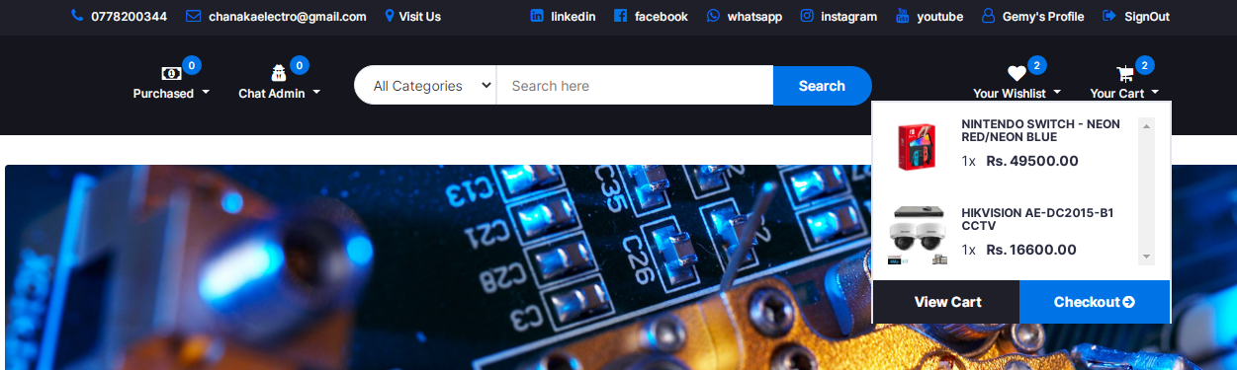

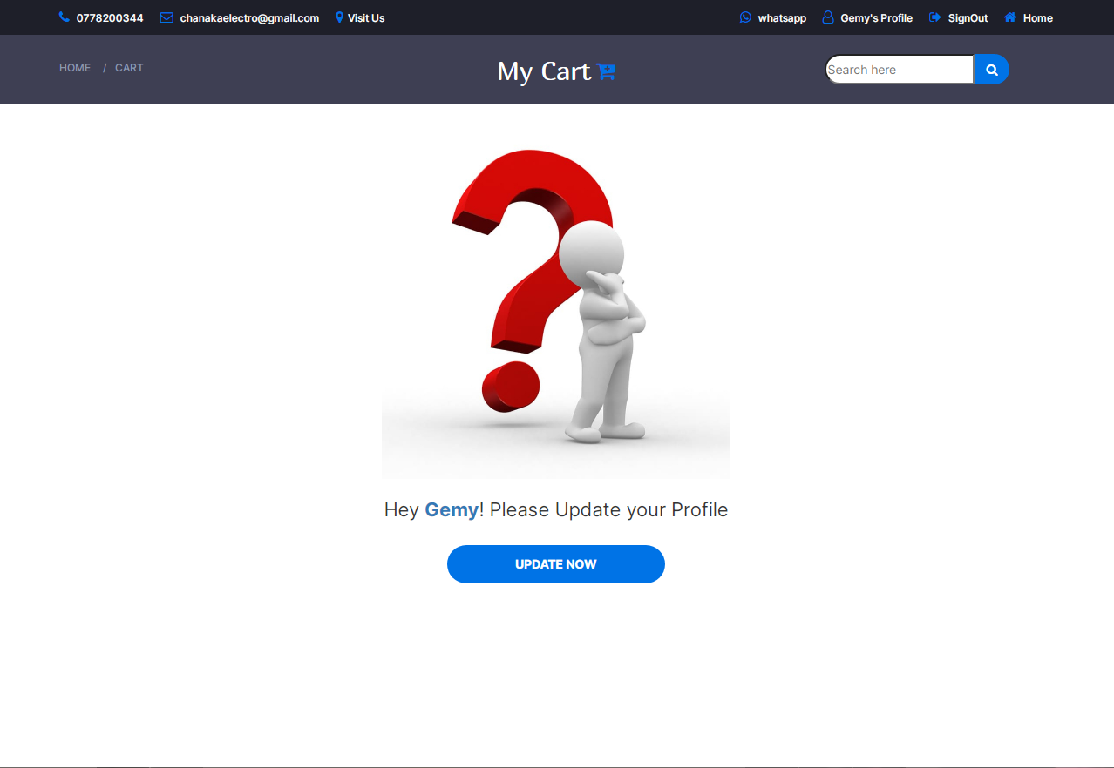

You can not access to cart until you update your profile

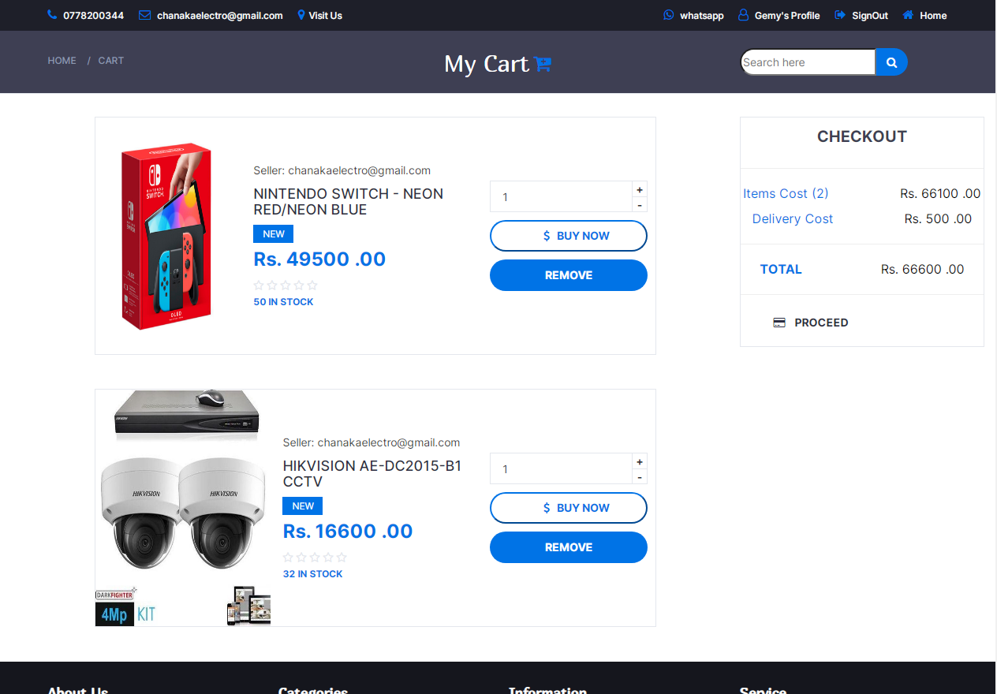

This is the cart page interface. The products that has been added to the cart by the user are displayed like this in this page. User can buy the products or remove the added producs from the cart page here.The total price of the added products are calculated and displayed in the Checkout box. User can search the products using the search bar here. User can navigate into the home page using the home link added in the bread crumb.

<!DOCTYPE html>

<html>

<?php

require "connection.php";

session_start();

if (isset($_SESSION["user"])) {

$email = $_SESSION["user"]["email"];

$total = 0;

$subtotal = 0;

$shipping = 0;

?>

<head>

<meta charset="utf-8" />

<meta name="viewport" content="width=device-width, initial-scale=1" />

<title><?php echo $_SESSION["user"]["fname"]; ?>'s Cart page</title>

<link href="https://fonts.googleapis.com/css?family=Montserrat:400,500,700" rel="stylesheet">

<link type="text/css" rel="stylesheet" href="css/bootstrap.min.css" />

<link type="text/css" rel="stylesheet" href="css/slick.css" />

<link type="text/css" rel="stylesheet" href="css/slick-theme.css" />

<link type="text/css" rel="stylesheet" href="css/nouislider.min.css" />

<link rel="stylesheet" href="css/font-awesome.min.css">

<link type="text/css" rel="stylesheet" href="css/style.css" />

<!-- <link rel="stylesheet" href="bootstrap.css" />

<link rel="stylesheet" href="bootstrap-icons.css" /> -->

<link rel="stylesheet" href="style.css" />

<link rel="stylesheet" href="bootstrap-icons.css" />

<link rel="icon" href="resources/logo.png" />

</head>

<body>

<?php require "header.php"; ?>

<div class="container-fluid vh-100">

<div class="row">

<div class="col-12 d-flex justify-content-center vh-100">

<!-- BREADCRUMB -->

<div id="breadcrumb" class="section" style="height:80px; background-color: rgba(43, 45, 66, 0.91);">

<!-- container -->

<div class="container">

<!-- row -->

<div class="row bread">

<div class="col-md-3 breadcrumb-resp" style="margin-top: 20px;">

<ul class="breadcrumb-tree">

<li><a href="home.php">Home</a></li>

<li><a href="cart.php">cart</a></li>

</ul>

</div>

<div class="col-md-6 col-sm-5 col-xs-5 wishlist" style="display: flex; justify-content: center; margin-top: 18px;">

<h2 class="f3" style="font-weight:normal; color: white;">My Cart</h2>

<a href="#" style="ont-size: 24px; margin-left: 5px; color: #0073e6;"><i class="fa fa-cart-plus" aria-hidden="true"></i></a>

</div>

<div class="col-md-3 col-sm-5 col-xs-5 search-bar">

<div class="header-search">

<input class="input-search" placeholder="Search here" id="c">

<button class="search-ion" style="font-size: 14px;"><i class="fa fa-search" aria-hidden="true" onclick="searchCart();"></i></button>

</div>

</div></div>

</div></div>

</div></div>

<?php

$cart_rs = Database::search("SELECT * FROM `cart` WHERE `user_email`='" . $email . "'");

$cart_num = $cart_rs->num_rows;

$addrerss_Rsesultset = Database::search("SELECT district.id AS did FROM `user_has_address` INNER JOIN `city` ON user_has_address.city_id=city.id

INNER JOIN `district` ON city.district_id=district.id WHERE `user_email`='" . $email . "'");

$address_num = $addrerss_Rsesultset->num_rows;

$addrerss_data = $addrerss_Rsesultset->fetch_assoc();

if ($address_num == 1) {

?>

<?php

if ($cart_num == 0) {

?>

<!-- empty view -->

<div class="col-12 ">

<div class="row">

<div class="col-12 empty-cart"></div><br>

<div class="col-12 text-center">

<label class="form-label f" style="font-size: 22px; font-weight: normal;">You have no items in your Cart

yet.</label>

</div><br>

<div class="offset-4 col-12 d-grid mb-3" style="display: flex; justify-content: center;">

<a class="primary-shop-btn cta-btn" href="home.php">Shop now</a>

</div><br>

</div>

</div>

<?php } else { ?>

<div class="col-12 col-lg-9" id="searchresult">

<?php

$query = "SELECT * FROM `product`";

for ($x = 0; $x < $cart_num; $x++) {

$cart_data = $cart_rs->fetch_assoc();

$product_rs = Database::search("SELECT * FROM `product` WHERE `id` = '" . $cart_data["product_id"] . "'");

$product_data = $product_rs->fetch_assoc();

$image_rs = Database::search("SELECT * FROM `image` WHERE `product_id`='" . $cart_data["product_id"] . "'");

$image_data = $image_rs->fetch_assoc();

$total = $total + ($product_data["price"] * $cart_data["qty"]);

$ship = 0;

if ($addrerss_data["did"] == '3') {

$ship = $product_data["delivery_fee_colombo"];

$shipping = $shipping + $ship;

} else {

$ship = $product_data["delivery_fee_other"];

$shipping = $shipping + $ship;

}

$seller_rs = Database::search("SELECT * FROM `user` WHERE `email` = '" . $cart_data["user_email"] . "'");

$seller_data = $seller_rs->fetch_assoc();

$seller = $seller_data["fname"] . " " . $seller_data["lname"];

?>

<div class="row " style="display: flex; justify-content: center;">

<div class="wishlist-box1 col-lg-8" style="height:325px; width:80%; margin-bottom: 20px;">

<div class="product-wishlist" style="display:flex; flex-direction:row; display: flex; align-items: center; display: flex; justify-content: center;">

<div class="product-image">

<img src="<?php echo $image_data["code"]; ?>" alt="" class="img">

</div>

<div class="product-details" style="margin-left: 15px;">

<div class="product-body">

<p class="product-category">Seller: <?php echo $product_data["admin_email"]; ?></p>

<h3 class="product-name"><a href="#"><?php echo $product_data["title"] ?></a></h3>

<div class="product-label1">

<span class="new">NEW</span>

</div>

<h4 class="product-price">Rs. <?php echo $product_data["price"] * $cart_data["qty"]; ?> .00</h4><br>

<?php

$Rf_rs1 = Database::search("SELECT * FROM `feedback`WHERE `product_id`='" . $product_data["id"] . "' ORDER BY `date` DESC");

$Rf_num1 = $Rf_rs1->num_rows;

$Rf_data1 = $Rf_rs1->fetch_assoc();

?>

<div class="product-rating">

//star ratings

</div>

<div>

<span class="product-available"><?php echo $product_data["qty"]; ?> In Stock</span>

</div>

</div></div>

<div class="product-details" style="margin-left: 10px; margin-right: 10px;">

<div class="">

<div class="qty-label" style="width: 200px; margin-top: 30px;">

<div class="input-number">

<input type="number" style="outline: none;" value="<?php echo $cart_data["qty"]; ?>" pattern="[0-9]" id="qty_input" onkeyup='checkValue(<?php echo $cart_data["qty"]; ?>);'>

<span class="qty-up" onkeyup='qty_inc(<?php echo $product_data["qty"]; ?>);' onclick='AddtoCart(<?php echo $product_data["id"]; ?>)'>+</span>

<span class="qty-down" onkeyup='qty_dec(<?php echo $product_data["qty"]; ?>);' onclick='MinCart(<?php echo $product_data["id"]; ?>)'>-</span>

</div>

</div></div>

<div class="add-to-cart" style="display: flex; flex-direction: column; ">

<!-- <button class="add-to-cart-btn" style="margin-top: 10px; width: 250px;"><i class="fa fa-shopping-cart"></i> add to cart</button> -->

<button class="add-to-cart-btn1" style="margin-top: 10px; width: 200px; font-weight: bold;" type="submit" id="payhere-payment" onclick="payNow(<?php echo $product_data['id']; ?>);"><i class="fa fa-usd"></i> &nbsp; BUY NOW</button>

<button class="add-to-cart-btn" style="margin-top: 10px; width: 200px;" onclick="deleteFromCart(<?php echo $cart_data['id']; ?>)" ;><i class="fa fa-trash"></i>remove</button>

</div>

</div></div>

</div></div>

<?php } ?>

</div>

<div class="col-12 col-lg-3" id="searchresult">

<div class="row product-wishlist">

<div class="col-12" style="display:flex; justify-content: center; align-content: center;">

<label class="form-label f1" style="color:rgba(43, 45, 66, 0.91); font-size: 20px; margin-top: 10px;">CHECKOUT</label>

</div>

<div class="col-12">

<hr class="hr" />

</div>

<div class="col-12" style="display: flex; flex-direction: row; justify-content: center;">

<div class="col-4 text-start mb-3">

<span class="fs-6 f1" style="color: #0073e6; margin-right: 90px; font-size: 16px;">Items Cost (<?php echo $cart_num; ?>)</span>

</div>

<div class="col-8 mb-3">

<span class="fs-5 f1" style="color: black; font-size: 16px;">Rs. <?php echo $total; ?> .00</span>

</div>

</div>

<div class="col-12" style="display: flex; flex-direction: row; margin-top: 10px; justify-content: center;">

<div class="col-6 text-start mb-3">

<span class="fs-6 f1" style="color: #0073e6; margin-right: 90px; font-size: 16px;">Delivery Cost</span>

</div>

<div class="col-6 mb-3">

<span class="fs-6 f1" style="color: black; font-size: 16px;">Rs. <?php echo $shipping; ?> .00</span>

</div>

</div>

<div class="col-12 mt-3">

<hr class="hr" />

</div>

<div style="display: flex; flex-direction: row; margin-top: 10px; justify-content: center;">

<div class="col-6">

<span class="fs-4 f1" style="color: #0073e6; font-weight: bold; margin-right: 100px; font-size: 16px;">TOTAL</span>

</div>

<div class="col-6 text-end">

<span class="fs-4 f1" style="color: black; font-size: 16px;">Rs. <?php echo ($shipping + $total); ?> .00</span>

</div>

</div>

<div class="col-12 mt-3">

<hr class="hr" />

</div>

<div class="product-details" style="display: flex; justify-content: center; ">

<div class="add-to-cart1" style="display: flex; flex-direction: column; margin-bottom: 20px;">

<a class="" style="margin-top: 5px; width: 225px; font-weight: bold;" type="submit" id="payhere-payment" href="checkout.php">

<i class="fa fa-credit-card" aria-hidden="true"></i>&nbsp; &nbsp;

PROCEED</a>

</div>

</div></div>

</div>

<?php } ?>

<!-- <responsive-medium-screen> -->

<div class="col-12" id="searchresult">

<?php

$cart_rs = Database::search("SELECT * FROM `cart` WHERE `user_email`='" . $email . "'");

$cart_num = $cart_rs->num_rows;

$query = "SELECT * FROM `product`";

for ($x = 0; $x < $cart_num; $x++) {

$cart_data = $cart_rs->fetch_assoc();

$product_rs = Database::search("SELECT * FROM `product` WHERE `id` = '" . $cart_data["product_id"] . "'");

$product_data = $product_rs->fetch_assoc();

$image_rs = Database::search("SELECT * FROM `image` WHERE `product_id`='" . $cart_data["product_id"] . "'");

$image_data = $image_rs->fetch_assoc();

$total = $total + ($product_data["price"] * $cart_data["qty"]);

$addrerss_Rsesultset = Database::search("SELECT district.id AS did FROM `user_has_address` INNER JOIN `city` ON user_has_address.city_id=city.id

INNER JOIN `district` ON city.district_id=district.id WHERE `user_email`='" . $email . "'");

$addrerss_data = $addrerss_Rsesultset->fetch_assoc();

$ship = 0;

if ($addrerss_data["did"] == 2) {

$ship = $product_data["delivery_fee_colombo"];

$shipping = $shipping + $ship;

} else {

$ship = $product_data["delivery_fee_other"];

$shipping = $shipping + $ship; }

$seller_rs = Database::search("SELECT * FROM `user` WHERE `email` = '" . $cart_data["user_email"] . "'");

$seller_data = $seller_rs->fetch_assoc();

$seller = $seller_data["fname"] . " " . $seller_data["lname"];

?>

<div class="row " style="display: flex; justify-content: center;">

<div class="wishlist-box2 d-lg-none" style="height:325px; width: 80%;">

<div class="product-wishlist" style="display:flex; flex-direction:row; display: flex; align-items: center; display: flex; justify-content: center;">

<div class="product-image">

<img src="<?php echo $image_data["code"]; ?>" alt="" class="img">

</div>

<div class="product-details" style="margin-left: 15px;">

<div class="product-body">

<p class="product-category">Seller: <?php echo $product_data["admin_email"]; ?></p>

<h3 class="product-name"><a href="#"><?php echo $product_data["title"] ?></a></h3>

<div class="product-label1">

<span class="new">NEW</span>

</div>

<h4 class="product-price">Rs. <?php echo ($product_data["price"] * $cart_data["qty"]); ?> .00</h4><br>

<?php

$Rf_rs1 = Database::search("SELECT * FROM `feedback`WHERE `product_id`='" . $product_data["id"] . "' ORDER BY `date` DESC");

$Rf_num1 = $Rf_rs1->num_rows;

$Rf_data1 = $Rf_rs1->fetch_assoc();

?>

<div class="product-rating">

<?php

if ($Rf_num1 == 0) {

?>

<i class="fa fa-star-o"></i>

<i class="fa fa-star-o"></i>

<i class="fa fa-star-o"></i>

<i class="fa fa-star-o"></i>

<i class="fa fa-star-o"></i>

<?php

} else {

?>

<?php

if ($Rf_data1["type"] == 5) {

?>

<i class="fa fa-star"></i>

<i class="fa fa-star"></i>

<i class="fa fa-star"></i>

<i class="fa fa-star"></i>

<i class="fa fa-star"></i>

<?php } ?>

<?php

if ($Rf_data1["type"] == 4) {

?>

<i class="fa fa-star"></i>

<i class="fa fa-star"></i>

<i class="fa fa-star"></i>

<i class="fa fa-star"></i>

<i class="fa fa-star-o"></i>

<?php } ?>

<?php

if ($Rf_data1["type"] == 3) {

?>

<i class="fa fa-star"></i>

<i class="fa fa-star"></i>

<i class="fa fa-star"></i>

<i class="fa fa-star-o"></i>

<i class="fa fa-star-o"></i>

<?php } ?>

<?php

if ($Rf_data1["type"] == 2) {

?>

<i class="fa fa-star"></i>

<i class="fa fa-star"></i>

<i class="fa fa-star-o"></i>

<i class="fa fa-star-o"></i>

<i class="fa fa-star-o"></i>

<?php } ?>

<?php

if ($Rf_data1["type"] == 1) {

?>

<i class="fa fa-star"></i>

<i class="fa fa-star-o"></i>

<i class="fa fa-star-o"></i>

<i class="fa fa-star-o"></i>

<i class="fa fa-star-o"></i>

<?php } ?>

<?php } ?>

</div>

<div>

<span class="product-available"><?php echo $product_data["qty"]; ?> In Stock</span>

</div>

</div>

</div>

<div class="product-details" style="margin-right: 5px; margin-left: 5px;">

<div class="">

<div class="qty-label" style="width: 190px; margin-top: 30px;">

<div class="input-number">

<input type="number" style="outline: none;" value="<?php echo $cart_data["qty"]; ?>" pattern="[0-9]" id="qty_input" onkeyup='checkValue(<?php echo $cart_data["qty"]; ?>);'>

<span class="qty-up" onkeyup='qty_inc(<?php echo $product_data["qty"]; ?>);' onclick='AddtoCart(<?php echo $product_data["id"]; ?>)'>+</span>

<span class="qty-down" onkeyup='qty_dec(<?php echo $product_data["qty"]; ?>);' onclick='MinCart(<?php echo $product_data["id"]; ?>)'>-</span>

</div>

</div>

</div>

<div class="add-to-cart" style="display: flex; flex-direction: column; ">

<!-- <button class="add-to-cart-btn" style="margin-top: 10px; width: 250px;"><i class="fa fa-shopping-cart"></i> add to cart</button> -->

<button class="add-to-cart-btn1" style="margin-top: 10px; width: 200px; font-weight: bold;" type="submit" id="payhere-payment" onclick="payNow(<?php echo $product_data['id']; ?>);"><i class="fa fa-usd"></i> &nbsp; BUY NOW</button>

<button class="add-to-cart-btn" style="margin-top: 10px; width: 200px;" onclick="deleteFromCart(<?php echo $cart_data['id']; ?>)" ;><i class="fa fa-trash"></i>remove</button>

</div>

</div></div>

</div></div>

<?php } ?>

</div>

<!-- <responsive-medium-screen> --

<!-- <responsive-small-screen> -->

<div class="col-12" id="searchresult">

<?php

$cart_rs = Database::search("SELECT * FROM `cart` WHERE `user_email`='" . $email . "'");

$cart_num = $cart_rs->num_rows;

$query = "SELECT * FROM `product`";

for ($x = 0; $x < $cart_num; $x++) {

$cart_data = $cart_rs->fetch_assoc();

$product_rs = Database::search("SELECT * FROM `product` WHERE `id` = '" . $cart_data["product_id"] . "'");

$product_data = $product_rs->fetch_assoc();

$image_rs = Database::search("SELECT * FROM `image` WHERE `product_id`='" . $cart_data["product_id"] . "'");

$image_data = $image_rs->fetch_assoc();

$total = $total + ($product_data["price"] * $cart_data["qty"]);

$addrerss_Rsesultset = Database::search("SELECT district.id AS did FROM `user_has_address` INNER JOIN `city` ON user_has_address.city_id=city.id

INNER JOIN `district` ON city.district_id=district.id WHERE `user_email`='" . $email . "'");

$addrerss_data = $addrerss_Rsesultset->fetch_assoc();

$ship = 0;

if ($addrerss_data["did"] == 2) {

$ship = $product_data["delivery_fee_colombo"];

$shipping = $shipping + $ship;

} else {

$ship = $product_data["delivery_fee_other"];

$shipping = $shipping + $ship; }

$seller_rs = Database::search("SELECT * FROM `user` WHERE `email` = '" . $cart_data["user_email"] . "'");

$seller_data = $seller_rs->fetch_assoc();

$seller = $seller_data["fname"] . " " . $seller_data["lname"];

?>

<div class="row " style="display: flex; justify-content: center;">

<div class="wishlist-box3" style="height:520px; width:60%; margin-top: 150px;">

<div class="product-wishlist" style="display:flex; flex-direction:column; display: flex; align-items: center; display: flex; justify-content: center;">

<div class="product-image" style="width: 70%; height: 275px;"

<img src="<?php echo $image_data["code"]; ?>" alt="" class="img">

</div>

<div class="product-details" style="margin-left: 15px;">

<div class="product-body">

<p class="product-category">Seller: <?php echo $product_data["admin_email"]; ?></p>

<h3 class="product-name"><a href="#"><?php echo $product_data["title"] ?></a></h3>

<div class="product-label1">

<span class="new">NEW</span>

</div>

<h4 class="product-price">Rs. <?php echo ($product_data["price"] * $cart_data["qty"]); ?> .00</h4><br>

<?php

$Rf_rs1 = Database::search("SELECT * FROM `feedback`WHERE `product_id`='" . $product_data["id"] . "' ORDER BY `date` DESC");

$Rf_num1 = $Rf_rs1->num_rows;

$Rf_data1 = $Rf_rs1->fetch_assoc();

?>

<div class="product-rating">

// star ratings

</div>

<div>

<span class="product-available"><?php echo $product_data["qty"]; ?> In Stock</span>

</div>

</div>

</div>

<div class="product-details">

<div class="">

<div class="qty-label" style="width: 225px; margin-top: 30px;">

<div class="input-number">

<input type="number" style="outline: none;" value="<?php echo $cart_data["qty"]; ?>" pattern="[0-9]" id="qty_input" onkeyup='checkValue(<?php echo $cart_data["qty"]; ?>);'>

<span class="qty-up" onkeyup='qty_inc(<?php echo $product_data["qty"]; ?>);' onclick='AddtoCart(<?php echo $product_data["id"]; ?>)'>+</span>

<span class="qty-down" onkeyup='qty_dec(<?php echo $product_data["qty"]; ?>);' onclick='MinCart(<?php echo $product_data["id"]; ?>)'>-</span>

</div>

</div></div>

<div class="add-to-cart" style="display: flex; flex-direction: column; ">

<!-- <button class="add-to-cart-btn" style="margin-top: 10px; width: 250px;"><i class="fa fa-shopping-cart"></i> add to cart</button> -->

<button class="add-to-cart-btn1" style="margin-top: 10px; width: 200px; font-weight: bold;" type="submit" id="payhere-payment" onclick="payNow(<?php echo $product_data['id']; ?>);"><i class="fa fa-usd"></i> &nbsp; BUY NOW</button>

<button class="add-to-cart-btn" style="margin-top: 10px; width: 200px;" onclick="deleteFromCart(<?php echo $cart_data['id']; ?>)" ;><i class="fa fa-trash"></i>remove</button>

</div>

</div></div>

</div></div>

<?php } ?>

</div>

<!-- <responsive-small-screen> -->

</div>

<script src="bootstrap.bundle.js"></script>

<script src="script.js"></script>

<script type="text/javascript" src="https://www.payhere.lk/lib/payhere.js"></script>

</body>

<?php require "footer.php"; ?>

</html>

<?php

            } else {

?>

<div class="col-12 ">

<div class="row">

<div class="col-12 empty-profile"></div><br>

<div class="col-12 text-center">

<label class="form-label f" style="font-size: 22px; font-weight: normal;">Hey <b class="text-primary"><?php echo $_SESSION["user"]["fname"]; ?></b>! Please Update your Profile </label>

</div><br>

<div class="offset-4 col-12 d-grid mb-3" style="display: flex; justify-content: center;">

<a class="primary-shop-btn cta-btn" href="userprofile.php">Update now</a>

</div><br>

</div>

</div>

<?php

} else {

header("location:home.php"); } ?>

**Add to cart process**

<?php

session_start();

require "connection.php";

if (isset($_SESSION["user"])) {

if (isset($_GET["id"])) {

$email = $_SESSION["user"]["email"];

$pid = $_GET["id"];

$cart_rs = Database::search("SELECT * FROM `cart` WHERE `product_id` = '" . $pid . "' AND `user_email`='" . $email . "'");

$cart_num = $cart_rs->num_rows;

$product_rs = Database::search("SELECT * FROM `product` WHERE `id`='" . $pid . "'");

$product_data = $product_rs->fetch_assoc();

$product_qty = $product_data["qty"];

if ($cart_num == 1) {

$cart_data = $cart_rs->fetch_assoc();

$current_qty = $cart_data["qty"];

$new_qty = (int)$current_qty + 1;

if ($product_qty >= $new_qty) {

Database::insUpdelete("UPDATE `cart` SET `qty`='" . $new_qty . "' WHERE `product_id` = '" . $pid . "' AND `user_email`='" . $email . "'");

echo ("product Updated");

} else {

echo ("Invalid Quantity");

}

} else {

Database::insUpdelete("INSERT INTO `cart`(`product_id`,`user_email`,`qty`) VALUES ('" . $pid . "' , '" . $email . "', '1')");

echo ("Product Saved Successfully");

}

} else {

echo ("something went wrong");

}

} else {

echo ("Please Sign In or Register");

}

**JavaScript Code**

function AddtoCart(id) {

var req = new XMLHttpRequest();

req.onreadystatechange = function () {

if (req.readyState == 4) {

var text18 = req.responseText;

alert(text18);

window.location.reload();

}

};

req.open("GET", "addTocartProcess.php?id=" + id, true);

req.send();

}

**Minus Cart QTY value process**

<?php

session_start();

require "connection.php";

if (isset($_SESSION["user"])) {

if (isset($_GET["id"])) {

$email = $_SESSION["user"]["email"];

$pid = $_GET["id"];

$cart_rs = Database::search("SELECT * FROM `cart` WHERE `product_id` = '" . $pid . "' AND `user_email`='" . $email . "'");

$cart_num = $cart_rs->num_rows;

$product_rs = Database::search("SELECT * FROM `product` WHERE `id`='" . $pid . "'");

$product_data = $product_rs->fetch_assoc();

$product_qty = $product_data["qty"];

if ($cart_num == 1) {

$cart_data = $cart_rs->fetch_assoc();

$current_qty = $cart_data["qty"];

$new_qty = (int)$current_qty - 1

if ($product_qty >= $new_qty) {

Database::insUpdelete("UPDATE `cart` SET `qty`='" . $new_qty . "' WHERE `product_id` = '" . $pid . "' AND `user_email`='" . $email . "'");

echo ("product Updated");

} else {

echo ("Invalid Quantity");

}

} else {

Database::insUpdelete("INSERT INTO `cart`(`product_id`,`user_email`,`qty`) VALUES ('" . $pid . "' , '" . $email . "', '1')");

echo ("Product Saved Successfully");

}

} else {

echo ("something went wrong");

}

} else {

echo ("Please Sign In or Register");

}

**JavaScript Code**

function MinCart(id) {

var req = new XMLHttpRequest();

req.onreadystatechange = function () {

if (req.readyState == 4) {

var text18 = req.responseText;

alert(text18);

window.location.reload();

}

};

req.open("GET", "minCartProcess.php?id=" + id, true);

req.send();

}

**Delete From Cart Process**

<?php

require "connection.php";

if(isset($_GET["id"])){

$cart_id = $_GET["id"];

$cart_rs = Database::search("SELECT * FROM `cart` WHERE `id` ='".$cart_id."'");

$cart_data = $cart_rs->fetch_assoc();

$user = $cart_data["user_email"];

$product = $cart_data["product_id"];

Database::insUpdelete("INSERT INTO `recent`(`product_id`, `user_email`)VALUES('".$product."' , '".$user."');");

Database::insUpdelete("DELETE FROM `cart` WHERE `id` = '".$cart_id."'");

echo("successfuly Removed");

}else{

echo("something Went Wrong"); } ?>

**JavaScript Code**

function deleteFromCart(id) {

var req = new XMLHttpRequest();

req.onreadystatechange = function () {

if (req.readyState == 4) {

var text20 = req.responseText;

if (text20 == "successfuly Removed") {

alert("Product Removed from the cart");

window.location.reload();

} else {

alert(text20);

}

}

};

req.open("GET", "deleteFromCartProcess.php?id=" + id, true);

req.send();

}

**Search from cart Process**

<?php

session_start();

require "connection.php";

if (isset($_SESSION["user"])) {

if (isset($_GET["c"])) {

$search = $_GET["c"];

$email = $_SESSION["user"]["email"];

$total = 0;

$subtotal = 0;

$shipping = 0;

$p_rs = Database::search("SELECT * FROM `product` WHERE `title` LIKE '%" . $search . "%'");

$p_data = $p_rs->fetch_assoc();

$cart_rs = Database::search("SELECT * FROM `cart` WHERE `user_email`='" . $email . "'

AND `product_id` = '" . $p_data['id'] . "'");

$cart_num = $cart_rs->num_rows;

$addrerss_Rsesultset = Database::search("SELECT district.id AS did FROM `user_has_address` INNER JOIN `city` ON user_has_address.city_id=city.id

INNER JOIN `district` ON city.district_id=district.id WHERE `user_email`='" . $email . "'");

$address_num = $addrerss_Rsesultset->num_rows;

$addrerss_data = $addrerss_Rsesultset->fetch_assoc();

if ($address_num == 1) {

if ($cart_num == 0) {

?>

<!-- empty view -->

<div class="col-12 ">

<div class="row">

<div class="col-12 empty-cart"></div><br>

<div class="col-12 text-center">

<label class="form-label f" style="font-size: 22px; font-weight: normal;">You have no items in your Cart

yet.</label>

</div><br>

<div class="offset-4 col-12 d-grid mb-3" style="display: flex; justify-content: center;">

<a class="primary-shop-btn cta-btn" href="home.php">Shop now</a>

</div><br>

</div>

</div>

<!-- empty view -->

<?php

} else {

$query = "SELECT * FROM `product`";

for ($x = 0; $x < $cart_num; $x++) {

$cart_data = $cart_rs->fetch_assoc();

$product_rs = Database::search("SELECT * FROM `product` WHERE `id` = '" . $cart_data["product_id"] . "'");

$product_data = $product_rs->fetch_assoc();

$image_rs = Database::search("SELECT * FROM `image` WHERE `product_id`='" . $cart_data["product_id"] . "'");

$image_data = $image_rs->fetch_assoc();

$total = $total + ($product_data["price"] * $cart_data["qty"]);

$addrerss_Rsesultset = Database::search("SELECT district.id AS did FROM `user_has_address` INNER JOIN `city` ON user_has_address.city_id=city.id

INNER JOIN `district` ON city.district_id=district.id WHERE `user_email`='" . $email . "'");

$addrerss_data = $addrerss_Rsesultset->fetch_assoc();

$ship = 0;

if ($addrerss_data["did"] == 2) {

$ship = $product_data["delivery_fee_colombo"];

$shipping = $shipping + $ship;

} else {

$ship = $product_data["delivery_fee_other"];

$shipping = $shipping + $ship;

}

$seller_rs = Database::search("SELECT * FROM `user` WHERE `email` = '" . $cart_data["user_email"] . "'");

$seller_data = $seller_rs->fetch_assoc();

$seller = $seller_data["fname"] . " " . $seller_data["lname"];

?>

<div class="row " style="display: flex; justify-content: center;">

<div class="wishlist-box1 col-lg-8" style="height:325px; width:80%; margin-bottom: 20px;">

<div class="product-wishlist" style="display:flex; flex-direction:row; display: flex; align-items: center; display: flex; justify-content: center;">

<div class="product-image">

<img src="<?php echo $image_data["code"]; ?>" alt="" class="img">

</div>

<div class="product-details" style="margin-left: 15px;">

<div class="product-body">

<p class="product-category">Seller: <?php echo $product_data["admin_email"]; ?></p>

<h3 class="product-name"><a href="#"><?php echo $product_data["title"] ?></a></h3>

<div class="product-label1">

<span class="new">NEW</span>

</div>

<h4 class="product-price">Rs. <?php echo $product_data["price"] * $cart_data["qty"]; ?> .00</h4><br>

<?php

$Rf_rs1 = Database::search("SELECT * FROM `feedback`WHERE `product_id`='" . $product_data["id"] . "' ORDER BY `date` DESC");

$Rf_num1 = $Rf_rs1->num_rows;

$Rf_data1 = $Rf_rs1->fetch_assoc();

?>

<div class="product-rating">

{ Star Rating Code }

</div>

<div>

<span class="product-available"><?php echo $product_data["qty"]; ?> In Stock</span>

</div>

</div></div>

<div class="product-details" style="margin-left: 10px; margin-right: 10px;">

<div class="">

<div class="qty-label" style="width: 200px; margin-top: 30px;">

<div class="input-number">

<input type="number" style="outline: none;" value="<?php echo $cart_data["qty"]; ?>" pattern="[0-9]" id="qty_input" onkeyup='checkValue(<?php echo $cart_data["qty"]; ?>);'>

<span class="qty-up" onkeyup='qty_inc(<?php echo $product_data["qty"]; ?>);' onclick='AddtoCart(<?php echo $product_data["id"]; ?>)'>+</span>

<span class="qty-down" onkeyup='qty_dec(<?php echo $product_data["qty"]; ?>);' onclick='MinCart(<?php echo $product_data["id"]; ?>)'>-</span>

</div>

</div>

</div>

<div class="add-to-cart" style="display: flex; flex-direction: column; ">

<!-- <button class="add-to-cart-btn" style="margin-top: 10px; width: 250px;"><i class="fa fa-shopping-cart"></i> add to cart</button> -->

<button class="add-to-cart-btn1" style="margin-top: 10px; width: 200px; font-weight: bold;" type="submit" id="payhere-payment" onclick="payNow(<?php echo $product_data['id']; ?>);"><i class="fa fa-usd"></i> &nbsp; BUY NOW</button>

<button class="add-to-cart-btn" style="margin-top: 10px; width: 200px;" onclick="deleteFromCart(<?php echo $cart_data['id']; ?>)" ;><i class="fa fa-trash"></i>remove</button>

</div>

</div></div>

</div></div>

<?php } ?>

</div>

<?php } ?>

<!-- <responsive-medium-screen> -->

<div class="col-12">

<?php

$cart_rs = Database::search("SELECT * FROM `cart` WHERE `user_email`='" . $email . "'");

$cart_num = $cart_rs->num_rows;

$query = "SELECT * FROM `product`";

for ($x = 0; $x < $cart_num; $x++) {

$cart_data = $cart_rs->fetch_assoc();

$product_rs = Database::search("SELECT * FROM `product` WHERE `id` = '" . $cart_data["product_id"] . "'");

$product_data = $product_rs->fetch_assoc();

$image_rs = Database::search("SELECT * FROM `image` WHERE `product_id`='" . $cart_data["product_id"] . "'");

$image_data = $image_rs->fetch_assoc();

$total = $total + ($product_data["price"] * $cart_data["qty"]);

$addrerss_Rsesultset = Database::search("SELECT district.id AS did FROM `user_has_address` INNER JOIN `city` ON user_has_address.city_id=city.id

INNER JOIN `district` ON city.district_id=district.id WHERE `user_email`='" . $email . "'");

$addrerss_data = $addrerss_Rsesultset->fetch_assoc();

$ship = 0;

if ($addrerss_data["did"] == 2) {

$ship = $product_data["delivery_fee_colombo"];

$shipping = $shipping + $ship;

} else {

$ship = $product_data["delivery_fee_other"];

$shipping = $shipping + $ship;

}

$seller_rs = Database::search("SELECT * FROM `user` WHERE `email` = '" . $cart_data["user_email"] . "'");

$seller_data = $seller_rs->fetch_assoc();

$seller = $seller_data["fname"] . " " . $seller_data["lname"];

?>

<div class="row " style="display: flex; justify-content: center;">

<div class="wishlist-box2 d-lg-none" style="height:325px; width: 80%;">

<div class="product-wishlist" style="display:flex; flex-direction:row; display: flex; align-items: center; display: flex; justify-content: center;">

<div class="product-image">

<img src="<?php echo $image_data["code"]; ?>" alt="" class="img">

</div>

<div class="product-details" style="margin-left: 15px;">

<div class="product-body">

<p class="product-category">Seller: <?php echo $product_data["admin_email"]; ?></p>

<h3 class="product-name"><a href="#"><?php echo $product_data["title"] ?></a></h3>

<div class="product-label1">

<span class="new">NEW</span>

</div>

<h4 class="product-price">Rs. <?php echo ($product_data["price"] * $cart_data["qty"]); ?> .00</h4><br>

<?php

$Rf_rs1 = Database::search("SELECT * FROM `feedback`WHERE `product_id`='" . $product_data["id"] . "' ORDER BY `date` DESC");

$Rf_num1 = $Rf_rs1->num_rows;

$Rf_data1 = $Rf_rs1->fetch_assoc();

?>

<div class="product-rating">

{Star Rating Code}

</div>

<div>

<span class="product-available"><?php echo $product_data["qty"]; ?> In Stock</span>

</div>

</div></div>

<div class="product-details" style="margin-right: 5px; margin-left: 5px;">

<div class="">

<div class="qty-label" style="width: 190px; margin-top: 30px;">

<div class="input-number">

<input type="number" style="outline: none;" value="<?php echo $cart_data["qty"]; ?>" pattern="[0-9]" id="qty_input" onkeyup='checkValue(<?php echo $cart_data["qty"]; ?>);'>

<span class="qty-up" onkeyup='qty_inc(<?php echo $product_data["qty"]; ?>);' onclick='AddtoCart(<?php echo $product_data["id"]; ?>)'>+</span>

<span class="qty-down" onkeyup='qty_dec(<?php echo $product_data["qty"]; ?>);' onclick='MinCart(<?php echo $product_data["id"]; ?>)'>-</span>

</div>

</div>

</div

<div class="add-to-cart" style="display: flex; flex-direction: column; ">

<!-- <button class="add-to-cart-btn" style="margin-top: 10px; width: 250px;"><i class="fa fa-shopping-cart"></i> add to cart</button> -->

<button class="add-to-cart-btn1" style="margin-top: 10px; width: 200px; font-weight: bold;" type="submit" id="payhere-payment" onclick="payNow(<?php echo $product_data['id']; ?>);"><i class="fa fa-usd"></i> &nbsp; BUY NOW</button>

<button class="add-to-cart-btn" style="margin-top: 10px; width: 200px;" onclick="deleteFromCart(<?php echo $cart_data['id']; ?>)" ;><i class="fa fa-trash"></i>remove</button>

</div>

</div>

</div></div>

</div>

<?php } ?>

</div>

<!-- <responsive-medium-screen> -->

<!-- <responsive-small-screen> -->

<div class="col-12">

<?php

$cart_rs = Database::search("SELECT * FROM `cart` WHERE `user_email`='" . $email . "'");

$cart_num = $cart_rs->num_rows;

$query = "SELECT * FROM `product`";

for ($x = 0; $x < $cart_num; $x++) {

$cart_data = $cart_rs->fetch_assoc();

$product_rs = Database::search("SELECT * FROM `product` WHERE `id` = '" . $cart_data["product_id"] . "'");

$product_data = $product_rs->fetch_assoc();

$image_rs = Database::search("SELECT * FROM `image` WHERE `product_id`='" . $cart_data["product_id"] . "'");

$image_data = $image_rs->fetch_assoc();

$total = $total + ($product_data["price"] * $cart_data["qty"]);

$addrerss_Rsesultset = Database::search("SELECT district.id AS did FROM `user_has_address` INNER JOIN `city` ON user_has_address.city_id=city.id

INNER JOIN `district` ON city.district_id=district.id WHERE `user_email`='" . $email . "'");

$addrerss_data = $addrerss_Rsesultset->fetch_assoc();

$ship = 0;

if ($addrerss_data["did"] == 2) {

$ship = $product_data["delivery_fee_colombo"];

$shipping = $shipping + $ship;

} else {

$ship = $product_data["delivery_fee_other"];

$shipping = $shipping + $ship;

}

$seller_rs = Database::search("SELECT * FROM `user` WHERE `email` = '" . $cart_data["user_email"] . "'");

$seller_data = $seller_rs->fetch_assoc();

$seller = $seller_data["fname"] . " " . $seller_data["lname"];

?>

<div class="row " style="display: flex; justify-content: center;">

<div class="wishlist-box3" style="height:520px; width:60%; margin-top: 150px;">

<div class="product-wishlist" style="display:flex; flex-direction:column; display: flex; align-items: center; display: flex; justify-content: center;">

<div class="product-image" style="width: 70%; height: 275px;">

<img src="<?php echo $image_data["code"]; ?>" alt="" class="img">

</div>

<div class="product-details" style="margin-left: 15px;">

<div class="product-body">

<p class="product-category">Seller: <?php echo $product_data["admin_email"]; ?></p>

<h3 class="product-name"><a href="#"><?php echo $product_data["title"] ?></a></h3>

<div class="product-label1">

<span class="new">NEW</span>

</div>

<h4 class="product-price">Rs. <?php echo ($product_data["price"] * $cart_data["qty"]); ?> .00</h4><br>

<?php

$Rf_rs1 = Database::search("SELECT * FROM `feedback`WHERE `product_id`='" . $product_data["id"] . "' ORDER BY `date` DESC");

$Rf_num1 = $Rf_rs1->num_rows;

$Rf_data1 = $Rf_rs1->fetch_assoc();

?>

<div class="product-rating">

{Star Rating Code}

</div>

<div>

<span class="product-available"><?php echo $product_data["qty"]; ?> In Stock</span>

</div>

</div>

</div>

<div class="product-details">

<div class="">

<div class="qty-label" style="width: 225px; margin-top: 30px;">

<div class="input-number">

<input type="number" style="outline: none;" value="<?php echo $cart_data["qty"]; ?>" pattern="[0-9]" id="qty_input" onkeyup='checkValue(<?php echo $cart_data["qty"]; ?>);'>

<span class="qty-up" onkeyup='qty_inc(<?php echo $product_data["qty"]; ?>);' onclick='AddtoCart(<?php echo $product_data["id"]; ?>)'>+</span>

<span class="qty-down" onkeyup='qty_dec(<?php echo $product_data["qty"]; ?>);' onclick='MinCart(<?php echo $product_data["id"]; ?>)'>-</span>

</div>

</div>

</div>

<div class="add-to-cart" style="display: flex; flex-direction: column; ">

<!-- <button class="add-to-cart-btn" style="margin-top: 10px; width: 250px;"><i class="fa fa-shopping-cart"></i> add to cart</button> -->

<button class="add-to-cart-btn1" style="margin-top: 10px; width: 200px; font-weight: bold;" type="submit" id="payhere-payment" onclick="payNow(<?php echo $product_data['id']; ?>);"><i class="fa fa-usd"></i> &nbsp; BUY NOW</button>

<button class="add-to-cart-btn" style="margin-top: 10px; width: 200px;" onclick="deleteFromCart(<?php echo $cart_data['id']; ?>)" ;><i class="fa fa-trash"></i>remove</button>

</div>

</div></div>

</div></div>

<?php }

} else {

?>

<div class="col-12 ">

<div class="row">

<div class="col-12 empty-profile"></div><br>

<div class="col-12 text-center">

<label class="form-label f" style="font-size: 22px; font-weight: normal;">Hey <b class="text-primary"><?php echo $_SESSION["user"]["fname"]; ?></b>! Please Update your Profile </label>

</div><br>

<div class="offset-4 col-12 d-grid mb-3" style="display: flex; justify-content: center;">

<a class="primary-shop-btn cta-btn" href="userprofile.php">Update now</a>

</div><br>

</div></div>

<?php }?>

</div>

<!-- <responsive-small-screen> -->

<?php

}

} else {

echo ("something went wrong"); } ?>

**JavaScript Code**

function searchCart() {

var search = document.getElementById("c").value;

var request = new XMLHttpRequest();

request.onreadystatechange = function () {

if (request.readyState == 4) {

var text21 = request.responseText;

document.getElementById("searchresult").innerHTML = text21;

}

};

request.open("GET", "searchCartProcess.php?c=" + search, true);

request.send();

}

**Value Checking JavaScript functions**

function checkValue(qty) {

var input = document.getElementById("qty_input");

if (input.value <= 0) {

alert("Quantity Must be 1 or more");

input.value = 1;

} else if (input.value > qty) {

alert("Maximum Quantity achieved");

input.value = qty;

}

}

function qty_inc(qty) {

var input = document.getElementById("qty_input");

if (input.value < qty) {

var newVlaue = parseInt(input.value) + 1;

input.value = newVlaue.toString();

} else {

alert("Maximum Quantity achieved");

}

}

function qty_dec() {

var input = document.getElementById("qty_input");

if (input.value > 1) {

var newVlaue = parseInt(input.value) - 1;

input.value = newVlaue.toString();

} else {

alert("Quantity Must be 1 or more");

input.value = 1;

}

}

1. Checkout Page

**Checkout User Interfaces**

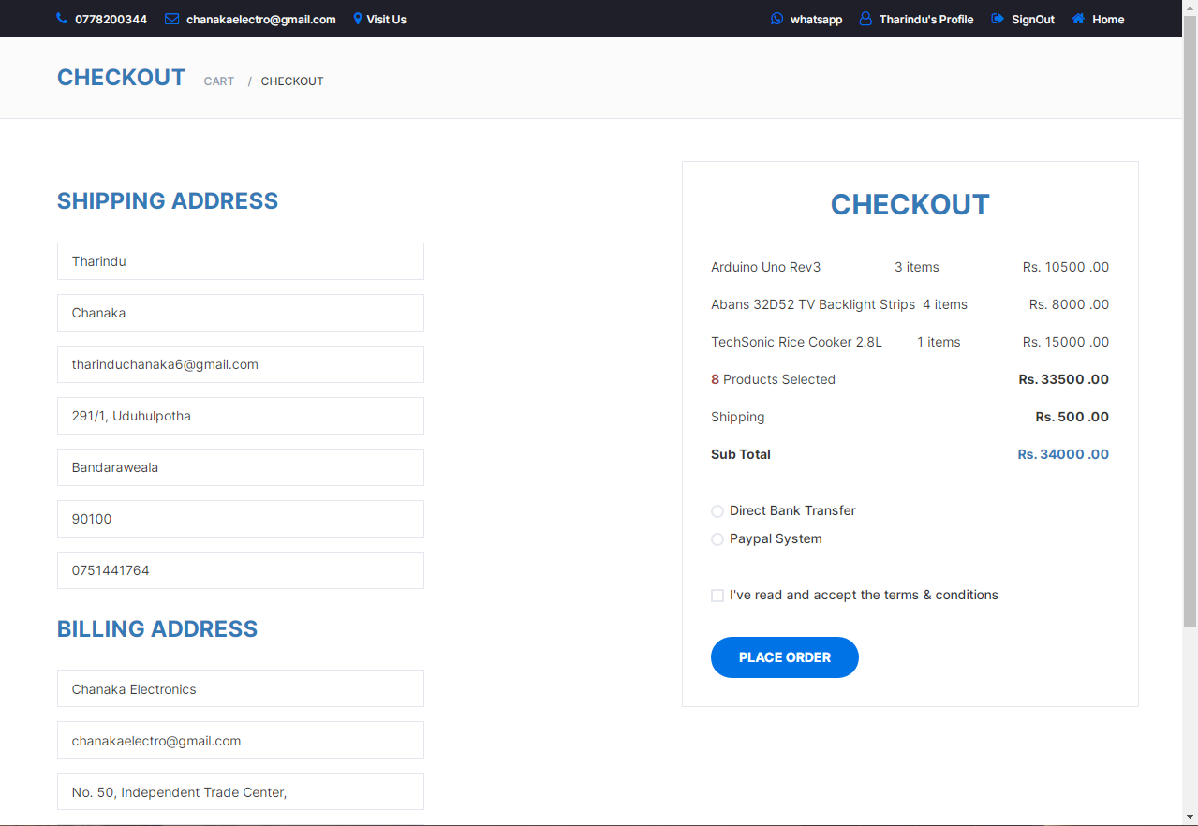

This is the checkout user interface. User can enter their shipping and billing details here and place an order. All the prices , quantity and products that user user is going to purchase are displayed in the checkout box.

<!DOCTYPE html>

<html lang="en">

<head>

<meta charset="utf-8">

<meta http-equiv="X-UA-Compatible" content="IE=edge">

<meta name="viewport" content="width=device-width, initial-scale=1">

<title>Checkout | Chanaka Electroinics</title>

<link href="https://fonts.googleapis.com/css?family=Montserrat:400,500,700" rel="stylesheet">

<link type="text/css" rel="stylesheet" href="css/bootstrap.min.css" />

<link type="text/css" rel="stylesheet" href="css/slick.css" />

<link type="text/css" rel="stylesheet" href="css/slick-theme.css" />

<link type="text/css" rel="stylesheet" href="css/nouislider.min.css" />

<link rel="stylesheet" href="css/font-awesome.min.css">

<link type="text/css" rel="stylesheet" href="css/style.css" />

<link rel="stylesheet" href="style.css" />

<link rel="stylesheet" href="bootstrap-icons.css" />

</head>

<body>

<?php

require "connection.php";

session_start();

include "header.php";

if (isset($_SESSION["user"])) {

$umail = $_SESSION["user"]["email"];

$total = 0;

$subtotal = 0;

$shipping = 0;

?>

<div id="breadcrumb" class="section">

<div class="container">

<div class="row">

<div class="col-md-12">

<h3 class="breadcrumb-header text-primary">Checkout</h3>

<ul class="breadcrumb-tree">

<li><a href="cart.php">Cart</a></li>

<li class="active">Checkout</li>

</ul>

</div></div>

</div></div>

<div class="section">

<!-- container -->

<div class="container">

<!-- row -->

<div class="row">

<div class=" col-12 col-lg-7">

<!-- Billing Details -->

<div class="billing-details">

<div class="section-title">

<h3 class="title text-primary">Shipping address</h3>

</div>

<div class="form-group">

<input class="input" type="text" name="first-name" value="<?php echo $_SESSION["user"]["fname"]; ?>" readonly>

</div>

<div class="form-group">

<input class="input" type="text" name="last-name" value="<?php echo $_SESSION["user"]["lname"]; ?>" readonly>

</div>

<div class="form-group">

<input class="input" type="email" name="email" value="<?php echo $_SESSION["user"]["email"]; ?>" readonly>

</div>

<div class="form-group">

<?php

$address_rs = Database::search("SELECT * FROM `user_has_address`

INNER JOIN `city` ON `user_has_address`.`city_id` = `city`.`id`

WHERE `user_email` = '" . $umail . "' ");

$address_data = $address_rs->fetch_assoc()

?>

<input class="input" type="text" name="address" value="<?php echo $address_data["line1"] . ", " . $address_data["line2"]; ?>" readonly>

</div>

<div class="form-group">

<input class="input" type="text" name="city" value="<?php echo $address_data["city_name"]; ?>" readonly>

</div>

<div class="form-group">

<input class="input" type="text" name="zip-code" value="<?php echo $address_data["postal_code"]; ?>" readonly>

</div>

<div class="form-group">

<input class="input" type="tel" name="tel" value="<?php echo $_SESSION["user"]["mobile"]; ?>" readonly>

</div>

</div>

<!-- Shiping Details -->

<div class="shiping-details">

<div class="section-title">

<h3 class="title text-primary">Billing address</h3>

</div>

<div class="form-group">

<input class="input" type="email" name="email" value="Chanaka Electronics" readonly>

</div>

<div class="form-group">

<input class="input" type="email" name="email" value="chanakaelectro@gmail.com" readonly>

</div>

<div class="form-group">

<input class="input" type="text" name="address" value="No. 50, Independent Trade Center," readonly>

</div>

<div class="form-group">

<input class="input" type="text" name="city" value="Bandarawela" readonly>

</div>

<div class="form-group">

<input class="input" type="text" name="country" value="Sri Lanka" readonly>

</div>

<div class="form-group">

<input class="input" type="text" name="zip-code" value="90100" readonly>

</div>

<div class="form-group">

<input class="input" type="tel" name="tel" value="+94 77 8200 344" readonly>

</div>

</div></div>

<!-- Order Details -->

<div class="col-md-5 order-details">

<div class="section-title text-center">

<?php

$cart_rs = Database::search("SELECT * FROM `cart` WHERE `user_email`='" . $umail . "'");

$cart_num = $cart_rs->num_rows;

?>

<h2 class="title text-primary">Checkout</h2>

</div>

<div class="order-summary">

<div class="order-col">

<?php

$query = "SELECT * FROM `product`";

for ($x = 0; $x < $cart_num; $x++) {

$cart_data = $cart_rs->fetch_assoc();

$product_rs = Database::search("SELECT * FROM `product` WHERE `id` = '" . $cart_data["product_id"] . "'");

$product_data = $product_rs->fetch_assoc();

$total = $total + ($product_data["price"] * $cart_data["qty"]);

$seller_rs = Database::search("SELECT * FROM `user` WHERE `email` = '" . $cart_data["user_email"] . "'");

$seller_data = $seller_rs->fetch_assoc();

$seller = $seller_data["fname"] . " " . $seller_data["lname"];

$addrerss_Rsesultset1 = Database::search("SELECT district.id AS did FROM `user_has_address` INNER JOIN `city` ON user_has_address.city_id=city.id

INNER JOIN `district` ON city.district_id=district.id WHERE `user_email`='" . $umail . "'");

$addrerss_data1 = $addrerss_Rsesultset1->fetch_assoc();

$ship = 0;

if ($addrerss_data1["did"] == '3') {

$ship = $product_data["delivery_fee_colombo"];

$shipping = $shipping + $ship;

} else {

$ship = $product_data["delivery_fee_other"];

$shipping = $shipping + $ship;

$countRs = Database::search("SELECT SUM(`cart`.`qty`)AS `CartQTY` FROM `cart` WHERE `user_email`='" . $umail . "'");

$count_data = $countRs->fetch_assoc();

$checkoutCountResultSet = Database::search("SELECT `product`.`delivery_fee_colombo`,`product`.`delivery_fee_other`,

SUM(`product`.`price`*`cart`.`qty`)AS `price` FROM `cart`

INNER JOIN `product` ON `cart`.`product_id` = `product`.`id`

WHERE `user_email`='" . $umail . "'

GROUP BY `product`.`delivery_fee_colombo`,`product`.`delivery_fee_other`");

$checkoutCountData = $checkoutCountResultSet->fetch_assoc();

?>

</div>

<div class="order-products">

<div class="order-col">

<div><?php echo $product_data["title"] ?></div>

<div><?php echo $cart_data["qty"]; ?> items</div>

<div>Rs. <?php echo $product_data["price"] * $cart_data["qty"]; ?> .00</div>

</div>

<?php } ?>

</div>

<div class="order-col">

<div><strong class="text-danger"><?php echo $count_data["CartQTY"]; ?></strong> Products Selected</div>

<div><strong>Rs. <?php echo $total; ?> .00</strong></div>

</div>

<div class="order-col">

<div id="qty_input">Shipping</div>

<div><strong>Rs. <?php echo $shipping; ?> .00</strong></div>

</div>

<div class="order-col">

<div><strong>Sub Total</strong></div>

<div><strong class="text-primary">Rs. <?php echo ($shipping + $total); ?> .00</strong></div>

</div>

</div>

<div class="payment-method">

<div class="input-radio">

<input type="radio" name="payment" id="payment-1">

<label for="payment-1">

<span></span>

Direct Bank Transfer

</label>

<div class="caption">

<p>Account Number :- 102068680627</p>

<p>Account Type :- Savings Account</p>

<p>Bank Name :- DFCC Bank</p>

<p>Branch Name :- Bandarawela</p>

<p>Account Holder Name :- H.P.K Tharindu Chanaka</p>

<p>Country:- Sri Lanka</p><br>

</div>

</div>

<div class="input-radio">

<input type="radio" name="payment" id="payment-3">

<label for="payment-3">

<span></span>

Paypal System

</label>

<div class="caption">

<p>Paypal systems are accepted</p>

</div>

</div>

</div>

<div class="input-checkbox">

<input type="checkbox" id="terms">

<label for="terms">

<span></span>

I've read and accept the <a href="#">terms & conditions</a>

</label>

</div>

<button type="submit" id="payhere-payment" onclick="payNow(<?php echo $cart_data['product_id']; ?>);" class="primary-btn order-submit">Place order</button>

</div>

</div>

</div>

</div>

<!-- /SECTION -->

<!-- jQuery Plugins -->

<script src="bootstrap.bundle.js"></script>

<script src="script.js"></script>

<script type="text/javascript" src="https://www.payhere.lk/lib/payhere.js"></script>

<script src="js/jquery.min.js"></script>

<script src="js/bootstrap.min.js"></script>

<script src="js/slick.min.js"></script>

<script src="js/nouislider.min.js"></script>

<script src="js/jquery.zoom.min.js"></script>

<script src="js/main.js"></script>

</body>

<?php

}

?>

</html>

1. Single Product View

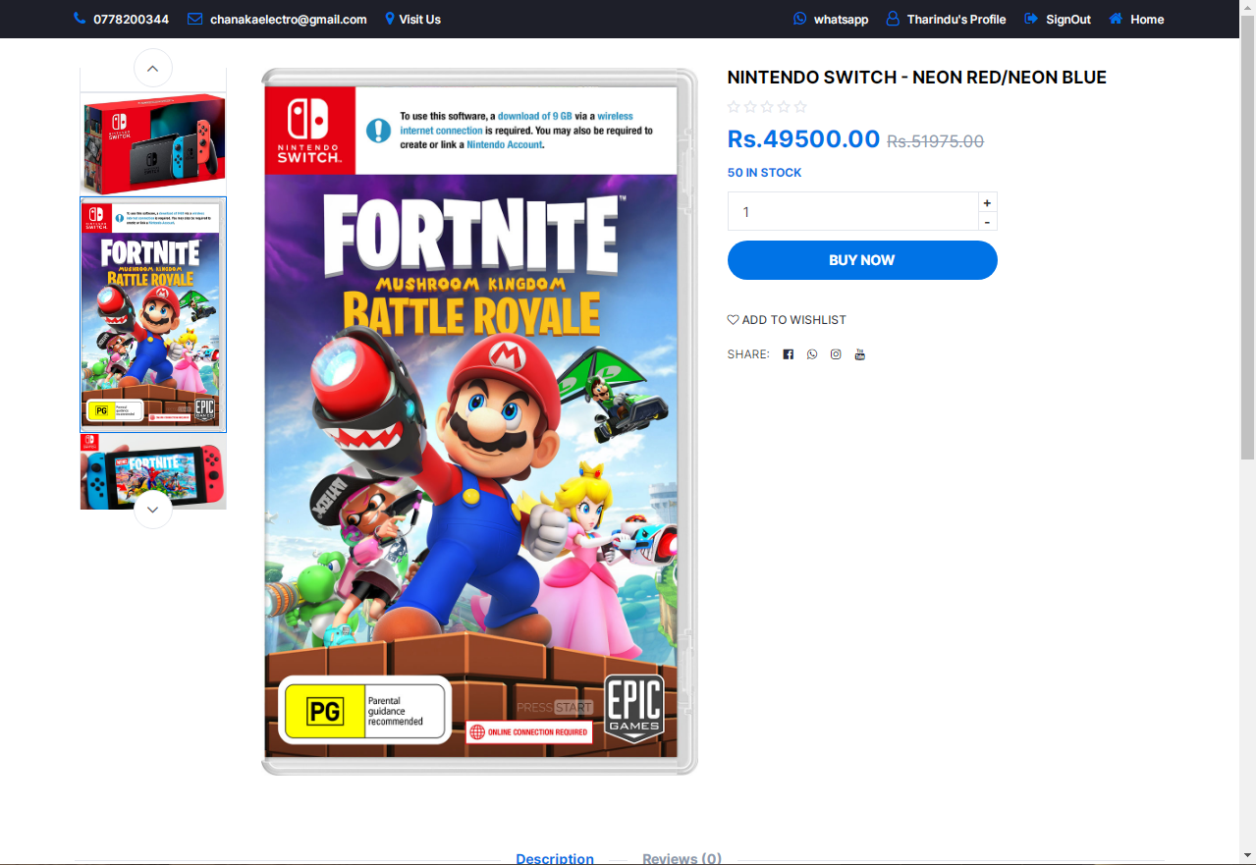**Single Product view UI**

This is the single product view UI.In this page the product details and product images of a selected product are displayed. User can zoom out images ane observe them. Also the user can buy this product from here and also add the product to the wishlist. The product description is also displayed here and users can add reviews and ratings to the product.

<!DOCTYPE html>

<?php

session_start();

require "connection.php";

require "header.php";

if (isset($_GET["id"])) {

$pid = $_GET["id"];

$product_Resultset =

Database::search("SELECT product.id,product.price,product.qty,product.description,product.title,product.datetime_added,product.delivery_fee_colombo,

product.delivery_fee_other,product.category_id,product.status_id,product.admin_email FROM `product` WHERE product.id='" . $pid . "'");

$product_num = $product_Resultset->num_rows;

if ($product_num == 1) {

$product_data = $product_Resultset->fetch_assoc();

if (isset($_SESSION["user"])) {

$email = $_SESSION["user"]["email"];

?>

<html lang="en">

<head>

<meta charset="utf-8">

<meta http-equiv="X-UA-Compatible" content="IE=edge">

<meta name="viewport" content="width=device-width, initial-scale=1">

<link rel="icon" href="resources/logo.png" />

<title><?php echo $product_data["title"]; ?></title>

<link href="https://fonts.googleapis.com/css?family=Montserrat:400,500,700" rel="stylesheet">

<link type="text/css" rel="stylesheet" href="css/bootstrap.min.css" />

<link type="text/css" rel="stylesheet" href="css/slick.css" />

<link type="text/css" rel="stylesheet" href="css/slick-theme.css" />

<link type="text/css" rel="stylesheet" href="css/nouislider.min.css" />

<link rel="stylesheet" href="css/font-awesome.min.css">

<link type="text/css" rel="stylesheet" href="css/style.css" />

<link rel="stylesheet" href="style.css">

<link rel="stylesheet" href="https://cdn.jsdelivr.net/npm/bootstrap-icons@1.9.1/font/bootstrap-icons.css" />

<link rel="stylesheet" href="bootstrap.css" />

</head>

<body style="overflow-x: hidden;">

<!-- SECTION -->

<div class="section">

<!-- container -->

<div class="container">

<!-- row -->

<div class="row">

<!-- Product main img -->

<!-- Product main img -->

<div class="col-md-5 col-md-push-2">

<div id="product-main-img">

<?php

$image_Rs = Database::search("SELECT * FROM `image` WHERE `product_id`='" . $pid . "'");

$image_num = $image_Rs->num_rows;

$img = array();

if ($image_num != 0) {

for ($y = 0; $y < $image_num; $y++) {

$image_data = $image_Rs->fetch_assoc();

$img[$y] = $image_data["code"];

?>

<div class="product-preview">

<img src="<?php echo $img["$y"]; ?>" />

</div>

<?php } ?>

</div>

</div>

<div class="col-md-2 col-md-pull-5">

<div id="product-imgs">

<?php

$image_Rs1 = Database::search("SELECT * FROM `image` WHERE `product_id`='" . $pid . "'");

$image_num1 = $image_Rs1->num_rows;

$img1 = array();

if ($image_num1 != 0) {

for ($x = 0; $x < $image_num1; $x++) {

$image_data1 = $image_Rs1->fetch_assoc();

$img1[$x] = $image_data1["code"];

?>

<div class="product-preview">

<img src="<?php echo $img1["$x"]; ?>" />

</div>

<?php } } ?>

</div>

</div>

<!-- /Product thumb imgs -->

<?php } ?>

<!-- Product details -->

<div class="col-md-5">

<div class="product-details">

<?php

?>

<h2 class="product-name" style="color: black;"><?php echo $product_data["title"]; ?></h2>

<div>

<?php

$Rf_rs1 = Database::search("SELECT * FROM `feedback`WHERE `product_id`='" . $product_data["id"] . "' ORDER BY `date` DESC");

$Rf_num1 = $Rf_rs1->num_rows;

$Rf_data1 = $Rf_rs1->fetch_assoc();

?>

<div class="product-rating">

<?php

if ($Rf_num1 == 0) {

?>

<i class="fa fa-star-o"></i>

<i class="fa fa-star-o"></i>

<i class="fa fa-star-o"></i>

<i class="fa fa-star-o"></i>

<i class="fa fa-star-o"></i>

<?php

} else {

?>

<?php

if ($Rf_data1["type"] == 5) {

?>

<i class="fa fa-star"></i>

<i class="fa fa-star"></i>

<i class="fa fa-star"></i>

<i class="fa fa-star"></i>

<i class="fa fa-star"></i>

<?php } ?>

<?php

if ($Rf_data1["type"] == 4) {

?>

<i class="fa fa-star"></i>

<i class="fa fa-star"></i>

<i class="fa fa-star"></i>

<i class="fa fa-star"></i>

<i class="fa fa-star-o"></i>

<?php } ?>

<?php

if ($Rf_data1["type"] == 3) {

?>

<i class="fa fa-star"></i>

<i class="fa fa-star"></i>

<i class="fa fa-star"></i>

<i class="fa fa-star-o"></i>

<i class="fa fa-star-o"></i>

<?php } ?>

<?php

if ($Rf_data1["type"] == 2) {

?>

<i class="fa fa-star"></i>

<i class="fa fa-star"></i>

<i class="fa fa-star-o"></i>

<i class="fa fa-star-o"></i>

<i class="fa fa-star-o"></i>

<?php } ?>

<?php

if ($Rf_data1["type"] == 1) {

?>

<i class="fa fa-star"></i>

<i class="fa fa-star-o"></i>

<i class="fa fa-star-o"></i>

<i class="fa fa-star-o"></i>

<i class="fa fa-star-o"></i>

<?php } ?>

<?php } ?>

</div>

</div>

<div>

<?php

$price = $product_data["price"];

$adding_price = ($price / 100) * 5;

$new_price = $price + $adding_price;

$difference = $new_price - $price;

$percentage = ($difference / $price) * 100;

?>

<h3 class="product-price">Rs.<?php echo $price; ?>.00 <del class="product-old-price">Rs.<?php echo $new_price; ?>.00</del></h3>

<div><span class="product-available"> <?php echo $product_data["qty"]; ?> In Stock</span>

</div>

</div>

<div class="">

<div class="qty-label" style="width: 275px; margin-top: 10px;">

<div class="input-number">

<input type="number" style="outline: none;" value="1" pattern="[0-9]" id="qty_input" onkeyup='checkValue(<?php echo $product_data["qty"]; ?>);'>

<span class="qty-up" onclick='qty_inc(<?php echo $product_data["qty"]; ?>);'>+</span>

<span class="qty-down" onclick='qty_dec(<?php echo $product_data["qty"]; ?>);'>-</span>

</div>

</div>

</div>

<div class="add-to-cart" style="display: flex; flex-direction: column;">

<button class="add-to-cart-btn" style="margin-top: 10px; width: 275px;" ; type="submit" id="payhere-payment" onclick="payNow(<?php echo $pid; ?>);"><i class="fa fa-usd"></i>buy

now</button>

</div

<ul class="product-btns">

<?php

$watchlist_Resultset = Database::search("SELECT * FROM `wishlist` WHERE `product_id`='" . $product_data["id"] . "' AND `user_email`= '" . $email . "'");

$watchlist_num = $watchlist_Resultset->num_rows;

if ($watchlist_num == 1) {

?>

<li><a href="#" onclick='addWishlist(<?php echo $product_data["id"]; ?>);'>

<i class="fa fa-heart-o text-primary" id='heart<?php echo $product_data["id"]; ?>'></i> Remove from wishlist</a></li>

<?php

} else {

?>

<li><a href="#" onclick='addWishlist(<?php echo $product_data["id"]; ?>);'>

<i class="fa fa-heart-o text-dark" id='heart<?php echo $product_data["id"]; ?>'></i>

add to wishlist</a></li>

<?php } } ?>

</ul>

<ul class="product-links">

<li>Share:</li>

<li><a href="https://www.facebook.com/50Bandarawela?mibextid=2JQ9oc"><i class="fa fa-facebook-official"></i></a></li>

<li><a href="https://wa.me/message/CBYLNI2IKXKII1"><i class="fa fa-whatsapp"></i></a></li>

<li><a href="https://instagram.com/chanaka.sanjeewa?igshid=MzRlODBiNWFlZA=="><i class="fa fa-instagram"></i></a></li>

<li><a href="https://youtube.com/@chanakaElectro?si=ob-OIXZGP6odFKTe"><i class="fa fa-youtube"></i></a></li>

</ul>

</div></div>

<!-- /Product details -->

<!-- Product tab -->

<div class="col-md-12">

<div id="product-tab">

<!-- product tab nav -->

<ul class="tab-nav">

<li class="active"><a data-toggle="tab" href="#tab1">Description</a></li>

<?php

$Rf_rs = Database::search("SELECT * FROM `feedback`WHERE `product_id`='" . $product_data["id"] . "' AND `Feed_status` ='1' ORDER BY `date` DESC");

$Rf_num = $Rf_rs->num_rows;

$Rf_data = $Rf_rs->fetch_assoc();

?>

<li><a data-toggle="tab" href="#tab3">Reviews (<?php echo $Rf_num; ?>)</a></li>

</ul>

<div class="tab-content">

<!-- tab1 -->

<div id="tab1" class="tab-pane fade in active">

<div class="row">

<div class="col-md-12">

<p><?php echo $product_data["description"]; ?></p>

</div>

</div></div>

<div id="tab3" class="tab-pane fade in">

<div class="row">

<!-- Rating -->

<?php

if ($Rf_num == 0) {

?>

<div class="col-md-3 d-none">

<?php

} else {

?>

<div class="col-md-3 d-sm-block d-lg-none">

<?php } ?>

<div id="rating">

<?php

if ($Rf_data["type"] == 5) {

?>

<div class="rating-avg">

<span>5.0</span>

<div class="rating-stars">

<i class="fa fa-star"></i>

<i class="fa fa-star"></i>

<i class="fa fa-star"></i>

<i class="fa fa-star"></i>

<i class="fa fa-star"></i>

</div>

</div>

<?php } ?>

<?php

if ($Rf_data["type"] == 4) {

?>

<div class="rating-avg">

<span>4.5</span>

<div class="rating-stars">

<i class="fa fa-star"></i>

<i class="fa fa-star"></i>

<i class="fa fa-star"></i>

<i class="fa fa-star"></i>

<i class="fa fa-star-o"></i>

</div>

</div>

<?php } ?>

<?php

if ($Rf_data["type"] == 3) {

?>

<div class="rating-avg">

<span>3.5</span>

<div class="rating-stars">

<i class="fa fa-star"></i>

<i class="fa fa-star"></i>

<i class="fa fa-star"></i>

<i class="fa fa-star-o"></i>

<i class="fa fa-star-o"></i>

</div></div>

<?php } ?>

<?php

if ($Rf_data["type"] == 2) {

?>

<div class="rating-avg">

<span>2.5</span>

<div class="rating-stars">

<i class="fa fa-star"></i>

<i class="fa fa-star"></i>

<i class="fa fa-star-o"></i>

<i class="fa fa-star-o"></i>

<i class="fa fa-star-o"></i>

</div>

</div>

<?php } ?>

<?php

if ($Rf_data["type"] == 1) {

?>

<div class="rating-avg">

<span>1.0</span>

<div class="rating-stars">

<i class="fa fa-star"></i>

<i class="fa fa-star-o"></i>

<i class="fa fa-star-o"></i>

<i class="fa fa-star-o"></i>

<i class="fa fa-star-o"></i>

</div></div>

<?php } ?>

</div></div>

<!-- Reviews -->

<div class="col-md-7">

<div id="reviews">

<ul class="reviews" id="view_area">

<?php

$feedback_rs = Database::search("SELECT * FROM `feedback` INNER JOIN `user` ON feedback.user_email=user.email WHERE `product_id`='" . $product_data["id"] . "' AND `Feed_status`='1'");

$feedback_num = $feedback_rs->num_rows;

for ($y = 0; $y < $feedback_num; $y++) {

$feedback_data = $feedback_rs->fetch_assoc();

?>

<li>

<div class="review-heading">

<h5 class="name text-dark">

<?php echo $feedback_data["fname"] . " " . $feedback_data["lname"]; ?>

</h5>

<p class="date"><?php echo $feedback_data["date"]; ?></p>

<div class="review-rating">

<?php

if ($feedback_data["type"] == 5) {

?>

<i class="fa fa-star"></i>

<i class="fa fa-star"></i>

<i class="fa fa-star"></i>

<i class="fa fa-star"></i>

<i class="fa fa-star"></i>

<?php } ?>

<?php

if ($feedback_data["type"] == 4) {

?>

<i class="fa fa-star"></i>

<i class="fa fa-star"></i>

<i class="fa fa-star"></i>

<i class="fa fa-star"></i>

<i class="fa fa-star-o empty"></i>

<?php } ?>

<?php

if ($feedback_data["type"] == 3) {

?>

<i class="fa fa-star"></i>

<i class="fa fa-star"></i>

<i class="fa fa-star"></i>

<i class="fa fa-star-o empty"></i>

<i class="fa fa-star-o empty"></i>

<?php } ?>

<?php

if ($feedback_data["type"] == 2) {

?>

<i class="fa fa-star"></i>

<i class="fa fa-star"></i>

<i class="fa fa-star-o empty"></i>

<i class="fa fa-star-o empty"></i>

<i class="fa fa-star-o empty"></i>

<?php } ?>

<?php

if ($feedback_data["type"] == 1) {

?>

<i class="fa fa-star"></i>

<i class="fa fa-star-o empty"></i>

<i class="fa fa-star-o empty"></i>

<i class="fa fa-star-o empty"></i>

<i class="fa fa-star-o empty"></i>

<?php } ?>

</div>

</div>

<div class="review-body">

<p><?php echo $feedback_data["feedback"]; ?></p>

</div>

</li>

<?php } ?>

</ul>

</div>

</div>

<!-- /Reviews -->

<!-- Review Form -->

<div class="col-md-5">

<div id="review-form">

<div class="review-form">

<textarea class="input" placeholder="Your Review" id="feed"></textarea>

<div class="input-rating">

<span>Your Rating: </span>

<div class="stars">

<input id="type5" name="rating" value="5" type="radio" /><label for="type5" checked></label>

<input id="type4" name="rating" value="4" type="radio"><label for="type4" checked></label>

<input id="type3" name="rating" value="3" type="radio" /><label for="type3" checked></label>

<input id="type2" name="rating" value="2" type="radio" /><label for="type2" checked></label>

<input id="type1" name="rating" value="1" type="radio" /><label for="type1" checked></label>

</div>

</div>

<button class="primary-btn" onclick="saveFeedback(<?php echo $pid; ?>);">Submit</button>

</div>

</div>

<br>

<div class="col-12 d-none" id="addmsgdiv">

<div class="alert alert-success" role="alert" id="addalertdiv">

<i class="bi bi-check2-circle fs-5" id="addmsg">

</i>

</div></div>

</div>

<!-- Review Form -->

</div>

</div></div>

</div></div>

</div></div>

</div>

<!-- jQuery Plugins -->

<!-- <script src="js/jquery.min.js"></script> -->

<script src="js/bootstrap.min.js"></script>

<script src="js/slick.min.js"></script>

<script src="js/nouislider.min.js"></script>

<script src="js/jquery.zoom.min.js"></script>

<script src="js/main.js"></script>

<script src="bootstrap.bundle.js"></script>

<script src="script.js"></script>

<script type="text/javascript" src="https://www.payhere.lk/lib/payhere.js"></script>

</body>

</html>

<?php

} else {

echo ("Sorry for the inconvenience"); } } ?>

<?php require "footer.php" ?>

**JavaScript Function**

function payNow(id) {

var qty = document.getElementById("qty_input").value;

var request = new XMLHttpRequest();

request.onreadystatechange = function () {

if ((request.status == 200) & (request.readyState == 4)) {

var response = request.responseText;

var obj = JSON.parse(response);

var mail = obj["umail"];

var amount = obj["amount"];

if (response == 1) {

alert("Please Login Or Sign Up");

window.location = "index.php";

} else if (response == 2) {

alert("Please update your profile.");

window.location = "userprofile.php";

} else {

// Payment completed. It can be a successful failure.

payhere.onCompleted = function onCompleted(orderId) {

console.log("Payment completed. OrderID:" + orderId);

saveInvoice(orderId, id, mail, amount, qty);

};

// Payment window closed

payhere.onDismissed = function onDismissed() {

// Note: Prompt user to pay again or show an error page

console.log("Payment dismissed");

};

// Error occurred

payhere.onError = function onError(error) {

// Note: show an error page

console.log("Error:" + error);

};

// Put the payment variables here

var payment = {

sandbox: true,

merchant_id: obj["mid"], // Replace your Merchant ID

return_url:

"http://localhost/ceOnlineStore/SingleProductView.php?id=1" + id, // Important

cancel_url:

"http://localhost/ceOnlineStore/SingleProductView.php?id=1" + id, // Important

notify_url: "http://sample.com/notify",

order_id: obj["id"],

items: obj["item"],

amount: amount + ".00",

currency: "LKR",

hash: obj["hash"], // *Replace with generated hash retrieved from backend

first_name: obj["fname"],

last_name: obj["lname"],

email: mail,

phone: obj["mobile"],

address: obj["address"],

city: obj["city"],

country: "Sri Lanka",

delivery_address: obj["address"],

delivery_city: obj["city"],

delivery_country: "Sri Lanka",

custom_1: "",

custom_2: "",

};

// Show the payhere.js popup, when "PayHere Pay" is clicked

// document.getElementById('payhere-payment').onclick = function (e) {

payhere.startPayment(payment);

// }; } } };

request.open("GET", "BuyNowProcess.php?id=" + id + "&qty=" + qty, true);

request.send();

}

1. Invoice page and process associated with it

**Invoice User Interface**

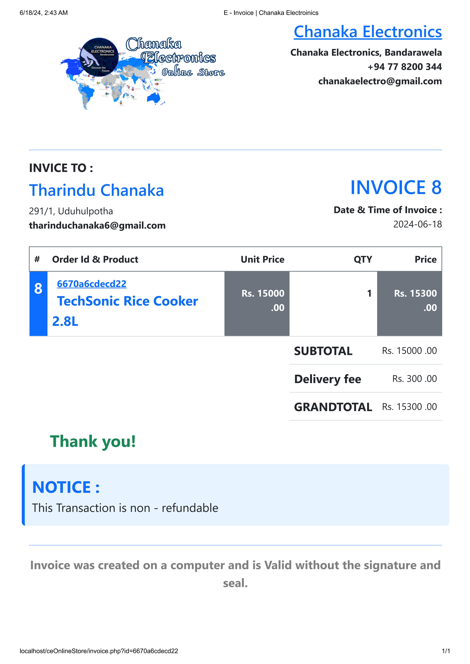

<!DOCTYPE html>

<html lang="en">

<head>

<meta charset="UTF-8">

<meta http-equiv="X-UA-Compatible" content="IE=edge">

<meta name="viewport" content="width=device-width, initial-scale=1.0">

<link rel="stylesheet" href="style.css" />

<link rel="stylesheet" href="bootstrap.css" />

<link rel="stylesheet" href="https://cdn.jsdelivr.net/npm/bootstrap-icons@1.9.1/font/bootstrap-icons.css" />

<title>E - Invoice | Chanaka Electroinics</title>

<link rel="icon" href="resources/logo.png" />

</head>

<body class="container-fluid" style="overflow-x: hidden;">

<?php

require "connection.php";

session_start();

include "header.php";

if (isset($_SESSION["user"])) {

$umail = $_SESSION["user"]["email"];

$oid = $_GET["id"];

?>

<div class="container-fluid">

<div class="row"

<div class="col-12">

<hr />

</div>

<div class="col-12 btn-toolbar justify-content-end">

<button class="btn btn-dark me-2" onclick="printInvoice();"><i class="bi bi-printer-fill"></i> Print</button>

<button class="btn btn-danger me-2" onclick="pdfInvoice();"><i class="bi bi-filetype-pdf"></i> Export as a PDF</button>

</div>

<div class="col-12">

<hr />

</div>

<div class="col-12" id="page">

<div class="row">

<div class="col-6">

<div class="ms-5 invoiceheader-IMG"></div>

</div>

<div class="col-6">

<div class="row">

<div class="col-12 text-primary text-decoration-underline text-end">

<h2>Chanaka Electronics</h2>

</div>

<div class="col-12 fw-bold text-end">

<span>Chanaka Electronics, Bandarawela</span><br />

<span>+94 77 8200 344</span><br />

<span>chanakaelectro@gmail.com</span><br />

</div>

</div></div>

<div class="col-12">

<hr class="border border-1 border-primary" />

</div>

<div class="col-12 mb-4">

<div class="row">

<div class="col-6">

<h5 class="fw-bold text-dark">INVICE TO : </h5>

<?php

$address_rs = Database::search("SELECT * FROM `user_has_address` WHERE `user_email` = '" . $umail . "' ");

$address_data = $address_rs->fetch_assoc();

?>

<h2 class="text-primary"><?php echo $_SESSION["user"]["fname"] . " " . $_SESSION["user"]["lname"]; ?></h2>

<span><?php echo $address_data["line1"] . ", " . $address_data["line2"]; ?></span><br />

<span><b><?php echo $umail; ?></b></span>

</div>

<?php

$invoice_rs = Database::search("SELECT * FROM `invoice` WHERE `order_id` = '" . $oid . "'");

$invoice_data = $invoice_rs->fetch_assoc();

?>

<div class="col-6 text-end mt-4">

<h1 class="text-primary">INVOICE <?php echo $invoice_data["id"]; ?></h1>

<span class="fw-bold">Date & Time of Invoice :</span><br />

<span><?php echo $invoice_data["date"]; ?></span>

</div>

</div></div>

<div class="col-12">

<table class="table">

<thead>

<tr class="border border-1 border-secondary">

<th>#</th>

<th>Order Id & Product</th>

<th class="text-end">Unit Price</th>

<th class="text-end">QTY</th>

<th class="text-end">Price</th>

</tr>

</thead>

<tbody>

<tr style="height:72px;">

<td class="bg-primary text-white fs-3 fw-bold"><?php echo $invoice_data["id"]; ?></td>

<td>

<span class="fw-bold text-primary text-decoration-underline p-2"><?php echo $oid ?></span><br />

<?php

$product_rs = Database::search("SELECT * FROM `product` WHERE `id` = '" . $invoice_data["product_id"] . "' ");

$product_data = $product_rs->fetch_assoc();

?>

<span class="fw-bold text-primary fs-4 p-2"><?php echo $product_data["title"]; ?></span>

</td>

<td class="fw-bold fs-6 text-end pt-4 bg-secondary text-white">Rs. <?php echo $product_data["price"]; ?> .00</td>

<td class="fw-bold fs-6 text-end pt-4"><?php echo $invoice_data["iqty"]; ?></td>

<td class="fw-bold fs-6 text-end pt-4 bg-secondary text-white">Rs. <?php echo $invoice_data["total"]; ?> .00</td>

</tr>

</tbody>

<tfoot>

<?php

$city_rs = Database::search("SELECT * FROM `city` WHERE `id` = '" . $address_data["city_id"] . "'");

$city_data = $city_rs->fetch_assoc();

if ($city_data["district_id"] == 2) {

$delivery = $product_data["delivery_fee_colombo"];

} else {

$delivery = $product_data["delivery_fee_other"];

}

$t = $invoice_data["total"];

$g = $t - $delivery;

?>

<tr>

<td colspan="3" class="border-0"></td>

<td class="fs-5 text-start fw-bold">SUBTOTAL</td>

<td class="text-end">Rs. <?php echo $g; ?> .00</td>

</tr>

<tr>

<td colspan="3" class="border-0"></td>

<td class="fs-5 text-start fw-bold">Delivery fee</td>

<td class="text-end">Rs. <?php echo $delivery; ?> .00</td>

</tr>

<tr>

<td colspan="3" class="border-0"></td>

<td class="fs-5 text-start fw-bold">GRANDTOTAL</td>

<td class="text-end">Rs. <?php echo $t; ?> .00</td>

</tr>

</tfoot>

</table>

</div>

<div class="col-4 text-center">

<h2 class="fs1 fw-bold text-success">Thank you!</h2>

</div>

<div class="col-12 border-start border-5 border-primary mt-3 mb-3 rounded" style="background-color: #e7f2ff;">

<div class="row">

<div class="col-12 mt-3 mb-3">

<span class="form-label fw-bold fs-2 text-primary">NOTICE :</span><br />

<span class="form-label fs-5">This Transaction is non - refundable</span>

</div>

</div></div>

<div class="col-12">

<hr class="border border-1 border-primary" />

</div>

<div class="col-12 text-center mb-1">

<label class="form-label fs-5 text-black-50 fw-bold">

Invoice was created on a computer and is Valid without the signature and seal.

</label>

</div></div>

</div>

<?php } ?>

</div>

</div>

<script src="bootstrap.bundle.js"></script>

<script src="script.js"></script>

</body>

</html>

**Invoice saving process**

<?php

session_start();

require "connection.php";

if (isset($_SESSION["user"])) {

$o_id = $_POST["o"];

$p_id = $_POST["i"];

$mail = $_POST["m"];

$amount = $_POST["a"];

$qty = $_POST["q"];

$product_Resultset = Database::search("SELECT * FROM `product` WHERE `id`= '" . $p_id . "' ");

$product_data = $product_Resultset->fetch_assoc();

$current_qty = $product_data["qty"];

$new_qty = $current_qty - $qty;

Database::insUpdelete("UPDATE `product` SET `qty` = '" . $new_qty . "' WHERE `id` = '" . $p_id . "'");

$d = new DateTime();

$tz = new DateTimeZone("Asia/Colombo");

$d->setTimezone($tz);

$date = $d->format("Y-m-d H:i:s");

Database::insUpdelete("INSERT INTO `invoice` (`order_id`, `date` , `total`, `d_status`, `iqty`, `product_id`, `user_email`,`remove_status`) VALUES

('" . $o_id . "','" . $date . "','" . $amount . "','0','" . $qty . "', '" . $p_id . "','" . $mail . "','1')");

echo ("success");

}

**JavaScript Function**

function saveInvoice(orderId, id, mail, amount, qty) {

var form = new FormData();

form.append("o", orderId);

form.append("i", id);

form.append("m", mail);

form.append("a", amount);

form.append("q", qty);

var request = new XMLHttpRequest();

request.onreadystatechange = function () {

if ((request.status == 200) & (request.readyState == 4)) {

var response = request.responseText;

if (response == "success") {

window.location = "invoice.php?id=" + orderId;

} else {

alert(response); } } };

request.open("POST", "saveInvoice.php", true);

request.send(form);

}

**Print Invoice function**

function printInvoice() {

var body = document.body.innerHTML;

var page = document.getElementById("page").innerHTML;

document.body.innerHTML = page;

window.print();

document.body.innerHTML = body;

}

1. Add Feedback Process

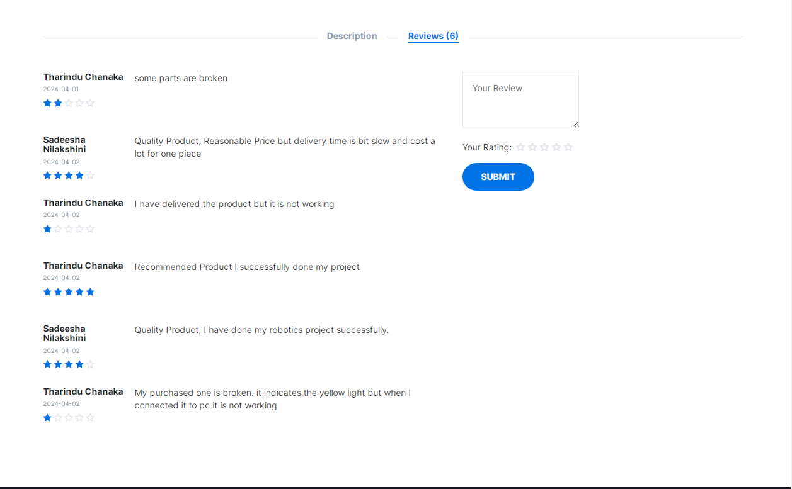

The feedbacks and ratings added for the product are displayed like this and users can add new feedbacks and ratings here.

**.php file**

<?php

session_start();

include "connection.php";

if (isset($_SESSION["user"])) {

$mail = $_SESSION["user"]["email"];

$pid = $_POST["pid"];

$type = $_POST["t"];

$feed = $_POST["f"];

$d = new DateTime();

$tz = new DateTimeZone("Asia/Colombo");

$d->setTimezone($tz);

$date = $d->format("Y-m-d H:i:s");

if (empty($feed)) {

echo ("Please Review your product");

} else if ($type == 0) {

echo ("Please Rate this product");

} else {

Database::insUpdelete("INSERT INTO `feedback`(`type`,`feedback`,`date`,`product_id`,`user_email`,`Feed_status`) VALUES

('" . $type . "','" . $feed . "','" . $date . "','" . $pid . "','" . $mail . "','2')");

echo ("Review Added Successfully");

}}

**.js file**

function saveFeedback(id) {

var type = 0;

if (document.getElementById("type1").checked) {

type = 1;

} else if (document.getElementById("type2").checked) {

type = 2;

} else if (document.getElementById("type3").checked) {

type = 3;

} else if (document.getElementById("type4").checked) {

type = 4;

} else if (document.getElementById("type5").checked) {

type = 5;

}

var feedback = document.getElementById("feed");

var form = new FormData();

form.append("pid", id);

form.append("t", type);

form.append("f", feedback.value);

var request = new XMLHttpRequest();

request.onreadystatechange = function () {

if ((request.status == 200) & (request.readyState == 4)) {

var response = request.responseText;

if (response == "Review Added Successfully") {

window.location.reload();

document.getElementById("addmsg").innerHTML = text7;

document.getElementById("addmsg").className =

"bi bi-check2-circle fs-5";

document.getElementById("addalertdiv").className =

"alert alert-success";

document.getElementById("addmsgdiv").className = "d-block";

} else {

document.getElementById("addmsg").innerHTML = response;

document.getElementById("addmsg").className =

"bi bi-x-octagon-fill fs-5";

document.getElementById("addalertdiv").className = "alert alert-danger";

document.getElementById("addmsgdiv").className = "d-block"; } } };

request.open("POST", "saveFeedbackProcess.php", true);

request.send(form);

}

1. Purchasing History & process associated with it

**Purchasing History User Interface**

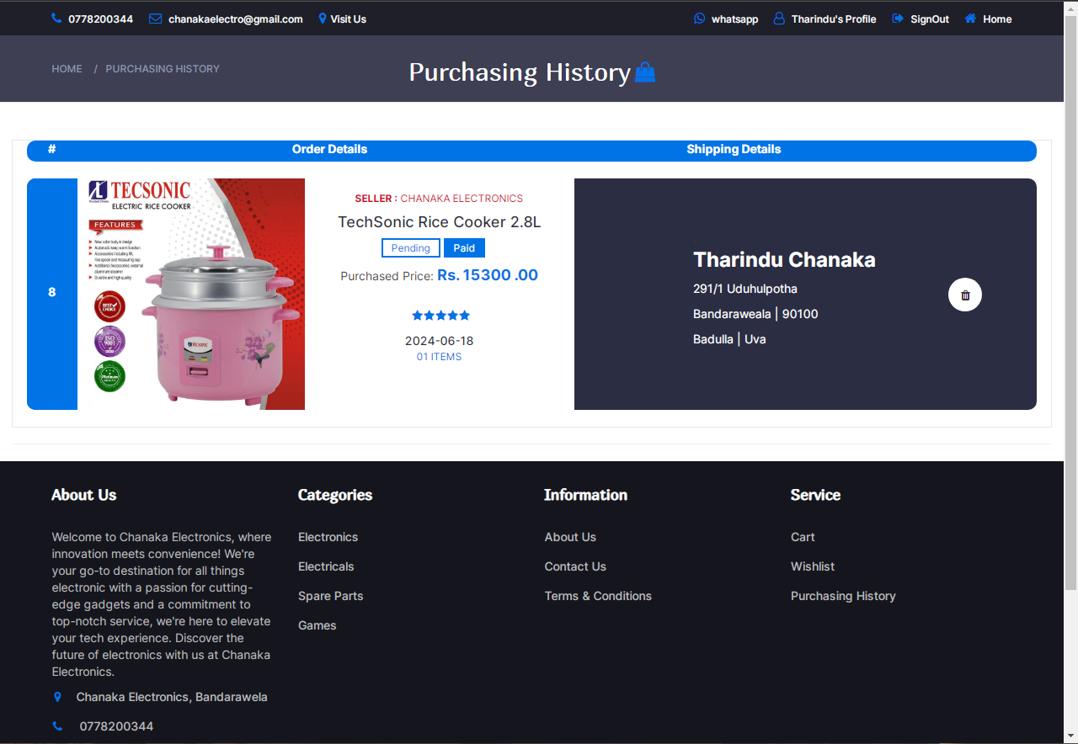

This is the purchasing history UI. The items that has been purchased by the user are added to this page and user can view his purchased products here. Also the user can delete products if he need.

<!DOCTYPE html>

<html>

<?php

require "connection.php";

session_start();

if (isset($_SESSION["user"])) {

$umail = $_SESSION["user"]["email"];

$invoice_rs = Database::search("SELECT * FROM `invoice` WHERE `user_email`='" . $umail . "' AND `remove_status` ='1'");

$invoice_num = $invoice_rs->num_rows;

?>

<head>

<meta charset="utf-8" />

<meta name="viewport" content="width=device-width, initial-scale=1" />

<title>Purchasing History</title>

//css codes

<link rel="icon" href="resources/logo.png" />

</head>

<body style="background-size: cover;">

<?php require "header.php"; ?>

<div class="container-fluid vh-100">

<div class="row">

<div class="col-12 d-flex justify-content-center vh-100">

<!-- BREADCRUMB -->

<div id="breadcrumb" class="section" style="height:80px; background-color: rgba(43, 45, 66, 0.91);">

<!-- container -->

<div class="container">

<!-- row -->

<div class="row bread">

<div class="col-md-3 breadcrumb-resp" style="margin-top: 20px;">

<ul class="breadcrumb-tree">

<li><a href="home.php">Home</a></li>

<li><a href="purchasingHistory.php">Purchasing History</a></li>

</ul>

</div>

<div class="col-md-6 col-sm-6 col-xs-6 wishlist" style="display: flex; justify-content: center; margin-top: 18px;">

<h2 class="f3" style="font-weight:normal; color: white;">Purchasing History</h2>

<a href="#" style="font-size: 24px; margin-left: 5px; color: #0073e6;"><i class="fa fa-shopping-bag" aria-hidden="true"></i>

</a>

</div></div>

</div></div>

</div>

</div>

<?php

if ($invoice_num == 0) {

?>

<div class="col-12 ">

<div class="row">

<div class="col-12 empty-purchasing-history"></div><br>

<div class="col-12 text-center">

<label class="form-label f" style="font-size: 22px; font-weight:normal;">You have not purchased any item yet.

</div>

<div class="col-12 text-center">

<label class="form-label f" style="font-size: 18px; font-weight: lighter;">Check back after your next shopping trip!

</div><br>

<div class="offset-4 col-12 d-grid mb-3" style="display: flex; justify-content: center;">

<a class="primary-shop-btn cta-btn" href="home.php">Shop now</a>

</div><br>

</div>

</div>

<!-- empty view -->

<?php

} else {

?>

<div class="col-12 col-mb-12 product">

<div class="row">

<div class="col-12 purchasing-top-bar" style="display: flex; justify-content: center; align-items: center; flex-direction: column;">

<div class="row" style="display: flex; flex-direction: row; width: 95%; height: 15%; background-color: #0073e6; margin-bottom: 20px; border-radius: 10px;">

<div class="col-1" style="width: 5%; display: flex; justify-content: center; align-items: center; color: white;">

<label class="form-label f4">#</label>

</div>

<div class="col-3" style="width: 50%; display: flex; justify-content: center; align-items: center; color: white; ">

<label class="form-label f4"> Order Details</label>

</div>

<div class="col-3" style="width: 30%; display: flex; justify-content: center; align-items: center; color: white;">

<label class="form-label f4">Shipping Details</label>

</div>

<div class="col-3" style="width: 15%; display: flex; justify-content: center; align-items: center;">

<label class="form-label f4"></label>

</div>

</div></div>

<?php

for ($x = 0; $x < $invoice_num; $x++) {

$invoice_data = $invoice_rs->fetch_assoc();

?>

<div class="col-12 purchase-large" style="display: flex; justify-content: center; align-items: center; flex-direction: column;">

<div class="row purchasing-table" style="display: flex; flex-direction: row; width: 95%; height: 275px; background-color: #2B2D42; margin-bottom: 20px; border-radius: 10px;">

<div class="col-12" style="width: 5%; display: flex; justify-content: center; align-items: center; background-color: #0073e6; border-top-left-radius: 10px; border-bottom-left-radius: 10px;">

<label class="form-label f4" style="color: #ffffff;"><?php echo $invoice_data["id"]; ?></label>

</div>

<div class="col-3" style="width: 55%; ">

<div class="" style=" display: flex; justify-content: start; align-items: start; ">

<div class="product-purchase" style="display:flex; flex-direction:row; align-items: start; ">

<div class="product-image" style="width: 270px; height: 275px;">

<?php

$pid = $invoice_data["product_id"];

$image_rs = Database::search("SELECT * FROM `image` WHERE `product_id`='" . $pid . "' ");

$image_data = $image_rs->fetch_assoc();

?>

<img src="<?php echo $image_data["code"]; ?>" alt="" class="img">

</div>

<div class="product-details" style="background-color: #ffffff; height: 275px; width: 320px;">

<div class="product-body">

<?php

$product_rs = Database::search("SELECT * FROM `product` WHERE `id`='" . $pid . "' ");

$product_data = $product_rs->fetch_assoc();

$seller_rs = Database::search("SELECT * FROM `admin` WHERE `email`='" . $product_data["admin_email"] . "' ");

$seller_data = $seller_rs->fetch_assoc();

$buyer_rs = Database::search("SELECT * FROM `user` WHERE `email`='" . $invoice_data["user_email"] . "' ");

$buyer_data = $buyer_rs->fetch_assoc();

$addr_resultSet = Database::search("SELECT * FROM `user_has_address`

INNER JOIN `city` ON user_has_address.city_id=city.id

INNER JOIN `district` ON city.district_id=district.id

INNER JOIN `province` ON district.province_id=province.id WHERE `user_email`='" . $invoice_data["user_email"] . "';");

$addrdata = $addr_resultSet->fetch_assoc();

?>

<p class="product-category f5" style="color: #D10024;"><b>Seller : </b><?php echo $seller_data["fname"] . " " . $seller_data["lname"]; ?></p>

<h4 class="product-name-purchase f5"><a href="#"><?php echo $product_data["title"]; ?></a></h4>

<div class="product-label1">

<?php

if ($invoice_data["d_status"] == 0) {

?>

<span class="sale f5">Pending</span>

<?php

} else if ($invoice_data["d_status"] == 1) {

?>

<span class="sale f5">Packaging</span>

<?php

} else if ($invoice_data["d_status"] == 2) {

?>

<span class="sale f5">Dispatching</span>

<?php

} else if ($invoice_data["d_status"] == 3) {

?>

<span class="sale f5">Shipping</span>

<?php

} else if ($invoice_data["d_status"] == 4) {

?>

<span class="sale f5">Delivering</span>

<?php

} else if ($invoice_data["d_status"] == 5) {

?>

<span class="sale f5">Completed</span>

<?php

}

?>

<span class="new f5">Paid</span>

</div>

<span>Purchased Price: <span class="product-price"><b>Rs. <?php echo $invoice_data["total"]; ?> .00</b></span></span><br>

<?php

$Rf_rs1 = Database::search("SELECT * FROM `feedback`WHERE `product_id`='" . $product_data["id"] . "' ORDER BY `date` DESC");

$Rf_num1 = $Rf_rs1->num_rows;

$Rf_data1 = $Rf_rs1->fetch_assoc();

?>

<div class="product-rating">

{Star Rating Code}

</div><br>

<time class="product-name-purchase f5"><a href="#"><?php echo $invoice_data["date"]; ?></a></time>

<p class="product-category f5" style="color: #0073e6;">0<?php echo $invoice_data["iqty"]; ?> Items</p>

</div>

</div></div>

</div></div>

<div class="col-3" style="width: 30%; display: flex; justify-content: center; align-items: center;">

<li>

<h3 class="product-category f5" style="color: white;"><?php echo $buyer_data["fname"] . " " . $buyer_data["lname"]; ?></h3>

<p class="product-category f5" style="color: white;"><?php echo $addrdata["line1"]; ?> <?php echo $addrdata["line2"]; ?></p>

<p class="product-category f5" style="color: white;"><?php echo $addrdata["city_name"]; ?> | <?php echo $addrdata["postal_code"]; ?></p>

<p class="product-category f5" style="color: white;"><?php echo $addrdata["district_name"]; ?> | <?php echo $addrdata["province_name"]; ?></p>

</li>

</div>

<div class="product-body" style="background-color:transparent; border-radius: 400px; justify-content: center; align-items: center; display: flex;">

<div class="product-btns" style="background-color:white; border-radius: 20px;">

<button class="quick-view" onclick="removeFromPurchasingHistory('<?php echo $invoice_data['id']; ?>');"><i class="fa fa-trash"></i><span class="tooltipp">Remove Item</span></button>

</div>

</div></div>

</div>

<div class="col-12 purchase-medium" style="margin-left: 35px; display: flex; justify-content:center; align-items: center; flex-direction: column;">

<div class="row purchasing-table" style="display: flex; flex-direction: row; width: 95%; height: 275px; background-color: #2B2D42; margin-bottom: 20px; border-radius: 10px;">

<div class="col-12" style="width: 5%; display: flex; justify-content: center; align-items: center; background-color: #0073e6; border-top-left-radius: 10px; border-bottom-left-radius: 10px;">

<label class="form-label f4" style="color: #ffffff;"><?php echo $invoice_data["id"]; ?></label>

</div>

<div class="col-3" style="width: 55%; ">

<div class="" style=" display: flex; justify-content: start; align-items: start; ">

<div class="product-purchase" style="display:flex; flex-direction:row; align-items: start; ">

<div class="product-image" style="width: 270px; height: 275px;">

<?php

$pid = $invoice_data["product_id"];

$image_rs = Database::search("SELECT * FROM `image` WHERE `product_id`='" . $pid . "' ");

$image_data = $image_rs->fetch_assoc();

?>

<img src="<?php echo $image_data["code"]; ?>" alt="" class="img">

</div>

<div class="product-details" style="background-color: #ffffff; height: 275px; width: 320px;">

<div class="product-body">

<?php

$product_rs = Database::search("SELECT * FROM `product` WHERE `id`='" . $pid . "' ");

$product_data = $product_rs->fetch_assoc();

$seller_rs = Database::search("SELECT * FROM `admin` WHERE `email`='" . $product_data["admin_email"] . "' ");

$seller_data = $seller_rs->fetch_assoc();

$buyer_rs = Database::search("SELECT * FROM `user` WHERE `email`='" . $invoice_data["user_email"] . "' ");

$buyer_data = $buyer_rs->fetch_assoc();

$addr_resultSet = Database::search("SELECT * FROM `user_has_address`

INNER JOIN `city` ON user_has_address.city_id=city.id

INNER JOIN `district` ON city.district_id=district.id

INNER JOIN `province` ON district.province_id=province.id WHERE `user_email`='" . $invoice_data["user_email"] . "';");

$addrdata = $addr_resultSet->fetch_assoc();

?>

<p class="product-category f5" style="color: #D10024;"><b>Seller : </b><?php echo $seller_data["fname"] . " " . $seller_data["lname"]; ?></p>

<h4 class="product-name-purchase f5"><a href="#"><?php echo $product_data["title"]; ?></a></h4>

<div class="product-label1">

<?php

if ($invoice_data["d_status"] == 0) { ?>

<span class="sale f5">Pending</span>

<?php

} else if ($invoice_data["d_status"] == 1) { ?>

<span class="sale f5">Packaging</span>

<?php

} else if ($invoice_data["d_status"] == 2) { ?>

<span class="sale f5">Dispatching</span>

<?php

} else if ($invoice_data["d_status"] == 3) { ?>

<span class="sale f5">Shipping</span>

<?php

} else if ($invoice_data["d_status"] == 4) { ?>

<span class="sale f5">Delivering</span>

<?php

} else if ($invoice_data["d_status"] == 5) { ?>

<span class="sale f5">Completed</span>

<?php } ?>

<span class="new f5">Paid</span>

</div>

<span>Purchased Price: <span class="product-price"><b>Rs. <?php echo $invoice_data["total"]; ?> .00</b></span></span><br>

<?php

$Rf_rs1 = Database::search("SELECT * FROM `feedback`WHERE `product_id`='" . $product_data["id"] . "' ORDER BY `date` DESC");

$Rf_num1 = $Rf_rs1->num_rows;

$Rf_data1 = $Rf_rs1->fetch_assoc();

?>

<div class="product-rating">

// star rating code

</div><br>

<time class="product-name-purchase f5"><a href="#"><?php echo $invoice_data["date"]; ?></a></time>

<p class="product-category f5" style="color: #0073e6;">0<?php echo $invoice_data["iqty"]; ?> Items</p>

</div></div>

</div></div>

</div>

<div class="col-3" style="width: 30%; display: flex; justify-content: center; align-items: center;">

<li>

<h3 class="product-category f5" style="color: white;"><?php echo $buyer_data["fname"] . " " . $buyer_data["lname"]; ?></h3>

<p class="product-category f5" style="color: white;"><?php echo $addrdata["line1"]; ?> <?php echo $addrdata["line2"]; ?></p>

<p class="product-category f5" style="color: white;"><?php echo $addrdata["city_name"]; ?> | <?php echo $addrdata["postal_code"]; ?></p>

<p class="product-category f5" style="color: white;"><?php echo $addrdata["district_name"]; ?> | <?php echo $addrdata["province_name"]; ?></p>

</li>

</div>

<div class="product-body" style="background-color:transparent; border-radius: 400px; justify-content: center; align-items: center; display: flex;">

<div class="product-btns" style="background-color:white; border-radius: 20px;">

<button class="quick-view" onclick="removeFromPurchasingHistory('<?php echo $invoice_data['id']; ?>');"><i class="fa fa-trash"></i><span class="tooltipp">Remove Item</span></button>

</div>

</div></div>

</div>

<div class="col-12 purchase-small" style="display: flex; justify-content: center; align-items: center; flex-direction: column;">

<div class="row" style="display: flex; flex-direction: column; width: 90%; height: 900px; background-color: #2B2D42; margin-bottom: 20px; border-radius: 10px;">

<div class="col-12 " style=" display: flex; justify-content: center; align-items: center; background-color: #0073e6; border-top-left-radius: 10px; border-bottom-left-radius: 10px; border-top-right-radius: 10px; border-bottom-right-radius: 10px;">

<label class="form-label f4" style="color: #ffffff;"><?php echo $invoice_data["id"]; ?></label>

</div>

<div class="col-12 product-purchase" style="display:flex; flex-direction:column; align-items: center; margin-top: 15px;">

<div class="product-image" style=" width:75%;">

<?php

$pid = $invoice_data["product_id"];

$image_rs = Database::search("SELECT * FROM `image` WHERE `product_id`='" . $pid . "' ");

$image_data = $image_rs->fetch_assoc();

?>

<img src="<?php echo $image_data["code"]; ?>" alt="" class="img">

</div>

<div class="product-details" style=" width:75%; margin-top: 15px; margin-left: 3px;">

<div class="product-body">

<?php

$product_rs = Database::search("SELECT * FROM `product` WHERE `id`='" . $pid . "' ");

$product_data = $product_rs->fetch_assoc();

$seller_rs = Database::search("SELECT * FROM `admin` WHERE `email`='" . $product_data["admin_email"] . "' ");

$seller_data = $seller_rs->fetch_assoc();

$buyer_rs = Database::search("SELECT * FROM `user` WHERE `email`='" . $invoice_data["user_email"] . "' ");

$buyer_data = $buyer_rs->fetch_assoc();

$addr_resultSet = Database::search("SELECT * FROM `user_has_address`

INNER JOIN `city` ON user_has_address.city_id=city.id

INNER JOIN `district` ON city.district_id=district.id

INNER JOIN `province` ON district.province_id=province.id WHERE `user_email`='" . $invoice_data["user_email"] . "';");

$addrdata = $addr_resultSet->fetch_assoc();

?>

<p class="product-category f5" style="color: #D10024;"><b>Seller : </b><?php echo $seller_data["fname"] . " " . $seller_data["lname"]; ?></p>

<h3 class="product-name-purchase f5"><a href="#"><?php echo $product_data["title"]; ?></a></h3>

<div class="product-label1">

<?php

if ($invoice_data["d_status"] == 0) { ?>

<span class="sale f5">Pending</span>

<?php

} else if ($invoice_data["d_status"] == 1) { ?>

<span class="sale f5">Packaging</span>

<?php

} else if ($invoice_data["d_status"] == 2) { ?>

<span class="sale f5">Dispatching</span>

<?php

} else if ($invoice_data["d_status"] == 3) { ?>

<span class="sale f5">Shipping</span>

<?php

} else if ($invoice_data["d_status"] == 4) { ?>

<span class="sale f5">Delivering</span>

<?php

} else if ($invoice_data["d_status"] == 5) { ?>

<span class="sale f5">Completed</span>

<?php } ?>

<span class="new f5">Paid</span>

</div>

<span>Purchased Price: <span class="product-price"><b>Rs. <?php echo $invoice_data["total"]; ?> .00</b></span></span><br>

<?php

$Rf_rs1 = Database::search("SELECT * FROM `feedback`WHERE `product_id`='" . $product_data["id"] . "' ORDER BY `date` DESC");

$Rf_num1 = $Rf_rs1->num_rows;

$Rf_data1 = $Rf_rs1->fetch_assoc();

?>

<div class="product-rating">

// star Rating

</div><br>

<time class="product-name-purchase f5"><a href="#"><?php echo $invoice_data["date"]; ?></a></time>

<p class="product-category f5" style="color: #D10024;">0<?php echo $invoice_data["iqty"]; ?> Items</p>

</div></div>

</div>

<div class="col-12" style=" margin-left: 50px;">

<li>

<h3 class="product-category f5" style="color: white;"><?php echo $buyer_data["fname"] . " " . $buyer_data["lname"]; ?></h3>

<p class="product-category f5" style="color: white;"><?php echo $addrdata["line1"]; ?> <?php echo $addrdata["line2"]; ?></p>

<p class="product-category f5" style="color: white;"><?php echo $addrdata["city_name"]; ?> | <?php echo $addrdata["postal_code"]; ?></p>

<p class="product-category f5" style="color: white;"><?php echo $addrdata["district_name"]; ?> | <?php echo $addrdata["province_name"]; ?></p>

</li>

</div>

<div class="product-body" style="background-color:transparent; border-radius: 400px; justify-content: center; align-items: center; display: flex; flex-direction: column;">

<div class="product-btns" style="background-color:white; border-radius: 20px;">

<button class="quick-view" onclick="removeFromPurchasingHistory('<?php echo $invoice_data['id']; ?>');"><i class="fa fa-trash"></i><span class="tooltipp">Remove Item</span></button>

</div>

</div></div>

</div>

<?php } ?>

</div></div>

<?php } ?>

<div class="col-12">

<hr />

</div>

<?php require "footer.php"; ?>

</div>

<!-- produc view -->

<?php } ?>

<script src="bootstrap.bundle.js"></script>

<script src="script.js"></script>

</body>

**Remove from purchasing history process**

<?php

require "connection.php";

if(isset($_GET["id"])){

$puid = $_GET["id"];

$purchasing_Resultset = Database::search("SELECT * FROM `invoice` WHERE `id` = '".$puid."'");

$purchasing_num = $purchasing_Resultset-> num_rows;

$purchasing_data = $purchasing_Resultset->fetch_assoc();

if($purchasing_num == 0){

echo("Something went wrong Please try again later");

}else{

Database::insUpdelete("UPDATE `invoice` SET `remove_status` = '2' WHERE `id` = '".$puid."'");

echo("success"); }

}else{ echo("Please select a Product"); } ?>

**JavaScript Function**

function removeFromPurchasingHistory(id) {

var request = new XMLHttpRequest();

request.onreadystatechange = function () {

if (request.readyState == 4) {

var textyy = request.responseText;

if (textyy == "success") {

window.location.reload();

} else {

alert(textyy); } }

};

request.open("GET", "removePurchasingHistory.php?id=" + id, true);

request.send();

}

1. Chat service

**UI Preview**

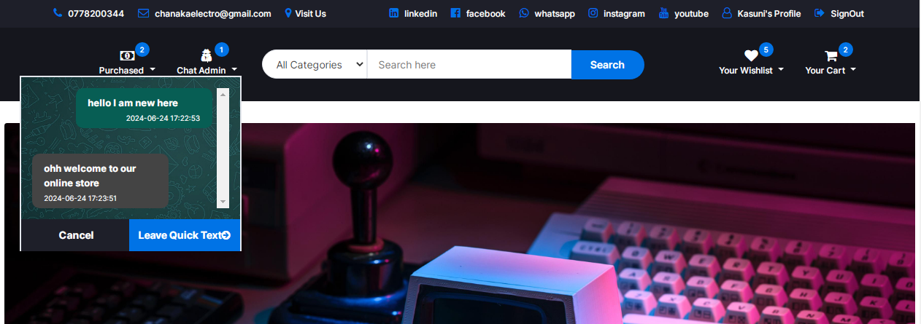

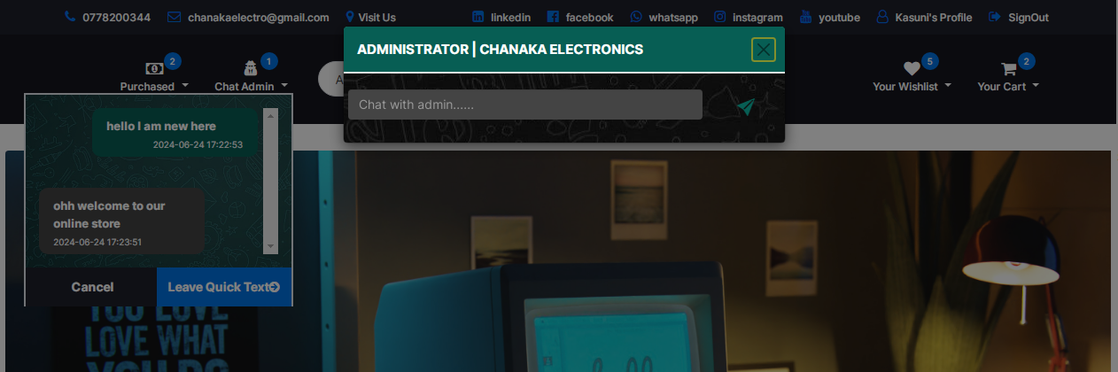

**Message Sending process**

<?php

session_start();

include "connection.php";

if (isset($_SESSION["user"])) {

$mail = $_SESSION["user"]["email"];

$msg = $_POST["f"];

$d = new DateTime();

$tz = new DateTimeZone("Asia/Colombo");

$d->setTimezone($tz);

$date = $d->format("Y-m-d H:i:s");

Database::insUpdelete("INSERT INTO `chat`(`message`,`datetime`,`status`,`toadmin`,`fromuser`) VALUES

('" . $msg . "','" . $date . "','0','chanakaelectro@gmail.com','" . $mail . "')");

echo ("Message Added Successfully");

}

**JavaScript Function**

var cam;

function contactAdmin() {

var m = document.getElementById("contactAdmin");

cam = new bootstrap.Modal(m);

cam.show();

}

function SEndAdminMsg1(email) {

var mtxt = document.getElementById("msgtxt");

var form = new FormData();

form.append("email", email);

form.append("f", mtxt.value);

var request = new XMLHttpRequest();

request.onreadystatechange = function () {

if ((request.status == 200) & (request.readyState == 4)) {

var response = request.responseText;

if (response == "Message Added Successfully") {

window.location.reload();

} else {

alert(response); } } };

request.open("POST", "sendAdminMessageProcess.php", true);

request.send(form);

}

**E commerce web application Admin side**

1. Admin Sign in UI and process associated with it

**Admin Sign in UI**

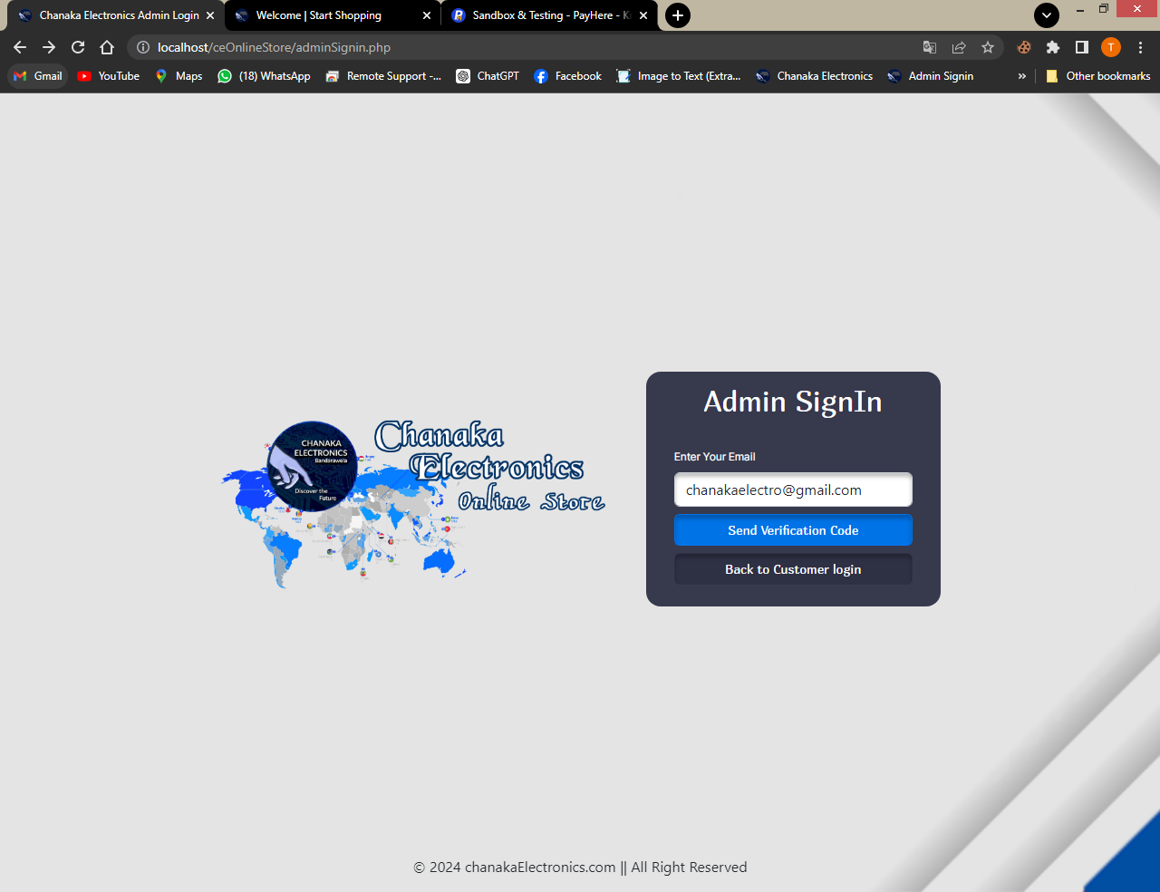

This is the admin signin UI.Admin can enter his email here and get a verification code to the email. After the verification code is sent, a model views and admin can enter the verification code there and login to the admin side. If the user wanted to login as a customer he can use the customer login button and navigate into the customer login page.

<!DOCTYPE html>

<?php

include "connection.php";

?>

<html>

<head>

<meta charset="utf-8">

<meta name="viewport" content="width=device-width, initial-scale=1">

<title> Chanaka Electronics Admin Login </title>

<link rel="stylesheet" href="bootstrap.css" />

<link rel="stylesheet" href="https://cdn.jsdelivr.net/npm/bootstrap-icons@1.9.1/font/bootstrap-icons.css">

<link rel="stylesheet" href="style.css" />

<link rel="icon" href="resources/logo.png" />

</head>

<body class="body2">

<div class="container-fluid vh-100 d-flex justify-content-center align-content-center" style="background-color: rgba(0, 0, 0, 0.10);">

<div class="row d-flex align-content-center justify-content-center">

<div class="col-lg-6 mx-3 d-lg-block logo"></div>

<div class="col-10 col-lg-5">

<div class="row g-2 d-flex justify-content-center mx-2 rounded-4" style="background-color: rgba(43, 45, 66, 0.93);">

<div class="col-12 d-flex justify-content-center">

<p class="title02">Admin SignIn</p>

</div>

<div class="col-10">

<label class="form-label f1" style="color: white;">Enter Your Email</label>

<input type="email" class="form-control" placeholder="Enter Valid Email Address" id="e" style="box-shadow: 0px 4px 4px 0px rgba(0, 0, 0, 0.25) inset;" />

</div>

<div class="col-10 d-grid mt-2">

<button class="btn f2" style="background-color: #0073e6; box-shadow: 0px 4px 4px 0px rgba(0, 0, 0, 0.25) inset; " onclick="adminVerification();">Send Verification Code</button>

</div>

<div class="col-10 d-grid mt-2 mb-4">

<button class="btn f2"style="background-color: rgba(43, 45, 66, 0.68); box-shadow: 0px 4px 4px 0px rgba(0, 0, 0, 0.25) inset;" onclick="window.location='index.php'">Back to Customer login</button>

</div>

</div></div>

<!-- modal -->

<div class="modal" tabindex="-1" id="veriFicationModal">

<div class="modal-dialog">

<div class="modal-content">

<div class="modal-header" style="background-color: rgba(43, 45, 66, 0.93);">

<h5 class="modal-title text-light fw-bold">Admin Verification</h5>

<button type="button" class="btn-close border border-2 border-primary text-light" data-bs-dismiss="modal" aria-label="Close"></button>

</div>

<div class="mb-3 col-10 offset-1">

<label class="form-label fw-bold f1 text-dark">Enter Your Verification Code</label>

<input type="text" class="form-control " id="vCode">

</div>

<div class="modal-footer" style="background-color: rgba(43, 45, 66, 0.93);">

<button type="button" class="btn btn-secondary" data-bs-dismiss="modal" style="background-color: rgba(209, 0, 36, 0.81); box-shadow: 0px 4px 4px 0px rgba(0, 0, 0, 0.25) inset;">Close</button>

<button type="button" class="btn btn-primary" style="background-color: #0073e6; box-shadow: 0px 4px 4px 0px rgba(0, 0, 0, 0.25) inset;" onclick="verify();">Verify</button>

</div>

</div></div>

</div>

<!-- modal -->

<!-- footer -->

<div class="col-12 fixed-bottom d-none d-lg-block">

<p class="text-center">&copy; 2024 chanakaElectronics.com || All Right Reserved</p>

</div>

<!-- footer -->

</div></div>

<script src="bootstrap.bundle.js"></script>

<script src="script.js"></script>

</body>

</html>

**Admin Verification Process**

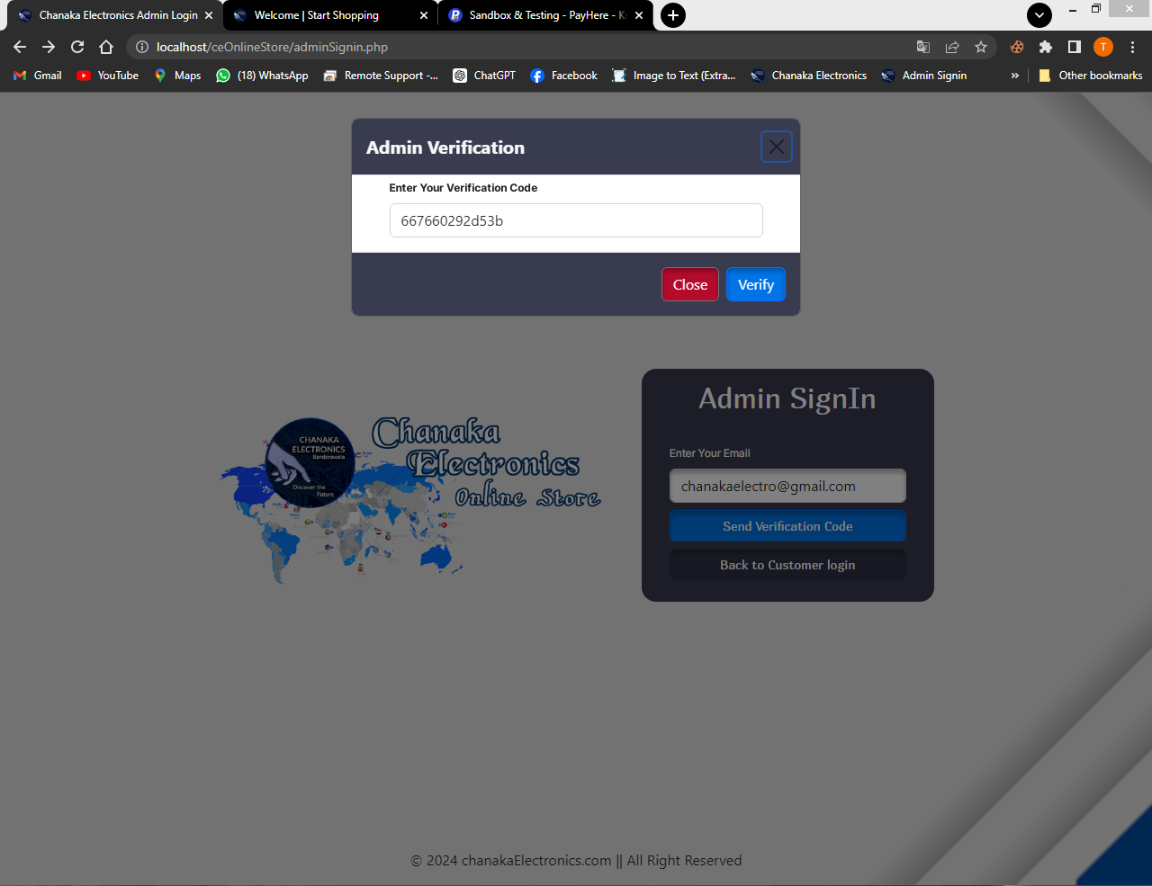

This is the admin verification model. This is viewed after a verification code sent to the admin email. He can enter the received code here and get verified and login as an admin.

<?php

require "connection.php";

require "SMTP.php";

require "PHPMailer.php";

require "Exception.php";

use PHPMailer\PHPMailer\PHPMailer;

if(isset($_POST["e"])){

$email = $_POST["e"];

$admin_Resultset = Database::search("SELECT * FROM `admin` WHERE `email` = '".$email."'");

$admin_num = $admin_Resultset -> num_rows;

if($admin_num >0){

$code = uniqid();

Database::insUpdelete("UPDATE `admin` SET `verification_code` = '".$code."' WHERE `email` = '".$email."'");

$mail = new PHPMailer;

$mail->IsSMTP();

$mail->Host = 'smtp.gmail.com';

$mail->SMTPAuth = true;

$mail->Username = 'tharibro2211@gmail.com';

$mail->Password = 'osproabgubeizhym';

$mail->SMTPSecure = 'ssl';

$mail->Port = 465;

$mail->setFrom('tharibro2211@gmail.com', 'Admin Verification');

$mail->addReplyTo('tharibro2211@gmail.com', 'Admin Verification');

$mail->addAddress($email);

$mail->isHTML(true);

$mail->Subject = 'Chanaka Electronics Admin Login verification_code';

$bodyContent = '<h1 style="color:#0073e6">Your Verification Code is ' . $code . '</h1>';

$mail->Body = $bodyContent;

if($mail -> send()){

echo "success";

}else{

echo 'Verification code sending failed';

}

}else{

echo("you are not a valid User"); }

}else{

echo("Email Field should not be empty"); }

**Admin Verification JavaScript Function**

var av;

function adminVerification() {

var email = document.getElementById("e");

var adminForm = new FormData();

adminForm.append("e", email.value);

var req = new XMLHttpRequest();

req.onreadystatechange = function () {

if (req.readyState == 4) {

var t = req.responseText;

if (t == "success") {

var adminVerificationModal =

document.getElementById("veriFicationModal");

av = new bootstrap.Modal(adminVerificationModal);

av.show();

} else {

alert(t); } }

};

req.open("POST", "adminVeriFicationProcess.php", true);

req.send(adminForm);

}

**Verification Process**

<?php

session_start();

require "connection.php";

if(isset($_GET["v"])){

$v = $_GET["v"];

$admin = Database::search("SELECT * FROM `admin` WHERE `verification_code` = '".$v."'");

$num = $admin -> num_rows;

if($num == 1){

$data = $admin -> fetch_assoc();

$_SESSION["aduser"] = $data;

echo("success");

}else{

echo("Invalid Verification Code"); }

}else{

echo("Please Enter Your Verification"); } ?>

**Verification Process JavaScript Function**

function verify() {

var VeriFication = document.getElementById("vCode");

var req = new XMLHttpRequest();

req.onreadystatechange = function () {

if (req.readyState == 4) {

var t = req.responseText;

if (t == "success") {

av.hide();

window.location = "html/index.php";

} else {

alert(t); } }

};

req.open("GET", "veriFicationProcess.php?v=" + VeriFication.value, true);

req.send();

}

1. Admin Dashboard

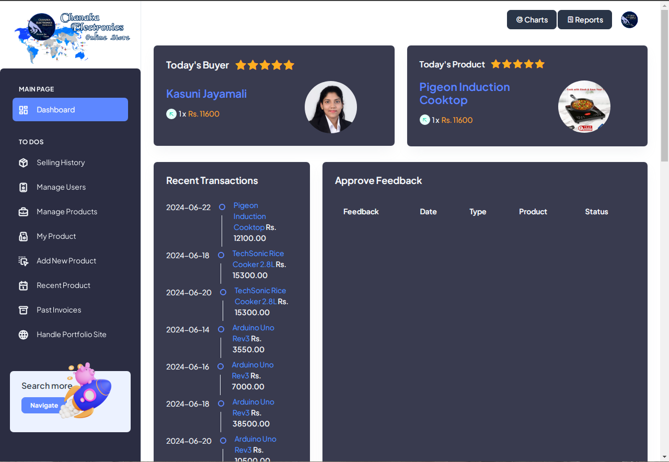

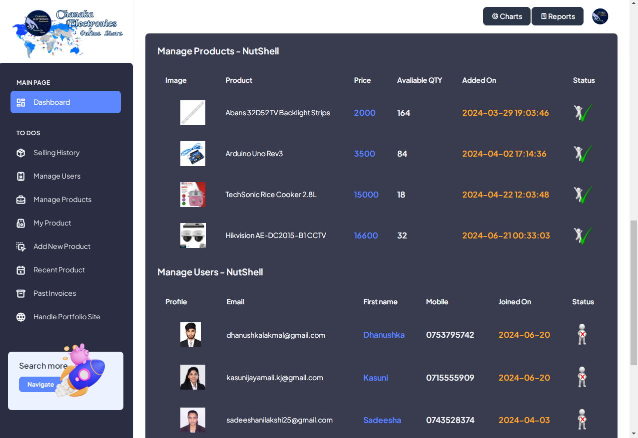

In admin Dashboard, only administrator and super admin can access in to it. There are bunch of functions on the Dashboard.

1. You can see the today’s famous buyer and the most moving product
2. You can see the recent Transactions
3. You can approve feedbacks or reject them
4. Then you have a option to disable the access of recent users
5. Also you can block some products if they are not available currently
6. Then you can access in to the business charts and see what are the rotations in business
7. Also you can have several reports
8. By clicking this profile icon you can have little dropdown and you can signout

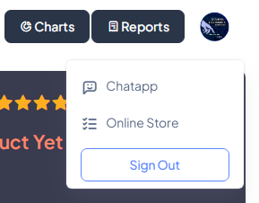

1. And also you can have Chat service to see customer messages if there are and reply
2. You can see invoices and their status
3. Above you had user management Nutshell, now there is fully functioned user management
4. Above you had Product management Nutshell, now there is fully functioned Product management
5. You can also sort and disable your product with My product page
6. You can add a new product and also can update it
7. You can see recently watched and removed products from watchlist
8. You can also analyse the deleted invoices by customer from purchasing history page
9. Last but not least you can handle the previously hosted portfolio site

<!doctype html>

<html lang="en">

<?php

session_start();

require "connection.php";

if (isset($_SESSION["aduser"])) {

?>

<head>

<meta charset="utf-8">

<meta name="viewport" content="width=device-width, initial-scale=1">

<title>Admin Panel | Chanaka Electronics</title>

<link rel="shortcut icon" type="image/png" href="../images/logos/logo.png" />

<link rel="stylesheet" href="../css/styles.min.css" />

<link href="https://fonts.googleapis.com/css?family=Montserrat:400,500,700" rel="stylesheet">

<link type="text/css" rel="stylesheet" href="css/bootstrap.min.css" />

<link type="text/css" rel="stylesheet" href="../css/slick.css" />

<link type="text/css" rel="stylesheet" href="../css/slick-theme.css" />

<link type="text/css" rel="stylesheet" href="../css/nouislider.min.css" />

<!-- Icon Font Stylesheet -->

<link href="https://cdnjs.cloudflare.com/ajax/libs/font-awesome/5.10.0/css/all.min.css" rel="stylesheet">

<link href="https://cdn.jsdelivr.net/npm/bootstrap-icons@1.4.1/font/bootstrap-icons.css" rel="stylesheet">

</head>

<body class="overflow-x-hidden">

<!-- Body Wrapper -->

<div class="page-wrapper" id="main-wrapper" data-layout="vertical" data-navbarbg="skin6" data-sidebartype="full" data-sidebar-position="fixed" data-header-position="fixed">

<!-- Sidebar Start -->

<aside class="left-sidebar">

<!-- Sidebar scroll-->

<div>

<div class="brand-logo d-flex align-items-center justify-content-between">

<a href="./index.php" class="text-nowrap logo-img">

<img src="../images/logos/logo2.png" width="230" alt="" />

</a>

<div class="close-btn d-xl-none d-block sidebartoggler cursor-pointer" id="sidebarCollapse">

<i class="ti ti-x fs-8"></i>

</div>

</div>

<!-- Sidebar navigation-->

<nav class="sidebar-nav scroll-sidebar" data-simplebar="" style="background-color: #2B2D42;">

<ul id="sidebarnav">

<li class="nav-small-cap">

<i class="ti ti-dots nav-small-cap-icon fs-3"></i>

<span class="hide-menu text-light">Main Page</span>

</li>

<li class="sidebar-item">

<a class="sidebar-link" href="./index.php" aria-expanded="false">

<span>

<i class="ti ti-layout-dashboard"></i>

</span>

<span class="hide-menu text-light">Dashboard</span>

</a>

</li>

<li class="nav-small-cap">

<i class="ti ti-dots nav-small-cap-icon fs-4"></i>

<span class="hide-menu text-light">TO DOs</span>

</li>

<li class="sidebar-item">

<a class="sidebar-link" href="../sellingHistory.php" aria-expanded="false">

<span>

<i class="ti ti-package text-light"></i>

</span>

<span class="hide-menu text-light">Selling History</span>

</a>

</li>

<li class="sidebar-item">

<a class="sidebar-link" href="../ManageUser.php" aria-expanded="false">

<span>

<i class="ti ti-id-badge text-light"></i>

</span>

<span class="hide-menu text-light">Manage Users</span>

</a></li>

<li class="sidebar-item">

<a class="sidebar-link" href="../ManageProduct.php" aria-expanded="false">

<span>

<i class="ti ti-briefcase text-light"></i>

</span>

<span class="hide-menu text-light">Manage Products</span>

</a></li>

<li class="sidebar-item">

<a class="sidebar-link" href="../myProducts.php" aria-expanded="false">

<span>

<i class="ti ti-paper-bag text-light"></i>

</span>

<span class="hide-menu text-light">My Product</span>

</a></li>

<li class="sidebar-item">

<a class="sidebar-link" href="#" aria-expanded="false">

<span>

<i class="ti ti-drag-drop text-light"></i>

</span>

<span class="hide-menu text-light">Add New Product</span>

</a></li>

<li class="sidebar-item">

<a class="sidebar-link" href="../recent.php" aria-expanded="false">

<span>

<i class="ti ti-calendar text-light"></i>

</span>

<span class="hide-menu text-light">Recent Product</span>

</a></li>

<li class="sidebar-item">

<a class="sidebar-link" href="../removedInv.php" aria-expanded="false">

<span>

<i class="ti ti-archive text-light"></i>

</span>

<span class="hide-menu text-light">Past Invoices</span>

</a></li>

<li class="sidebar-item">

<a class="sidebar-link" href="https://chanakaelectronics.000webhostapp.com/adminSign.php" aria-expanded="false">

<span>

<i class="ti ti-world text-light"></i>

</span>

<span class="hide-menu text-light">Handle Portfolio Site</span>

</a></li>

</ul>

<div class="unlimited-access hide-menu bg-light-primary position-relative mb-7 mt-5 rounded">

<div class="d-flex">

<div class="unlimited-access-title me-3">

<h6 class="fw-semibold fs-4 mb-6 text-dark w-85">Search more</h6>

<a href="http://chanakaelectronics.000webhostapp.com/index.php" target="_blank" class="btn btn-primary fs-2 fw-semibold lh-sm">Navigate</a>

</div>

<div class="unlimited-access-img">

<img src="../images/backgrounds/rocket.png" alt="" class="img-fluid">

</div>

</div></div>

</nav></div>

<!-- End Sidebar scroll-->

</aside>

<!-- Sidebar End -->

<!-- Main wrapper -->

<div class="body-wrapper">

<!-- Header Start -->

<header class="app-header">

<nav class="navbar navbar-expand-lg navbar-light">

<ul class="navbar-nav">

<li class="nav-item d-block d-xl-none">

<a class="nav-link sidebartoggler nav-icon-hover" id="headerCollapse" href="javascript:void(0)">

<i class="ti ti-menu-2"></i>

</a>

</li>

</ul>

<div class="navbar-collapse justify-content-end px-0" id="navbarNav">

<ul class="navbar-nav flex-row ms-auto align-items-center justify-content-end">

<a href="./AllCharts.php" class="btn btn-dark"> <i class="ti ti-chart-donut"></i> Charts</a>&nbsp;

<a href="../reports/UserReports.php" class="btn btn-dark"> <i class="ti ti-receipt"></i> Reports</a>

<li class="nav-item dropdown">

<a class="nav-link nav-icon-hover" href="javascript:void(0)" id="drop2" data-bs-toggle="dropdown" aria-expanded="false">

<img src="../images/logos/logo.png" alt="" width="35" height="35" class="rounded-circle">

</a>

<div class="dropdown-menu dropdown-menu-end dropdown-menu-animate-up" aria-labelledby="drop2">

<div class="message-body">

<a href="javascript:void(0)" class="d-flex align-items-center gap-2 dropdown-item">

<i class="ti ti-user fs-6"></i>

<p class="mb-0 fs-3">My Profile</p>

</a>

<a href="../home.php" class="d-flex align-items-center gap-2 dropdown-item">

<i class="ti ti-list-check fs-6"></i>

<p class="mb-0 fs-3">Online Store</p>

</a><a href="../adminSignin.php" class="btn btn-outline-primary mx-3 mt-2 d-block">Sign Out</a>

</div></div>

</li>

</ul>

</div></nav>

</header>

<!-- Header End -->

<div class="container-fluid">

<div class="row">

<div class="col-lg-6 align-items-lg-stretch">

<!-- Yearly Breakup -->

<div class="card overflow-hidden">

<div class="card-body p-4" style="background-color: rgba(43, 45, 66, 0.93);">

<h5 class="card-title mb-9 fw-semibold text-light">Today's Buyer &nbsp;&nbsp;

<i class="bi bi-star-fill text-warning fs-6"></i>

<i class="bi bi-star-fill text-warning fs-6"></i>

<i class="bi bi-star-fill text-warning fs-6"></i>

<i class="bi bi-star-fill text-warning fs-6"></i>

<i class="bi bi-star-fill text-warning fs-6"></i>

</h5>

<div class="row align-items-center">

<?php

$today = date("Y-m-d");

$thismonth = date("m");

$thisyear = date("Y");

$a = "0";

$b = "0";

$c = "0";

$e = "0";

$f = "0";

$invoice_rs = Database::search("SELECT * FROM `invoice`");

$invoice_num = $invoice_rs->num_rows;

for ($x = 0; $x < $invoice_num; $x++) {

$invoice_data = $invoice_rs->fetch_assoc();

$f = $f + $invoice_data["iqty"]; //total qty

$d = $invoice_data["date"];

$splitDate = explode(" ", $d); //separate date time

$pdate = $splitDate[0]; //sold date

if ($pdate == $today) {

$a = $a + $invoice_data["total"];

$c = $c + $invoice_data["iqty"]; }

$splitMonth = explode("-", $pdate); //separate year,month & date

$pyear = $splitMonth[0]; // year

$pmonth = $splitMonth[1]; // month

if ($pyear == $thisyear) {

if ($pmonth == $thismonth) {

$b = $b + $invoice_data["total"];

$e = $e + $invoice_data["iqty"]; } } }

$freq_rs = Database::search("SELECT `total`,`iqty`,`user_email`,`product_id`,COUNT(`product_id`) AS `value_occurance`

FROM `invoice` WHERE `date` LIKE '%" . $today . "%' GROUP BY `product_id`,`user_email`,`iqty`,`total` ORDER BY

`value_occurance` DESC LIMIT 1");

$freq_num = $freq_rs->num_rows;

if ($freq_num > 0) {

$freq_data = $freq_rs->fetch_assoc();

$product_Rs = Database::search("SELECT * FROM `product` WHERE `id` = '" . $freq_data["product_id"] . "'");

$product_data = $product_Rs->fetch_assoc();

$proimg_rs = Database::search("SELECT * FROM `profile_image` WHERE `user_email` = '" . $freq_data["user_email"] . "'");

$pro_data = $proimg_rs->fetch_assoc();

$user_rs1 = Database::search("SELECT * FROM `user` WHERE `email` = '" . $freq_data["user_email"] . "'");

$user_Data = $user_rs1->fetch_assoc();

$qty_rs = Database::search("SELECT SUM(`iqty`) AS `qty_total` FROM `invoice` WHERE `product_id` = '" . $freq_data["product_id"] . "' AND `date` LIKE '%" . $today . "%'");

$qty_data = $qty_rs->fetch_assoc();

?>

<div class="col-6">

<h4 class="fw-semibold mb-3 text-primary"><?php echo $user_Data["fname"] . " " . $user_Data["lname"]; ?></h4>

<div class="d-flex align-items-center mb-3">

<span class="me-1 rounded-circle bg-light-success round-20 d-flex align-items-center justify-content-center">

<i class="ti ti-arrow-up-left text-success"></i>

</span>

<p class="text-light me-1 fs-3 mb-0"><?php echo $qty_data["qty_total"]; ?> x</p>

<p class="fs-3 mb-0 text-warning">Rs. <?php echo $qty_data["qty_total"] * $product_data["price"]; ?></p>

</div></div>

<?php

} else {

?>

<div class="col-8">

<h4 class="fw-semibold mb-3 text-danger">No Buyer Yet </h4>

<div class="d-flex align-items-center mb-3">

<span class="me-1 rounded-circle bg-light-success round-20 d-flex align-items-center justify-content-center">

<i class="ti ti-arrow-up-left text-success"></i>

</span>

<p class="text-light me-1 fs-3 mb-0">0 x</p>

<p class="fs-3 mb-0 text-warning">00</p>

</div></div>

<?php } ?>

<div class="col-6">

<div class="d-flex justify-content-center">

<img class="img-fluid rounded-circle mx-auto mb-0" src="../<?php echo $pro_data["path"]; ?>" style="width: 100px; height: 100px;">

</div>

</div></div>

</div></div>

</div>

<div class="col-lg-6 align-items-lg-stretch">

<div class="card overflow-hidden">

<div class="card-body p-4" style="background-color: rgba(43, 45, 66, 0.93);">

<h5 class="card-title mb-9 fw-semibold text-light fs-4">Today's Product &nbsp;&nbsp;

<i class="bi bi-star-fill text-warning fs-5"></i>

<i class="bi bi-star-fill text-warning fs-5"></i>

<i class="bi bi-star-fill text-warning fs-5"></i>

<i class="bi bi-star-fill text-warning fs-5"></i>

<i class="bi bi-star-fill text-warning fs-5"></i>

</h5>

<div class="row align-items-center">

<?php

$today = date("Y-m-d");

$thismonth = date("m");

$thisyear = date("Y");

$a = "0";

$b = "0";

$c = "0";

$e = "0";

$f = "0";

$invoice_rs = Database::search("SELECT * FROM `invoice`");

$invoice_num = $invoice_rs->num_rows;

for ($x = 0; $x < $invoice_num; $x++) {

$invoice_data = $invoice_rs->fetch_assoc()

$f = $f + $invoice_data["iqty"]; //total qty

$d = $invoice_data["date"];

$splitDate = explode(" ", $d); //separate date time

$pdate = $splitDate[0]; //sold date

if ($pdate == $today) {

$a = $a + $invoice_data["total"];

$c = $c + $invoice_data["iqty"];

$splitMonth = explode("-", $pdate); //separate year,month & date

$pyear = $splitMonth[0]; // year

$pmonth = $splitMonth[1]; // mont

if ($pyear == $thisyear) {

if ($pmonth == $thismonth) {

$b = $b + $invoice_data["total"];

$e = $e + $invoice_data["iqty"]; } }

}

$freq_rs = Database::search("SELECT `total`,`iqty`,`user_email`,`product_id`,COUNT(`product_id`) AS `value_occurance`

FROM `invoice` WHERE `date` LIKE '%" . $today . "%' GROUP BY `product_id`,`user_email`,`iqty`,`total` ORDER BY

`value_occurance` DESC LIMIT 1");

$freq_num = $freq_rs->num_rows;

if ($freq_num > 0) {

$freq_data = $freq_rs->fetch_assoc();

$product_Rs = Database::search("SELECT * FROM `product` WHERE `id` = '" . $freq_data["product_id"] . "'");

$product_data = $product_Rs->fetch_assoc();

$image_rs = Database::search("SELECT * FROM `image` WHERE `product_id` = '" . $freq_data["product_id"] . "'");

$image_data = $image_rs->fetch_assoc();

$qty_rs = Database::search("SELECT SUM(`iqty`) AS `qty_total` FROM `invoice` WHERE `product_id` = '" . $freq_data["product_id"] . "' AND `date` LIKE '%" . $today . "%'");

$qty_data = $qty_rs->fetch_assoc();

?>

<div class="col-6">

<h4 class="fw-semibold mb-3 text-primary"><?php echo $product_data["title"]; ?></h4>

<div class="d-flex align-items-center mb-3">

<span class="me-1 rounded-circle bg-light-success round-20 d-flex align-items-center justify-content-center">

<i class="ti ti-arrow-up-left text-success"></i>

</span>

<p class="text-light me-1 fs-3 mb-0"><?php echo $qty_data["qty_total"]; ?> x</p>

<p class="fs-3 mb-0 text-warning">Rs. <?php echo $qty_data["qty_total"] * $product_data["price"]; ?></p>

</div></div>

<?php

} else {

?>

<div class="col-8">

<h4 class="fw-semibold mb-3 text-danger">No Recent Product Yet </h4>

<div class="d-flex align-items-center mb-3">

<span class="me-1 rounded-circle bg-light-success round-20 d-flex align-items-center justify-content-center">

<i class="ti ti-arrow-up-left text-success"></i>

</span>

<p class="text-light me-1 fs-3 mb-0">0 x</p>

<p class="fs-3 mb-0 text-warning">00</p>

</div>

</div>

<?php } ?>

<div class="col-6">

<div class="d-flex justify-content-center">

<img class="img-fluid rounded-circle mx-auto mb-0" src="../<?php echo $image_data["code"]; ?>" style="width: 100px; height: 100px;">

</div> </div> </div>

</div> </div>

</div></div>

<div class="row">

<div class="col-lg-4 d-flex align-items-stretch">

<div class="card w-100" style="background-color: rgba(43, 45, 66, 0.93);">

<div class="card-body p-4">

<div class="mb-4">

<h5 class="card-title fw-semibold text-light">Recent Transactions</h5>

</div>

<ul class="timeline-widget mb-0 position-relative mb-n5">

<?php

$product_resultSet = Database::search("SELECT `date`,`title`,`total` FROM `invoice`

INNER JOIN `product` ON `product`.`id`= `invoice`.`product_id` ORDER BY `datetime_added` DESC");

$product_num = $product_resultSet->num_rows;

for ($z = 0; $z < $product_num; $z++) {

$product_data = $product_resultSet->fetch_assoc();

?>

<li class="timeline-item d-flex position-relative overflow-hidden">

<div class="timeline-time text-light flex-shrink-0 text-end"><?php echo $product_data["date"]; ?></div>

<div class="timeline-badge-wrap d-flex flex-column align-items-center">

<span class="timeline-badge border-2 border border-primary flex-shrink-0 my-8"></span>

<span class="timeline-badge-border d-block flex-shrink-0"></span>

</div>

<div class="timeline-desc fs-3 text-info mt-n1"><?php echo $product_data["title"]; ?> <span class="text-light fw-bold">Rs. <?php echo $product_data["total"]; ?>.00</span> </div>

</li>

<?php } ?>

</ul>

</div> </div> </div>

<div class="col-lg-8 d-flex align-items-stretch">

<div class="card w-100" style="background-color: rgba(43, 45, 66, 0.93);">

<div class="card-body p-4">

<h5 class="card-title fw-semibold mb-4 text-light">Approve Feedback</h5>

<div class="table-responsive">

<table class="table text-nowrap mb-0 align-middle">

<thead class="text-dark fs-4">

<tr>

<th class="border-bottom-0">

<h6 class="fw-semibold mb-0 text-light">Feedback</h6></th>

<th class="border-bottom-0">

<h6 class="fw-semibold mb-0 text-light">Date</h6></th>

<th class="border-bottom-0">

<h6 class="fw-semibold mb-0 text-light">Type</h6></th>

<th class="border-bottom-0">

<h6 class="fw-semibold mb-0 text-light">Product</h6></th>

<th class="border-bottom-0">

<h6 class="fw-semibold mb-0 text-light">Status</h6></th></tr>

</thead>

<tbody>

<?php

$fproduct_resultSet = Database::search("SELECT * FROM `feedback`

INNER JOIN `product` ON `product`.`id`= `feedback`.`product_id`

INNER JOIN `user` ON `user`.`email`= `feedback`.`user_email` WHERE `Feed_status` = '2' ORDER BY `feedback`.`feed_id` ASC");

$fproduct_num = $fproduct_resultSet->num_rows;

for ($z = 0; $z < $fproduct_num; $z++) {

$fproduct_data = $fproduct_resultSet->fetch_assoc();

?>

<tr>

<td class="border-bottom-0">

<h6 class="fw-semibold mb-0 text-primary"><?php echo $fproduct_data["feedback"]; ?></h6>

<span class="text-light fw-bold"><?php echo $fproduct_data["fname"] ?> <?php echo $fproduct_data["lname"] ?></span>

</td>

<td class="border-bottom-0">

<p class="mb-0 fw-normal text-light"><?php echo $fproduct_data["date"]; ?></p>

</td>

<td class="border-bottom-0">

<div class="d-flex align-items-center gap-2">

<?php

if ($fproduct_data["type"] == 5) {

?>

<span class="badge bg-success rounded-3 fw-semibold">5 Stars</span>

<?php } ?>

<?php

if ($fproduct_data["type"] == 4) {

?>

<span class="badge bg-primary rounded-3 fw-semibold">4 Stars</span>

<?php } ?>

<?php

if ($fproduct_data["type"] == 3) {

?>

<span class="badge bg-info rounded-3 fw-semibold">3 Stars</span>

<?php } ?>

<?php

if ($fproduct_data["type"] == 2) {

?>

<span class="badge bg-warning rounded-3 fw-semibold">2 Stars</span>

<?php } ?>

<?php

if ($fproduct_data["type"] == 1) {

?>

<span class="badge bg-danger rounded-3 fw-semibold">Weak</span>

<?php } ?>

</div>

</td>

<td class="border-bottom-0">

<h6 class="fw-semibold mb-0 fs-4 text-warning"><?php echo $fproduct_data["title"]; ?></h6>

</td>

<td class="border-bottom-0">

<button id="UB<?php echo $fproduct_data["feed_id"]; ?>" class="bg-transparent border border-0" onclick="approve('<?php echo $fproduct_data['feed_id']; ?>');"><img src="../images/backgrounds/check-mark-transparent-gif-13.png" width="40"></button>

</td>

</tr>

<?php } ?>

</tbody>

</table>

</div>

<br>

</div></div>

</div>

<div class="col-lg-12 d-flex align-items-stretch">

<div class="card w-100" style="background-color: rgba(43, 45, 66, 0.93);">

<div class="card-body p-4">

<h5 class="card-title fw-semibold mb-4 text-light">Manage Products - NutShell</h5>

<div class="table-responsive">

<table class="table text-nowrap mb-0 align-middle">

<thead class="text-dark fs-4">

<tr>

<th class="border-bottom-0">

<h6 class="fw-semibold mb-0 text-light">Image</h6></th>

<th class="border-bottom-0">

<h6 class="fw-semibold mb-0 text-light">Product</h6></th>

<th class="border-bottom-0">

<h6 class="fw-semibold mb-0 text-light">Price</h6></th>

<th class="border-bottom-0">

<h6 class="fw-semibold mb-0 text-light">Avaliable QTY</h6></th>

<th class="border-bottom-0">

<h6 class="fw-semibold mb-0 text-light">Added On</h6></th>

<th class="border-bottom-0">

<h6 class="fw-semibold mb-0 text-light">Status</h6></th></tr>

</thead>

<tbody>

<?php

$mproduct_resultSet = Database::search("SELECT * FROM `product` ORDER BY `product`.`id` ASC LIMIT 4");

$mproduct_num = $mproduct_resultSet->num_rows;

for ($z = 0; $z < $mproduct_num; $z++) {

$mproduct_data = $mproduct_resultSet->fetch_assoc();

?>

<tr>

<td class="border-bottom-0">

<?php

$product_img_rs = Database::search("SELECT * FROM `image` WHERE `product_id` = '" . $mproduct_data["id"] . "';");

$product_img_data = $product_img_rs->fetch_assoc();

?>

<img src="../<?php echo $product_img_data["code"]; ?>" style="height: 50px; margin-left: 30px;" />

</td>

<td class="border-bottom-0">

<p class="mb-0 fw-normal text-light"><?php echo $mproduct_data["title"]; ?></p>

</td>

<td class="border-bottom-0">

<h6 class="fw-semibold mb-0 fs-4 text-primary"><?php echo $mproduct_data["price"]; ?></h6>

</td>

<td class="border-bottom-0">

<h6 class="fw-semibold mb-0 fs-4 text-light"><?php echo $mproduct_data["qty"]; ?></h6>

</td>

<td class="border-bottom-0">

<h6 class="fw-semibold mb-0 fs-4 text-warning"><?php echo $mproduct_data["datetime_added"]; ?></h6>

</td>

<td class="border-bottom-0">

<?php

if ($mproduct_data["status_id"] == 1) {

?>

<button id="pb<?php echo $mproduct_data["id"]; ?>" class="bg-transparent border border-0" onclick="blockProduct('<?php echo $mproduct_data['id']; ?>');"><img src="../images/backgrounds/check-mark-transparent-gif-13.png" width="40"></button>

<?php } else { ?>

<button id="pb<?php echo $mproduct_data["id"]; ?>" class="bg-transparent border border-0" onclick="blockProduct('<?php echo $mproduct_data['id']; ?>');"><img src="../img/sad.ico" width="40"></button>

<?php } ?>

</td>

</tr>

<?php } ?>

</tbody>

</table>

</div>

<br>

<h5 class="card-title fw-semibold mb-4 text-light">Manage Users - NutShell</h5>

<div class="table-responsive">

<table class="table text-nowrap mb-0 align-middle">

<thead class="text-dark fs-4">

<tr>

<th class="border-bottom-0">

<h6 class="fw-semibold mb-0 text-light">Profile</h6></th>

<th class="border-bottom-0">

<h6 class="fw-semibold mb-0 text-light">Email</h6></th>

<th class="border-bottom-0">

<h6 class="fw-semibold mb-0 text-light">First name</h6></th>

<th class="border-bottom-0">

<h6 class="fw-semibold mb-0 text-light">Mobile</h6></th>

<th class="border-bottom-0">

<h6 class="fw-semibold mb-0 text-light">Joined On</h6></th>

<th class="border-bottom-0">

<h6 class="fw-semibold mb-0 text-light">Status</h6></th>

</tr>

</thead>

<tbody>

<?php

$user_resultSet = Database::search("SELECT * FROM `user`LIMIT 4");

$user_num = $user_resultSet->num_rows;

for ($z = 0; $z < $user_num; $z++) {

$user_data = $user_resultSet->fetch_assoc();

?>

<tr>

<td class="border-bottom-0">

<?php

$user_img_rs = Database::search("SELECT * FROM `profile_image` WHERE `user_email` = '" . $user_data["email"] . "';");

$user_img_data = $user_img_rs->fetch_assoc();

?>

<img src="../<?php echo $user_img_data["path"]; ?>" style="height: 50px; margin-left: 30px;" /></td>

<td class="border-bottom-0">

<p class="mb-0 fw-normal text-light"><?php echo $user_data["email"]; ?></p></td>

<td class="border-bottom-0">

<h6 class="fw-semibold mb-0 fs-4 text-primary"><?php echo $user_data["fname"]; ?></h6></td>

<td class="border-bottom-0">

<h6 class="fw-semibold mb-0 fs-4 text-light"><?php echo $user_data["mobile"]; ?></h6></td>

<td class="border-bottom-0">

<h6 class="fw-semibold mb-0 fs-4 text-warning"><?php echo $user_data["join_date"]; ?></h6></td>

<td class="border-bottom-0">

<?php

if ($user_data["status"] == 0) {

?>

<button id="UB<?php echo $user_data['email']; ?>" class="bg-transparent border border-0" onclick="blockUser('<?php echo $user_data['email']; ?>');"><img src="../images/backgrounds/check-mark-transparent-gif-13.png" width="40"></button>

<?php

} else {

?>

<button id="UB<?php echo $user_data['email']; ?>" class="bg-transparent border border-0" onclick="blockUser('<?php echo $user_data['email']; ?>');"><img src="../images/backgrounds/uncheck-mark-transparent-gif-13.png" width="40"></button>

<?php } ?>

</td>

</tr>

<?php } ?>

</tbody>

</table>

</div>

<br>

<h5 class="card-title fw-semibold mb-4 text-light">View Admins</h5>

<div class="table-responsive">

<table class="table text-nowrap mb-0 align-middle">

<thead class="text-dark fs-4">

<tr>

<th class="border-bottom-0">

<h6 class="fw-semibold mb-0 text-light">Email</h6></th>

<th class="border-bottom-0">

<h6 class="fw-semibold mb-0 text-light">First name</h6></th>

<th class="border-bottom-0">

<h6 class="fw-semibold mb-0 text-light">Last name</h6></th>

<th class="border-bottom-0">

<h6 class="fw-semibold mb-0 text-light">Last Verification Code</h6></th>

</tr>

</thead>

<tbody>

<?php

$user_resultSet = Database::search("SELECT * FROM `admin`");

$user_num = $user_resultSet->num_rows;

for ($z = 0; $z < $user_num; $z++) {

$user_data = $user_resultSet->fetch_assoc();

?>

<tr>

<td class="border-bottom-0">

<p class="mb-0 fw-normal text-light"><?php echo $user_data["email"]; ?></p></td>

<td class="border-bottom-0">

<h6 class="fw-semibold mb-0 fs-4 text-primary"><?php echo $user_data["fname"]; ?></h6></td>

<td class="border-bottom-0">

<h6 class="fw-semibold mb-0 fs-4 text-primary"><?php echo $user_data["lname"]; ?></h6></td>

<td class="border-bottom-0">

<h6 class="fw-semibold mb-0 fs-4 text-warning"><?php echo $user_data["verification_code"]; ?></h6></td>

</tr>

<?php } ?>

</tbody>

</table>

</div> </div> </div>

</div> </div>

</div> </div>

</div></div>

<script src="https://cdn.jsdelivr.net/npm/chart.js"></script>

<script src="../libs/jquery/dist/jquery.min.js"></script>

<script src="../libs/bootstrap/dist/js/bootstrap.bundle.min.js"></script>

<script src="../js/sidebarmenu.js"></script>

<script src="../js/app.min.js"></script>

<script src="../libs/apexcharts/dist/apexcharts.min.js"></script>

<script src="../libs/simplebar/dist/simplebar.js"></script>

<script src="../js/dashboard.js"></script>

</body>

</html>

<?php

} else {

header("location:../adminSignin.php");

}

?>

1. User Reports

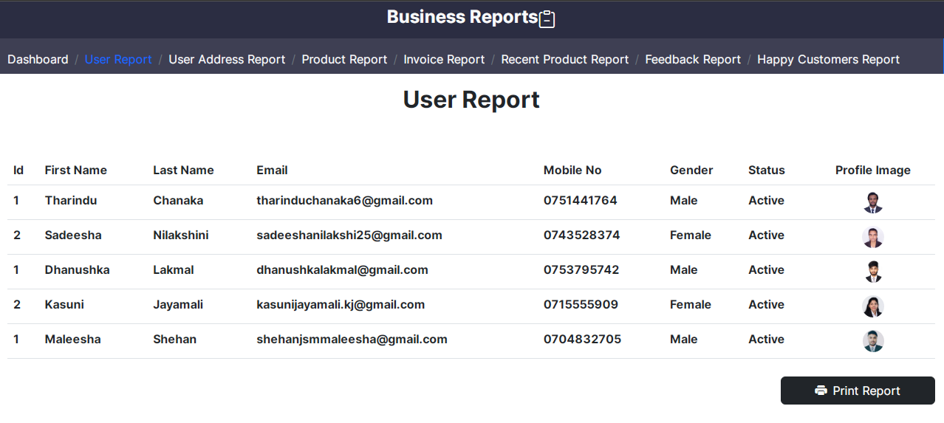

<!DOCTYPE html>

<html>

<?php

session_start();

require "../connection.php";

if (isset($_SESSION["aduser"])) {

$email = $_SESSION["aduser"]["email"];

$rs = Database::search("SELECT * FROM `user` INNER JOIN `gender` ON `user`.`gender_id` = `gender`.`id`

ORDER BY `user`.`join_date` ASC");

$num = $rs->num_rows;

?>

<head>

<meta charset="UTF-8">

<meta name="viewport" content="width=device-width, initial-scale=1.0">

<title>Business Reports | Chanaka Electronics</title>

<link rel="stylesheet" href="../bootstrap.css" />

<link rel="stylesheet" href="https://cdn.jsdelivr.net/npm/bootstrap-icons@1.9.1/font/bootstrap-icons.css" />

<link rel="stylesheet" href="../style.css" />

<link rel="icon" href="../resources/logo.png" />

</head>

<body class="bodyreport" style="background-size: 115%;">

<div class="container-fluid">

<div class="row">

<div class="col-lg-12 text-center" style="background-color:black;">

<label class="form-label text-light title1 fs-3 fw-bold f3">Business Reports</label>&nbsp;

<i class="bi bi-clipboard-minus" style="color: white; font-size: 30px;"></i>

</div>

<div class="border-0 border-end border-1 border-primary" style="background-color:#2B2D42;">

<nav aria-label="breadcrumb" class="mt-2">

<ol class="breadcrumb">

<li class="breadcrumb-item f4" aria-current="page"><a href="../html/index.php" class="text-decoration-none text-light">Dashboard</a></li>

<li class="breadcrumb-item f4 active text-primary">User Report</li>

<li class="breadcrumb-item f4" aria-current="page"><a href="userAdreessReport.php" class="text-decoration-none text-light">User Address Report</a></li>

<li class="breadcrumb-item f4" aria-current="page"><a href="ProductReport.php" class="text-decoration-none text-light">Product Report</a></li>

<li class="breadcrumb-item f4" aria-current="page"><a href="invoiceReport.php" class="text-decoration-none text-light">Invoice Report</a></li>

<li class="breadcrumb-item f4" aria-current="page"><a href="RecentReports.php" class="text-decoration-none text-light">Recent Product Report</a></li>

<li class="breadcrumb-item f4" aria-current="page"><a href="feedbackReports.php" class="text-decoration-none text-light">Feedback Report</a></li>

<li class="breadcrumb-item f4" aria-current="page"><a href="HappycustomerReports.php" class="text-decoration-none text-light">Happy Customers Report</a></li>

</ol>

</nav></div>

<div class="container mt-3" id="printArea">

<h2 class="text-center fw-bold col-12">User Report</h2>

<table class="table table-hover mt-5 table-responsive">

<thead class="fw-bold col-12">

<tr>

<th>Id</th>

<th>First Name</th>

<th>Last Name</th>

<th>Email</th>

<th>Mobile No</th>

<th>Gender</th>

<th>Status</th>

<th class="text-center">Profile Image</th>

</tr>

</thead>

<tbody class="fw-bold">

<?php

for ($i = 0; $i < $num; $i++) {

$data = $rs->fetch_assoc();

$img_resultSet = Database::search("SELECT*FROM `profile_image` WHERE `user_email`='" . $data["email"] . "';");

$imgdata = $img_resultSet->fetch_assoc();

?>

<tr>

<td><?php echo $data["id"] ?></td>

<td><?php echo $data["fname"] ?></td>

<td><?php echo $data["lname"] ?></td>

<td><?php echo $data["email"] ?></td>

<td><?php echo $data["mobile"] ?></td>

<td><?php echo $data["gender_name"] ?></td>

<td>

<?php

if ($data["status"] == 1) {

echo ("Active");

} else {

echo ("Inactive"); }

?></td>

<td class="text-center">

<?php

if (empty($imgdata["path"])) {

?>

<img src="../resources/user.png" height="30px">

</td>

<?php

} else {

?>

<img src="../<?php echo $imgdata["path"]; ?>" height="30px" class="rounded-circle"></td>

<?php } ?>

</tr>

<?php } ?>

</tbody>

</table>

</div>

<div class="d-flex justify-content-end container mt-2">

<button class="btn btn-dark col-2" onclick="printDiv();"><i class="bi bi-printer-fill me-2"></i>Print Report</button>

</div>

<script src="../script.js"></script>

<script src="../bootstrap.bundle.js"></script>

</body>

</html>

<?php

} else {

header("location:html/index.php"); } ?>

1. User Address Reports

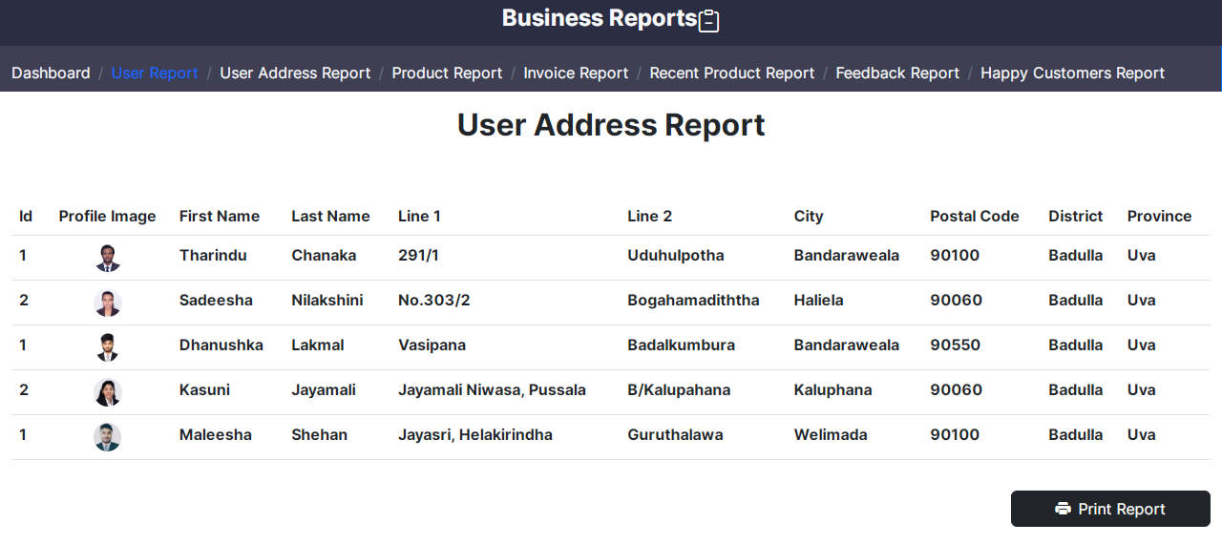

<!DOCTYPE html>

<html>

<?php

session_start();

require "../connection.php";

if (isset($_SESSION["aduser"])) {

$email = $_SESSION["aduser"]["email"];

$rs = Database::search("SELECT * FROM `user` INNER JOIN `gender` ON `user`.`gender_id` = `gender`.`id`

ORDER BY `user`.`join_date` ASC");

$num = $rs->num_rows;

?>

<head>

<meta charset="UTF-8">

<meta name="viewport" content="width=device-width, initial-scale=1.0">

<title>Business Reports | Chanaka Electronics</title

<link rel="stylesheet" href="../bootstrap.css" />

<link rel="stylesheet" href="https://cdn.jsdelivr.net/npm/bootstrap-icons@1.9.1/font/bootstrap-icons.css" />

<link rel="stylesheet" href="../style.css" />

<link rel="icon" href="../resources/logo.png" />

</head>

<body class="body" style="background-size: 115%;">

<div class="container-fluid">

<div class="row">

<div class="col-12 text-center" style="background-color:black;">

<label class="form-label text-light title1 fs-3 fw-bold f3">Business Reports</label>&nbsp;

<i class="bi bi-clipboard-minus" style="color: white; font-size: 30px;"></i>

</div>

<div class="col-12 border-0 border-end border-1 border-primary" style="background-color:#2B2D42;">

<nav aria-label="breadcrumb" class="mt-2">

<ol class="breadcrumb">

<li class="breadcrumb-item f4" aria-current="page"><a href="../html/index.php" class="text-decoration-none text-light">Dashboard</a></li>

<li class="breadcrumb-item f4" aria-current="page"><a href="UserReports.php" class="text-decoration-none text-light">User Report</a></li>

<li class="breadcrumb-item f4 active text-primary" aria-current="page">User Address Report</li>

<li class="breadcrumb-item f4" aria-current="page"><a href="ProductReport.php" class="text-decoration-none text-light">Product Report</a></li>

<li class="breadcrumb-item f4" aria-current="page"><a href="invoiceReport.php" class="text-decoration-none text-light">Invoice Report</a></li>

<li class="breadcrumb-item f4" aria-current="page"><a href="RecentReports.php" class="text-decoration-none text-light">Recent Product Report</a></li>

<li class="breadcrumb-item f4" aria-current="page"><a href="feedbackReports.php" class="text-decoration-none text-light">Feedback Report</a></li>

<li class="breadcrumb-item f4" aria-current="page"><a href="HappycustomerReports.php" class="text-decoration-none text-light">Happy Customers Report</a></li>

</ol>

</nav>

</div>

<div class="container mt-3" id="printArea">

<h2 class="text-center fw-bold">User Address Report</h2>

<table class="table table-hover mt-5 table-responsive">

<thead class="fw-bold">

<tr>

<th>Id</th>

<th class="text-center">Profile Image</th>

<th>First Name</th>

<th>Last Name</th>

<th>Line 1</th>

<th>Line 2</th>

<th>City</th>

<th>Postal Code</th>

<th>District</th>

<th>Province</th>

</tr>

</thead>

<tbody class="fw-bold">

<?php

for ($i = 0; $i < $num; $i++) {

$data = $rs->fetch_assoc();

$img_resultSet = Database::search("SELECT*FROM `profile_image` WHERE `user_email`='" . $data["email"] . "';");

$imgdata = $img_resultSet->fetch_assoc();

$addr_resultSet = Database::search("SELECT*FROM `user_has_address`

INNER JOIN `city` ON user_has_address.city_id=city.id

INNER JOIN `district` ON city.district_id=district.id

INNER JOIN `province`ON district.province_id=province.id WHERE `user_email`='" . $data["email"] . "';");

$addrdata = $addr_resultSet->fetch_assoc();

?> <tr>

<td><?php echo $data["id"] ?></td>

<td class="text-center">

<?php

if (empty($imgdata["path"])) {

?>

<img src="../resources/user.png" height="30px">

</td>

<?php

} else {

?>

<img src="../<?php echo $imgdata["path"]; ?>" height="30px" class="rounded-circle"></td>

<?php } ?>

<td><?php echo $data["fname"] ?></td>

<td><?php echo $data["lname"] ?></td>

<td><?php echo $addrdata["line1"] ?></td>

<td><?php echo $addrdata["line2"] ?></td>

<td><?php echo $addrdata["city_name"] ?></td>

<td><?php echo $addrdata["postal_code"] ?></td>

<td><?php echo $addrdata["district_name"] ?></td>

<td><?php echo $addrdata["province_name"] ?></td>

</tr>

<?php } ?>

</tbody>

</table>

</div>

<div class="d-flex justify-content-end container mt-2">

<button class="btn btn-dark col-2" onclick="printDiv();"><i class="bi bi-printer-fill me-2"></i>Print Report</button>

</div>

<script src="../script.js"></script>

<script src="../bootstrap.bundle.js"></script>

</body>

</html>

<?php

} else {

header("location:html/index.php"); } ?>

1. Product Reports

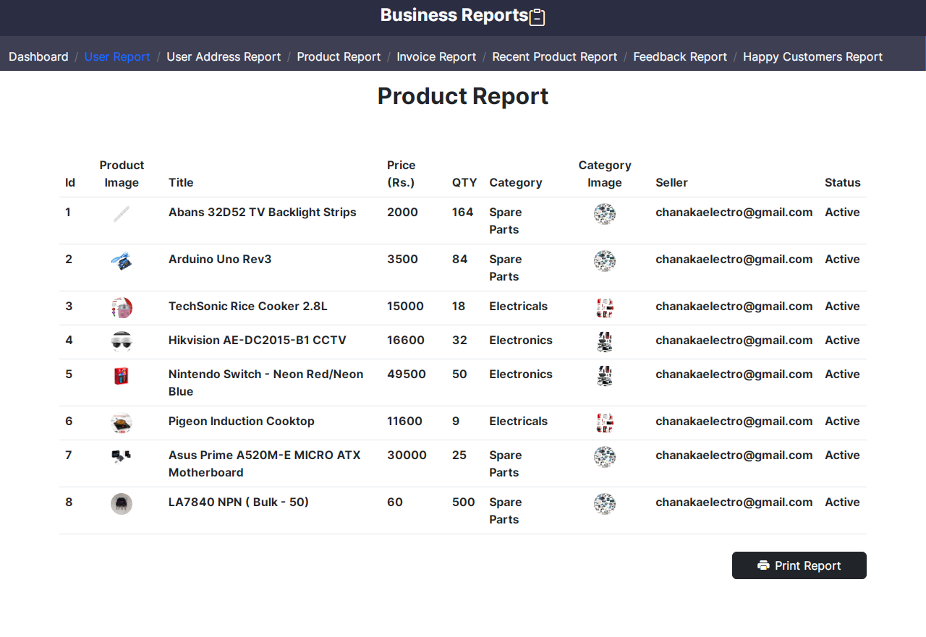

<!DOCTYPE html>

<html>

<?php

session_start();

require "../connection.php";

if (isset($_SESSION["aduser"])) {

$email = $_SESSION["aduser"]["email"];

$rs = Database::search("SELECT * FROM `product`

INNER JOIN `status` ON `product`.`status_id` = `status`.`s_id`

INNER JOIN `admin` ON `product`.`admin_email` = `admin`.`email`

INNER JOIN `category` ON `product`.`category_id` = `category`.`c_id`

ORDER BY `product`.`id` ASC");

$num = $rs->num_rows;

?>

<head>

<meta charset="UTF-8">

<meta name="viewport" content="width=device-width, initial-scale=1.0">

<title>Business Reports | Chanaka Electronics</title>

<link rel="stylesheet" href="../bootstrap.css" />

<link rel="stylesheet" href="https://cdn.jsdelivr.net/npm/bootstrap-icons@1.9.1/font/bootstrap-icons.css" />

<link rel="stylesheet" href="../style.css" />

<link rel="icon" href="../resources/logo.png" />

</head>

<body class="body" style="background-size: 115%;">

<div class="container-fluid">

<div class="row">

<div class="col-12 text-center" style="background-color:black;">

<label class="form-label text-light title1 fs-3 fw-bold f3">Business Reports</label>&nbsp;

<i class="bi bi-clipboard-minus" style="color: white; font-size: 30px;"></i>

</div>

<div class="col-12 border-0 border-end border-1 border-primary" style="background-color:#2B2D42;">

<nav aria-label="breadcrumb" class="mt-2">

<ol class="breadcrumb">

<li class="breadcrumb-item f4" aria-current="page"><a href="../html/index.php" class="text-decoration-none text-light">Dashboard</a></li>

<li class="breadcrumb-item f4" aria-current="page"><a href="UserReports.php" class="text-decoration-none text-light">User Report</a></li>

<li class="breadcrumb-item f4" aria-current="page"><a href="userAdreessReport.php" class="text-decoration-none text-light">User Address Report</a></li>

<li class="breadcrumb-item f4 active text-primary" aria-current="page">Product Report</li>

<li class="breadcrumb-item f4" aria-current="page"><a href="invoiceReport.php" class="text-decoration-none text-light">Invoice Report</a></li>

<li class="breadcrumb-item f4" aria-current="page"><a href="RecentReports.php" class="text-decoration-none text-light">Recent Product Report</a></li>

<li class="breadcrumb-item f4" aria-current="page"><a href="feedbackReports.php" class="text-decoration-none text-light">Feedback Report</a></li>

<li class="breadcrumb-item f4" aria-current="page"><a href="HappycustomerReports.php" class="text-decoration-none text-light">Happy Customers Report</a></li>

</ol>

</nav>

</div>

<div class="container mt-3" id="printArea">

<h2 class="text-center fw-bold">Product Report</h2>

<table class="table table-hover mt-5 table-responsive">

<thead class="fw-bold">

<tr>

<th>Id</th>

<th class="text-center">Product Image</th>

<th>Title</th>

<th>Price (Rs.)</th>

<th>QTY</th>

<th>Category</th>

<th class="text-center">Category Image</th>

<th>Seller</th>

<th>Status</th>

</tr>

</thead>

<tbody class="fw-bold">

<?php

for ($i = 0; $i < $num; $i++) {

$data = $rs->fetch_assoc();

$img_resultSet = Database::search("SELECT*FROM `image` WHERE `product_id`='" . $data["id"] . "';");

$imgdata = $img_resultSet->fetch_assoc();

?>

<tr>

<td><?php echo $data["id"] ?></td>

<td class="text-center">

<?php

if (empty($imgdata["code"])) {

?>

<img src="../resources/-F7T.png" height="30px">

</td>

<?php } else { ?>

<img src="../<?php echo $imgdata["code"]; ?>" height="30px" class="rounded-circle"></td>

<?php }

?>

<td><?php echo $data["title"] ?></td>

<td><?php echo $data["price"] ?></td>

<td><?php echo $data["qty"] ?></td>

<td><?php echo $data["name"] ?></td>

<td class="text-center">

<?php

if (empty($data["path"])) {

?>

<img src="../resources/-F7T.png" height="30px">

</td>

<?php } else { ?>

<img src="../<?php echo $data["path"]; ?>" height="30px" class="rounded-circle"></td>

<?php }

?>

<td><?php echo $data["admin_email"] ?></td>

<td><?php echo $data["s_name"] ?></td>

</tr>

<?php } ?>

</tbody>

</table>

</div>

<div class="d-flex justify-content-end container mt-2">

<button class="btn btn-dark col-2" onclick="printDiv();"><i class="bi bi-printer-fill me-2"></i>Print Report</button>

</div>

<script src="../script.js"></script>

<script src="../bootstrap.bundle.js"></script>

</body>

</html>

<?php

} else {

header("location:html/index.php");

} ?>

1. Invoice Report

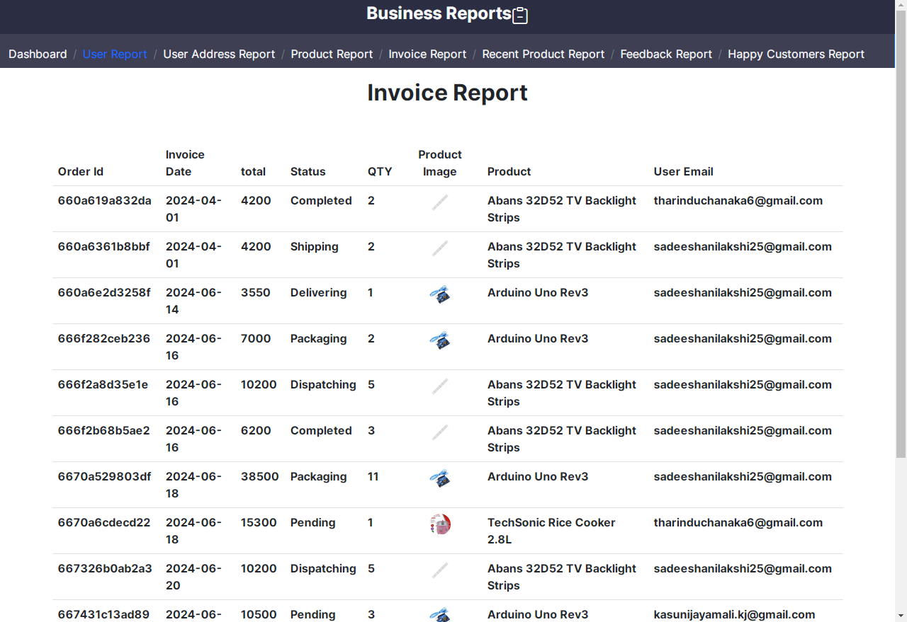

<!DOCTYPE html>

<html>

<?php

session_start();

require "../connection.php";

if (isset($_SESSION["aduser"])) {

$rs = Database::search("SELECT * FROM `invoice`

INNER JOIN `user` ON `invoice`.`user_email` = `user`.`email`

INNER JOIN `product` ON `invoice`.`product_id` = `product`.`id`

ORDER BY `invoice`.`id` ASC");

$num = $rs->num_rows;

?>

<head>

<meta charset="UTF-8">

<meta name="viewport" content="width=device-width, initial-scale=1.0">

<title>Business Reports | Chanaka Electronics</title>

<link rel="stylesheet" href="../bootstrap.css" />

<link rel="stylesheet" href="https://cdn.jsdelivr.net/npm/bootstrap-icons@1.9.1/font/bootstrap-icons.css" />

<link rel="stylesheet" href="../style.css" />

<link rel="icon" href="../resources/logo.png" />

</head>

<body class="body" style="background-size: 115%;">

<div class="container-fluid">

<div class="row">

<div class="col-12 text-center" style="background-color:black;">

<label class="form-label text-light title1 fs-3 fw-bold f3">Business Reports</label>&nbsp;

<i class="bi bi-clipboard-minus" style="color: white; font-size: 30px;"></i>

</div>

<div class="col-12 border-0 border-end border-1 border-primary" style="background-color:#2B2D42;">

<nav aria-label="breadcrumb" class="mt-2">

<ol class="breadcrumb">

<li class="breadcrumb-item f4" aria-current="page"><a href="../html/index.php" class="text-decoration-none text-light">Dashboard</a></li>

<li class="breadcrumb-item f4" aria-current="page"><a href="UserReports.php" class="text-decoration-none text-light">User Report</a></li>

<li class="breadcrumb-item f4" aria-current="page"><a href="userAdreessReport.php" class="text-decoration-none text-light">User Address Report</a></li>

<li class="breadcrumb-item f4" aria-current="page"><a href="ProductReport.php" class="text-decoration-none text-light">Product Report</a></li>

<li class="breadcrumb-item f4 active text-primary">Invoice Report</li>

<li class="breadcrumb-item f4" aria-current="page"><a href="RecentReports.php" class="text-decoration-none text-light">Recent Product Report</a></li>

<li class="breadcrumb-item f4" aria-current="page"><a href="feedbackReports.php" class="text-decoration-none text-light">Feedback Report</a></li>

<li class="breadcrumb-item f4" aria-current="page"><a href="HappycustomerReports.php" class="text-decoration-none text-light">Happy Customers Report</a></li>

</ol>

</nav>

</div>

<div class="container mt-3" id="printArea">

<h2 class="text-center fw-bold">Invoice Report</h2>

<table class="table table-hover mt-5 table-responsive">

<thead class="fw-bold">

<tr>

<th>Order Id</th>

<th>Invoice Date</th>

<th>total</th>

<th>Status</th>

<th>QTY</th>

<th class="text-center">Product Image</th>

<th>Product</th>

<th>User Email</th>

</tr>

</thead>

<tbody class="fw-bold">

<?php

for ($i = 0; $i < $num; $i++) {

$data = $rs->fetch_assoc();

$img_resultSet = Database::search("SELECT*FROM `image` WHERE `product_id`='" . $data["id"] . "';");

$imgdata = $img_resultSet->fetch_assoc(); ?>

<tr>

<td><?php echo $data["order_id"] ?></td>

<td><?php echo $data["date"] ?></td>

<td><?php echo $data["total"] ?></td>

<td>

<?php

if ($data["d_status"] == 0) {

echo ("Pending");

}else if ($data["d_status"] == 1) {

echo ("Packaging");

}else if ($data["d_status"] == 2) {

echo ("Dispatching");

}else if ($data["d_status"] == 3) {

echo ("Shipping");

}else if ($data["d_status"] == 4) {

echo ("Delivering");

}else if ($data["d_status"] == 5) {

echo ("Completed");

}else {

echo ("None"); }

?></td>

<td><?php echo $data["iqty"] ?></td>

<td class="text-center">

<?php

if (empty($imgdata["code"])) {

?>

<img src="../resources/user.png" height="30px">

</td>

<?php } else { ?>

<img src="../<?php echo $imgdata["code"]; ?>" height="30px" class="rounded-circle"></td>

<?php } ?>

<td><?php echo $data["title"] ?></td>

<td><?php echo $data["user_email"] ?></td>

</tr>

<?php } ?>

</tbody>

</table>

</div>

<div class="d-flex justify-content-end container mt-2">

<button class="btn btn-dark col-2" onclick="printDiv();"><i class="bi bi-printer-fill me-2"></i>Print Report</button>

</div>

<script src="../script.js"></script>

<script src="../bootstrap.bundle.js"></script>

</body>

</html>

<?php

} else {

header("location:html/index.php"); } ?>

1. Recent Product Report

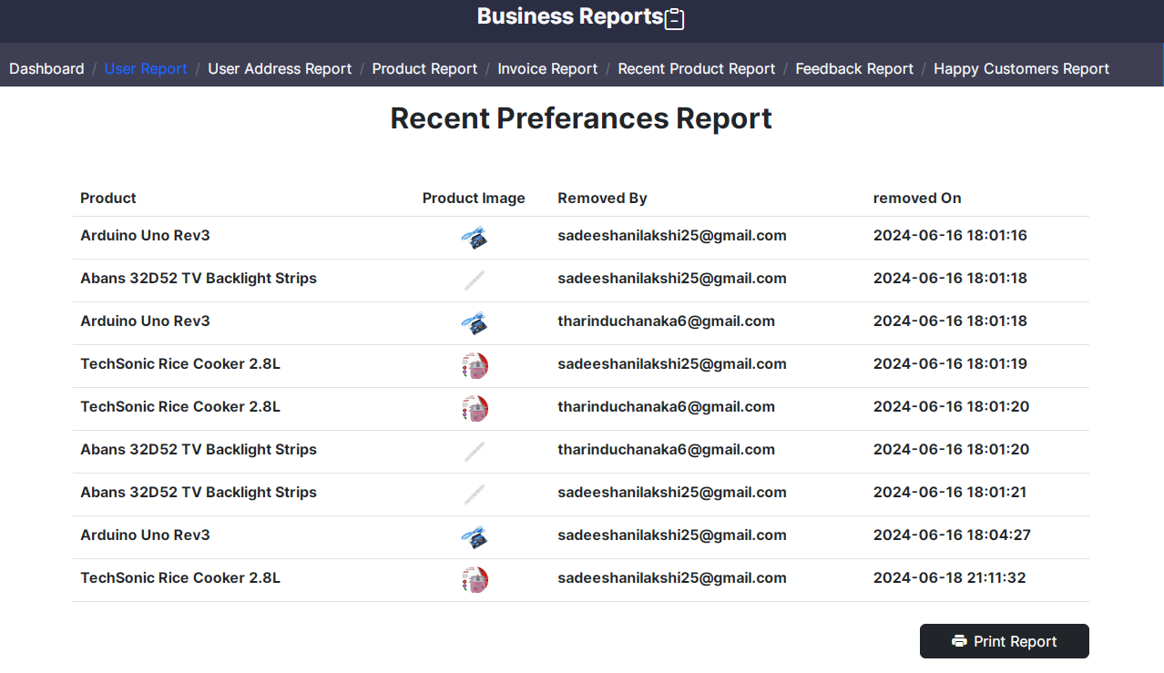

<!DOCTYPE html>

<html>

<?php

session_start();

require "../connection.php";

if (isset($_SESSION["aduser"])) {

$rs = Database::search("SELECT * FROM `recent`

INNER JOIN `user` ON `recent`.`user_email` = `user`.`email`

INNER JOIN `product` ON `recent`.`product_id` = `product`.`id`

ORDER BY `recent`.`removed` ASC");

$num = $rs->num_rows;

?>

<head>

<meta charset="UTF-8">

<meta name="viewport" content="width=device-width, initial-scale=1.0">

<title>Business Reports | Chanaka Electronics</title>

<link rel="stylesheet" href="../bootstrap.css" />

<link rel="stylesheet" href="https://cdn.jsdelivr.net/npm/bootstrap-icons@1.9.1/font/bootstrap-icons.css" />

<link rel="stylesheet" href="../style.css" />

<link rel="icon" href="../resources/logo.png" />

</head>

<body class="body" style="background-size: 115%;">

<div class="container-fluid">

<div class="row">

<div class="col-12 text-center" style="background-color:black;">

<label class="form-label text-light title1 fs-3 fw-bold f3">Business Reports</label>&nbsp;

<i class="bi bi-clipboard-minus" style="color: white; font-size: 30px;"></i>

</div>

<div class="col-12 border-0 border-end border-1 border-primary" style="background-color:#2B2D42;">

<nav aria-label="breadcrumb" class="mt-2">

<ol class="breadcrumb">

<li class="breadcrumb-item f4" aria-current="page"><a href="../html/index.php" class="text-decoration-none text-light">Dashboard</a></li>

<li class="breadcrumb-item f4" aria-current="page"><a href="UserReports.php" class="text-decoration-none text-light">User Report</a></li>

<li class="breadcrumb-item f4" aria-current="page"><a href="userAdreessReport.php" class="text-decoration-none text-light">User Address Report</a></li>

<li class="breadcrumb-item f4" aria-current="page"><a href="ProductReport.php" class="text-decoration-none text-light">Product Report</a></li>

<li class="breadcrumb-item f4" aria-current="page"><a href="invoiceReport.php" class="text-decoration-none text-light">Invoice Report</a></li>

<li class="breadcrumb-item f4 active text-primary">Recent Product Report</li>

<li class="breadcrumb-item f4" aria-current="page"><a href="feedbackReports.php" class="text-decoration-none text-light">Feedback Report</a></li>

<li class="breadcrumb-item f4" aria-current="page"><a href="HappycustomerReports.php" class="text-decoration-none text-light">Happy Customers Report</a></li>

</ol>

</nav>

</div>

<div class="container mt-3" id="printArea">

<h2 class="text-center fw-bold">Recent Preferances Report</h2>

<table class="table table-hover mt-5 table-responsive">

<thead class="fw-bold">

<tr>

<th>Product</th>

<th class="text-center">Product Image</th>

<th>Removed By</th>

<th>removed On</th>

</tr>

</thead>

<tbody class="fw-bold">

<?php

for ($i = 0; $i < $num; $i++) {

$data = $rs->fetch_assoc();

$img_resultSet = Database::search("SELECT*FROM `image` WHERE `product_id`='" . $data["id"] . "';");

$imgdata = $img_resultSet->fetch_assoc(); ?>

<tr>

<td><?php echo $data["title"] ?></td>

<td class="text-center">

<?php

if (empty($imgdata["code"])) {

?>

<img src="../resources/user.png" height="30px">

</td>

<?php } else { ?>

<img src="../<?php echo $imgdata["code"]; ?>" height="30px" class="rounded-circle"></td>

<?php } ?>

<td><?php echo $data["user_email"] ?></td>

<td><?php echo $data["removed"] ?></td>

</tr>

<?php } ?>

</tbody>

</table>

</div>

<div class="d-flex justify-content-end container mt-2">

<button class="btn btn-dark col-2" onclick="printDiv();"><i class="bi bi-printer-fill me-2"></i>Print Report</button>

</div>

<script src="../script.js"></script>

<script src="../bootstrap.bundle.js"></script>

</body>

</html>

<?php

} else {

header("location:html/index.php"); } ?>

1. Feedback Report

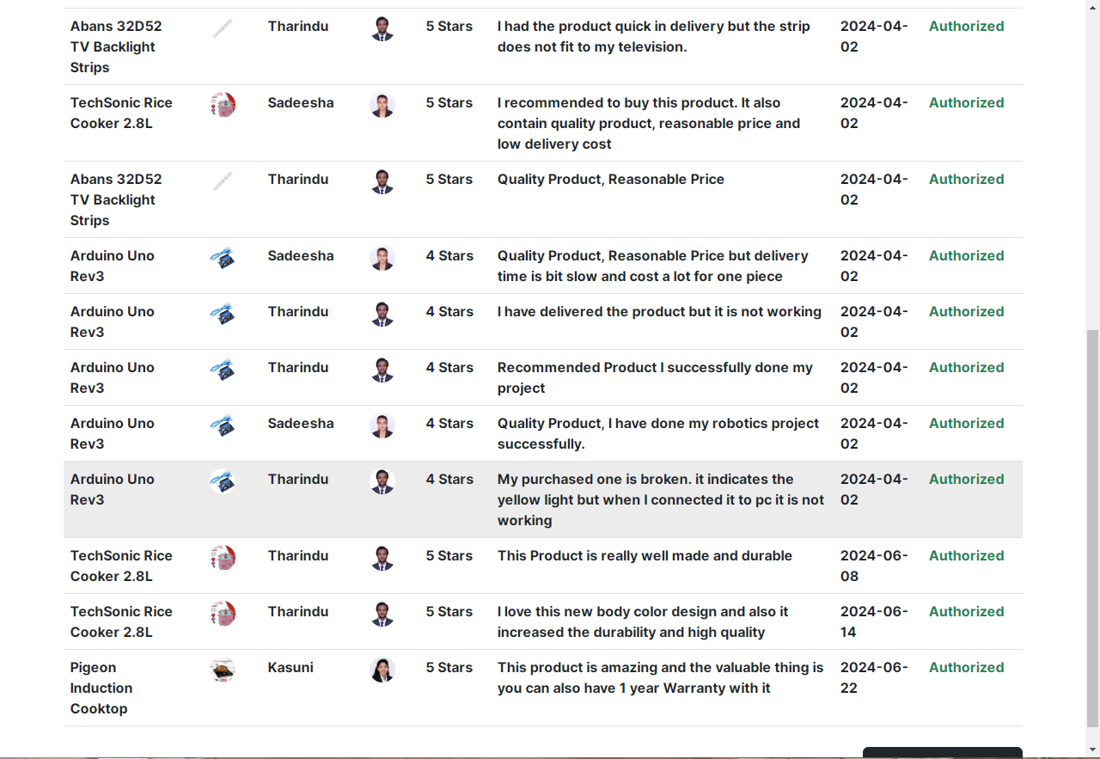

<!DOCTYPE html>

<html>

<?php

session_start();

require "../connection.php";

if (isset($_SESSION["aduser"])) {

$rs = Database::search("SELECT * FROM `feedback`

INNER JOIN `user` ON `feedback`.`user_email` = `user`.`email`

INNER JOIN `product` ON `feedback`.`product_id` = `product`.`id`

ORDER BY `feedback`.`date` ASC");

$num = $rs->num_rows;

?>

<head>

<meta charset="UTF-8">

<meta name="viewport" content="width=device-width, initial-scale=1.0">

<title>Business Reports | Chanaka Electronics</title>

<link rel="stylesheet" href="../bootstrap.css" />

<link rel="stylesheet" href="https://cdn.jsdelivr.net/npm/bootstrap-icons@1.9.1/font/bootstrap-icons.css" />

<link rel="stylesheet" href="../style.css" />

<link rel="icon" href="../resources/logo.png" />

</head>

<body class="body" style="background-size: 115%;">

<div class="container-fluid">

<div class="row">

<div class="col-12 text-center" style="background-color:black;">

<label class="form-label text-light title1 fs-3 fw-bold f3">Business Reports</label>&nbsp;

<i class="bi bi-clipboard-minus" style="color: white; font-size: 30px;"></i>

</div>

<div class="col-12 border-0 border-end border-1 border-primary" style="background-color:#2B2D42;">

<nav aria-label="breadcrumb" class="mt-2">

<ol class="breadcrumb">

<li class="breadcrumb-item f4" aria-current="page"><a href="../html/index.php" class="text-decoration-none text-light">Dashboard</a></li>

<li class="breadcrumb-item f4" aria-current="page"><a href="UserReports.php" class="text-decoration-none text-light">User Report</a></li>

<li class="breadcrumb-item f4" aria-current="page"><a href="userAdreessReport.php" class="text-decoration-none text-light">User Address Report</a></li>

<li class="breadcrumb-item f4" aria-current="page"><a href="ProductReport.php" class="text-decoration-none text-light">Product Report</a></li>

<li class="breadcrumb-item f4" aria-current="page"><a href="invoiceReport.php" class="text-decoration-none text-light">Invoice Report</a></li>

<li class="breadcrumb-item f4" aria-current="page"><a href="RecentReports.php" class="text-decoration-none text-light">Recent Product Report</a></li>

<li class="breadcrumb-item f4 active text-primary">Feedback Report</li>

<li class="breadcrumb-item f4" aria-current="page"><a href="HappycustomerReports.php" class="text-decoration-none text-light">Happy Customers Report</a></li>

</ol>

</nav>

</div>

<div class="container mt-3" id="printArea">

<h2 class="text-center fw-bold">Feedback Report</h2>

<table class="table table-hover mt-5 table-responsive">

<thead class="fw-bold">

<tr>

<th>Product Name</th>

<th class="text-center">Product Image</th>

<th>Reviewed By</th>

<th class="text-center">Profile Picture</th>

<th>Star Ratings</th>

<th>feedback</th>

<th>Reviewed Date</th>

<th>Authorized Status</th>

</tr>

</thead>

<tbody class="fw-bold">

<?php

for ($i = 0; $i < $num; $i++) {

$data = $rs->fetch_assoc();

$img_resultSet = Database::search("SELECT*FROM `image` WHERE `product_id`='" . $data["id"] . "';");

$imgdata = $img_resultSet->fetch_assoc();

$proimg_resultSet = Database::search("SELECT*FROM `profile_image` WHERE `user_email`='" . $data["email"] . "';");

$proimgdata = $proimg_resultSet->fetch_assoc();

$Rf_rs1 = Database::search("SELECT * FROM `feedback`WHERE `product_id`='" . $data["id"] . "' ORDER BY `date` DESC");

$Rf_num1 = $Rf_rs1->num_rows;

$Rf_data1 = $Rf_rs1->fetch_assoc();

?>

<tr>

<td><?php echo $data["title"] ?></td>

<td class="text-center">

<?php

if (empty($imgdata["code"])) {

?>

<img src="../resources/user.png" height="30px">

</td>

<?php } else { ?>

<img src="../<?php echo $imgdata["code"]; ?>" height="30px" class="rounded-circle"></td>

<?php } ?>

<td><?php echo $data["fname"]; ?></td>

<td class="text-center">

<?php

if (empty($proimgdata["path"])) {

?>

<img src="../resources/user.png" height="30px">

</td>

<?php } else { ?>

<img src="../<?php echo $proimgdata["path"]; ?>" height="30px" class="rounded-circle"></td>

<?php } ?>

<td>

<?php

if ($Rf_data1["type"] == 1) {

echo ("1 Stars");

} else if ($Rf_data1["type"] == 2) {

echo ("2 Stars");

} else if ($Rf_data1["type"] == 3) {

echo ("3 Stars");

} else if ($Rf_data1["type"] == 4) {

echo ("4 Stars");

} else if ($Rf_data1["type"] == 5) {

echo ("5 Stars");

} else {

echo ("None"); } ?>

</td>

<td><?php echo $data["feedback"] ?></td>

<td><?php echo $data["date"] ?></td>

<td>

<?php

if ($data["Feed_status"] == 2) {

?>

<span class="text-danger">

<?php

echo ("Unauthorized");

?>

</span>

<?php } else { ?>

<span class="text-success">

<?php

echo ("Authorized");

?>

</span>

<?php } ?>

</td>

</tr>

<?php } ?>

</tbody>

</table>

</div>

<div class="d-flex justify-content-end container mt-2">

<button class="btn btn-dark col-2" onclick="printDiv();"><i class="bi bi-printer-fill me-2"></i>Print Report</button>

</div>

<script src="../script.js"></script>

<script src="../bootstrap.bundle.js"></script>

</body>

</html>

<?php

} else {

header("location:html/index.php"); } ?>

1. Happy customers Report

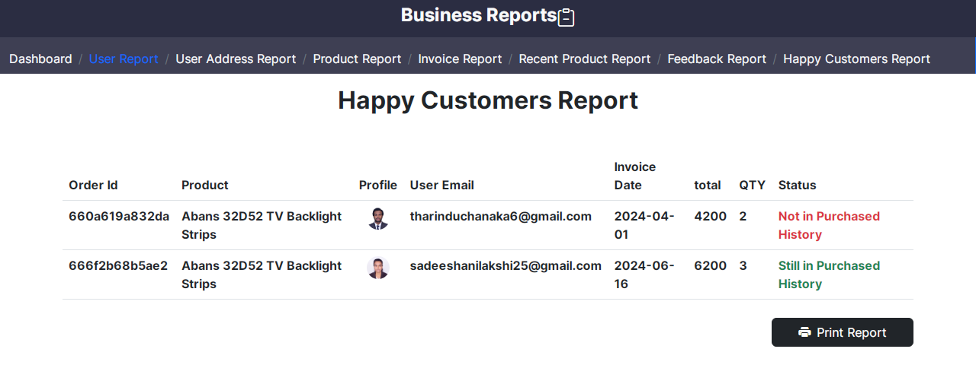

<!DOCTYPE html>

<html>

<?php

session_start();

require "../connection.php";

if (isset($_SESSION["aduser"])) {

$rs = Database::search("SELECT * FROM `invoice`

INNER JOIN `user` ON `invoice`.`user_email` = `user`.`email`

INNER JOIN `product` ON `invoice`.`product_id` = `product`.`id`

WHERE `invoice`.`d_status` = 5

ORDER BY `invoice`.`id` ASC");

$num = $rs->num_rows;

?>

<head>

<meta charset="UTF-8">

<meta name="viewport" content="width=device-width, initial-scale=1.0">

<title>Business Reports | Chanaka Electronics</title>

<link rel="stylesheet" href="../bootstrap.css" />

<link rel="stylesheet" href="https://cdn.jsdelivr.net/npm/bootstrap-icons@1.9.1/font/bootstrap-icons.css" />

<link rel="stylesheet" href="../style.css" />

<link rel="icon" href="../resources/logo.png" />

</head

<body class="body" style="background-size: 115%;">

<div class="container-fluid">

<div class="row">

<div class="col-12 text-center" style="background-color:black;">

<label class="form-label text-light title1 fs-3 fw-bold f3">Business Reports</label>&nbsp;

<i class="bi bi-clipboard-minus" style="color: white; font-size: 30px;"></i>

</div>

<div class="col-12 border-0 border-end border-1 border-primary" style="background-color:#2B2D42;">

<nav aria-label="breadcrumb" class="mt-2">

<ol class="breadcrumb">

<li class="breadcrumb-item f4" aria-current="page"><a href="../html/index.php" class="text-decoration-none text-light">Dashboard</a></li>

<li class="breadcrumb-item f4" aria-current="page"><a href="UserReports.php" class="text-decoration-none text-light">User Report</a></li>

<li class="breadcrumb-item f4" aria-current="page"><a href="userAdreessReport.php" class="text-decoration-none text-light">User Address Report</a></li>

<li class="breadcrumb-item f4" aria-current="page"><a href="ProductReport.php" class="text-decoration-none text-light">Product Report</a></li>

<li class="breadcrumb-item f4" aria-current="page"><a href="invoiceReport.php" class="text-decoration-none text-light">Invoice Report</a></li>

<li class="breadcrumb-item f4" aria-current="page"><a href="RecentReports.php" class="text-decoration-none text-light">Recent Product Report</a></li>

<li class="breadcrumb-item f4" aria-current="page"><a href="feedbackReports.php" class="text-decoration-none text-light">Feedback Report</a></li>

<li class="breadcrumb-item f4 active text-primary">Happy Customers Report</li>

</ol>

</nav>

</div>

<div class="container mt-3" id="printArea">

<h2 class="text-center fw-bold">Happy Customers Report</h2>

<table class="table table-hover mt-5 table-responsive">

<thead class="fw-bold">

<tr>

<th>Order Id</th>

<th>Product</th>

<th class="text-center">Profile</th>

<th>User Email</th>

<th>Invoice Date</th>

<th>total</th>

<th>QTY</th>

<th>Status</th>

</tr>

</thead>

<tbody class="fw-bold">

<?php

for ($i = 0; $i < $num; $i++) {

$data = $rs->fetch_assoc();

$proimg_resultSet = Database::search("SELECT*FROM `profile_image` WHERE `user_email`='" . $data["email"] . "';");

$proimgdata = $proimg_resultSet->fetch_assoc();

?>

<tr>

<td><?php echo $data["order_id"] ?></td>

<td><?php echo $data["title"] ?></td>

<td class="text-center">

<?php

if (empty($proimgdata["path"])) {

?>

<img src="../resources/user.png" height="30px">

</td>

<?php

} else {

?>

<img src="../<?php echo $proimgdata["path"]; ?>" height="30px" class="rounded-circle"></td>

<?php } ?>

<td><?php echo $data["user_email"] ?></td>

<td><?php echo $data["date"] ?></td>

<td><?php echo $data["total"] ?></td>

<td><?php echo $data["iqty"] ?></td>

<td>

<?php

if ($data["remove_status"] == 1) {

?>

<span class="text-success">

<?php

echo ("Still in Purchased History");

?>

</span>

<?php

} else {

?>

<span class="text-danger">

<?php

echo ("Not in Purchased History");

?>

</span>

<?php } ?>

</td>

</tr>

<?php } ?>

</tbody>

</table>

</div>

<div class="d-flex justify-content-end container mt-2">

<button class="btn btn-dark col-2" onclick="printDiv();"><i class="bi bi-printer-fill me-2"></i>Print Report</button>

</div>

<script src="../script.js"></script>

<script src="../bootstrap.bundle.js"></script>

</body>

</html>

<?php

} else {

header("location:html/index.php");

}

?>

1. Report Printing

function printDiv() {

var orginalContent = document.body.innerHTML;

var printArea = document.getElementById("printArea").innerHTML;

document.body.innerHTML = printArea;

window.print();

document.body.innerHTML = orginalContent;

}

request.open("POST", path, true);

request.send(fd);

1. Feedback Approving Process

<?php

require "connection.php";

if (isset($_GET["fid"])) {

$fid = $_GET["fid"];

Database::insUpdelete("UPDATE `feedback` SET `Feed_status`= '1' WHERE `feedback`.`feed_id`='" . $fid . "'");

echo ("Approved");

} else {

echo ("Something went wrong.");

}

1. User Blocking process

<?php

require "connection.php";

if(isset($_GET["email"])){

$user_email = $_GET["email"];

$user_rs = Database::search("SELECT * FROM `user` WHERE `email` = '".$user_email."' ");

$user_num = $user_rs -> num_rows;

if($user_num == 1){

$user_data = $user_rs -> fetch_assoc();

if($user_data ["status"] == 1){

Database::insUpdelete("UPDATE `user` SET `status` = '0' WHERE `email` = '".$user_email."'");

echo("Blocked");

}else if($user_data ["status"] == 0){

Database::insUpdelete("UPDATE `user` SET `status` = '1' WHERE `email` = '".$user_email."'");

echo("UnBlocked");

}

}else{

echo("Cannot find the user. Please try again later.");

}

}else{

echo("Something Went Wrong");

}

?>

1. Product Blocking process

<?php

require "connection.php"

if(isset($_GET["id"])){

$pid = $_GET["id"];

$product_rs = Database::search("SELECT * FROM `product` WHERE `id`='".$pid."'");

$product_num = $product_rs->num_rows;

if($product_num == 1){

$product_data = $product_rs->fetch_assoc();

if($product_data["status_id"] == 1){

Database::insUpdelete("UPDATE `product` SET `status_id`= '2' WHERE `id`='".$pid."'");

echo ("blocked");

}else if($product_data["status_id"] == 2){

Database::insUpdelete("UPDATE `product` SET `status_id`= '1' WHERE `id`='".$pid."'");

echo ("unblocked");

}

}else{

echo ("Cannot find the product. Please try again later.");

}

}else{

echo ("Something went wrong.");

}

?>

1. All Chart Page

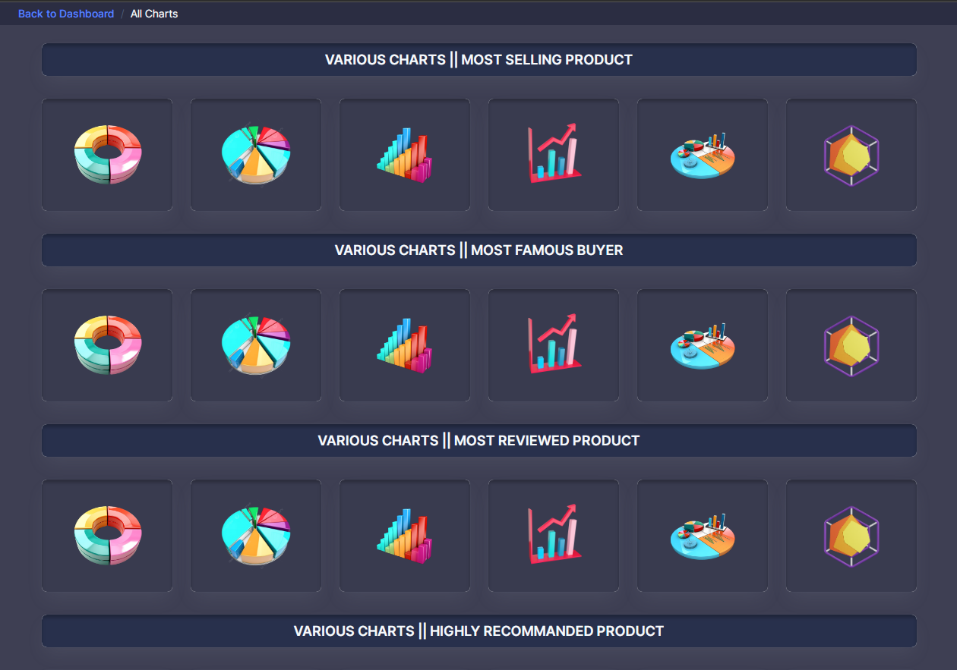

There you can analyze 5 differeent scenarios using different kind of charts

* Most Selling product
* Most famous Buyer
* Most Reviewed Product
* Rotation of star ratings
* Customer preferances

Using,

* Doughnut Charts
* Pie Charts
* Bar Charts
* Line Charts
* Polar area Charts
* Radar Chart

Inside documentation I just mentioned 5 scenarios with an one type of chart

<!doctype html>

<html lang="en">

<?php

session_start();

require "connection.php";

if (isset($_SESSION["aduser"])) {

?>

<head>

<meta charset="utf-8">

<meta name="viewport" content="width=device-width, initial-scale=1">

<title>Admin Panel | Chart Page</title>

<link rel="shortcut icon" type="image/png" href="../images/logos/logo.png" />

<link rel="stylesheet" href="../css/styles.min.css" />

<link href="https://fonts.googleapis.com/css?family=Montserrat:400,500,700" rel="stylesheet">

<link type="text/css" rel="stylesheet" href="css/bootstrap.min.css" />

<link type="text/css" rel="stylesheet" href="../css/slick.css" />

<link type="text/css" rel="stylesheet" href="../css/slick-theme.css" />

<link type="text/css" rel="stylesheet" href="../css/nouislider.min.css" />

<link rel="stylesheet" href="../style.css">

<!-- Icon Font Stylesheet -->

<link href="https://cdnjs.cloudflare.com/ajax/libs/font-awesome/5.10.0/css/all.min.css" rel="stylesheet">

<link href="https://cdn.jsdelivr.net/npm/bootstrap-icons@1.4.1/font/bootstrap-icons.css" rel="stylesheet">

</head>

<body class="overflow-x-hidden body3">

<div class="body-wrapper">

<!-- Header Start -->

<header class="app-header" style="background-color: black;">

<div class="col-12" style="background-color: black;">

<nav aria-label="breadcrumb">

<ol class="breadcrumb">

<li class="breadcrumb-item fw-bold"><a href="index.php">Back to Dashboard</a></li>

<li class="breadcrumb-item active text-light f4" aria-current="page">All Charts</li>

</ol>

</nav>

</div>

</header>

<!-- Header End -->

<div class="container-fluid">

<!-- Row 1 -->

<div class="col-12 align-content-lg-stretch">

<div class="card overflow-hidden">

<div class="card-body p-2 align-content-center justify-content-center text-center" style="background-color: rgba(40, 48, 76, 1);">

<span class="card-title mb-12 fw-semibold text-light fs-5">VARIOUS CHARTS || MOST SELLING PRODUCT</span>

</div>

</div></div>

<div class="row">

<div class="col-lg-2 col-4 align-items-lg-stretch">

<div class="card overflow-hidden">

<div class="card-body p-4" style="background-color: rgba(43, 45, 66, 0.93);">

<div class="row align-items-center">

<div class="col-12">

<div class="d-flex justify-content-center">

<img class="img-fluid rounded-circle mx-auto mb-0" src="../resources/doughnut.png" style="width: 100px; height: 100px;" title="Doughnut Chart" onclick='window.location = "../doughnet/MostSoldProduct.php"'>

</div>

</div></div>

</div></div>

</div>

<div class="col-lg-2 col-4 align-items-lg-stretch">

<div class="card overflow-hidden">

<div class="card-body p-4" style="background-color: rgba(43, 45, 66, 0.93);">

<div class="row align-items-center">

<div class="col-12">

<div class="d-flex justify-content-center">

<img class="img-fluid rounded-circle mx-auto mb-0" src="../resources/piechart.png" style="width: 100px; height: 100px;" title="Pie Chart" onclick='window.location = "../pie/MostSoldProduct.php"'>

</div> </div>

</div> </div> </div>

</div>

<div class="col-lg-2 col-4 align-items-lg-stretch">

<div class="card overflow-hidden">

<div class="card-body p-4" style="background-color: rgba(43, 45, 66, 0.93);">

<div class="row align-items-center">

<div class="col-12">

<div class="d-flex justify-content-center">

<img class="img-fluid rounded-circle mx-auto mb-0" src="../resources/barchart.png" style="width: 100px; height: 100px;" title="Bar Chart" onclick='window.location = "../bar/MostSoldProduct.php"'>

</div> </div>

</div> </div> </div>

</div>

<div class="col-lg-2 col-4 align-items-lg-stretch">

<div class="card overflow-hidden">

<div class="card-body p-4" style="background-color: rgba(43, 45, 66, 0.93);">

<div class="row align-items-center">

<div class="col-12">

<div class="d-flex justify-content-center">

<img class="img-fluid rounded-circle mx-auto mb-0" src="../resources/linechart.png" style="width: 100px; height: 100px;" title="Line Chart" onclick='window.location = "../line/MostSoldProduct.php"'>

</div>

</div> </div>

</div> </div>

</div>

<div class="col-lg-2 col-4 align-items-lg-stretch">

<div class="card overflow-hidden">

<div class="card-body p-4" style="background-color: rgba(43, 45, 66, 0.93);">

<div class="row align-items-center">

<div class="col-12">

<div class="d-flex justify-content-center">

<img class="img-fluid rounded-circle mx-auto mb-0" src="../resources/poler.png" style="width: 100px; height: 100px;" title="Poler Chart" onclick='window.location = "../polear/MostSoldProduct.php"'>

</div>

</div>

</div> </div>

</div> </div>

<div class="col-lg-2 col-4 align-items-lg-stretch">

<div class="card overflow-hidden">

<div class="card-body p-4" style="background-color: rgba(43, 45, 66, 0.93);">

<div class="row align-items-center">

<div class="col-12">

<div class="d-flex justify-content-center">

<img class="img-fluid rounded-circle mx-auto mb-0" src="../resources/radar-chart.webp" style="width: 100px; height: 100px;" title="Radar Chart" onclick='window.location = "../radar/MostSoldProduct.php"'>

</div>

</div> </div> </div>

</div> </div>

</div>

<div class="col-12 align-content-lg-stretch">

<div class="card overflow-hidden">

<div class="card-body p-2 align-content-center justify-content-center text-center" style="background-color: rgba(40, 48, 76, 1);">

<span class="mb-12 fw-semibold text-light fs-5">VARIOUS CHARTS || MOST FAMOUS BUYER</span>

</div> </div> </div>

<div class="col-12 align-content-lg-stretch">

<div class="card overflow-hidden">

<div class="card-body p-2 align-content-center justify-content-center text-center" style="background-color: rgba(40, 48, 76, 1);">

<span class="mb-12 fw-semibold text-light fs-5">VARIOUS CHARTS || MOST REVIEWED PRODUCT</span>

</div> </div>

</div>

<div class="col-12 align-content-lg-stretch">

<div class="card overflow-hidden">

<div class="card-body p-2 align-content-center justify-content-center text-center" style="background-color: rgba(40, 48, 76, 1);">

<span class="mb-12 fw-semibold text-light fs-5">VARIOUS CHARTS || HIGHLY RECOMMANDED PRODUCT</span>

</div> </div>

</div>

<div class="col-12 align-content-lg-stretch">

<div class="card overflow-hidden">

<div class="card-body p-2 align-content-center justify-content-center text-center" style="background-color: rgba(40, 48, 76, 1);">

<span class="mb-12 fw-semibold text-light fs-5">VARIOUS CHARTS || HIGHLY RECOMMANDED PRODUCT</span>

</div> </div>

</div>

<div class="col-12 align-content-lg-stretch">

<div class="card overflow-hidden">

<div class="card-body p-2 align-content-center justify-content-center text-center" style="background-color: rgba(40, 48, 76, 1);">

<span class="mb-12 fw-semibold text-light fs-5">VARIOUS CHARTS || CUSTOMER PREFERANCES</span>

</div></div>

</div>

<div class="row">

<div class="col-lg-2 col-4 align-items-lg-stretch">

<div class="card overflow-hidden">

<div class="card-body p-4" style="background-color: rgba(43, 45, 66, 0.93);">

<div class="row align-items-center">

<div class="col-12">

<div class="d-flex justify-content-center">

<img class="img-fluid rounded-circle mx-auto mb-0" src="../resources/doughnut.png" style="width: 100px; height: 100px;" title="Doughnut Chart" onclick='window.location = "../doughnet/mostWishlist.php"'>

</div> </div>

</div> </div>

</div>

</div>

<div class="col-lg-2 col-4 align-items-lg-stretch">

<div class="card overflow-hidden">

<div class="card-body p-4" style="background-color: rgba(43, 45, 66, 0.93);">

<div class="row align-items-center">

<div class="col-12">

<div class="d-flex justify-content-center">

<img class="img-fluid rounded-circle mx-auto mb-0" src="../resources/piechart.png" style="width: 100px; height: 100px;" title="Pie Chart" onclick='window.location = "../pie/mostWishlist.php"'>

</div> </div>

</div> </div>

</div>

</div>

<div class="col-lg-2 col-4 align-items-lg-stretch">

<div class="card overflow-hidden">

<div class="card-body p-4" style="background-color: rgba(43, 45, 66, 0.93);">

<div class="row align-items-center">

<div class="col-12">

<div class="d-flex justify-content-center">

<img class="img-fluid rounded-circle mx-auto mb-0" src="../resources/barchart.png" style="width: 100px; height: 100px;" title="Bar Chart" onclick='window.location = "../bar/mostWishlist.php"'>

</div> </div> </div>

</div></div>

</div>

<div class="col-lg-2 col-4 align-items-lg-stretch">

<div class="card overflow-hidden">

<div class="card-body p-4" style="background-color: rgba(43, 45, 66, 0.93);">

<div class="row align-items-center">

<div class="col-12">

<div class="d-flex justify-content-center">

<img class="img-fluid rounded-circle mx-auto mb-0" src="../resources/linechart.png" style="width: 100px; height: 100px;" title="Line Chart" onclick='window.location = "../line/mostWishlist.php"'>

</div> </div> </div>

</div></div>

</div>

<div class="col-lg-2 col-4 align-items-lg-stretch">

<div class="card overflow-hidden">

<div class="card-body p-4" style="background-color: rgba(43, 45, 66, 0.93);">

<div class="row align-items-center">

<div class="col-12">

<div class="d-flex justify-content-center">

<img class="img-fluid rounded-circle mx-auto mb-0" src="../resources/poler.png" style="width: 100px; height: 100px;" title="Poler Chart" onclick='window.location = "../polear/mostWishlist.php"'>

</div>

</div> </div> </div>

</div></div>

<div class="col-lg-2 col-4 align-items-lg-stretch">

<div class="card overflow-hidden">

<div class="card-body p-4" style="background-color: rgba(43, 45, 66, 0.93);">

<div class="row align-items-center">

<div class="col-12">

<div class="d-flex justify-content-center">

<img class="img-fluid rounded-circle mx-auto mb-0" src="../resources/radar-chart.webp" style="width: 100px; height: 100px;" title="Radar Chart"onclick='window.location = "../radar/mostWishlist.php"'>

</div> </div> </div> </div> </div> </div>

</div>

</div>

</div>

<script src="https://cdn.jsdelivr.net/npm/chart.js"></script>

<script src="../libs/jquery/dist/jquery.min.js"></script>

<script src="../libs/bootstrap/dist/js/bootstrap.bundle.min.js"></script>

<script src="../js/sidebarmenu.js"></script>

<script src="../js/app.min.js"></script>

<script src="../libs/apexcharts/dist/apexcharts.min.js"></script>

<script src="../libs/simplebar/dist/simplebar.js"></script>

<script src="../js/dashboard.js"></script>

</body>

</html>

<?php

} else {

header("location:html/index.php");

}

?>

1. Admin Dashboard JavaScript function

$(function () {

// Admin Panel settings

//****************************

/* This is for the mini-sidebar if width is less then 1170*/

//****************************

var setsidebartype = function () {

var width =

window.innerWidth > 0 ? window.innerWidth : this.screen.width;

if (width < 1199) {

$("#main-wrapper").attr("data-sidebartype", "mini-sidebar");

$("#main-wrapper").addClass("mini-sidebar");

} else {

$("#main-wrapper").attr("data-sidebartype", "full");

$("#main-wrapper").removeClass("mini-sidebar");

}

};

$(window).ready(setsidebartype);

$(window).on("resize", setsidebartype);

$(".sidebartoggler").on("click", function () {

$("#main-wrapper").toggleClass("mini-sidebar");

if ($("#main-wrapper").hasClass("mini-sidebar")) {

$(".sidebartoggler").prop("checked", !0);

$("#main-wrapper").attr("data-sidebartype", "mini-sidebar");

} else {

$(".sidebartoggler").prop("checked", !1);

$("#main-wrapper").attr("data-sidebartype", "full");

}

});

$(".sidebartoggler").on("click", function () {

$("#main-wrapper").toggleClass("show-sidebar");

});

})

function approve(fid) {

var request = new XMLHttpRequest();

request.onreadystatechange = function() {

if (request.readyState == 4) {

var txt = request.responseText;

if (txt == "Approved") {

window.location.reload();

document.getElementById("UB" + fid).innerHTML = '<img src="../images/backgrounds/check-mark-transparent-gif-13.png" width="40">';

} else {

alert(txt); } }

};

request.open("GET", "approveprocess.php?fid=" + fid, true);

request.send();

}

function blockProduct(id) {

var request = new XMLHttpRequest();

request.onreadystatechange = function () {

if (request.readyState == 4) {

var txt = request.responseText;

if (txt == "unblocked") {

document.getElementById("pb" + id).innerHTML = '<img src="../images/backgrounds/check-mark-transparent-gif-13.png" width="40">';

} else if (txt == "blocked") {

document.getElementById("pb" + id).innerHTML = '<img src="../images/backgrounds/uncheck-mark-transparent-gif-13.png" width="40">';

} else {

alert(txt); } }

}

request.open("GET", "productBlockProcess.php?id=" + id, true);

request.send();

}

function blockUser(email) {

var req = new XMLHttpRequest();

req.onreadystatechange = function () {

if (req.readyState == 4) {

var txt = req.responseText;

if (txt == "Blocked") {

document.getElementById("UB" + email).innerHTML = '<img src="../images/backgrounds/check-mark-transparent-gif-13.png" width="40">';

} else if (txt == "UnBlocked") {

document.getElementById("UB" + email).innerHTML = '<img src="../images/backgrounds/uncheck-mark-transparent-gif-13.png" width="40">';

} else {

alert(txt); } }

}

req.open("GET", "UserBlockProcess.php?email=" + email, true);

req.send();

}

1. Selling History UI & advance processes associated with it

**Selling History User Interfaces**

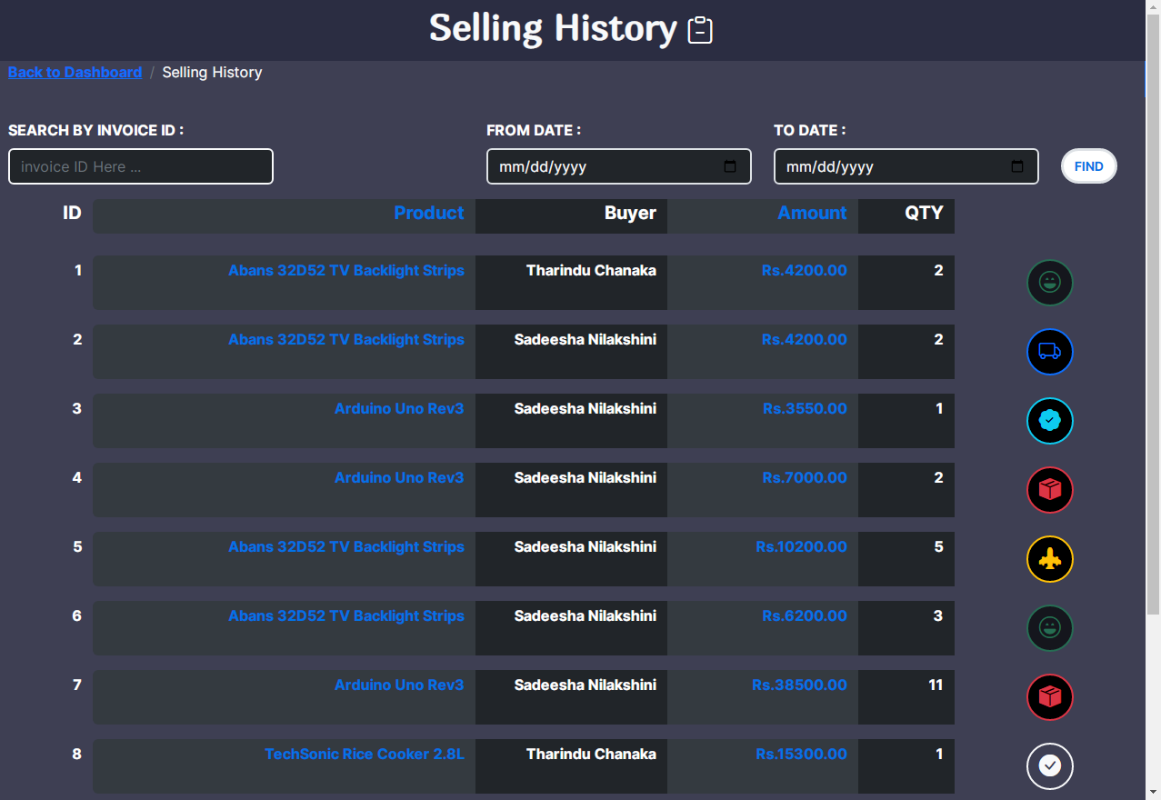

<!DOCTYPE html>

<html>

<?php

session_start();

require "connection.php";

if (isset($_SESSION["aduser"]))

$email = $_SESSION["aduser"]["email"];

$pageno;

?>

<head>

<meta charset="UTF-8">

<meta name="viewport" content="width=device-width, initial-scale=1.0">

<title>Selling History | Chanaka Electronics</title>

<link rel="stylesheet" href="bootstrap.css" />

<link rel="stylesheet" href="https://cdn.jsdelivr.net/npm/bootstrap-icons@1.9.1/font/bootstrap-icons.css" />

<link rel="stylesheet" href="style.css" />

<link rel="icon" href="resources/logo.png" />

</head>

<body class="body" style="background-size: 115%; background-color: rgba(43, 45, 66, 0.91);">

<div class="container-fluid">

<div class="row">

<div class="col-12 text-center" style="background-color:#2B2D42;">

<label class="form-label text-light title1 fs-1 fw-bold f3">Selling History</label>&nbsp;

<i class="bi bi-clipboard-minus" style="color: white; font-size: 30px;"></i>

</div>

<div class="col-12 border-0 border-end border-1 border-primary">

<nav aria-label="breadcrumb">

<ol class="breadcrumb">

<li class="breadcrumb-item fw-bold f4"><a href="html/index.php">Back to Dashboard</a></li>

<li class="breadcrumb-item active text-light f4" aria-current="page">Selling History</li>

</ol>

</nav>

</div>

<div class="col-12 main-body mt-3 mb-3">

<div class="row">

<div class="col-12 col-lg-3 mt-2">

<label class="form-label fs-6 text-white fw-bold text-uppercase">Search By invoice ID :</label>

<input type="text" class="form-control border border-2 border-light bg-dark text-light fs-6" placeholder="invoice ID Here ..." id="searchtxt" onkeyup="searchInvoiceID();" />

</div>

<div class="col-12 col-lg-3 offset-lg-2 mt-2">

<label class="form-label text-white fw-bold text-uppercase fs-6">From Date :

</label>

<input type="date" class="form-control fs-6 text-light bg-dark border border-2" id="from" />

</div>

<div class="col-12 col-lg-3 mt-2">

<label class="form-label text-white fw-bold text-uppercase fs-6">To Date :

</label>

<input type="date" class="form-control fs-6 text-light bg-dark border border-2" id="to" />

</div>

<div class="col-12 col-lg-1" style="margin-top: 40px;">

<button class="btn bg-white border border-3 text-uppercase fw-bold rounded-5" style="color: #0073e6; font-size: 14px; border-color: #0073e6;" onclick="findSellings();">Find

</button>

</div>

</div>

</div>

<div class="col-12">

<div class="row align-items-center"

<div class="col-2 col-md-1 col-lg-1 bg-transparent text-md-end text-center">

<label class="form-label fs-5 fw-bold text-white">ID</label>

</div>

<div class="col-3 col-md-4 col-lg-4 text-md-end text-center rounded-start" style="background-color: #343a40;">

<label class="form-label fs-5 fw-bold" style="color:#0073e6;">Product</label>

</div>

<div class="col-3 col-lg-2 d-none d-lg-block bg-dark text-end">

<label class="form-label fs-5 fw-bold text-white">Buyer</label>

</div>

<div class="col-3 col-md-3 col-lg-2 text-md-end text-center" style="background-color: #343a40;">

<label class="form-label fs-5 fw-bold" style="color:#0073e6;">Amount</label>

</div>

<div class="col-2 col-md-2 col-lg-1 bg-dark text-md-end text-center">

<label class="form-label fs-5 fw-bold text-white">QTY</label>

</div>

<div class="col-lg-1 col-3 d-none d-md-block bg-transparent"></div>

</div>

</div>

<div class="col-12 mt-2 " id="viewarea">

<?php

$query = "SELECT * FROM `invoice`";

$pageno;

if (isset($_GET["page"])) {

$pageno = $_GET["page"];

} else {

$pageno = 1; }

$results_per_page = 10;

$page_results = ($pageno - 1) * $results_per_page;

$product_rs = Database::search($query . " LIMIT " . $results_per_page . " OFFSET " . $page_results . "");

$product_num = $product_rs->num_rows;

$number_of_pages = ceil($product_num / $results_per_page);

for ($x = 0; $x < $product_num; $x++) {

$product_data = $product_rs->fetch_assoc();

$title_rs = Database::search("SELECT * FROM `product` WHERE `id` = '" . $product_data["product_id"] . "'");

$title_data = $title_rs->fetch_assoc();

$customer_rs = Database::search("SELECT * FROM `user` WHERE `email` = '" . $product_data["user_email"] . "'");

$customer_data = $customer_rs->fetch_assoc();

$customer = $customer_data["fname"] . " " . $customer_data["lname"];

?>

<div class="row mt-3 mb-3">

<div class="col-2 col-md-1 col-lg-1 text-md-end text-center">

<label class="form-label fs-6 fw-bold text-white mt-1 mb-1"><?php echo $product_data["id"]; ?></label></div>

<div class="col-3 col-md-4 col-lg-4 text-md-end text-center rounded-start" style="background-color: #343a40;">

<label class="form-label fs-6 fw-bold mt-1 mb-1" style="color:#0073e6;"><?php echo $title_data["title"]; ?></label></div>

<div class="col-3 col-lg-2 d-none d-lg-block bg-dark text-end">

<label class="form-label fs-6 fw-bold text-white mt-1 mb-1"><?php echo $customer; ?></label></div>

<div class="col-3 col-md-3 col-lg-2 text-md-end text-center" style="background-color: #343a40;">

<label class="form-label fs-6 fw-bold mt-1 mb-1" style="color:#0073e6;">Rs.<?php echo $product_data["total"]; ?>.00</label></div>

<div class="col-2 col-md-2 col-lg-1 text-md-end text-center bg-dark">

<label class="form-label fs-6 fw-bold text-white mt-1 mb-1"><?php echo $product_data["iqty"]; ?></label></div>

<div class="col-1 col-md-2 col-lg-2 text-center">

<?php if ($product_data["d_status"] == 0) { ?>

<button class="btn border border-2 border-light fw-bold mt-1 mb-1 text-uppercase fs-4 rounded-circle" title="Pending Confirmation" id="btn<?php echo $product_data["id"]; ?>" onclick="changeInvStatus('<?php echo $product_data['id']; ?>');">

<i class="bi bi-check-circle-fill text-light fs-4"></i></button>

<?php } else if ($product_data["d_status"] == 1) { ?>

<button class="btn bg-black border border-2 border-danger fw-bold mt-1 mb-1 text-uppercase fs-4 rounded-circle" title="Packaging" id="btn<?php echo $product_data["id"]; ?>" onclick="changeInvStatus('<?php echo $product_data['id']; ?>');">

<i class="bi bi-box-seam-fill text-danger fs-4"></i></button>

<?php } else if ($product_data["d_status"] == 2) { ?>

<button class="btn bg-black border border-2 border-warning fw-bold mt-1 mb-1 text-uppercase fs-4 rounded-circle" title="Dispatching" id="btn<?php echo $product_data["id"]; ?>" onclick="changeInvStatus('<?php echo $product_data['id']; ?>');">

<i class="bi bi-airplane-engines-fill text-warning fs-4"></i>

</button>

<?php } else if ($product_data["d_status"] == 3) { ?>

<button class="btn bg-black border border-2 border-primary fw-bold mt-1 mb-1 text-uppercase fs-4 rounded-circle" title="Shipping Status" id="btn<?php echo $product_data["id"]; ?>" onclick="changeInvStatus('<?php echo $product_data['id']; ?>');">

<i class="bi bi-truck text-primary fs-4"></i>

</button>

<?php } else if ($product_data["d_status"] == 4) { ?>

<button class="btn bg-black border border-2 border-info fw-bold mt-1 mb-1 text-uppercase fs-4 rounded-circle" title="Delivering" id="btn<?php echo $product_data["id"]; ?>" onclick="changeInvStatus('<?php echo $product_data['id']; ?>');">

<i class="bi bi-patch-check-fill text-info fs-4"></i>

</button>

<?php } else if ($product_data["d_status"] == 5) { ?>

<button class="btn bg-black border border-2 border-success fw-bold mt-1 mb-1 text-uppercase fs-4 rounded-circle disabled" title="Completed" id="btn<?php echo $product_data["id"]; ?>" onclick="changeInvStatus('<?php echo $product_data['id']; ?>');">

<i class="bi bi-emoji-laughing text-success fs-4"></i>

</button>

<?php } ?>

</div></div>

<?php } ?>

</div>

<div class="offset-2 offset-lg-3 col-8 col-lg-6 text-center mt-3">

<nav aria-label="Page navigation example">

<ul class="pagination pagination-lg justify-content-center">

<li class="page-item">

<a class="page-link fw-bold" href="<?php if ($pageno <= 1) {

echo ("#");

} else {

echo "?page=" . ($pageno - 1);

} ?>" aria-label="Previous">

<span aria-hidden="true">&laquo;</span>

</a></li>

<?php

for ($x = 1; $x <= $number_of_pages; $x++) {

if ($x == $pageno) { ?>

<li class="page-item active">

<a class="page-link fw-bold" href="<?php echo "?page=" . ($x) ?>"><?php echo $x; ?></a>

</li>

<?php } else { ?>

<li class="page-item">

<a class="page-link fw-bold" href="<?php echo "?page=" . ($x) ?>"><?php echo $x; ?></a>

</li>

<?php } } ?>

<li class="page-item">

<a class="page-link fw-bold" href="<?php if ($pageno >= $number_of_pages) {

echo ("#");

} else {

echo "?page=" . ($pageno + 1);

} ?>" aria-label="Next">

<span aria-hidden="true">&raquo;</span>

</a></li>

</ul>

</nav></div>

</div></div>

<script src="script.js"></script>

<script src="bootstrap.bundle.js"></script>

</body>

</html>

<?php

} else {

header("location:html/index.php"); } ?>

**Search Invoice ID process**

<?php

require "connection.php";

if (isset($_GET["id"])) {

$invoice_id = $_GET["id"];

$invoice_rs = Database::search("SELECT * FROM `invoice` WHERE `id` = '" . $invoice_id . "'");

$invoice_num = $invoice_rs->num_rows;

if ($invoice_num == 1) {

$invoice_data = $invoice_rs->fetch_assoc();

$title_rs = Database::search("SELECT * FROM `product` WHERE `id` = '" . $invoice_data["product_id"] . "'");

$title_data = $title_rs->fetch_assoc();

$customer_rs = Database::search("SELECT * FROM `user` WHERE `email` = '" . $invoice_data["user_email"] . "'");

$customer_data = $customer_rs->fetch_assoc();

$customer = $customer_data["fname"] . " " . $customer_data["lname"];

?>

<div class="row mt-3 mb-3">

<div class="col-2 col-md-1 col-lg-1 text-md-end text-center">

<label class="form-label fs-6 fw-bold text-white mt-1 mb-1"><?php echo $invoice_data["id"]; ?></label></div>

<div class="col-3 col-md-4 col-lg-4 text-md-end text-center rounded-start" style="background-color: #343a40;">

<label class="form-label fs-6 fw-bold mt-1 mb-1" style="color:#0073e6;"><?php echo $title_data["title"]; ?></label></div>

<div class="col-3 col-lg-2 d-none d-lg-block bg-dark text-end">

<label class="form-label fs-6 fw-bold text-white mt-1 mb-1"><?php echo $customer; ?></label></div>

<div class="col-3 col-md-3 col-lg-2 text-md-end text-center" style="background-color: #343a40;">

<label class="form-label fs-6 fw-bold mt-1 mb-1" style="color:#0073e6;">Rs.<?php echo $invoice_data["total"]; ?>.00</label></div>

<div class="col-2 col-md-2 col-lg-1 text-md-end text-center bg-dark">

<label class="form-label fs-6 fw-bold text-white mt-1 mb-1"><?php echo $invoice_data["iqty"]; ?></label></div>

<div class="col-lg-2 col-3 bg-transparent">

<?php

if ($invoice_data["d_status"] == 0) {?>

<button class="btn bg-black border border-2 border-light fw-bold mt-1 mb-1 text-uppercase fs-4 rounded-circle" title="Pending Confirmation" id="btn<?php echo $invoice_data["id"]; ?>" onclick="changeInvStatus('<?php echo $invoice_data['id']; ?>');"><i class="bi bi-check-circle-fill text-light fs-4"></i>

</button>

<?php

} else if ($invoice_data["d_status"] == 1) {?>

<button class="btn bg-black border border-2 border-danger fw-bold mt-1 mb-1 text-uppercase fs-4 rounded-circle" title="Packaging" id="btn<?php echo $invoice_data["id"]; ?>" onclick="changeInvStatus('<?php echo $invoice_data['id']; ?>');"><i class="bi bi-box-seam-fill text-danger fs-4"></i>

</button>

<?php

} else if ($invoice_data["d_status"] == 2) {?>

<button class="btn bg-black border border-2 border-warning fw-bold mt-1 mb-1 text-uppercase fs-4 rounded-circle" title="Dispatching" id="btn<?php echo $invoice_data["id"]; ?>" onclick="changeInvStatus('<?php echo $invoice_data['id']; ?>');"><i class="bi bi-airplane-engines-fill text-warning fs-4"></i>

</button>

<?php

} else if ($invoice_data["d_status"] == 3) {?>

<button class="btn bg-black border border-2 border-primary fw-bold mt-1 mb-1 text-uppercase fs-4 rounded-circle" title="Shipping Status" id="btn<?php echo $invoice_data["id"]; ?>" onclick="changeInvStatus('<?php echo $invoice_data['id']; ?>');"><i class="bi bi-truck text-primary fs-4"></i>

</button>

<?php

} else if ($invoice_data["d_status"] == 4) {?>

<button class="btn bg-black border border-2 border-info fw-bold mt-1 mb-1 text-uppercase fs-4 rounded-circle" title="Delivering" id="btn<?php echo $invoice_data["id"]; ?>" onclick="changeInvStatus('<?php echo $invoice_data['id']; ?>');"><i class="bi bi-patch-check-fill text-info fs-4"></i>

</button>

<?php

} else if ($invoice_data["d_status"] == 5) {?>

<button class="btn bg-black border border-2 border-success fw-bold mt-1 mb-1 text-uppercase fs-4 rounded-circle disabled" title="Completed" id="btn<?php echo $invoice_data["id"]; ?>" onclick="changeInvStatus('<?php echo $invoice_data['id']; ?>');"><i class="bi bi-emoji-laughing text-success fs-4"></i>

</button>

<?php } ?>

</div></div>

<?php

} else {

echo ("invalid Invoice ID"); } } ?>

**Find Selling process**

<?php

require "connection.php";

if (isset($_GET["f"]) && isset($_GET["t"])) {

$from = $_GET["f"];

$to = $_GET["t"];

$invoice_rs = Database::search("SELECT * FROM `invoice`");

$invoice_num = $invoice_rs->num_rows;

for ($x = 0; $x < $invoice_num; $x++) {

$invoice_data = $invoice_rs->fetch_assoc();

$sold_date = $invoice_data["date"];

$date = explode(" ", $sold_date);

$d = $date[0];

// $t = $date[1];

$title_rs = Database::search("SELECT * FROM `product` WHERE `id` = '" . $invoice_data["product_id"] . "'");

$title_data = $title_rs->fetch_assoc();

$customer_rs = Database::search("SELECT * FROM `user` WHERE `email` = '" . $invoice_data["user_email"] . "'");

$customer_data = $customer_rs->fetch_assoc();

$customer = $customer_data["fname"] . " " . $customer_data["lname"];

if (!empty($from) && empty($to)) {

if ($from <= $d) {

?>

<div class="row mt-3 mb-3">

<div class="col-2 col-md-1 col-lg-1 text-md-end text-center">

<label class="form-label fs-6 fw-bold text-white mt-1 mb-1"><?php echo $invoice_data["id"]; ?></label></div>

<div class="col-3 col-md-4 col-lg-4 text-md-end text-center rounded-start" style="background-color: #343a40;">

<label class="form-label fs-6 fw-bold mt-1 mb-1" style="color:#0073e6;"><?php echo $title_data["title"]; ?></label></div>

<div class="col-3 col-lg-2 d-none d-lg-block bg-dark text-end">

<label class="form-label fs-6 fw-bold text-white mt-1 mb-1"><?php echo $customer; ?></label></div>

<div class="col-3 col-md-3 col-lg-2 text-md-end text-center" style="background-color: #343a40;">

<label class="form-label fs-6 fw-bold mt-1 mb-1" style="color:#0073e6;">Rs.<?php echo $invoice_data["total"]; ?>.00</label></div>

<div class="col-2 col-md-2 col-lg-1 text-md-end text-center bg-dark">

<label class="form-label fs-6 fw-bold text-white mt-1 mb-1"><?php echo $invoice_data["iqty"]; ?></label></div>

<div class="col-lg-2 col-3 bg-transparent">

<?php

if ($invoice_data["d_status"] == 0) {

?>

<button class="btn bg-black border border-2 border-light fw-bold mt-1 mb-1 text-uppercase fs-4 rounded-circle" title="Pending Confirmation" id="btn<?php echo $invoice_data["id"]; ?>" onclick="changeStatus('<?php echo $invoice_data['id']; ?>');"><i class="bi bi-check-circle-fill text-light fs-4"></i>

</button>

<?php

} else if ($invoice_data["d_status"] == 1) {

?>

<button class="btn bg-black border border-2 border-danger fw-bold mt-1 mb-1 text-uppercase fs-4 rounded-circle" title="Packaging" id="btn<?php echo $invoice_data["id"]; ?>" onclick="changeStatus('<?php echo $invoice_data['id']; ?>');"><i class="bi bi-box-seam-fill text-danger fs-4"></i>

</button>

<?php

} else if ($invoice_data["d_status"] == 2) {

?>

<button class="btn bg-black border border-2 border-warning fw-bold mt-1 mb-1 text-uppercase fs-4 rounded-circle" title="Dispatching" id="btn<?php echo $invoice_data["id"]; ?>" onclick="changeStatus('<?php echo $invoice_data['id']; ?>');"><i class="bi bi-airplane-engines-fill text-warning fs-4"></i>

</button>

<?php

} else if ($invoice_data["d_status"] == 3) {

?>

<button class="btn bg-black border border-2 border-primary fw-bold mt-1 mb-1 text-uppercase fs-4 rounded-circle" title="Shipping Status" id="btn<?php echo $invoice_data["id"]; ?>" onclick="changeStatus('<?php echo $invoice_data['id']; ?>');"><i class="bi bi-truck text-primary fs-4"></i>

</button>

<?php

} else if ($invoice_data["d_status"] == 4) {

?>

<button class="btn bg-black border border-2 border-info fw-bold mt-1 mb-1 text-uppercase fs-4 rounded-circle" title="Delivering" id="btn<?php echo $invoice_data["id"]; ?>" onclick="changeStatus('<?php echo $invoice_data['id']; ?>');"><i class="bi bi-patch-check-fill text-info fs-4"></i>

</button>

<?php

} else if ($invoice_data["d_status"] == 5) {

?>

<button class="btn bg-black border border-2 border-success fw-bold mt-1 mb-1 text-uppercase fs-4 rounded-circle disabled" title="Completed" id="btn<?php echo $invoice_data["id"]; ?>" onclick="changeStatus('<?php echo $invoice_data['id']; ?>');"><i class="bi bi-emoji-laughing text-success fs-4"></i>

</button>

<?php } ?>

</div></div>

<?php }

} else if (empty($from) && !empty($to)) {

if ($to >= $d) {

?>

<div class="row mt-3 mb-3">

<div class="col-2 col-md-1 col-lg-1 text-md-end text-center">

<label class="form-label fs-6 fw-bold text-white mt-1 mb-1"><?php echo $invoice_data["id"]; ?></label>

</div>

<div class="col-3 col-md-4 col-lg-4 text-md-end text-center rounded-start" style="background-color: #343a40;">

<label class="form-label fs-6 fw-bold mt-1 mb-1" style="color:#0073e6;"><?php echo $title_data["title"]; ?></label>

</div>

<div class="col-3 col-lg-2 d-none d-lg-block bg-dark text-end">

<label class="form-label fs-6 fw-bold text-white mt-1 mb-1"><?php echo $customer; ?></label>

</div>

<div class="col-3 col-md-3 col-lg-2 text-md-end text-center" style="background-color: #343a40;">

<label class="form-label fs-6 fw-bold mt-1 mb-1" style="color:#0073e6;">Rs.<?php echo $invoice_data["total"]; ?>.00</label>

</div>

<div class="col-2 col-md-2 col-lg-1 text-md-end text-center bg-dark">

<label class="form-label fs-6 fw-bold text-white mt-1 mb-1"><?php echo $invoice_data["iqty"]; ?></label>

</div>

<div class="col-lg-2 col-3 bg-transparent">

<?php

if ($invoice_data["d_status"] == 0) {

?>

<button class="btn bg-black border border-2 border-light fw-bold mt-1 mb-1 text-uppercase fs-4 rounded-circle" title="Pending Confirmation" id="btn<?php echo $invoice_data["id"]; ?>" onclick="changeStatus('<?php echo $invoice_data['id']; ?>');"><i class="bi bi-check-circle-fill text-light fs-4"></i>

</button>

<?php

} else if ($invoice_data["d_status"] == 1) {

?>

<button class="btn bg-black border border-2 border-danger fw-bold mt-1 mb-1 text-uppercase fs-4 rounded-circle" title="Packaging" id="btn<?php echo $invoice_data["id"]; ?>" onclick="changeStatus('<?php echo $invoice_data['id']; ?>');"><i class="bi bi-box-seam-fill text-danger fs-4"></i>

</button>

<?php

} else if ($invoice_data["d_status"] == 2) {

?>

<button class="btn bg-black border border-2 border-warning fw-bold mt-1 mb-1 text-uppercase fs-4 rounded-circle" title="Dispatching" id="btn<?php echo $invoice_data["id"]; ?>" onclick="changeStatus('<?php echo $invoice_data['id']; ?>');"><i class="bi bi-airplane-engines-fill text-warning fs-4"></i>

</button>

<?php

} else if ($invoice_data["d_status"] == 3) {

?>

<button class="btn bg-black border border-2 border-primary fw-bold mt-1 mb-1 text-uppercase fs-4 rounded-circle" title="Shipping Status" id="btn<?php echo $invoice_data["id"]; ?>" onclick="changeStatus('<?php echo $invoice_data['id']; ?>');"><i class="bi bi-truck text-primary fs-4"></i>

</button>

<?php

} else if ($invoice_data["d_status"] == 4) {

?>

<button class="btn bg-black border border-2 border-info fw-bold mt-1 mb-1 text-uppercase fs-4 rounded-circle" title="Delivering" id="btn<?php echo $invoice_data["id"]; ?>" onclick="changeStatus('<?php echo $invoice_data['id']; ?>');"><i class="bi bi-patch-check-fill text-info fs-4"></i>

</button>

<?php

} else if ($invoice_data["d_status"] == 5) {

?>

<button class="btn bg-black border border-2 border-success fw-bold mt-1 mb-1 text-uppercase fs-4 rounded-circle disabled" title="Completed" id="btn<?php echo $invoice_data["id"]; ?>" onclick="changeStatus('<?php echo $invoice_data['id']; ?>');"><i class="bi bi-emoji-laughing text-success fs-4"></i>

</button>

<?php } ?>

</div>

</div>

<?php }

} else if (!empty($from) && !empty($to)) {

if ($from <= $d && $to >= $d) {

?>

<div class="row mt-3 mb-3">

<div class="col-2 col-md-1 col-lg-1 text-md-end text-center">

<label class="form-label fs-6 fw-bold text-white mt-1 mb-1"><?php echo $invoice_data["id"]; ?></label>

</div>

<div class="col-3 col-md-4 col-lg-4 text-md-end text-center rounded-start" style="background-color: #343a40;">

<label class="form-label fs-6 fw-bold mt-1 mb-1" style="color:#0073e6;"><?php echo $title_data["title"]; ?></label>

</div>

<div class="col-3 col-lg-2 d-none d-lg-block bg-dark text-end">

<label class="form-label fs-6 fw-bold text-white mt-1 mb-1"><?php echo $customer; ?></label>

</div>

<div class="col-3 col-md-3 col-lg-2 text-md-end text-center" style="background-color: #343a40;">

<label class="form-label fs-6 fw-bold mt-1 mb-1" style="color:#0073e6;">Rs.<?php echo $invoice_data["total"]; ?>.00</label>

</div>

<div class="col-2 col-md-2 col-lg-1 text-md-end text-center bg-dark">

<label class="form-label fs-6 fw-bold text-white mt-1 mb-1"><?php echo $invoice_data["iqty"]; ?></label>

</div>

<div class="col-lg-2 col-3 bg-transparent">

<?php

if ($invoice_data["d_status"] == 0) {

?>

<button class="btn bg-black border border-2 border-light fw-bold mt-1 mb-1 text-uppercase fs-4 rounded-circle" title="Pending Confirmation" id="btn<?php echo $invoice_data["id"]; ?>" onclick="changeStatus('<?php echo $invoice_data['id']; ?>');"><i class="bi bi-check-circle-fill text-light fs-4"></i>

</button>

<?php

} else if ($invoice_data["d_status"] == 1) {

?>

<button class="btn bg-black border border-2 border-danger fw-bold mt-1 mb-1 text-uppercase fs-4 rounded-circle" title="Packaging" id="btn<?php echo $invoice_data["id"]; ?>" onclick="changeStatus('<?php echo $invoice_data['id']; ?>');"><i class="bi bi-box-seam-fill text-danger fs-4"></i>

</button>

<?php

} else if ($invoice_data["d_status"] == 2) {

?>

<button class="btn bg-black border border-2 border-warning fw-bold mt-1 mb-1 text-uppercase fs-4 rounded-circle" title="Dispatching" id="btn<?php echo $invoice_data["id"]; ?>" onclick="changeStatus('<?php echo $invoice_data['id']; ?>');"><i class="bi bi-airplane-engines-fill text-warning fs-4"></i>

</button>

<?php

} else if ($invoice_data["d_status"] == 3) {

?>

<button class="btn bg-black border border-2 border-primary fw-bold mt-1 mb-1 text-uppercase fs-4 rounded-circle" title="Shipping Status" id="btn<?php echo $invoice_data["id"]; ?>" onclick="changeStatus('<?php echo $invoice_data['id']; ?>');"><i class="bi bi-truck text-primary fs-4"></i>

</button>

<?php

} else if ($invoice_data["d_status"] == 4) {

?>

<button class="btn bg-black border border-2 border-info fw-bold mt-1 mb-1 text-uppercase fs-4 rounded-circle" title="Delivering" id="btn<?php echo $invoice_data["id"]; ?>" onclick="changeStatus('<?php echo $invoice_data['id']; ?>');"><i class="bi bi-patch-check-fill text-info fs-4"></i>

</button>

<?php

} else if ($invoice_data["d_status"] == 5) {

?>

<button class="btn bg-black border border-2 border-success fw-bold mt-1 mb-1 text-uppercase fs-4 rounded-circle disabled" title="Completed" id="btn<?php echo $invoice_data["id"]; ?>" onclick="changeStatus('<?php echo $invoice_data['id']; ?>');"><i class="bi bi-emoji-laughing text-success fs-4"></i>

</button>

<?php } ?>

</div>

</div>

<?php } } }

}

?>

**JavaScript Functions associated with selling history**

function changeInvStatus(id) {

var req = new XMLHttpRequest();

req.onreadystatechange = function () {

if (req.readyState == 4) {

var t = req.responseText;

if (t == 1) {

document.getElementById("btn" + id).innerHTML =

"<i class='bi bi-box-seam-fill text-danger fs-4'></i>";

document.getElementById("btn" + id).classList =

"btn bg-black border border-2 border-danger fw-bold mt-1 mb-1 text-uppercase fs-4 rounded-circle";

} else if (t == 2) {

document.getElementById("btn" + id).innerHTML =

"<i class='bi bi-airplane-engines-fill text-warning fs-4'></i>";

document.getElementById("btn" + id).classList =

"btn bg-black border border-2 border-warning fw-bold mt-1 mb-1 text-uppercase fs-4 rounded-circle";

} else if (t == 3) {

document.getElementById("btn" + id).innerHTML =

"<i class='bi bi-truck text-primary fs-4'></i>";

document.getElementById("btn" + id).classList =

"btn bg-black border border-2 border-primary fw-bold mt-1 mb-1 text-uppercase fs-4 rounded-circle";

} else if (t == 4) {

document.getElementById("btn" + id).innerHTML =

"<i class='bi bi-patch-check-fill text-info fs-4'></i>";

document.getElementById("btn" + id).classList =

"btn bg-black border border-2 border-info fw-bold mt-1 mb-1 text-uppercase fs-4 rounded-circle";

} else if (t == 5) {

document.getElementById("btn" + id).innerHTML =

"<i class='bi bi-emoji-laughing text-success fs-4'></i>";

document.getElementById("btn" + id).classList =

"btn bg-black border border-2 border-success fw-bold mt-1 mb-1 text-uppercase fs-4 rounded-circle disabled";

} else {

window.location.reload(); } }

};

req.open("GET", "ChangeInvStatusProcess.php?id=" + id, true);

req.send();

}

function searchInvoiceID() {

var txt = document.getElementById("searchtxt").value;

var request = new XMLHttpRequest();

request.onreadystatechange = function () {

if (request.readyState == 4) {

var t = request.responseText;

document.getElementById("viewarea").innerHTML = t;

} };

request.open("GET", "SearchInvoiceIDProcess.php?id=" + txt, true);

request.send();

}

function findSellings() {

var from = document.getElementById("from").value;

var to = document.getElementById("to").value;

var request = new XMLHttpRequest();

request.onreadystatechange = function () {

if (request.readyState == 4) {

var t = request.responseText;

document.getElementById("viewarea").innerHTML = t;

} };

request.open("GET", "findSellingsProcess.php?f=" + from + "&t=" + to, true);

request.send(); }

1. My product User Interface & processes associated with it

**My Product User Interface**

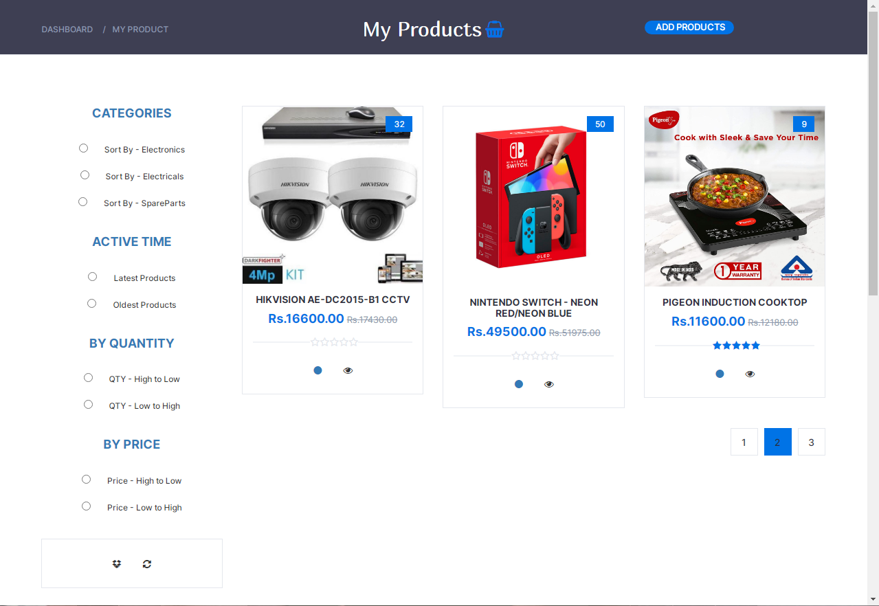

<!DOCTYPE html>

<html lang="en">

<!-- changes -->

<?php

session_start();

require "connection.php";

if (isset($_SESSION["aduser"])) {

$email = $_SESSION["aduser"]["email"];

$pageno;

?>

<head>

<meta charset="utf-8">

<meta http-equiv="X-UA-Compatible" content="IE=edge">

<meta name="viewport" content="width=device-width, initial-scale=1">

<!-- The above 3 meta tags *must* come first in the head; any other head content must come *after* these tags -->

<title>My Product</title>

<link href="https://fonts.googleapis.com/css?family=Montserrat:400,500,700" rel="stylesheet">

<link type="text/css" rel="stylesheet" href="css/bootstrap.min.css" />

<link type="text/css" rel="stylesheet" href="css/slick.css" />

<link type="text/css" rel="stylesheet" href="css/slick-theme.css" />

<link type="text/css" rel="stylesheet" href="css/nouislider.min.css" />

<link rel="stylesheet" href="css/font-awesome.min.css">

<link type="text/css" rel="stylesheet" href="css/style.css" />

<link rel="stylesheet" href="style.css" />

<link rel="icon" href="resources/logo.png" />

</head>

<body class="body">

<div class="container-fluid vh-100">

<div class="row">

<div class="col-12 d-flex justify-content-center vh-100">

<!-- BREADCRUMB -->

<div id="breadcrumb" class="section" style="height:80px; background-color: rgba(43, 45, 66, 0.91);">

<!-- container -->

<div class="container">

<!-- row -->

<div class="row bread">

<div class="col-md-3 breadcrumb-resp" style="margin-top: 22px;">

<ul class="breadcrumb-tree">

<li><a href="html/index.php">Dashboard</a></li>

<li><a href="myProducts.php">My Product</a></li>

<!-- <li><a href="#">Accessories</a></li>

<li class="active">Headphones (227,490 Results)</li> -->

</ul>

</div>

<div class="col-md-6 col-sm-6 col-xs-6 wishlist" style="display: flex; justify-content: center; margin-top: 16px;">

<h2 class="f3" style="font-weight:normal; color: white;">My Products</h2>

<a href="#" style="font-size: 24px; margin-left: 5px; color: #0073e6;"><i class="fa fa-shopping-basket" aria-hidden="true"></i></a>

</div>

<div class="col-md-3 col-sm-6 col-xs-6">

<ul class="add-product-btns d-block justify-content-center align-content-center" style="margin-top: 20px;">

<li style="font-size: 13px; background-color: #0073e6; width:130px; height: 20px; border-radius: 10px;"><a href="#" style="margin-left: 16px; color: white; align-items: center;">ADD PRODUCTS</a></li>

</ul>

</div></div>

</div>

</div></div>

<div class="section">

<!-- container -->

<div class="container">

<!-- row -->

<div class="row">

<!-- ASIDE -->

<div id="aside" class="col-12 col-sm-12 col-md-3 text-center">

<!-- aside Widget -->

<div class="aside">

<h3 class="aside-title text-primary">Categories</h3>

<div class="checkbox-filter">

<div class="input-checkbox">

<input type="radio" id="Electronic" name="r1">

<label for="Electronic">

<span></span>

Sort By - Electronics

</label>

</div>

<div class="input-checkbox">

<input type="radio" id="Electricals" name="r1">

<label for="Electricals">

<span></span>

Sort By - Electricals

</label></div>

<div class="input-checkbox">

<input type="radio" id="spares" name="r1">

<label for="spares">

<span></span>

Sort By - SpareParts

</label>

</div></div></div>

<!-- /aside Widget -->

<!-- aside Widget -->

<div class="aside">

<h3 class="aside-title text-primary">Active Time</h3>

<div class="checkbox-filter">

<div class="input-checkbox">

<input type="radio" id="new" name="r2">

<label for="new">

<span></span>

Latest Products

</label></div>

<div class="input-checkbox">

<input type="radio" id="old" name="r2">

<label for="old">

<span></span>

Oldest Products

</label>

</div> </div>

</div>

<div class="aside">

<h3 class="aside-title text-primary">By Quantity</h3>

<div class="checkbox-filter">

<div class="input-checkbox">

<input type="radio" id="high" name="r5">

<label for="high">

<span></span>

QTY - High to Low

</label>

</div>

<div class="input-checkbox">

<input type="radio" id="low" name="r5">

<label for="low">

<span></span>

QTY - Low to High

</label>

</div>

</div>

</div>

<div class="aside">

<h3 class="aside-title text-primary">By Price</h3>

<div class="checkbox-filter">

<div class="input-checkbox">

<input type="radio" id="hprice" name="r5">

<label for="hprice">

<span></span>

Price - High to Low

</label>

</div>

<div class="input-checkbox">

<input type="radio" id="lprice" name="r5">

<label for="lprice">

<span></span>

Price - Low to High

</label>

</div></div>

</div>

<div class="aside">

<div class="product">

<div class="product product-body">

<div class="product-btns">

<button class="add-to-wishlist" onclick="sort1(0);">

<i class="fa fa-dropbox text-dark"></i>

<span class="tooltipp">Sort Product</span>

</button>

<button class="add-to-wishlist" onclick="clearSort();">

<i class="fa fa-refresh text-dark"></i>

<span class="tooltipp">Clear Sort</span>

</button>

</div></div>

</div></div>

<div class="aside">

<h3 class="aside-title text-primary">Most Recent Products</h3>

<?php

$product_resultSet = Database::search("SELECT * FROM `product` WHERE `category_id`= '1' AND `status_id` = '1' ORDER BY `datetime_added` DESC LIMIT 1 OFFSET 0");

$product_num = $product_resultSet->num_rows;

for ($z = 0; $z < $product_num; $z++) {

$product_data = $product_resultSet->fetch_assoc(); ?>

<div class="product-widget">

<?php

$image_resultSet = Database::search("SELECT * FROM `image` WHERE `product_id` = '" . $product_data["id"] . "';");

$image_data = $image_resultSet->fetch_assoc()

?>

<div class="product-img">

<img src="<?php echo $image_data["code"]; ?>" alt="">

</div>

<div class="product-body">

<p class="product-category">Electronic Items</p>

<h3 class="product-name"><a href="#"><?php echo $product_data["title"]; ?></a></h3>

<h4 class="product-price">Rs. <?php echo $product_data["price"]; ?>.00 </h4>

</div></div>

<?php } ?>

<?php

$product_resultSet = Database::search("SELECT * FROM `product` WHERE `category_id`= '2' AND `status_id` = '1' ORDER BY `datetime_added` DESC LIMIT 1 OFFSET 0");

$product_num = $product_resultSet->num_rows;

for ($z = 0; $z < $product_num; $z++) {

$product_data = $product_resultSet->fetch_assoc(); ?>

<div class="product-widget">

<?php

$image_resultSet = Database::search("SELECT * FROM `image` WHERE `product_id` = '" . $product_data["id"] . "';");

$image_data = $image_resultSet->fetch_assoc();

?>

<div class="product-img">

<img src="<?php echo $image_data["code"]; ?>" alt="">

</div>

<div class="product-body">

<p class="product-category">Electrical Items</p>

<h3 class="product-name"><a href="#"><?php echo $product_data["title"]; ?></a></h3>

<h4 class="product-price">Rs. <?php echo $product_data["price"]; ?>.00 </h4>

</div></div>

<?php } ?>

<?php

$product_resultSet = Database::search("SELECT * FROM `product` WHERE `category_id`= '3' AND `status_id` = '1' ORDER BY `datetime_added` DESC LIMIT 1 OFFSET 0");

$product_num = $product_resultSet->num_rows;

for ($z = 0; $z < $product_num; $z++) {

$product_data = $product_resultSet->fetch_assoc();

?>

<div class="product-widget">

<?php

$image_resultSet = Database::search("SELECT * FROM `image` WHERE `product_id` = '" . $product_data["id"] . "';");

$image_data = $image_resultSet->fetch_assoc(); ?>

<div class="product-img">

<img src="<?php echo $image_data["code"]; ?>" alt=""> </div>

<div class="product-body">

<p class="product-category">Spare Parts</p>

<h3 class="product-name"><a href="#"><?php echo $product_data["title"]; ?></a></h3>

<h4 class="product-price">Rs. <?php echo $product_data["price"]; ?>.00 </h4>

</div>

</div>

<?php } ?>

</div></div>

<div id="store" class="col-12 col-md-9">

<div class="row" id="sort">

<?php

if (isset($_GET["page"])) {

$pageno = $_GET["page"];

} else {

$pageno = 1; }

$product_Rs = Database::search("SELECT * FROM `product`

WHERE `admin_email` = '" . $email . "';");

$product_num = $product_Rs->num_rows;

$result_per_page = 3;

$number_of_pages = ceil($product_num / $result_per_page); // EX :-(2-1)*4 (3-1)*4

$page_results = ($pageno - 1) * $result_per_page;

$selected_rs = Database::search("SELECT * FROM `product`

WHERE `admin_email` = '" . $email . "'

LIMIT " . $result_per_page . "

OFFSET " . $page_results . "");

$selected_num = $selected_rs->num_rows;

for ($x = 0; $x < $selected_num; $x++) {

$selected_data = $selected_rs->fetch_assoc(); ?>

<!-- product -->

<div class="col-12 col-md-4">

<div class="product">

<div class="product-img">

<?php

$product_img_rs = Database::search("SELECT * FROM `image`

WHERE `product_id` = '" . $selected_data["id"] . "';");

$product_img_data = $product_img_rs->fetch_assoc();

?>

<img src="<?php echo $product_img_data["code"]; ?>" alt="">

<div class="product-label">

<span class="new"><?php echo $selected_data["qty"]; ?></span>

</div>

</div>

<div class="product-body">

<h3 class="product-name"><a href="#"><?php echo $selected_data["title"]; ?></a></h3>

<?php

$price = $selected_data["price"];

$adding_price = ($price / 100) * 5;

$new_price = $price + $adding_price;

$difference = $new_price - $price;

$percentage = ($difference / $price) * 100;

?>

<h4 class="product-price">Rs.<?php echo $price; ?>.00 <del class="product-old-price">Rs.<?php echo $new_price; ?>.00</del></h4>

<?php

$Rf_rs = Database::search("SELECT * FROM `feedback`WHERE `product_id`='" . $selected_data["id"] . "' ORDER BY `date` DESC");

$Rf_num = $Rf_rs->num_rows;

$Rf_data = $Rf_rs->fetch_assoc();

?>

<div class="product-rating">

<?php

if ($Rf_num == 0) {

?>

<i class="fa fa-star-o"></i>

<i class="fa fa-star-o"></i>

<i class="fa fa-star-o"></i>

<i class="fa fa-star-o"></i>

<i class="fa fa-star-o"></i>

<?php

} else {

?>

<?php

if ($Rf_data["type"] == 5) {

?>

<i class="fa fa-star"></i>

<i class="fa fa-star"></i>

<i class="fa fa-star"></i>

<i class="fa fa-star"></i>

<i class="fa fa-star"></i>

<?php } ?>

<?php

if ($Rf_data["type"] == 4) {

?>

<i class="fa fa-star"></i>

<i class="fa fa-star"></i>

<i class="fa fa-star"></i>

<i class="fa fa-star"></i>

<i class="fa fa-star-o"></i>

<?php } ?>

<?php

if ($Rf_data["type"] == 3) {

?>

<i class="fa fa-star"></i>

<i class="fa fa-star"></i>

<i class="fa fa-star"></i>

<i class="fa fa-star-o"></i>

<i class="fa fa-star-o"></i>

<?php } ?>

<?php

if ($Rf_data["type"] == 2) {

?>

<i class="fa fa-star"></i>

<i class="fa fa-star"></i>

<i class="fa fa-star-o"></i>

<i class="fa fa-star-o"></i>

<i class="fa fa-star-o"></i>

<?php } ?>

<?php

if ($Rf_data["type"] == 1) {

?>

<i class="fa fa-star"></i>

<i class="fa fa-star-o"></i>

<i class="fa fa-star-o"></i>

<i class="fa fa-star-o"></i>

<i class="fa fa-star-o"></i>

<?php } ?>

<?php } ?>

</div>

<div class="product-btns">

<?php if ($selected_data["status_id"] == 2) { ?>

<button class="add-to-wishlist" id="fd<?php echo $selected_data["id"]; ?>" <?php if ($selected_data["status_id"] == 2) { ?>checked<?php } ?> onclick="changeStatus(<?php echo $selected_data['id']; ?>);">

<i class="fa fa-circle-o text-primary"></i>

<span class="tooltipp">Activate</span>

</button>

<?php } else { ?>

<button class="add-to-wishlist" id="fd<?php echo $selected_data["id"]; ?>" <?php if ($selected_data["status_id"] == 1) { ?>checked<?php } ?> onclick="changeStatus(<?php echo $selected_data['id']; ?>);">

<i class="fa fa-circle text-primary"></i><span class="tooltipp">Deactivate</span></button>

<?php } ?>

<button class="quick-view"><i class="fa fa-eye"></i><span class="tooltipp">Update Product</span></button>

</div>

</div>

</div>

<div class="col-12" style="display: none;" id="activemsgdiv">

<div class="alert alert-danger" role="alert" id="activealertdiv">

<i class="bi bi-x-octagon-fill fs-5" id="activemsg">

</i>

</div>

</div>

</div>

<!-- /product -->

<div class="clearfix visible-sm visible-xs"></div>

<?php } ?>

</div>

<div class="store-filter clearfix">

<ul class="store-pagination">

<?php

for ($x = 1; $x <= $number_of_pages; $x++) {

if ($x == $pageno) { ?>

<li class="active"><a href="<?php echo "?page=" . ($x); ?>" class="text-light"><?php echo $x; ?></a></li>

<?php } else { ?>

<li><a href="<?php echo "?page=" . ($x); ?>"><?php echo $x; ?></a></li>

<?php } } ?>

</ul>

</div> </div> </div>

</div></div>

</div>

</div>

<?php require "footer.php" ?>

<!-- jQuery Plugins -->

<script src="js/jquery.min.js"></script>

<script src="js/bootstrap.min.js"></script>

<script src="js/slick.min.js"></script>

<script src="js/nouislider.min.js"></script>

<script src="js/jquery.zoom.min.js"></script>

<script src="js/main.js"></script>

<script src="script.js"></script>

<script src="bootstrap.bundle.js"></script>

</body>

</html>

<?php

} else {

header("location:html/index.php"); } ?>

**Change Status Process**

<?php

require "connection.php";

$product = $_GET["p"];

$product_Resultset = Database::search

("SELECT * FROM `product`

WHERE `id` = '".$product."';");

$product_num = $product_Resultset -> num_rows;

if($product_num == 1){

$product_data = $product_Resultset -> fetch_assoc();

$status = $product_data["status_id"];

if($status == 1){

Database::insUpdelete("UPDATE `product`

SET `status_id` = '2'

WHERE `id` = '".$product."';");

echo("Product Activated");

}else if($status == 2){

Database::insUpdelete("UPDATE `product`

SET `status_id` = '1'

WHERE `id` = '".$product."';");

echo("Product Deactivated"); }

}else{

echo("Something went wrong please try again later!!!"); } ?>

**Change Status JavaScript Function**

function changeStatus(id) {

var product_id = id;

var r = new XMLHttpRequest();

r.onreadystatechange = function () {

if (r.readyState == 4) {

var text10 = r.responseText;

if (text10 == "Product Deactivated") {

window.location.reload();

document.getElementById("activemsg").innerHTML = text10;

document.getElementById("activemsg").className =

"bi bi-check2-circle fs-5";

document.getElementById("activealertdiv").className =

"alert alert-danger";

document.getElementById("activemsgdiv").className = "d-block";

} else if (text10 == "Product Activated") {

window.location.reload();

document.getElementById("activemsg").innerHTML = text10;

document.getElementById("activemsg").className =

"bi bi-check2-circle fs-5";

document.getElementById("activealertdiv").className =

"alert alert-success";

document.getElementById("activemsgdiv").className = "d-block";

} else {

alert(text10);

} } };

r.open("GET", "ChangeStatusProcess.php?p=" + product_id, true);

r.send();

}

**Sort Process**

<?php

session_start();

require "connection.php";

$user = $_SESSION["aduser"];

// $search = $_POST["search"];

$time = $_POST["time"];

$qty = $_POST["qty"];

$category = $_POST["cat"];

$price = $_POST["price"];

$query = "SELECT * FROM `product` WHERE `admin_email` = '" . $user["email"] . "'"; //This query is common for all filters

$status = 0;

if ($category != "0") {

if ($category == "1") {

$query .= "AND `category_id`= '1' ";

} else if ($category == "2") {

$query .= "AND `category_id`= '2' ";

} else if ($category == "3") {

$query .= "AND `category_id`= '3' ";

} }

// Active time sorting

if ($time != "0") {

if ($time == "1") {

$query .= " ORDER BY `datetime_added` DESC";

} else if ($time == "2") {

$query .= " ORDER BY `datetime_added` ASC";

} }

if ($time != "0" && $qty != "0") {

if ($qty == "1") {

$query .= " , `qty` DESC ";

} else if ($qty == "2") {

$query .= " , `qty` ASC ";

}

} else if ($time == "0" && $qty != "0") {

if ($qty == "1") {

$query .= " ORDER BY `qty` DESC ";

} else if ($qty == "2") {

$query .= " ORDER BY `qty` ASC ";

} }

if ($time != "0" && $price != "0") {

if ($price == "1") {

$query .= " , `price` DESC ";

} else if ($price == "2") {

$query .= " , `price` ASC ";

}

} else if ($time == "0" && $price != "0") {

if ($price == "1") {

$query .= " ORDER BY `price` DESC ";

} else if ($price == "2") {

$query .= " ORDER BY `price` ASC ";

} }

?>

<div class="offset-1 col-10 text-center">

<!-- store products -->

<div class="row">

<?php

if (isset($_GET["page"])) {

$pageno = $_GET["page"];

} else {

$pageno = 1;

}

$product_Rs = Database::search($query);

$product_num = $product_Rs->num_rows;

$result_per_page = 4;

$number_of_pages = ceil($product_num / $result_per_page);

$page_results = ($pageno - 1) * $result_per_page;

$selected_rs = Database::search($query . " LIMIT " . $result_per_page . " OFFSET " . $page_results . "");

$selected_num = $selected_rs->num_rows;

for ($x = 0; $x < $selected_num; $x++) {

$selected_data = $selected_rs->fetch_assoc();

?>

<!-- product -->

<div class="col-md-9">

<div class="product">

<div class="product-img">

<?php

$product_img_rs = Database::search("SELECT * FROM `image`

WHERE `product_id` = '" . $selected_data["id"] . "';");

$product_img_data = $product_img_rs->fetch_assoc();

?>

<img src="<?php echo $product_img_data["code"]; ?>" alt="">

<div class="product-label">

<span class="new"><?php echo $selected_data["qty"]; ?></span>

</div>

</div>

<div class="product-body">

<h3 class="product-name"><a href="#"><?php echo $selected_data["title"]; ?></a></h3>

<?php

$price = $selected_data["price"];

$adding_price = ($price / 100) * 5;

$new_price = $price + $adding_price;

$difference = $new_price - $price;

$percentage = ($difference / $price) * 100;

?>

<h4 class="product-price">Rs.<?php echo $price; ?>.00 <del class="product-old-price">Rs.<?php echo $new_price; ?>.00</del></h4>

<?php

$Rf_rs = Database::search("SELECT * FROM `feedback`WHERE `product_id`='" . $selected_data["id"] . "' ORDER BY `date` DESC");

$Rf_num = $Rf_rs->num_rows;

$Rf_data = $Rf_rs->fetch_assoc();

?>

<div class="product-rating">

<?php

if ($Rf_num == 0) {

?>

<i class="fa fa-star-o"></i>

<i class="fa fa-star-o"></i>

<i class="fa fa-star-o"></i>

<i class="fa fa-star-o"></i>

<i class="fa fa-star-o"></i>

<?php

} else {

?>

<?php

if ($Rf_data["type"] == 5) {

?>

<i class="fa fa-star"></i>

<i class="fa fa-star"></i>

<i class="fa fa-star"></i>

<i class="fa fa-star"></i>

<i class="fa fa-star"></i>

<?php } ?>

<?php

if ($Rf_data["type"] == 4) {

?>

<i class="fa fa-star"></i>

<i class="fa fa-star"></i>

<i class="fa fa-star"></i>

<i class="fa fa-star"></i>

<i class="fa fa-star-o"></i>

<?php } ?>

<?php

if ($Rf_data["type"] == 3) {

?>

<i class="fa fa-star"></i>

<i class="fa fa-star"></i>

<i class="fa fa-star"></i>

<i class="fa fa-star-o"></i>

<i class="fa fa-star-o"></i>

<?php } ?>

<?php

if ($Rf_data["type"] == 2) {

?>

<i class="fa fa-star"></i>

<i class="fa fa-star"></i>

<i class="fa fa-star-o"></i>

<i class="fa fa-star-o"></i>

<i class="fa fa-star-o"></i>

<?php } ?>

<?php

if ($Rf_data["type"] == 1) {

?>

<i class="fa fa-star"></i>

<i class="fa fa-star-o"></i>

<i class="fa fa-star-o"></i>

<i class="fa fa-star-o"></i>

<i class="fa fa-star-o"></i>

<?php } ?>

<?php } ?>

</div>

<div class="product-btns">

<?php if ($selected_data["status_id"] == 2) { ?>

<button class="add-to-wishlist" id="fd<?php echo $selected_data["id"]; ?>" <?php if ($selected_data["status_id"] == 2) { ?>checked<?php } ?> onclick="changeStatus(<?php echo $selected_data['id']; ?>);">

<i class="fa fa-circle-o text-primary"></i>

<span class="tooltipp">Activate</span>

</button>

<?php } else { ?>

<button class="add-to-wishlist" id="fd<?php echo $selected_data["id"]; ?>" <?php if ($selected_data["status_id"] == 1) { ?>checked<?php } ?> onclick="changeStatus(<?php echo $selected_data['id']; ?>);">

<i class="fa fa-circle text-primary"></i><span class="tooltipp">Deactivate</span></button>

<?php } ?>

<button class="quick-view"><i class="fa fa-eye"></i><span class="tooltipp">Update Product</span></button>

</div> </div>

</div>

<div class="col-12" style="display: none;" id="activemsgdiv">

<div class="alert alert-danger" role="alert" id="activealertdiv">

<i class="bi bi-x-octagon-fill fs-5" id="activemsg"></i>

</div>

</div> </div>

<!-- /product -->

<div class="clearfix visible-sm visible-xs"></div>

<?php } ?>

</div> </div>

**Sort Process JavaScript function**

function sort1(x) {

// var search = document.getElementById("search");

var time = "0";

if (document.getElementById("new").checked) {

time = "1";

} else if (document.getElementById("old").checked) {

time = "2";

}

var qty = "0";

if (document.getElementById("high").checked) {

qty = "1";

} else if (document.getElementById("low").checked) {

qty = "2";

}

var price = "0";

if (document.getElementById("hprice").checked) {

price = "1";

} else if (document.getElementById("lprice").checked) {

price = "2";

}

var cat = "0";

if (document.getElementById("Electronic").checked) {

cat = "1";

} else if (document.getElementById("Electricals").checked) {

cat = "2";

} else if (document.getElementById("spares").checked) {

cat = "3";

}

var sortproductform = new FormData();

// sortproductform.append("search", search.value);

sortproductform.append("time", time);

sortproductform.append("qty", qty);

sortproductform.append("cat", cat);

sortproductform.append("price", price);

sortproductform.append("page", x);

var request = new XMLHttpRequest();

request.onreadystatechange = function () {

if (request.readyState == 4) {

var text11 = request.responseText;

document.getElementById("sort").innerHTML = text11;

} };

request.open("POST", "SortProcess.php", true);

request.send(sortproductform);

}

function clearSort() {

window.location.reload();

}

1. Update Product UI and Process

**Update Specific Product UI**

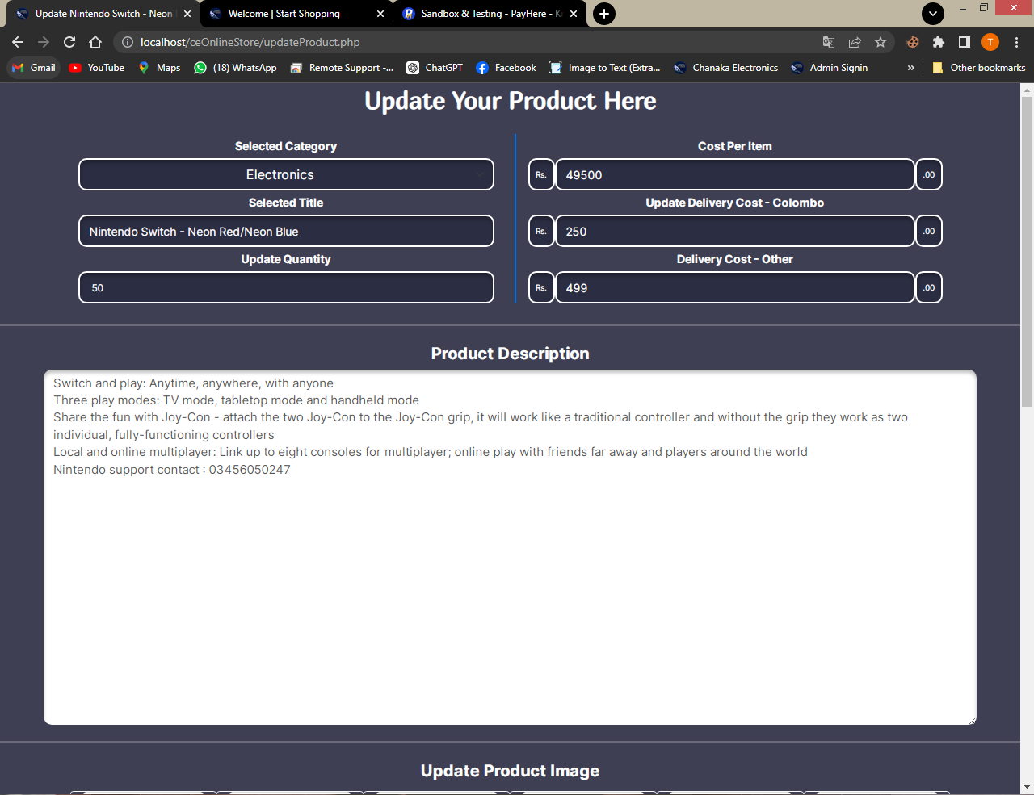

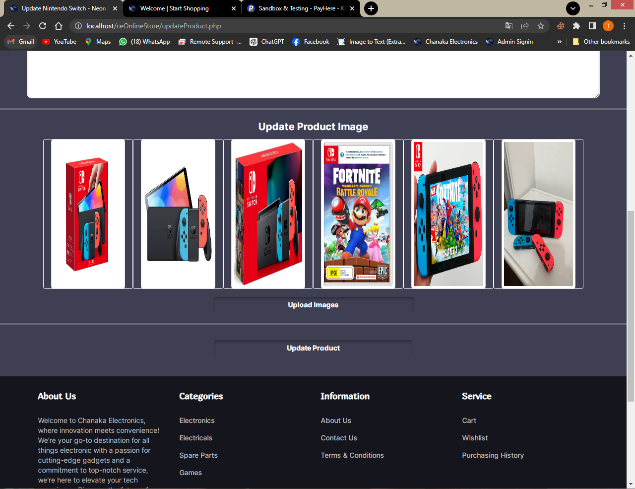

<!DOCTYPE html>

<html>

<?php

session_start();

require "connection.php";

if (isset($_SESSION["aduser"])) {

if (isset($_SESSION["product"])) {

$email = $_SESSION["aduser"]["email"];

$pageno;

?>

<head>

<meta charset="utf-8" />

<meta name="viewport" content="width=device-width, initial-scale=1" />

<title>Update <?php echo $_SESSION["product"]["title"]; ?></title>

<link rel="stylesheet" href="bootstrap.css" />

<link rel="stylesheet" href="style.css" />

<link rel="stylesheet" href="https://cdn.jsdelivr.net/npm/bootstrap-icons@1.9.1/font/bootstrap-icons.css" />

<link href="https://fonts.googleapis.com/css?family=Montserrat:400,500,700" rel="stylesheet">

<link type="text/css" rel="stylesheet" href="css/bootstrap.min.css" />

<link type="text/css" rel="stylesheet" href="css/slick.css" />

<link type="text/css" rel="stylesheet" href="css/slick-theme.css" />

<link type="text/css" rel="stylesheet" href="css/nouislider.min.css" />

<link rel="stylesheet" href="css/font-awesome.min.css">

<link type="text/css" rel="stylesheet" href="css/style.css" />

<link rel="icon" href="resources/logo.png" />

</head>

<body class="body" style="background-color: rgba(43, 45, 66, 0.91);">

<div class="col-12">

<div class="row">

<div class="col-12 d-flex justify-content-center align-items-center">

<div class="row ">

<h2 class="f3 text-white mt-2">Update Your Product Here</h2>

</div>

</div>

<div class="col-12 d-none" id="addmsgdiv">

<div class="alert alert-danger" role="alert" id="addalertdiv">

<i class="bi bi-x-octagon-fill fs-5" id="addmsg"></i>

</div>

</div>

<div class="col-12">

<div class="row d-flex justify-content-center mt-3 add-product-details">

<div class="col-lg-5 col-md-5 col-sm-10 mx-2 my-2">

<div class="col-12 d-flex justify-content-center">

<label class="text-white my-2">Selected Category</label>

</div>

<div class="col-12 d-flex justify-content-center">

<select class="form-select text-center text-white rounded-4" disabled style="height: 40px; background-color: #2b2d42; border: 2px solid white; box-shadow: 0px 4px 4px 0px rgba(0, 0, 0, 0.25) inset; font-size: medium;">

<?php

$product = $_SESSION["product"];

$category_Resultset =

Database::search("SELECT * FROM `category`

WHERE `c_id` = '" . $product["category_id"] . "';");

$category_data = $category_Resultset->fetch_assoc();

?>

<option><?php echo $category_data["name"]; ?></option>

</select>

</div>

<div class="col-12 d-flex justify-content-center">

<label class="text-white my-2">Selected Title</label>

</div>

<div class="col-12">

<input type="text" disabled class="form-control f1 text-white rounded-4" value="<?php echo $product["title"]; ?>" style="height: 40px; background-color: #2b2d42; border: 2px solid white; box-shadow: 0px 4px 4px 0px rgba(0, 0, 0, 0.25) inset;">

</div>

<div class="col-12 d-flex justify-content-center">

<label class="text-white my-2">Update Quantity</label>

</div>

<div class="input-number col-12 d-flex justify-content-center">

<input type="number" class="rounded-4 f1 text-white" value="<?php echo $product["qty"]; ?>" style="outline: none; height: 40px; background-color: #2b2d42; border: 2px solid white; box-shadow: 0px 4px 4px 0px rgba(0, 0, 0, 0.25) inset;" min="0" pattern="[0-9]" id="upqty">

</div>

</div>

<div class="col-lg-5 col-md-5 col-sm-10 mx-2 my-2 add-product-detail-box-2" style="border-left:2px solid #0073e6;">

<div class="col-12 d-flex justify-content-center">

<label class="text-white my-2">Cost Per Item</label>

</div>

<div class="col-12 d-flex justify-content-center">

<span class="input-group-text rounded-4 text-white" style="outline: none; height: 40px; background-color: #2b2d42; border: 2px solid white; box-shadow: 0px 4px 4px 0px rgba(0, 0, 0, 0.25) inset;">Rs.</span>

<input type="number" value="<?php echo $product["price"]; ?>" disabled class="form-control rounded-4 text-white" style="outline: none; height: 40px; background-color: #2b2d42; border: 2px solid white; box-shadow: 0px 4px 4px 0px rgba(0, 0, 0, 0.25) inset;">

<span class="input-group-text rounded-4 text-white" style="outline: none; height: 40px; background-color: #2b2d42; border: 2px solid white; box-shadow: 0px 4px 4px 0px rgba(0, 0, 0, 0.25) inset;">.00</span>

</div>

<div class="col-12 d-flex justify-content-center">

<label class="text-white my-2">Update Delivery Cost - Colombo</label>

</div>

<div class="col-12 d-flex justify-content-center">

<span class="input-group-text rounded-4 text-white" style="outline: none; height: 40px; background-color: #2b2d42; border: 2px solid white; box-shadow: 0px 4px 4px 0px rgba(0, 0, 0, 0.25) inset;">Rs.</span>

<input type="number" id="updwc" value="<?php echo $product["delivery_fee_colombo"]; ?>" class="form-control rounded-4 text-white" style="outline: none; height: 40px; background-color: #2b2d42; border: 2px solid white; box-shadow: 0px 4px 4px 0px rgba(0, 0, 0, 0.25) inset;">

<span class="input-group-text rounded-4 text-white" style="outline: none; height: 40px; background-color: #2b2d42; border: 2px solid white; box-shadow: 0px 4px 4px 0px rgba(0, 0, 0, 0.25) inset;">.00</span>

</div>

<div class="col-12 d-flex justify-content-center">

<label class="text-white my-2">Delivery Cost - Other</label>

</div>

<div class="col-12 d-flex justify-content-center">

<span class="input-group-text rounded-4 text-white" style="outline: none; height: 40px; background-color: #2b2d42; border: 2px solid white; box-shadow: 0px 4px 4px 0px rgba(0, 0, 0, 0.25) inset;">Rs.</span>

<input type="number" id="updoc" value="<?php echo $product["delivery_fee_other"]; ?>" class="form-control rounded-4 text-white" style="outline: none; height: 40px; background-color: #2b2d42; border: 2px solid white; box-shadow: 0px 4px 4px 0px rgba(0, 0, 0, 0.25) inset;">

<span class="input-group-text rounded-4 text-white" style="outline: none; height: 40px; background-color: #2b2d42; border: 2px solid white; box-shadow: 0px 4px 4px 0px rgba(0, 0, 0, 0.25) inset;">.00</span>

</div>

</div></div>

</div>

<div class="col-12">

<hr class="" style="border-width: 3px; color: white;" />

</div>

<div class="container">

<div class="row justify-content-center">

<div class="col-12 col-lg-12">

<div class="row">

<div class="col-12 text-center">

<label class="form-label fw-bold text-white f5" style="font-size: 20px;">Product Description</label>

</div>

<div class="col-12 add-description-box">

<textarea class="form-control f5 rounded-4" id="updesc" placeholder="Add product description..." cols="30" rows="20" style="font-size: 15px; border: none; box-shadow: 0px 4px 4px 0px rgba(0, 0, 0, 0.25) inset; width: 100%; min-height: 200px;"><?php echo $product["description"]; ?></textarea>

</div>

</div></div>

</div></div>

<div class="col-12">

<hr class="" style="border-width: 3px; color: white;" />

</div>

<div class="col-12">

<div class="row">

<div class="col-12 text-center">

<label class="form-label fw-bold text-white" style="font-size:20px;">Update Product Image</label>

</div>

<div class="col-lg-10 offset-lg-1 col-10 offset-1">

<?php

$img = array();

$img[0] = "resources\addproductimg.svg";

$img[1] = "resources\addproductimg.svg";

$img[2] = "resources\addproductimg.svg";

$img[3] = "resources\addproductimg.svg";

$img[4] = "resources\addproductimg.svg";

$img[5] = "resources\addproductimg.svg";

$image_Resultset =

Database::search("SELECT * FROM `image`

WHERE `product_id` = '" . $product["id"] . "'");

$image_num = $image_Resultset->num_rows;

for ($x = 0; $x < $image_num; $x++) {

$image_data = $image_Resultset->fetch_assoc();

$img[$x] = $image_data["code"];

}

?>

<div class="row">

<div class="col-lg-2 col-md-4 col-sm-12 d-flex justify-content-center border border-light rounded my-2">

<img src="<?php echo $img[0]; ?>" class="img-fluid img-thumbnail" style="width:200px; height:300px;" id="i0" />

</div>

<div class="col-lg-2 col-md-4 col-sm-12 d-flex justify-content-center border border-light rounded my-2">

<img src="<?php echo $img[1]; ?>" class="img-fluid img-thumbnail" style="width:200px; height:300px;" id="i1" />

</div>

<div class="col-lg-2 col-md-4 col-sm-12 d-flex justify-content-center border border-light rounded my-2">

<img src="<?php echo $img[2]; ?>" class="img-fluid img-thumbnail" style="width:200px; height:300px;" id="i2" />

</div>

<div class="col-lg-2 col-md-4 col-sm-12 d-flex justify-content-center border border-light rounded my-2">

<img src="<?php echo $img[3]; ?>" class="img-fluid img-thumbnail" style="width:200px; height:300px;" id="i3" />

</div>

<div class="col-lg-2 col-md-4 col-sm-12 d-flex justify-content-center border border-light rounded my-2">

<img src="<?php echo $img[4]; ?>" class="img-fluid img-thumbnail" style="width:200px; height:300px;" id="i4" />

</div>

<div class="col-lg-2 col-md-4 col-sm-12 d-flex justify-content-center border border-light rounded my-2">

<img src="<?php echo $img[5]; ?>" class="img-fluid img-thumbnail" style="width:200px; height:300px;" id="i5" />

</div></div></div>

<div class="offset-lg-4 col-12 col-lg-4 d-grid mt-3">

<input type="file" class="d-none" id="imageuploder" multiple />

<label for="imageuploder" class="col-12 btn btn-outline-primary fw-bold text-white" style="box-shadow: 0px 4px 4px 0px rgba(0, 0, 0, 0.25) inset;" onclick="changeProductimg();">Upload Images</label>

</div>

</div></div>

<div class="col-12">

<hr class="" style="border-width: 3px; color: white;" />

</div>

<div class="offset-lg-4 col-12 col-lg-4 d-grid mt-3 mb-3">

<button class="btn btn-outline-primary fw-bold text-white" style="box-shadow: 0px 4px 4px 0px rgba(0, 0, 0, 0.25) inset;" onclick="Updateproduct();">Update Product</button>

</div></div>

</div>

<?php require "footer.php"; ?>

<script src="bootstrap.bundle.js"></script>

<script src="script.js"></script>

</body>

</html>

<?php

} else {

header("location : myProducts.php");}

} else {

header("location:html/index.php"); } ?>

**Send Product ID Process**

<?php

session_start();

require "connection.php";

$email = $_SESSION["aduser"]["email"];

$product_ID = $_GET["id"];

$product_Resultset =

Database::search("SELECT * FROM `product`

WHERE `id` ='".$product_ID."'

AND `admin_email`='".$email."';");

$product_num = $product_Resultset->num_rows;

if($product_num == 1){

$product_data = $product_Resultset->fetch_assoc();

$_SESSION["product"] = $product_data;

echo("success");

}else{

echo "Something Went Wrong"; } ?>

**JavaScript Function**

function sendId(id) {

var req = new XMLHttpRequest();

req.onreadystatechange = function () {

if (req.readyState == 4) {

var text12 = req.responseText;

if (text12 == "success") {

window.location = "updateProduct.php";

} else {

alert(text12); } } };

req.open("GET", "SendProductID.php?id=" + id, true);

req.send();

}

**Update Product Process**

<?php

session_start();

require "connection.php";

if (isset($_SESSION["product"])) {

$product_id = $_SESSION["product"]["id"];

$qty = $_POST["upqty"];

$dwc = $_POST["updwc"];

$doc = $_POST["updoc"];

$desc = $_POST["updesc"];

Database::insUpdelete("UPDATE `product` SET `qty` = '" . $qty . "' , `delivery_fee_colombo` = '" . $dwc . "' ,

`delivery_fee_other` = '" . $doc . "' ,`description` = '" . $desc . "' WHERE `id` = '" . $product_id . "'");

$length = sizeof($_FILES);

$allowed_img_ex = array("image/jpg", "image/jpeg", "image/png", "image/svg+xml");

Database::insUpdelete("DELETE FROM `image` WHERE `product_id` ='" . $product_id . "'");

if ($length <= 6 && $length > 0) {

for ($x = 0; $x < $length; $x++) {

if (isset($_FILES["i" . $x])) {

$img_file = $_FILES["i" . $x];

$file_type = $img_file["type"];

if (in_array($file_type, $allowed_img_ex)) {

$new_img_ex;

if ($file_type == "image/jpg") {

$new_img_ex = ".jpg";

} else if ($file_type == "image/jpeg") {

$new_img_ex = ".jpeg";

} else if ($file_type == "image/png") {

$new_img_ex = ".png";

} else if ($file_type == "image/svg+xml") {

$new_img_ex = ".svg";

}

$titleRS = Database::search("SELECT `title` FROM `product` WHERE `id`= '" . $product_id . "' ");

$title = $titleRS->fetch_assoc();

$file_name = "category//Product//" . $title["title"] . "_" . $x . "_" . uniqid() . $new_img_ex;

move_uploaded_file($img_file["tmp_name"], $file_name);

Database::insUpdelete("INSERT INTO `image` (`code` , `product_id`)

VALUES ('" . $file_name . "','" . $product_id . "')");

} else {

echo ("File Type not allowed ! "); } }

}

echo ("Product has been updated Successfully !!");

} else {

echo ("Invalid Image Count");

} }

**JavaScript Function**

function Updateproduct() {

var qty = document.getElementById("upqty");

var dwc = document.getElementById("updwc");

var doc = document.getElementById("updoc");

var desc = document.getElementById("updesc");

var image = document.getElementById("imageuploder");

var Updateform = new FormData();

Updateform.append("upqty", qty.value);

Updateform.append("updwc", dwc.value);

Updateform.append("updoc", doc.value);

Updateform.append("updesc", desc.value);

var img_count = image.files.length;

for (var x = 0; x < img_count; x++) {

Updateform.append("i" + x, image.files[x]);

}

var request = new XMLHttpRequest();

request.onreadystatechange = function () {

if (request.readyState == 4) {

var text13 = request.responseText;

if (text13 == "Product has been updated Successfully !!") {

window.location.reload();

document.getElementById("addmsg").innerHTML = text13;

document.getElementById("addmsg").className =

"bi bi-check2-circle fs-5";

document.getElementById("addalertdiv").className =

"alert alert-success";

document.getElementById("addmsgdiv").className = "d-block";

} else {

document.getElementById("addmsg").innerHTML = text13;

document.getElementById("addmsg").className =

"bi bi-x-octagon-fill fs-5";

document.getElementById("addalertdiv").className = "alert alert-danger";

document.getElementById("addmsgdiv").className = "d-block"; } }

};

request.open("POST", "updateProductProcess.php", true);

request.send(Updateform);

}

1. New Product Registration

**Add Product User Interface**

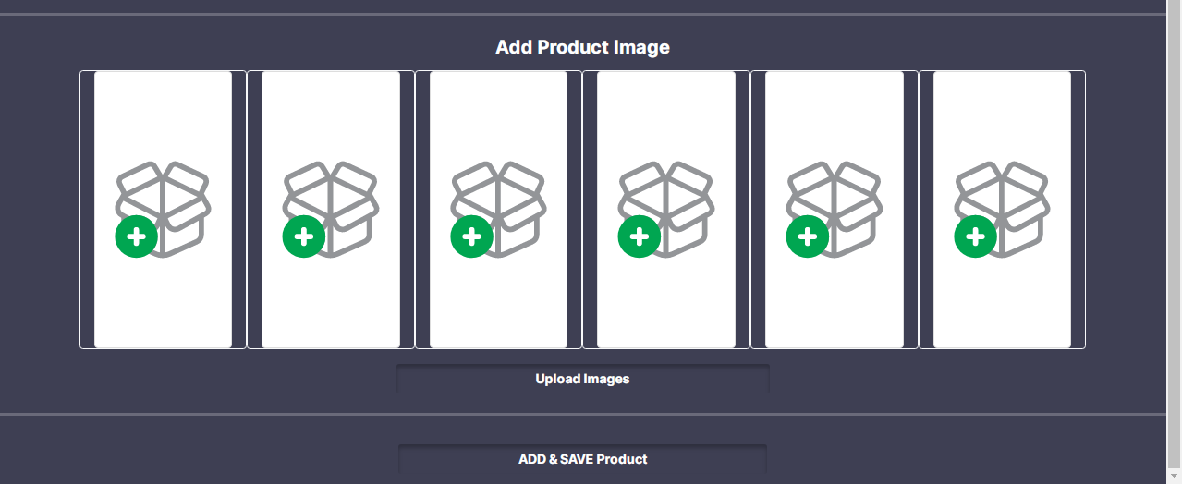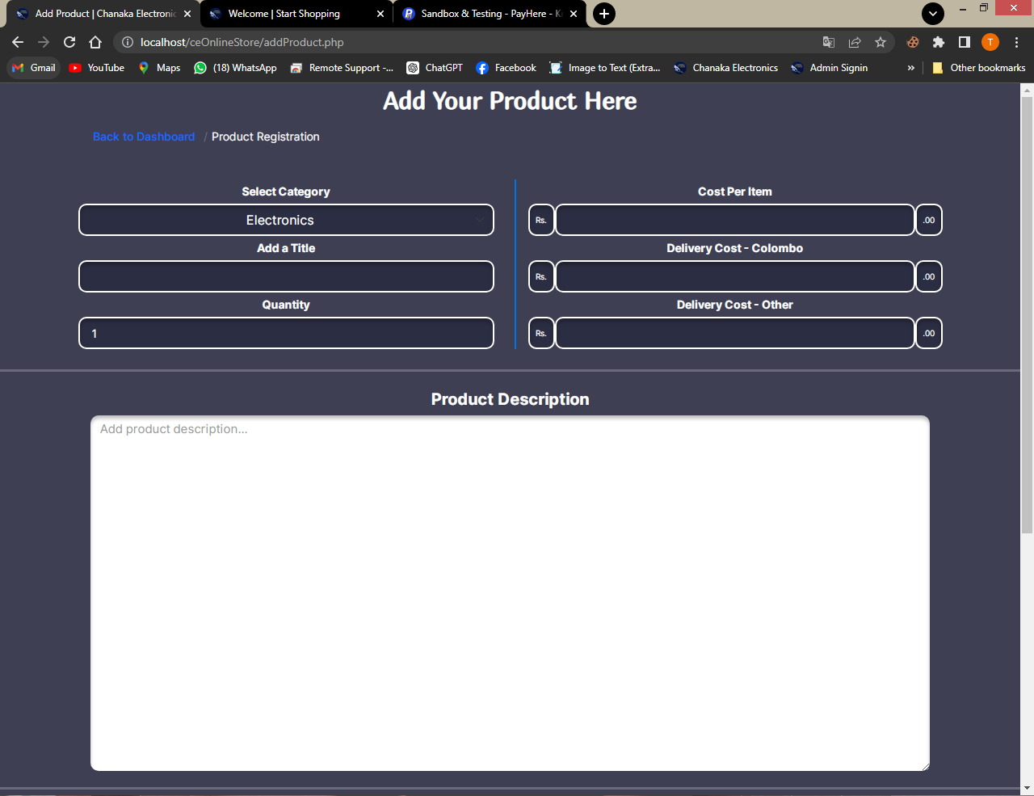

This is the add product interface. Admin can add new products to sell in the web application here. Admin can add the required product details, description about the product and maximum six product images.

<!DOCTYPE html>

<html>

<?php

session_start();

require "connection.php";

if (isset($_SESSION["aduser"])) {

$email = $_SESSION["aduser"]["email"];

$pageno;

?>

<head>

<meta charset="utf-8" />

<meta name="viewport" content="width=device-width, initial-scale=1" />

<title>Add Product | Chanaka Electronics</title>

<link rel="stylesheet" href="bootstrap.css" />

<link rel="stylesheet" href="style.css" />

<link rel="stylesheet" href="https://cdn.jsdelivr.net/npm/bootstrap-icons@1.9.1/font/bootstrap-icons.css" />

<link href="https://fonts.googleapis.com/css?family=Montserrat:400,500,700" rel="stylesheet">

<link type="text/css" rel="stylesheet" href="css/bootstrap.min.css" />

<link type="text/css" rel="stylesheet" href="css/slick.css" />

<link type="text/css" rel="stylesheet" href="css/slick-theme.css" />

<link type="text/css" rel="stylesheet" href="css/nouislider.min.css" />

<link rel="stylesheet" href="css/font-awesome.min.css">

<link type="text/css" rel="stylesheet" href="css/style.css" />

<link rel="icon" href="resources/logo.png" />

</head>

<body class="body" style="background-color: rgba(43, 45, 66, 0.91);">

<div class="col-12">

<div class="row">

<div class="col-12 d-flex justify-content-center align-items-center">

<div class="row ">

<h2 class="f3 text-white mt-2">Add Your Product Here</h2>

</div></div>

<div class="col-10 offset-1">

<nav aria-label="breadcrumb">

<ol class="breadcrumb bg-transparent">

<li class="breadcrumb-item fw-bold"><a href="html/index.php" class="text-primary">Back to Dashboard</a></li>

<li class="breadcrumb-item active text-light" aria-current="page">Product Registration</li>

</ol>

</nav> </div>

<div class="col-12 d-none" id="addmsgdiv">

<div class="alert alert-success" role="alert" id="addalertdiv">

<i class="bi bi-check2-circle fs-5" id="addmsg"> </i>

</div> </div>

<div class="col-12">

<div class="row d-flex justify-content-center mt-3 add-product-details">

<div class="col-lg-5 col-md-5 col-sm-10 mx-2 my-2">

<div class="col-12 d-flex justify-content-center">

<label class="text-white my-2">Select Category</label>

</div>

<div class="col-12 d-flex justify-content-center">

<select class="form-select text-center text-white rounded-4" id="category" style="height: 40px; background-color: #2b2d42; border: 2px solid white; box-shadow: 0px 4px 4px 0px rgba(0, 0, 0, 0.25) inset; font-size: medium;">

<?php

$category_rs = Database::search("SELECT * FROM `category`");

$category_num = $category_rs->num_rows;

for ($x = 0; $x < $category_num; $x++) {

$category_data = $category_rs->fetch_assoc();

?>

<option value="<?php echo $category_data["c_id"]; ?>">

<?php echo $category_data["name"]; ?>

</option>

<?php } ?>

</select>

</div>

<div class="col-12 d-flex justify-content-center">

<label class="text-white my-2">Add a Title</label>

</div>

<div class="col-12">

<input type="text" id="title" class="form-control f1 text-white rounded-4" style="height: 40px; background-color: #2b2d42; border: 2px solid white; box-shadow: 0px 4px 4px 0px rgba(0, 0, 0, 0.25) inset;">

</div>

<div class="col-12 d-flex justify-content-center">

<label class="text-white my-2">Quantity</label>

</div>

<div class="input-number col-12 d-flex justify-content-center">

<input type="number" class="rounded-4 text-white" style="outline: none; height: 40px; background-color: #2b2d42; border: 2px solid white; box-shadow: 0px 4px 4px 0px rgba(0, 0, 0, 0.25) inset;" value="1" pattern="[0-9]" id="qty_input">

</div> </div>

<div class="col-lg-5 col-md-5 col-sm-10 mx-2 my-2 add-product-detail-box-2" style="border-left:2px solid #0073e6;">

<div class="col-12 d-flex justify-content-center">

<label class="text-white my-2">Cost Per Item</label>

</div>

<div class="col-12 d-flex justify-content-center">

<span class="input-group-text rounded-4 text-white" style="outline: none; height: 40px; background-color: #2b2d42; border: 2px solid white; box-shadow: 0px 4px 4px 0px rgba(0, 0, 0, 0.25) inset;">Rs.</span>

<input type="number" id="cost" class="form-control rounded-4 text-white" style="outline: none; height: 40px; background-color: #2b2d42; border: 2px solid white; box-shadow: 0px 4px 4px 0px rgba(0, 0, 0, 0.25) inset;">

<span class="input-group-text rounded-4 text-white" style="outline: none; height: 40px; background-color: #2b2d42; border: 2px solid white; box-shadow: 0px 4px 4px 0px rgba(0, 0, 0, 0.25) inset;">.00</span>

</div>

<div class="col-12 d-flex justify-content-center">

<label class="text-white my-2">Delivery Cost - Colombo</label>

</div>

<div class="col-12 d-flex justify-content-center">

<span class="input-group-text rounded-4 text-white" style="outline: none; height: 40px; background-color: #2b2d42; border: 2px solid white; box-shadow: 0px 4px 4px 0px rgba(0, 0, 0, 0.25) inset;">Rs.</span>

<input type="number" id="dwc" class="form-control rounded-4 text-white" style="outline: none; height: 40px; background-color: #2b2d42; border: 2px solid white; box-shadow: 0px 4px 4px 0px rgba(0, 0, 0, 0.25) inset;">

<span class="input-group-text rounded-4 text-white" style="outline: none; height: 40px; background-color: #2b2d42; border: 2px solid white; box-shadow: 0px 4px 4px 0px rgba(0, 0, 0, 0.25) inset;">.00</span>

</div>

<div class="col-12 d-flex justify-content-center">

<label class="text-white my-2">Delivery Cost - Other</label>

</div>

<div class="col-12 d-flex justify-content-center">

<span class="input-group-text rounded-4 text-white" style="outline: none; height: 40px; background-color: #2b2d42; border: 2px solid white; box-shadow: 0px 4px 4px 0px rgba(0, 0, 0, 0.25) inset;">Rs.</span>

<input type="number" id="doc" class="form-control rounded-4 text-white" style="outline: none; height: 40px; background-color: #2b2d42; border: 2px solid white; box-shadow: 0px 4px 4px 0px rgba(0, 0, 0, 0.25) inset;">

<span class="input-group-text rounded-4 text-white" style="outline: none; height: 40px; background-color: #2b2d42; border: 2px solid white; box-shadow: 0px 4px 4px 0px rgba(0, 0, 0, 0.25) inset;">.00</span>

</div>

</div> </div>

</div>

<div class="col-12">

<hr class="" style="border-width: 3px; color: white;" />

</div>

<div class="container">

<div class="row justify-content-center">

<div class="col-12 col-lg-12">

<div class="row">

<div class="col-12 text-center">

<label class="form-label fw-bold text-white f5" style="font-size: 20px;">Product Description</label>

</div>

<div class="col-12 add-description-box d-flex justify-content-center">

<textarea class="form-control f5 rounded-4" id="desc" placeholder="Add product description..." cols="30" rows="20" style="font-size: 15px; border: none; box-shadow: 0px 4px 4px 0px rgba(0, 0, 0, 0.25) inset; width: 90%; min-height: 200px;"></textarea>

</div>

</div> </div>

</div> </div>

<div class="col-12">

<hr class="" style="border-width: 3px; color: white;" />

</div>

<div class="col-12">

<div class="row">

<div class="col-12 text-center">

<label class="form-label fw-bold text-white" style="font-size:20px;">Add Product Image</label>

</div>

<div class="col-lg-10 offset-lg-1 col-10 offset-1">

<div class="row">

<div class="col-lg-2 col-md-4 col-sm-12 d-flex justify-content-center border border-light rounded my-2">

<img src="resources/addproductimg.svg" class="img-fluid img-thumbnail" style="width:200px; height:300px;" id="i0" />

</div>

<div class="col-lg-2 col-md-4 col-sm-12 d-flex justify-content-center border border-light rounded my-2">

<img src="resources/addproductimg.svg" class="img-fluid img-thumbnail" style="width:200px; height:300px;" id="i1" /></div>

<div class="col-lg-2 col-md-4 col-sm-12 d-flex justify-content-center border border-light rounded my-2">

<img src="resources/addproductimg.svg" class="img-fluid img-thumbnail" style="width:200px; height:300px;" id="i2" /></div>

<div class="col-lg-2 col-md-4 col-sm-12 d-flex justify-content-center border border-light rounded my-2">

<img src="resources/addproductimg.svg" class="img-fluid img-thumbnail" style="width:200px; height:300px;" id="i3" /></div>

<div class="col-lg-2 col-md-4 col-sm-12 d-flex justify-content-center border border-light rounded my-2">

<img src="resources/addproductimg.svg" class="img-fluid img-thumbnail" style="width:200px; height:300px;" id="i4" /></div>

<div class="col-lg-2 col-md-4 col-sm-12 d-flex justify-content-center border border-light rounded my-2">

<img src="resources/addproductimg.svg" class="img-fluid img-thumbnail" style="width:200px; height:300px;" id="i5" />

</div></div>

</div>

<div class="offset-lg-4 col-12 col-lg-4 d-grid mt-3">

<input type="file" class="d-none" id="imageuploder" multiple />

<label for="imageuploder" class="col-12 btn btn-outline-danger fw-bold text-white" style="box-shadow: 0px 4px 4px 0px rgba(0, 0, 0, 0.25) inset;" onclick="changeProductimg();">Upload Images</label>

</div></div>

</div>

<div class="col-12">

<hr class="" style="border-width: 3px; color: white;" />

</div>

<div class="offset-lg-4 col-12 col-lg-4 d-grid mt-3 mb-3">

<button class="btn btn-outline-primary fw-bold text-white" style="box-shadow: 0px 4px 4px 0px rgba(0, 0, 0, 0.25) inset;" onclick="addProduct();">ADD & SAVE Product</button>

</div></div>

</div>

<script src="bootstrap.bundle.js"></script>

<script src="script.js"></script>

</body>

</html>

<?php } else {

header("location:html/index.php"); } ?>

**Add Product Process**

<?php

session_start();

require "connection.php";

$email = $_SESSION["aduser"]["email"];

$category = $_POST["category"];

$title = $_POST["title"];

$qty = $_POST["qty"];

$cost = $_POST["cost"];

$dwc = $_POST["dwc"];

$doc = $_POST["doc"];

$description = $_POST["desc"];

if ($category == "0") {

echo ("Please select a category");

} else if (empty($title)) {

echo ("Please Enter Product title that you want to sell");

} else if (strlen($title <= 100)) {

echo ("Title should have less than 100 chars");

} else if (empty($qty)) {

echo ("Please enter the quantity");

} else if ($qty == "0" | $qty == "e" | $qty < 0) {

echo ("Invalid input for Quantity");

} else if (empty($cost)) {

echo ("Please Enter Product Price");

} else if (!is_numeric($cost)) {

echo ("Please input for Price/ Cost");

} else if (empty($dwc)) {

echo ("Please Enter delivery cost for Colombo area");

} else if (!is_numeric($dwc)) {

echo ("Please input valid price for Delivery Cost inside Colombo");

} else if (empty($doc)) {

echo ("Please Enter delivery cost for out of Colombo");

} else if (!is_numeric($doc)) {

echo ("Please input valid Price for Delivery Cost out of Colombo");

} else if (empty($description)) {

echo ("Please enter the Description");

} else {

$datetime = new DateTime();

$timezone = new DateTimeZone("Asia/Colombo");

$datetime->setTimezone($timezone);

$date = $datetime->format("Y-m-d H:i:s");

$status = 1;

Database::insUpdelete("INSERT INTO `product`

(`price`,`qty`,`description`,`title`,`datetime_added`,`delivery_fee_colombo`,`delivery_fee_other`,

`category_id`,`status_id`,`admin_email`)

VALUES ('" . $cost . "' , '" . $qty . "', '" . $description . "', '" . $title . "', '" . $date . "','" . $dwc . "' ,'" . $doc . "'

,'" . $category . "' ,'" . $status . "' , '" . $email . "')");

$product_id = Database::$connection->insert_id;

$length = sizeof($_FILES); //We can get a length of array using sizeof

if ($length <= 6 && $length > 0) {

$allowed_img_extension = array("image/jpeg", "image/jpg", "image/png", "image/svg+xml");

for ($x = 0; $x < $length; $x++) {

if (isset($_FILES["img" . $x])) {

$image_file = $_FILES["img" . $x];

$file_ex = $image_file["type"];

if (in_array($file_ex, $allowed_img_extension)) {

$new_img_ex;

if ($file_ex == "image/jpg") {

$new_img_ex = ".jpg";

} else if ($file_ex == "image/jpeg") {

$new_img_ex = ".jpeg";

} else if ($file_ex == "image/png") {

$new_img_ex = ".png";

} else if ($file_ex == "image/svg+xml") {

$new_img_ex = ".svg"; }

$file_name = "category//Product//" . $title . "_" . $x . "_" . uniqid() . $new_img_ex;

move_uploaded_file($image_file["tmp_name"], $file_name);

Database::insUpdelete("INSERT INTO `image`(`code`,`product_id`)

VALUES ('" . $file_name . "','" . $product_id . "')");

} else {

echo ("invalid Image type"); } } }

echo ("Product Saved Successfully");

} else {

echo ("Invalid Image count"); } }

**JavaScript Function**

function addProduct() {

var category = document.getElementById("category");

var title = document.getElementById("title");

var qty = document.getElementById("qty_input");

var cost = document.getElementById("cost");

var dwc = document.getElementById("dwc");

var doc = document.getElementById("doc");

var description = document.getElementById("desc");

var image = document.getElementById("imageuploder");

var form = new FormData();

form.append("category", category.value);

form.append("title", title.value);

form.append("qty", qty.value);

form.append("cost", cost.value);

form.append("dwc", dwc.value);

form.append("doc", doc.value);

form.append("desc", description.value);

var file_count = image.files.length;

for (var x = 0; x < file_count; x++) {

form.append("img" + x, image.files[x]);

}

var request = new XMLHttpRequest();

request.onreadystatechange = function () {

if (request.readyState == 4) {

var text7 = request.responseText;

if (text7 == "Product Saved Successfully") {

document.getElementById("addmsg").innerHTML = text7;

document.getElementById("addmsg").className =

"bi bi-x-octagon-fill fs-5";

document.getElementById("addalertdiv").className = "alert alert-danger";

document.getElementById("addmsgdiv").className = "d-block";

} else {

window.location.reload();

document.getElementById("addmsg").innerHTML = text7;

document.getElementById("addmsg").className =

"bi bi-check2-circle fs-5";

document.getElementById("addalertdiv").className =

"alert alert-success";

document.getElementById("addmsgdiv").className = "d-block";

} } };

request.open("POST", "AddProductProcess.php", true);

request.send(form);

}

**Image Uploading JavaScript Function**

function changeProductimg() {

var image = document.getElementById("imageuploder");

image.onchange = function () {

var file_count = image.files.length;

if (file_count <= 6) {

for (var x = 0; x < file_count; x++) {

var file = this.files[x];

var url = window.URL.createObjectURL(file);

document.getElementById("i" + x).src = url;

}

} else {

alert("Please Select 6 images or Less than 6 images ");

} }; }

1. Recent Product page

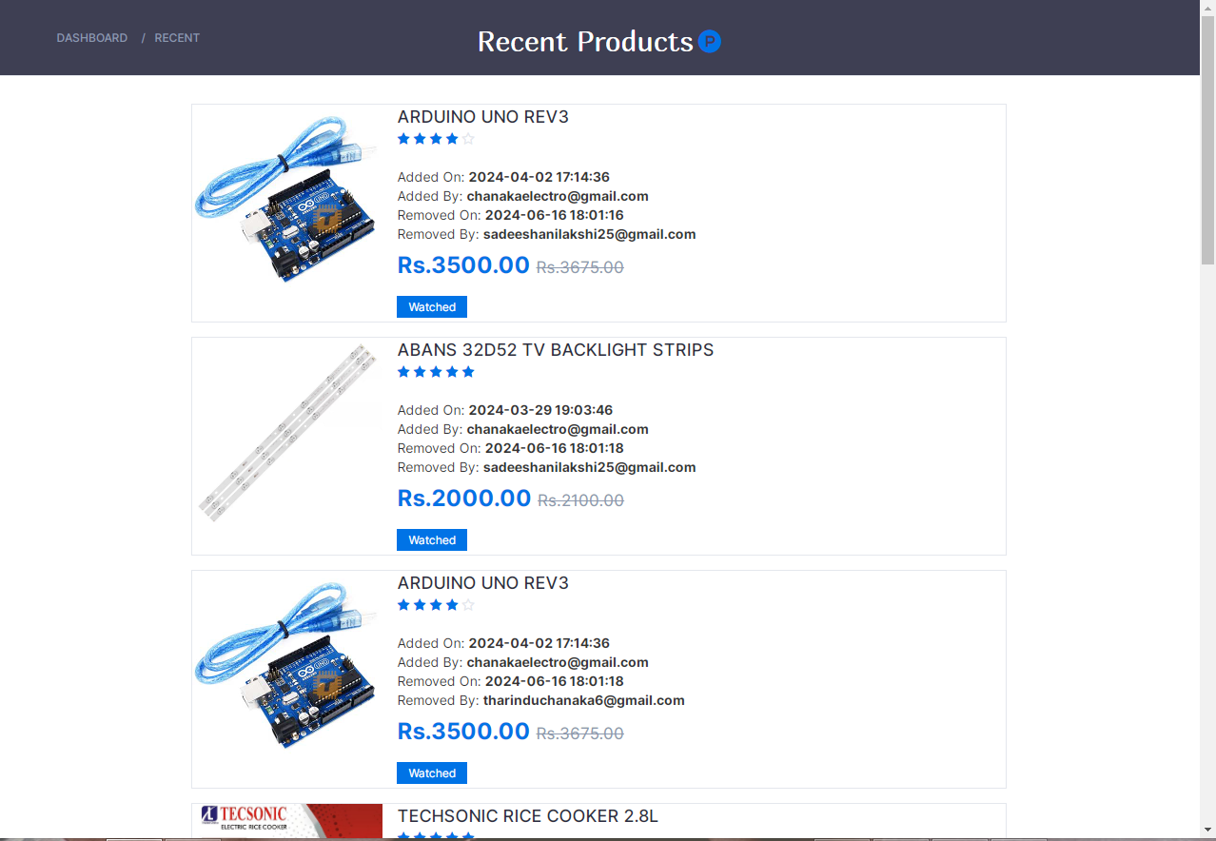

This is the recent product page. The items that are removed from the wishlist by costomers are displayed here.

<!DOCTYPE html>

<html>

<?php session_start(); ?>

<head>

<meta charset="utf-8" />

<meta name="viewport" content="width=device-width, initial-scale=1" />

<title>Recent Customer Preferances</title>

<link href="https://fonts.googleapis.com/css?family=Montserrat:400,500,700" rel="stylesheet">

<link type="text/css" rel="stylesheet" href="css/bootstrap.min.css" />

<link type="text/css" rel="stylesheet" href="css/slick.css" />

<link type="text/css" rel="stylesheet" href="css/slick-theme.css" />

<link type="text/css" rel="stylesheet" href="css/nouislider.min.css" />

<link rel="stylesheet" href="css/font-awesome.min.css">

<link type="text/css" rel="stylesheet" href="css/style.css" />

<link rel="stylesheet" href="style.css" />

<link rel="stylesheet" href="bootstrap-icons.css" />

<link rel="icon" href="resources/logo.png" />

</head>

<body>

<?php

if (isset($_SESSION["aduser"])) {

?>

<div class="container-fluid vh-100">

<div class="row">

<div class="col-12 d-flex justify-content-center vh-100">

<!-- BREADCRUMB -->

<div id="breadcrumb" class="section" style="height:80px; background-color: rgba(43, 45, 66, 0.91);">

<!-- container -->

<div class="container">

<!-- row -->

<div class="row bread">

<div class="col-md-3 breadcrumb-resp" style="margin-top: 20px;">

<ul class="breadcrumb-tree">

<li><a href="html\index.php">Dashboard</a></li>

<li><a href="recent.php">Recent</a></li>

</ul>

</div>

<div class="col-md-6 col-sm-6 col-xs-6 wishlist" style="display: flex; justify-content: center; margin-top: 18px;">

<h2 class="f3" style="font-weight:normal; color: white;">Recent Products</h2>

<a href="#" style="font-size: 24px; margin-left: 5px; color: #0073e6;"><i class="fa fa-product-hunt" aria-hidden="true"></i></a>

</div></div>

</div>

</div></div>

</div>

<?php

require "connection.php";

$watch_rs = Database::search("SELECT * FROM `recent`

INNER JOIN `product` ON `recent`.`product_id` = `product`.`id`

INNER JOIN `user` ON `recent`.`user_email` = `user`.`email`

WHERE `recent_status` = '1'");

$watch_num = $watch_rs->num_rows;

if ($watch_num == 0) {

?>

<!-- empty view -->

<div class="col-12 ">

<div class="row">

<div class="col-12 emptyView"></div><br>

<div class="col-12 text-center">

<label class="form-label f" style="font-size: 22px; font-weight: normal;">No Recent Preferances</label>

</div><br>

</div>

</div>

<!-- empty view -->

<?php

} else {

?>

<!-- <responsive-Large-screen> -->

<div class="col-12">

<div class="row " style="display: flex; justify-content: center;">

<?php

$query = "SELECT * FROM `product`";

for ($x = 0; $x < $watch_num; $x++) {

$watch_data = $watch_rs->fetch_assoc();

$product_rs = Database::search("SELECT* FROM `product` WHERE `id`='" . $watch_data["product_id"] . "'");

$product_data = $product_rs->fetch_assoc();

$image_rs = Database::search("SELECT * FROM `image` WHERE `product_id`='" . $watch_data["product_id"] . "'");

$image_data = $image_rs->fetch_assoc();

$Rf_rs1 = Database::search("SELECT * FROM `feedback`WHERE `product_id`='" . $product_data["id"] . "' ORDER BY `date` DESC");

$Rf_num1 = $Rf_rs1->num_rows;

$Rf_data1 = $Rf_rs1->fetch_assoc();

$price = $product_data["price"];

$adding_price = ($price / 100) * 5;

$new_price = $price + $adding_price;

$difference = $new_price - $price;

$percentage = ($difference / $price) * 100;

?>

<div class="wishlist-box1 col-lg-12" style="height:200px; width:70%; margin-bottom: 45px;">

<div class="product-wishlist" style="display:flex; flex-direction:row; display: flex; align-items: start; display: flex; justify-content: start;">

<div class="product-image" style="height: 200px; width: 200px;">

<img src="<?php echo $image_data["code"]; ?>" alt="" class="img">

</div>

<div class="product-details" style="margin-left: 15px;">

<span class="product-name"><a href="#"><?php echo $product_data["title"] ?></a></span><br />

<div class="product-rating">

<?php

if ($Rf_num1 == 0) {

?>

<i class="fa fa-star-o"></i>

<i class="fa fa-star-o"></i>

<i class="fa fa-star-o"></i>

<i class="fa fa-star-o"></i>

<i class="fa fa-star-o"></i>

<?php

} else {

?>

<?php

if ($Rf_data1["type"] == 5) {

?>

<i class="fa fa-star"></i>

<i class="fa fa-star"></i>

<i class="fa fa-star"></i>

<i class="fa fa-star"></i>

<i class="fa fa-star"></i>

<?php } ?>

<?php

if ($Rf_data1["type"] == 4) {

?>

<i class="fa fa-star"></i>

<i class="fa fa-star"></i>

<i class="fa fa-star"></i>

<i class="fa fa-star"></i>

<i class="fa fa-star-o"></i>

<?php } ?>

<?php

if ($Rf_data1["type"] == 3) {

?>

<i class="fa fa-star"></i>

<i class="fa fa-star"></i>

<i class="fa fa-star"></i>

<i class="fa fa-star-o"></i>

<i class="fa fa-star-o"></i>

<?php } ?>

<?php

if ($Rf_data1["type"] == 2) {

?>

<i class="fa fa-star"></i>

<i class="fa fa-star"></i>

<i class="fa fa-star-o"></i>

<i class="fa fa-star-o"></i>

<i class="fa fa-star-o"></i>

<?php } ?>

<?php

if ($Rf_data1["type"] == 1) {

?>

<i class="fa fa-star"></i>

<i class="fa fa-star-o"></i>

<i class="fa fa-star-o"></i>

<i class="fa fa-star-o"></i>

<i class="fa fa-star-o"></i>

<?php } ?>

<?php } ?>

</div>

<br> <br>

<span>Added On: <b><?php echo $product_data["datetime_added"] ?></b></span><br>

<span>Added By: <b><?php echo $product_data["admin_email"] ?></b></span><br>

<span>Removed On: <b><?php echo $watch_data["removed"] ?></b></span><br>

<span>Removed By: <b><?php echo $watch_data["user_email"] ?></b></span><br />

<h4 class="product-price">Rs.<?php echo $price; ?>.00 <del class="product-old-price">Rs.<?php echo $new_price; ?>.00</del></h4>

<div class="product-label1" style="margin-bottom: 6px;">

<span class="new">Watched</span>

</div>

</div> </div>

</div> </div>

</div>

<div class="col-12" id="searchresult">

<div class="row " style="display: flex; justify-content: center;">

<div class="wishlist-box2 d-lg-none" style="height:200px; width: 70%; margin-bottom: 120px;">

<div class="product-wishlist" style="display:flex; flex-direction:row; display: flex; align-items: start; display: flex; justify-content: start;">

<div class="product-image">

<img src="<?php echo $image_data["code"]; ?>" alt="" class="img">

</div>

<div class="product-details" style="margin-left: 15px;">

<span class="product-name"><a href="#"><?php echo $product_data["title"] ?></a></span><br />

<div class="product-rating">

<?php

if ($Rf_num1 == 0) {

?>

<i class="fa fa-star-o"></i>

<i class="fa fa-star-o"></i>

<i class="fa fa-star-o"></i>

<i class="fa fa-star-o"></i>

<i class="fa fa-star-o"></i>

<?php

} else {

?>

<?php

if ($Rf_data1["type"] == 5) {

?>

<i class="fa fa-star"></i>

<i class="fa fa-star"></i>

<i class="fa fa-star"></i>

<i class="fa fa-star"></i>

<i class="fa fa-star"></i>

<?php } ?>

<?php

if ($Rf_data1["type"] == 4) {

?>

<i class="fa fa-star"></i>

<i class="fa fa-star"></i>

<i class="fa fa-star"></i>

<i class="fa fa-star"></i>

<i class="fa fa-star-o"></i>

<?php } ?>

<?php

if ($Rf_data1["type"] == 3) {

?>

<i class="fa fa-star"></i>

<i class="fa fa-star"></i>

<i class="fa fa-star"></i>

<i class="fa fa-star-o"></i>

<i class="fa fa-star-o"></i>

<?php } ?>

<?php

if ($Rf_data1["type"] == 2) {

?>

<i class="fa fa-star"></i>

<i class="fa fa-star"></i>

<i class="fa fa-star-o"></i>

<i class="fa fa-star-o"></i>

<i class="fa fa-star-o"></i>

<?php } ?>

<?php

if ($Rf_data1["type"] == 1) {

?>

<i class="fa fa-star"></i>

<i class="fa fa-star-o"></i>

<i class="fa fa-star-o"></i>

<i class="fa fa-star-o"></i>

<i class="fa fa-star-o"></i>

<?php } ?>

<?php } ?>

</div>

<br> <br>

<span>Added On: <b><?php echo $product_data["datetime_added"] ?></b></span><br>

<span>Added By: <b><?php echo $product_data["admin_email"] ?></b></span><br>

<span>Removed On: <b><?php echo $watch_data["removed"] ?></b></span><br>

<span>Removed By: <b><?php echo $watch_data["user_email"] ?></b></span><br />

<h4 class="product-price">Rs.<?php echo $price; ?>.00 <del class="product-old-price">Rs.<?php echo $new_price; ?>.00</del></h4>

<div class="product-label1" style="margin-bottom: 6px;">

<span class="new">Watched</span>

</div>

</div> </div>

</div> </div>

</div>

<div class="col-12">

<div class="row " style="display: flex; justify-content: center;">

<div class="wishlist-box3" style="height:520px; width:70%; margin-bottom: 15px;">

<div class="product-wishlist" style="display:flex; flex-direction:column; display: flex; align-items: center; display: flex; justify-content: center;">

<div class="product-image" style="width: 80%; height: 275px;">

<img src="<?php echo $image_data["code"]; ?>" alt="" class="img">

</div>

<div class="product-details" style="margin-left: 12px;">

<span class="product-name"><a href="#"><?php echo $product_data["title"] ?></a></span><br />

<div class="product-rating">

{Star Ratings)

</div>

<br> <br>

<span>Added On: <b><?php echo $product_data["datetime_added"] ?></b></span><br>

<span>Added By: <b><?php echo $product_data["admin_email"] ?></b></span><br>

<span>Removed On: <b><?php echo $watch_data["removed"] ?></b></span><br>

<span>Removed By: <b><?php echo $watch_data["user_email"] ?></b></span><br />

<h4 class="product-price">Rs.<?php echo $price; ?>.00 <del class="product-old-price">Rs.<?php echo $new_price; ?>.00</del></h4>

<div class="product-label1" style="margin-bottom: 6px;">

<span class="new">Watched</span>

</div>

</div></div>

</div>

<?php } ?>

</div>

</div>

<!-- <responsive-small-screen> -->

<?php require "footer.php"; ?>

<?php }

} else {

header("location:home.php");

}

?>

<script src="bootstrap.bundle.js"></script>

<script src="script.js"></script>

</body>

</html>

1. Completed and removed items from purchasing history

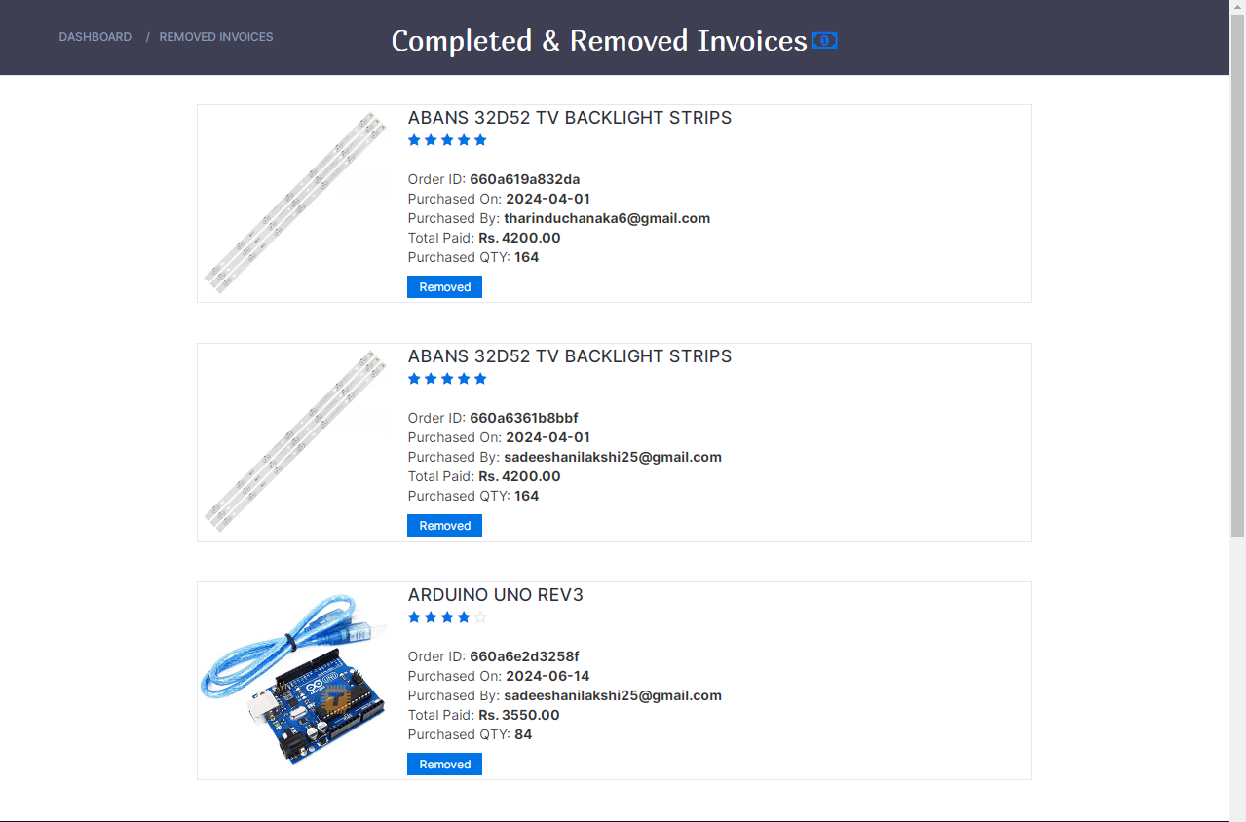

This is the Removed Invoice page UI. The items that has been purchased by customers and after comlpleting the delivery process if they deleted their purchasing history, those items are added to this page.

<!DOCTYPE html>

<html>

<?php session_start(); ?>

<head>

<meta charset="utf-8" />

<meta name="viewport" content="width=device-width, initial-scale=1" />

<title>Completed & removed Invoices</title>

<link href="https://fonts.googleapis.com/css?family=Montserrat:400,500,700" rel="stylesheet">

<link type="text/css" rel="stylesheet" href="css/bootstrap.min.css" />

<link type="text/css" rel="stylesheet" href="css/slick.css" />

<link type="text/css" rel="stylesheet" href="css/slick-theme.css" />

<link type="text/css" rel="stylesheet" href="css/nouislider.min.css" />

<link rel="stylesheet" href="css/font-awesome.min.css">

<link type="text/css" rel="stylesheet" href="css/style.css" />

<!-- <link rel="stylesheet" href="bootstrap.css" />

<link rel="stylesheet" href="bootstrap-icons.css" /> -->

<link rel="stylesheet" href="style.css" />

<link rel="stylesheet" href="bootstrap-icons.css" />

<link rel="icon" href="resources/logo.png" />

</head>

<body>

<?php

if (isset($_SESSION["aduser"])) {

?>

<div class="container-fluid vh-100">

<div class="row">

<div class="col-12 d-flex justify-content-center vh-100">

<!-- BREADCRUMB -->

<div id="breadcrumb" class="section" style="height:80px; background-color: rgba(43, 45, 66, 0.91);">

<!-- container -->

<div class="container">

<!-- row -->

<div class="row bread">

<div class="col-md-3 breadcrumb-resp" style="margin-top: 20px;">

<ul class="breadcrumb-tree">

<li><a href="html\index.php">Dashboard</a></li>

<li><a href="removedInv.php">Removed Invoices</a></li>

</ul>

</div>

<div class="col-md-6 col-sm-12 col-xs-6 wishlist" style="display: flex; justify-content: center; margin-top: 18px;">

<h2 class="f3" style="font-weight:normal; color: white;">Completed & Removed Invoices </h2>

<a href="#" style="font-size: 24px; margin-left: 5px; color: #0073e6;"> <i class="fa fa-money" aria-hidden="true"></i></a>

</div>

</div> </div>

</div> </div>

</div>

<?php

require "connection.php";

$inv_rs = Database::search("SELECT * FROM `invoice`

INNER JOIN `product` ON `invoice`.`product_id` = `product`.`id`

INNER JOIN `user` ON `invoice`.`user_email` = `user`.`email`

WHERE `remove_status` = '2'");

$inv_num = $inv_rs->num_rows;

if ($inv_num == 0) {

?>

<!-- empty view -->

<div class="col-12 ">

<div class="row">

<div class="col-12 empty-purchasing-history"></div><br>

<div class="col-12 text-center">

<label class="form-label f" style="font-size: 22px; font-weight:normal;">You have not purchased any item yet.

</div>

<div class="col-12 text-center">

<label class="form-label f" style="font-size: 18px; font-weight: lighter;">Check back after your next shopping trip!

</div><br>

<div class="offset-4 col-12 d-grid mb-3" style="display: flex; justify-content: center;">

</div><br>

</div>

</div>

<!-- empty view -->

<?php } else { ?>

<div class="col-12">

<div class="row " style="display: flex; justify-content: center;">

<?php

$query = "SELECT * FROM `product`";

for ($x = 0; $x < $inv_num; $x++) {

$inv_data = $inv_rs->fetch_assoc();

$product_rs = Database::search("SELECT* FROM `product` WHERE `id`='" . $inv_data["product_id"] . "'");

$product_data = $product_rs->fetch_assoc();

$image_rs = Database::search("SELECT * FROM `image` WHERE `product_id`='" . $inv_data["product_id"] . "'");

$image_data = $image_rs->fetch_assoc();

$Rf_rs1 = Database::search("SELECT * FROM `feedback`WHERE `product_id`='" . $product_data["id"] . "' ORDER BY `date` DESC");

$Rf_num1 = $Rf_rs1->num_rows;

$Rf_data1 = $Rf_rs1->fetch_assoc();

$price = $product_data["price"];

$adding_price = ($price / 100) * 5;

$new_price = $price + $adding_price;

$difference = $new_price - $price;

$percentage = ($difference / $price) * 100;

?>

<div class="wishlist-box1 col-lg-12" style="height:200px; width:70%; margin-bottom: 45px;">

<div class="product-wishlist" style="display:flex; flex-direction:row; display: flex; align-items: start; display: flex; justify-content: start;">

<div class="product-image" style="height: 200px; width: 200px;">

<img src="<?php echo $image_data["code"]; ?>" alt="" class="img">

</div>

<div class="product-details" style="margin-left: 15px;">

<span class="product-name"><a href="#"><?php echo $product_data["title"] ?></a></span><br />

<div class="product-rating">

{Star Rating}

</div>

<br> <br>

<span>Order ID: <b><?php echo $inv_data["order_id"] ?></b></span><br>

<span>Purchased On: <b><?php echo $inv_data["date"] ?></b></span><br>

<span>Purchased By: <b><?php echo $inv_data["user_email"] ?></b></span><br>

<span>Total Paid: <b>Rs. <?php echo $inv_data["total"] ?>.00</b></span><br>

<span>Purchased QTY: <b><?php echo $inv_data["qty"] ?></b></span><br>

<div class="product-label1" style="margin-bottom: 6px;">

<span class="new">Removed</span>

</div>

</div>

</div> </div>

</div></div>

<!-- <responsive-Large-screen> -->

<!-- <responsive-medium-screen> -->

<div class="col-12" id="searchresult">

<div class="row " style="display: flex; justify-content: center;">

<div class="wishlist-box2 d-lg-none" style="height:200px; width: 70%; margin-bottom: 120px;">

<div class="product-wishlist" style="display:flex; flex-direction:row; display: flex; align-items: start; display: flex; justify-content: start;">

<div class="product-image">

<img src="<?php echo $image_data["code"]; ?>" alt="" class="img">

</div>

<div class="product-details" style="margin-left: 15px;">

<span class="product-name"><a href="#"><?php echo $product_data["title"] ?></a></span><br />

<div class="product-rating">

//star ratings

</div>

<br> <br>

<span>Order ID: <b><?php echo $inv_data["order_id"] ?></b></span><br>

<span>Purchased On: <b><?php echo $inv_data["date"] ?></b></span><br>

<span>Purchased By: <b><?php echo $inv_data["user_email"] ?></b></span><br>

<span>Total Paid: <b>Rs. <?php echo $inv_data["total"] ?>.00</b></span><br>

<span>Purchased QTY: <b><?php echo $inv_data["qty"] ?></b></span><br>

<div class="product-label1" style="margin-bottom: 6px;">

<span class="new">Removed</span>

</div> </div>

</div>

</div> </div>

</div>

<!-- <responsive-medium-screen> -->

<!-- <responsive-small-screen> -->

<div class="col-12">

<div class="row " style="display: flex; justify-content: center;">

<div class="wishlist-box3" style="height:520px; width:70%; margin-bottom: 15px;">

<div class="product-wishlist" style="display:flex; flex-direction:column; display: flex; align-items: center; display: flex; justify-content: center;">

<div class="product-image" style="width: 80%; height: 275px;">

<img src="<?php echo $image_data["code"]; ?>" alt="" class="img">

</div>

<div class="product-details" style="margin-left: 12px;">

<span class="product-name"><a href="#"><?php echo $product_data["title"] ?></a></span><br />

<div class="product-rating">

….

</div>

<br> <br>

<span>Order ID: <b><?php echo $inv_data["order_id"] ?></b></span><br>

<span>Purchased On: <b><?php echo $inv_data["date"] ?></b></span><br>

<span>Purchased By: <b><?php echo $inv_data["user_email"] ?></b></span><br>

<span>Total Paid: <b>Rs. <?php echo $inv_data["total"] ?>.00</b></span><br>

<span>Purchased QTY: <b><?php echo $inv_data["qty"] ?></b></span><br>

<div class="product-label1" style="margin-bottom: 6px;">

<span class="new">Removed</span>

</div></div>

</div></div>

<?php } ?>

</div>

</div>

<!-- <responsive-small-screen> -->

<?php require "footer.php"; ?>

<?php }

} else {

header("location:home.php"); }

?>

<script src="bootstrap.bundle.js"></script>

<script src="script.js"></script>

</body>

</html>

1. Manage All Users UI & Processes associated with it

**Manage Users User Interface**

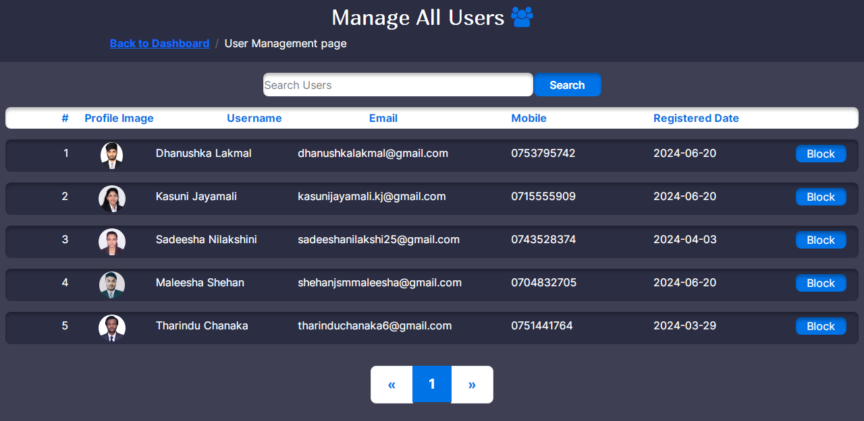

This is the manage user interface. Admin can manage users and view their details here. Admin has the ability to block any user if need from here.

<!DOCTYPE html>

<html>

<!DOCTYPE html>

<html>

<?php

session_start();

require "connection.php";

if (isset($_SESSION["aduser"])) {

$email = $_SESSION["aduser"]["email"];

?>

<head>

<meta charset="utf-8" />

<meta name="viewport" content="width=device-width, initial-scale=1" />

<title>Manage Users</title>

<link rel="stylesheet" href="bootstrap.css" />

<link rel="stylesheet" href="css/font-awesome.min.css" />

<link rel="stylesheet" href="style.css" /

<link rel="icon" href="resources/logo.png" />

</head>

<body class="body" style="background-color: rgba(43, 45, 66, 0.91);">

<div class="col-12">

<div class="row h-25 d-flex justify-content-center" style="background-color: #2b2d42">

<div class="col-lg-6 col-md-5 col-sm-12">

<h2 class="f3 text-white mt-2" style="display: flex; align-items: center; justify-content: center">

Manage All Users

<a href="#" style="font-size: 30px; margin-left: 10px; color: #0073e6"><i class="fa fa-users" aria-hidden="true"></i>

</a>

</h2></div>

<div class="col-10 offset-1">

<nav aria-label="breadcrumb">

<ol class="breadcrumb">

<li class="breadcrumb-item fw-bold"><a href="html/index.php">Back to Dashboard</a></li>

<li class="breadcrumb-item active text-light" aria-current="page">User Management page</li>

</ol>

</nav>

</div> </div>

</div>

<div class="col-12">

<div class="row ">

<div class="col-12 d-flex justify-content-center">

<div class="mt-3">

<input class="input-search rounded-3 manage-search" style="font-size: 16px; border: none; width: 400px; box-shadow: 0px 4px 4px 0px rgba(0, 0, 0, 0.25) inset;" placeholder="Search Users" id="mu">

<button class="search-icon rounded-3" style="font-size: 16px; border: none; background-color: #0073e6; color: white; width: 100px; box-shadow: 0px 4px 4px 0px rgba(0, 0, 0, 0.25) inset;" onclick="searchMU();">Search</button>

</div>

</div>

<div class="col-12 mt-3 d-lg-block d-none">

<div class="row mx-2 rounded-3 " style="background-color: white; box-shadow: 0px 4px 4px 0px rgba(0, 0, 0, 0.25) inset;">

<div class="col-lg-1 text-end">

<label class="form-label f4 fs-6 fw-bold my-1" style="color: #0073e6;">#</label>

</div>

<div class="col-lg-2 ">

<label class="form-label f4 fs-6 fw-bold my-1" style="color: #0073e6;">Profile Image</label></div>

<div class="col-lg-2 ">

<label class="form-label f4 fs-6 fw-bold my-1" style="color: #0073e6;">Username</label></div>

<div class="col-lg-2 ">

<label class="form-label f4 fs-6 fw-bold my-1" style="color: #0073e6;">Email</label></div>

<div class="col-lg-2 ">

<label class="form-label f4 fs-6 fw-bold my-1" style="color: #0073e6;">Mobile</label></div>

<div class="col-lg-2 ">

<label class="form-label f4 fs-6 fw-bold my-1" style="color: #0073e6;">Registered Date</label></div>

</div></div>

<div class="col-12" id="searchResults">

<?ph

$query = "SELECT * FROM `user`";

$pageno;

if (isset($_GET["page"])) {

$pageno = $_GET["page"];

} else {

$pageno = 1;

}

$user_rs = Database::search($query);

$user_num = $user_rs->num_rows;

$results_per_page = 10;

$number_of_pages = ceil($user_num / $results_per_page);

$page_results = ($pageno - 1) * $results_per_page;

$selected_rs = Database::search($query . " LIMIT " . $results_per_page . " OFFSET " . $page_results . "");

$selected_num = $selected_rs->num_rows;

for ($x = 0; $x < $selected_num; $x++) {

$selected_data = $selected_rs->fetch_assoc();

$pro_img_rs = Database::search("SELECT * FROM `profile_image`

WHERE `user_email` = '" . $selected_data["email"] . "';");

$pro_img_data = $pro_img_rs->fetch_assoc(); ?>

<div class="row mx-2 my-3 rounded-3 " style="background-color: #2b2d42; box-shadow: 0px 4px 4px 0px rgba(0, 0, 0, 0.25) inset;">

<div class="col-lg-1 text-end">

<label class="form-label f4 fs-6 my-2 text-white"><?php echo $x + 1; ?></label>

</div>

<div class="col-lg-1 d-flex justify-content-center my-1">

<img src="<?php echo $pro_img_data["path"]; ?>" class="rounded-circle" style="height: 40px;"

</div>

<div class="col-lg-2">

<label class="form-label f4 fs-6 my-2 text-white"><?php echo $selected_data["fname"] . " " . $selected_data["lname"]; ?></label>

</div>

<div class="col-lg-3">

<label class="form-label f4 fs-6 my-2 text-white"><?php echo $selected_data['email']; ?></label>

</div>

<div class="col-lg-2">

<label class="form-label f4 fs-6 my-2 text-white"><?php echo $selected_data['mobile']; ?></label></div>

<div class="col-lg-2">

<label class="form-label f4 fs-6 my-2 text-white"><?php echo $selected_data['join_date']; ?></label></div>

<div class="col-lg-1">

<?php

if ($selected_data["status"] == 1) { ?>

<button id="UB<?php echo $selected_data['email']; ?>" class="rounded-3 text-white my-2" style="background-color: #0073e6; border: none; width: 75px; box-shadow: 0px 4px 4px 0px rgba(0, 0, 0, 0.25) inset;" onclick="blockUser('<?php echo $selected_data['email']; ?>');">Block</button>

<?php } else { ?>

<button id="UB<?php echo $selected_data['email']; ?>" class="rounded-3 text-white my-2" style="background-color: #2b2d42; border: none; width: 75px; box-shadow: 0px 4px 4px 0px rgba(0, 0, 0, 0.25) inset;" onclick="blockUser('<?php echo $selected_data['email']; ?>');">Unblock</button>

<?php } ?>

</div> </div>

<?php } ?>

</div>

<div class="offset-2 offset-lg-3 col-8 col-lg-6 text-center mt-3">

<nav aria-label="Page navigation example">

<ul class="pagination pagination-lg justify-content-center">

<li class="page-item">

<a class="page-link fw-bold" style="color: #0073e6;" href="<?php if ($pageno <= 1) {

echo ("#");

} else {

echo "?page=" . ($pageno - 1);

} ?>" aria-label="Previous">

<span aria-hidden="true">&laquo;</span>

</a>

</li>

<?php

for ($x = 1; $x <= $number_of_pages; $x++) {

if ($x == $pageno) {

?>

<li class="page-item active">

<a class="page-link fw-bold" style="background-color: #0073e6; border: none;" href="<?php echo "?page=" . ($x) ?>"><?php echo $x; ?></a>

</li>

<?php} else { ?>

<li class="page-item">

<a class="page-link fw-bold" style="border: none;" href="<?php echo "?page=" . ($x) ?>"><?php echo $x; ?></a>

</li>

<?php } }

?>

<li class="page-item">

<a class="page-link fw-bold" style="color: #0073e6;" href="<?php if ($pageno >= $number_of_pages) {

echo ("#");

} else {

echo "?page=" . ($pageno + 1);

} ?>" aria-label="Next">

<span aria-hidden="true">&raquo;</span>

</a>

</li> </ul> </nav>

</div> </div>

</div>

<script src="bootstrap.bundle.js"></script>

<script src="script.js"></script>

</body>

</html>

<?php

} else {

header("location:html/index.php");

}

?>

**User Blocking Process**

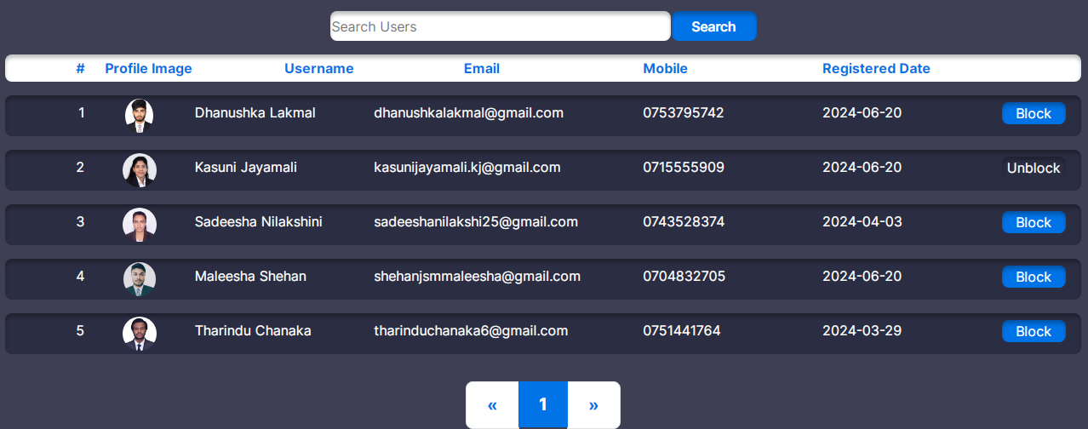

<?php

require "connection.php";

if(isset($_GET["email"])){

$user_email = $_GET["email"];

$user_rs = Database::search("SELECT * FROM `user` WHERE `email` = '".$user_email."' ");

$user_num = $user_rs -> num_rows;

if($user_num == 1){

$user_data = $user_rs -> fetch_assoc();

if($user_data ["status"] == 1){

Database::insUpdelete("UPDATE `user` SET `status` = '0' WHERE `email` = '".$user_email."'");

echo("Blocked");

}else if($user_data ["status"] == 0){

Database::insUpdelete("UPDATE `user` SET `status` = '1' WHERE `email` = '".$user_email."'");

echo("UnBlocked");

}

}else{

echo("Cannot find the user. Please try again later.");

}

}else{

echo("Something Went Wrong");

}

?>

**JavaScript Function**

function blockUser(email) {

var req = new XMLHttpRequest();

req.onreadystatechange = function () {

if (req.readyState == 4) {

var txt = req.responseText;

if (txt == "Blocked") {

document.getElementById("UB" + email).innerHTML = "Unblock";

document.getElementById("UB" + email).classList =

"rounded-3 text-white my-2 style='background-color: #2b2d42; border: none; width: 75px; box-shadow: 0px 4px 4px 0px rgba(0, 0, 0, 0.25) inset;'";

window.location.reload();

} else if (txt == "UnBlocked") {

document.getElementById("UB" + email).innerHTML = "Block";

document.getElementById("UB" + email).classList =

"rounded-3 text-white my-2 style='background-color: #0073e6; border: none; width: 75px; box-shadow: 0px 4px 4px 0px rgba(0, 0, 0, 0.25) inset;'";

window.location.reload();

} else {

alert(txt); } }

};

req.open("GET", "UserBlockProcess.php?email=" + email, true);

req.send();

}

**User Searching Process**

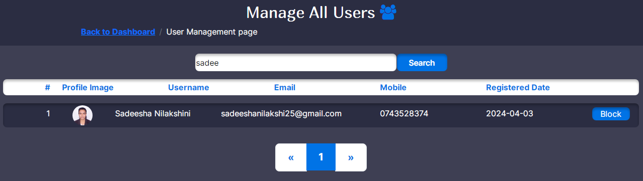

This is the manage users interface searched view. Admin can search users using the search bar.

<?php

session_start();

require "connection.php";

if (isset($_GET["mu"])) {

$search = $_GET["mu"];

$query = "SELECT * FROM `user`";

$p_rs = Database::search($query . "WHERE `fname` LIKE '%" . $search . "%' LIMIT 1");

$p_num = $p_rs->num_rows;

if ($p_num == 0) {

echo ("No users you are sarching for");

} else {

for ($x = 0; $x < $p_num; $x++) {

$p_data = $p_rs->fetch_assoc();

$pro_img_rs = Database::search("SELECT * FROM `profile_image`

WHERE `user_email` = '" . $p_data["email"] . "';");

$pro_img_data = $pro_img_rs->fetch_assoc();

?>

<div class="col-12">

<div class="row mx-2 my-3 rounded-3" style="background-color: #2b2d42; box-shadow: 0px 4px 4px 0px rgba(0, 0, 0, 0.25) inset;">

<div class="col-lg-1 text-end">

<label class="form-label f4 fs-6 my-2 text-white"><?php echo $x + 1; ?></label></div>

<div class="col-lg-1 d-flex justify-content-center my-1">

<img src="<?php echo $pro_img_data["path"]; ?>" class="rounded-circle" style="height: 40px;"></div>

<div class="col-lg-2 ">

<label class="form-label f4 fs-6 my-2 text-white"><?php echo $p_data["fname"] . " " . $p_data["lname"]; ?></label></div>

<div class="col-lg-3 ">

<label class="form-label f4 fs-6 my-2 text-white"><?php echo $p_data['email']; ?></label></div>

<div class="col-lg-2 ">

<label class="form-label f4 fs-6 my-2 text-white"><?php echo $p_data['mobile']; ?></label></div>

<div class="col-lg-2 ">

<label class="form-label f4 fs-6 my-2 text-white"><?php echo $p_data['join_date']; ?></label></div>

<div class="col-lg-1">

<?php

if ($p_data["status"] == 1) {

?>

<button id="UB<?php echo $p_data['email']; ?>" class="rounded-3 text-white my-2" style="background-color: #0073e6; border: none; width: 75px; box-shadow: 0px 4px 4px 0px rgba(0, 0, 0, 0.25) inset;" onclick="blockUser('<?php echo $p_data['email']; ?>');">Block</button>

<?php

} else {

?>

<button id="UB<?php echo $p_data['email']; ?>" class="rounded-3 text-white my-2" style="background-color: #2b2d42; border: none; width: 75px; box-shadow: 0px 4px 4px 0px rgba(0, 0, 0, 0.25) inset;" onclick="blockUser('<?php echo $p_data['email']; ?>');">Unblock</button>

<?php } ?>

</div</div>

</div>

<?php } ?>

<?php } } ?>

**JavaScript Function**

function searchMU() {

var search = document.getElementById("mu").value;

var request = new XMLHttpRequest();

request.onreadystatechange = function () {

if (request.readyState == 4) {

var text = request.responseText;

document.getElementById("searchResults").innerHTML = text; } };

request.open("GET", "SearchInmanageUser.php?mu=" + search, true);

request.send();

}

1. Manage All Products UI & Processes associated with it

**Manage All Products User Interface**

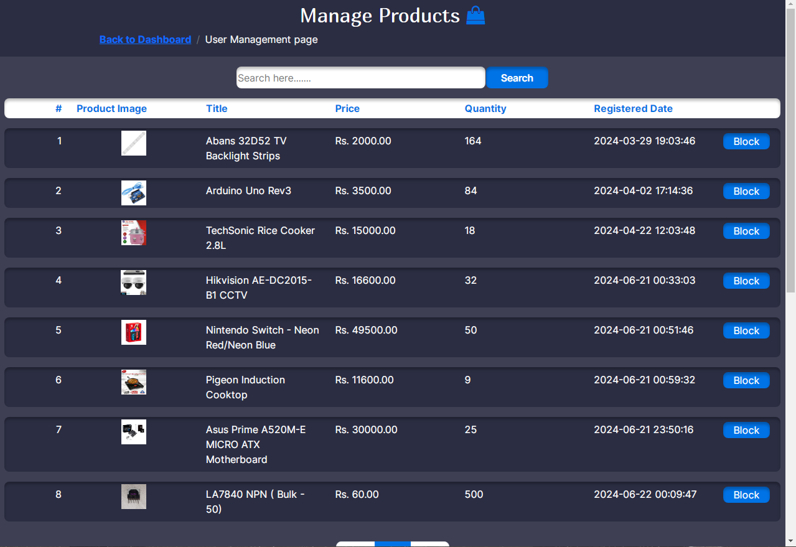

This is the manage product interface. Product details are viewed here and admin can block products if needed using the ‘block’ button.

<!DOCTYPE html>

<html>

<?php

session_start();

require "connection.php";

if (isset($_SESSION["aduser"])) {

$email = $_SESSION["aduser"]["email"];

?>

<head>

<meta charset="utf-8" />

<meta name="viewport" content="width=device-width, initial-scale=1" />

<title>Manage Products</title>

<link rel="stylesheet" href="bootstrap.css" />

<link rel="stylesheet" href="css/font-awesome.min.css" />

<link rel="stylesheet" href="style.css" />

<link rel="icon" href="resources/logo.png" />

</head>

<body class="body" style="background-color: rgba(43, 45, 66, 0.91);">

<div class="col-12">

<div class="row h-25 d-flex justify-content-center" style="background-color: #2b2d42">

<div class="col-lg-6 col-md-5 col-sm-12">

<h2 class="f3 text-white mt-2" style="display: flex; align-items: center; justify-content: center">

Manage Products

<a href="#" style="font-size: 30px; margin-left: 10px; color: #0073e6"><i class="fa fa-shopping-bag" aria-hidden="true"></i>

</a>

</h2></div>

<div class="col-10 offset-1">

<nav aria-label="breadcrumb">

<ol class="breadcrumb">

<li class="breadcrumb-item fw-bold"><a href="html/index.php">Back to Dashboard</a></li>

<li class="breadcrumb-item active text-light" aria-current="page">User Management page</li>

</ol>

</nav></div>

</div</div>

<div class="col-12">

<div class="row ">

<div class="col-12 d-flex justify-content-center">

<div class="mt-3">

<input class="input-search rounded-3 manage-search" style="font-size: 16px; border: none; width: 400px; box-shadow: 0px 4px 4px 0px rgba(0, 0, 0, 0.25) inset;" placeholder="Search here......." id="mp">

<button class="search-icon rounded-3 " style="font-size: 16px; border: none; background-color: #0073e6; color: white; width: 100px; box-shadow: 0px 4px 4px 0px rgba(0, 0, 0, 0.25) inset;" onclick="searchMP();">Search</button>

</div></div>

<div class="col-12 mt-3 d-lg-block d-none">

<div class="row mx-2 rounded-3 " style="background-color: white; box-shadow: 0px 4px 4px 0px rgba(0, 0, 0, 0.25) inset;">

<div class="col-lg-1 text-end">

<label class="form-label f4 fs-6 fw-bold my-1" style="color: #0073e6;">#</label>

</div>

<div class="col-lg-2 ">

<label class="form-label f4 fs-6 fw-bold my-1" style="color: #0073e6;">Product Image</label>

</div>

<div class="col-lg-2 ">

<label class="form-label f4 fs-6 fw-bold my-1" style="color: #0073e6;">Title</label></div>

<div class="col-lg-2 ">

<label class="form-label f4 fs-6 fw-bold my-1" style="color: #0073e6;">Price</label></div>

<div class="col-lg-2 ">

<label class="form-label f4 fs-6 fw-bold my-1" style="color: #0073e6;">Quantity</label></div>

<div class="col-lg-2 ">

<label class="form-label f4 fs-6 fw-bold my-1" style="color: #0073e6;">Registered Date</label></div>

</div></div>

<div class="col-12" id="searchResults">

<?php

$query = "SELECT * FROM `product`";

$pageno;

if (isset($_GET["page"])) {

$pageno = $_GET["page"];

} else {

$pageno = 1;

}

$product_rs = Database::search($query);

$product_num = $product_rs->num_rows;

$results_per_page = 10;

$number_of_pages = ceil($product_num / $results_per_page);

$page_results = ($pageno - 1) * $results_per_page;

$selected_rs = Database::search($query . " LIMIT " . $results_per_page . " OFFSET " . $page_results . "");

$selected_num = $selected_rs->num_rows;

for ($x = 0; $x < $selected_num; $x++) {

$selected_data = $selected_rs->fetch_assoc();

$product_img_rs = Database::search("SELECT * FROM `image` WHERE `product_id` = '" . $selected_data["id"] . "';");

$product_img_data = $product_img_rs->fetch_assoc();

?>

<div class="row mx-2 my-3 rounded-3 " style="background-color: #2b2d42; box-shadow: 0px 4px 4px 0px rgba(0, 0, 0, 0.25) inset;">

<div class="col-lg-1 text-end">

<label class="form-label text-white f4 fs-6 my-2"><?php echo $selected_data["id"]; ?></label>

</div>

<div class="col-lg-2 d-flex justify-content-center my-1">

<img src="<?php echo $product_img_data["code"]; ?>" style="height: 40px;">

</div>

<div class="col-lg-2 ">

<label class="form-label f4 fs-6 my-2 text-white"><?php echo $selected_data["title"]; ?></label></div>

<div class="col-lg-2 ">

<label class="form-label f4 fs-6 my-2 text-white">Rs. <?php echo $selected_data["price"]; ?>.00</label></div>

<div class="col-lg-2 ">

<label class="form-label f4 fs-6 my-2 text-white"><?php echo $selected_data["qty"]; ?></label></div>

<div class="col-lg-2 ">

<label class="form-label f4 fs-6 my-2 text-white"><?php echo $selected_data["datetime_added"]; ?></label>

</div><div class="col-lg-1">

<?php

if ($selected_data["status_id"] == 1) {

?>

<button id="pb<?php echo $selected_data['id']; ?>" class="rounded-3 text-white my-2" style="background-color: #0073e6; border: none; width: 75px; box-shadow: 0px 4px 4px 0px rgba(0, 0, 0, 0.25) inset;" onclick="blockProduct('<?php echo $selected_data['id']; ?>');">Block</button>

<?php } else { ?>

<button id="pb<?php echo $selected_data['id']; ?>" class="rounded-3 text-white my-2" style="background-color: #2b2d42; border: none; width: 75px; box-shadow: 0px 4px 4px 0px rgba(0, 0, 0, 0.25) inset;" onclick="blockProduct('<?php echo $selected_data['id']; ?>');">Unblock</button>

<?php } ?>

</div> </div>

<?php } ?>

</div>

<div class="offset-2 offset-lg-3 col-8 col-lg-6 text-center mt-3">

<nav aria-label="Page navigation example">

<ul class="pagination pagination-lg justify-content-center">

<li class="page-item">

<a class="page-link fw-bold" style="color: #0073e6;" href="<?php if ($pageno <= 1) {

echo ("#");

} else {

echo "?page=" . ($pageno - 1);

} ?>" aria-label="Previous">

<span aria-hidden="true">&laquo;</span>

</a> </li>

<?php

for ($x = 1; $x <= $number_of_pages; $x++) {

if ($x == $pageno) {

?>

<li class="page-item active">

<a class="page-link fw-bold" style="background-color: #0073e6; border: none;" href="<?php echo "?page=" . ($x) ?>"><?php echo $x; ?></a>

</li>

<?php} else {?>

<li class="page-item">

<a class="page-link fw-bold" style="border: none;" href="<?php echo "?page=" . ($x) ?>"><?php echo $x; ?></a>

</li>

<?php } } ?>

<li class="page-item">

<a class="page-link fw-bold" style="color: #0073e6;" href="<?php if ($pageno >= $number_of_pages) {

echo ("#");

} else {

echo "?page=" . ($pageno + 1);

} ?>" aria-label="Next">

<span aria-hidden="true">&raquo;</span>

</a></li>

</ul>

</nav>

</div>

</div>

<div class="offset-2 offset-lg-3 col-8 col-lg-6 text-center mt-3">

<nav aria-label="Page navigation example">

<ul class="pagination pagination-lg justify-content-center">

<li class="page-item">

<a class="page-link fw-bold" style="color: #0073e6;" href="<?php if ($pageno <= 1) {

echo ("#");

} else {

echo "?page=" . ($pageno - 1);

} ?>" aria-label="Previous">

<span aria-hidden="true">&laquo;</span>

</a>

</li>

<?php

for ($x = 1; $x <= $number_of_pages; $x++) {

if ($x == $pageno) {

?>

<li class="page-item active">

<a class="page-link fw-bold" style="background-color: #0073e6; border: none;" href="<?php echo "?page=" . ($x) ?>"><?php echo $x; ?></a>

</li>

<?php} else {?>

<li class="page-item">

<a class="page-link fw-bold" style="border: none;" href="<?php echo "?page=" . ($x) ?>"><?php echo $x; ?></a>

</li>

<?php } } ?>

<li class="page-item">

<a class="page-link fw-bold" style="color: #0073e6;" href="<?php if ($pageno >= $number_of_pages) {

echo ("#");

} else {

echo "?page=" . ($pageno + 1);

} ?>" aria-label="Next">

<span aria-hidden="true">&raquo;</span>

</a>

</li>

</ul>

</nav>

</div>

**Product Blocking Process**

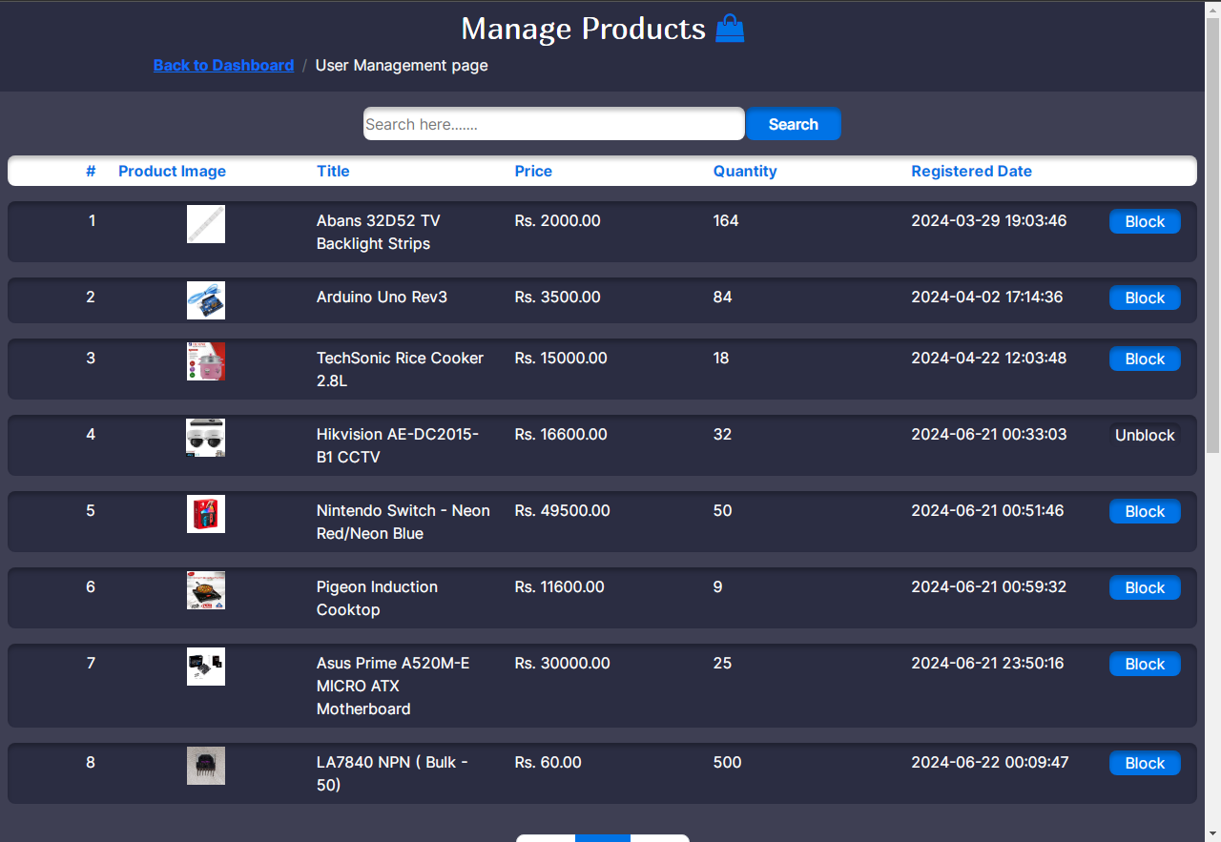

After blocking a product the button chage into ‘unblock’. Admin can unblock the product it he needed.

<?php

require "connection.php";

if(isset($_GET["id"])){

$pid = $_GET["id"];

$product_rs = Database::search("SELECT * FROM `product` WHERE `id`='".$pid."'");

$product_num = $product_rs->num_rows;

if($product_num == 1){

$product_data = $product_rs->fetch_assoc();

if($product_data["status_id"] == 1){

Database::insUpdelete("UPDATE `product` SET `status_id`= '2' WHERE `id`='".$pid."'");

echo ("blocked");

}else if($product_data["status_id"] == 2){

Database::insUpdelete("UPDATE `product` SET `status_id`= '1' WHERE `id`='".$pid."'");

echo ("unblocked");

}}else{

echo ("Cannot find the product. Please try again later.");

}

}else{

echo ("Something went wrong.");

}

?>

**JavaScript Function**

function blockProduct(id) {

var request = new XMLHttpRequest();

request.onreadystatechange = function () {

if (request.readyState == 4) {

var txt = request.responseText;

if (txt == "unblocked") {

document.getElementById("pb" + id).innerHTML = "Unblock";

document.getElementById("pb" + id).classList =

"rounded-3 text-white my-2 style='background-color: #2b2d42; border: none; width: 75px; box-shadow: 0px 4px 4px 0px rgba(0, 0, 0, 0.25) inset;'";

window.location.reload();

} else if (txt == "blocked") {

document.getElementById("pb" + id).innerHTML = "Block";

document.getElementById("pb" + id).classList =

"rounded-3 text-white my-2 style='background-color: #0073e6; border: none; width: 75px; box-shadow: 0px 4px 4px 0px rgba(0, 0, 0, 0.25) inset;'";

window.location.reload();

} else {

alert(txt);

}}};

request.open("GET", "productBlockProcess.php?id=" + id, true);

request.send();

}

**Searching Product Process**

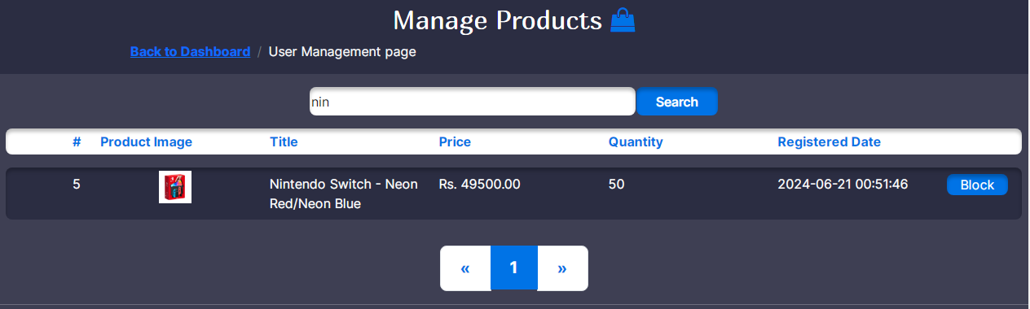

This the manage product interface searched view. After searching a product using the search bar, searched product is viewed like this.

<?php

session_start();

require "connection.php";

if (isset($_GET["mp"])) {

$search = $_GET["mp"];

$query = "SELECT * FROM `product`";

$p_rs = Database::search($query . "WHERE `title` LIKE '%" . $search . "%'");

$p_num = $p_rs->num_rows;

if ($p_num == 0) {

echo ("There is not that kind a product");

} else {

for ($x = 0; $x < $p_num; $x++) {

$p_data = $p_rs->fetch_assoc();

$product_img_rs = Database::search("SELECT * FROM `image`

WHERE `product_id` = '" . $p_data["id"] . "';");

$product_img_data = $product_img_rs->fetch_assoc();

?>

<div class="col-12">

<div class="row mx-2 my-3 rounded-3 " style="background-color: #2b2d42; box-shadow: 0px 4px 4px 0px rgba(0, 0, 0, 0.25) inset;">

<div class="col-lg-1 text-end">

<label class="form-label text-white f4 fs-6 my-2"><?php echo $p_data["id"]; ?></label></div>

<div class="col-lg-2 d-flex justify-content-center my-1">

<img src="<?php echo $product_img_data["code"]; ?>" style="height: 40px;"></div>

<div class="col-lg-2 ">

<label class="form-label f4 fs-6 my-2 text-white"><?php echo $p_data["title"]; ?></label></div>

<div class="col-lg-2 ">

<label class="form-label f4 fs-6 my-2 text-white">Rs. <?php echo $p_data["price"]; ?>.00</label></div>

<div class="col-lg-2 ">

<label class="form-label f4 fs-6 my-2 text-white"><?php echo $p_data["qty"]; ?></label></div>

<div class="col-lg-2 ">

<label class="form-label f4 fs-6 my-2 text-white"><?php echo $p_data["datetime_added"]; ?></label>

</div>

<div class="col-lg-1">

<?php

if ($p_data["status_id"] == 1) {

?>

<button id="pb<?php echo $p_data['id']; ?>" class="rounded-3 text-white my-2" style="background-color: #0073e6; border: none; width: 75px; box-shadow: 0px 4px 4px 0px rgba(0, 0, 0, 0.25) inset;" onclick="blockProduct('<?php echo $p_data['id']; ?>');">Block</button>

<?php } else { ?>

<button id="pb<?php echo $p_data['id']; ?>" class="rounded-3 text-white my-2" style="background-color: #2b2d42; border: none; width: 75px; box-shadow: 0px 4px 4px 0px rgba(0, 0, 0, 0.25) inset;" onclick="blockProduct('<?php echo $p_data['id']; ?>');">Unblock</button>

<?php } ?>

</div></div>

</div>

<?php } ?>

<?php } } ?>

**JavaScript Function**

function searchMP() {

var search = document.getElementById("mp").value;

var request = new XMLHttpRequest();

request.onreadystatechange = function () {

if (request.readyState == 4) {

var text = request.responseText;

document.getElementById("searchResults").innerHTML = text; } };

request.open("GET", "SearchINmanageProduct.php?mp=" + search, true);

request.send();

}

1. Manage Categories UI & Processes associated with it

**Manage Category User Interface**

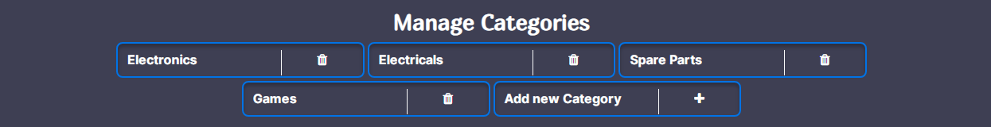

In the manage product interface there is a part added to manage categories. Admin can add new categories or delete categories here.

<hr style="color: white;" />

<div class="col-12 text-center">

<h3 class=" fw-bold text-white f3">Manage Categories</h3>

</div>

<div class="col-12 mb-3">

<div class="row gap-1 justify-content-center mx-2">

<?php

$category_rs = Database::search("SELECT * FROM `category`");

$category_num = $category_rs->num_rows;

for ($x = 0; $x < $category_num; $x++) {

$category_data = $category_rs->fetch_assoc();?>

<div class="col-12 col-lg-3 rounded-3" style="height: 45px; border: 2px solid #0073e6; box-shadow: 0px 4px 4px 0px rgba(0, 0, 0, 0.25) inset;">

<div class="row">

<div class="col-8 mt-2 mb-2">

<label class="form-label fw-bold fs-6 text-white f4"><?php echo $category_data["name"]; ?></label>

</div>

<div class="col-4 border-start border-light text-center mt-2 mb-2">

<label class="form-label fs-6 text-white"><i class="fa fa-trash"></i></label>

</div></div>

</div>

<?php } ?>

<div class="col-12 col-lg-3 rounded-3" style="height: 45px; border: 2px solid #0073e6; box-shadow: 0px 4px 4px 0px rgba(0, 0, 0, 0.25) inset;" onclick="addNewCategory();">

<div class="row">

<div class="col-8 mt-2 mb-2">

<label class="form-label fw-bold fs-6 text-white">Add new Category</label>

</div>

<div class="col-4 border-start border-light text-center mt-2 mb-2">

<label class="form-label fs-6 text-white"><i class="fa fa-plus" aria-hidden="true"></i>

</label>

</div></div>

</div></div>

</div>

<div class="col-12 text-center">

<h3 class=" fw-bold text-white f3">Add Images For Categories</h3>

</div>

<div class="col-12 d-none" id="addmsgdiv">

<div class="alert alert-success" role="alert" id="addalertdiv">

<i class="bi bi-check2-circle fs-5" id="addmsg">

</i>

</div></div>

<div class="col-lg-3 offset-lg-3 d-flex justify-content-center">

<select class="form-select text-center text-white rounded-4" id="category1" style="height: 40px; background-color: #2b2d42; border: 2px solid white; box-shadow: 0px 4px 4px 0px rgba(0, 0, 0, 0.25) inset; font-size: medium;">

<?php

$category_rs = Database::search("SELECT * FROM `category`");

$category_num = $category_rs->num_rows;

for ($x = 0; $x < $category_num; $x++) {

$category_data = $category_rs->fetch_assoc();?>

<option value="<?php echo $category_data["c_id"]; ?>">

<?php echo $category_data["name"]; ?>

</option>

<?php } ?>

</select>

</div>

<div class="col-12 col-lg-3 d-flex justify-content-center">

<input type="file" class="d-none" id="imageuploder" />

<label for="imageuploder" class="col-12 btn btn-outline-primary fw-bold text-white" style="box-shadow: 0px 4px 4px 0px rgba(0, 0, 0, 0.25) inset;" onclick="changeProductimg();">Upload Images</label>

</div>

<div class="col-lg-12 text-center">

<div class="col-lg-6 offset-lg-3 col-md-4 col-sm-10 offset-sm-1 d-flex justify-content-center border border-light rounded my-2">

<img src="resources/addproductimg.svg" class="img-fluid" style="width:350px; height:350px;" id="i0" />

</div>

</div>

<div class="col-lg-6 offset-lg-3 col-md-4 col-sm-10 offset-sm-1 d-flex justify-content-center">

<button class="btn btn-outline-primary fw-bold text-white" style="box-shadow: 0px 4px 4px 0px rgba(0, 0, 0, 0.25) inset;" onclick="addCatImg();">Add Category Image</button>

</div>

<div class="col-12">

<hr class="" style="border-width: 3px; color: white;" />

</div>

<!-- modal 2 -->

<div class="modal" tabindex="-1" id="addCategoryModal">

<div class="modal-dialog">

<div class="modal-content">

<div class="modal-header" style="color: #ffffff; background-color: #2b2d42;">

<h5 class="modal-title text-uppercase fw-bold">Add New Category</h5>

<button type="button" class="btn-close bg-light text-light border border-2 border-danger" data-bs-dismiss="modal" aria-label="Close"></button>

</div>

<div class="modal-body body3">

<div class="col-12">

<input type="text" class="form-control border border-2 border-primary text-primary" placeholder="Enter new category........" id="m" />

</div>

<br>

<div class="col-12">

<input type="text" class="form-control border border-2 border-success text-primary" placeholder="Enter Your Email........" id="e" />

</div>

</div>

<div class="modal-footer" style="color: #ffffff; background-color: #2b2d42;">

<button type="button" class="btn bg-dark text-danger border border-2 border-danger rounded text-uppercase fw-bold" data-bs-dismiss="modal">Close</button>

<button type="button" class="btn bg-dark text-primary border border-2 border-primary rounded text-uppercase fw-bold" onclick="verifyCategory();">Save New Category</button>

</div>

</div>

</div>

</div>

<div class="modal" tabindex="-1" id="addCategoryVerificationModal">

<div class="modal-dialog">

<div class="modal-content">

<div class="modal-header" style="color: #ffffff; background-color: #2b2d42;">

<h5 class="modal-title text-uppercase fw-bold" style="color: #ffffff;">Verification</h5>

<button type="button" class="btn-close" data-bs-dismiss="modal" aria-label="Close"></button>

</div>

<div class="modal-body body3">

<div class="col-12 mt-3 mb-3">

<label class="form-label text-light fw-bold">Enter Verification Code :</label>

<input type="text" class="form-control bg-black text-white fw-bold border border-2 border-info " id="modaltxt" />

</div></div>

<div class="modal-footer" style="color: #ffffff; background-color: #2b2d42;">

<button type="button" class="btn bg-dark text-danger border border-2 border-danger rounded text-uppercase fw-bold" data-bs-dismiss="modal">Close</button>

<button type="button" class="btn bg-dark text-info border border-2 border-info rounded text-uppercase fw-bold" onclick="saveCategory();">Verify & Save</button>

</div></div>

</div></div>

</div></div>

**Add New Category Process**

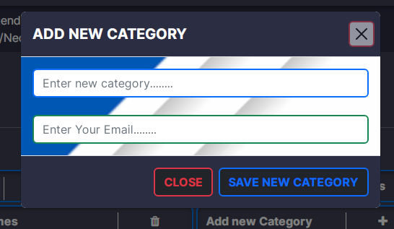

This is the add new category model. After clicking the add new category button in manage products interface, this model is viewd. Admin can add a new category here.

<?php

session_start();

require "connection.php";

require "SMTP.php";

require "PHPMailer.php";

require "Exception.php";

use PHPMailer\PHPMailer\PHPMailer;

if (isset($_POST["email"]) && isset($_POST["name"])) {

if ($_SESSION["aduser"]["email"] == $_POST["email"]) {

$cname = $_POST["name"];

$umail = $_POST["email"];

$category_rs = Database::search("SELECT * FROM `category` WHERE `name` LIKE '%" . $cname . "%'");

$category_num = $category_rs->num_rows;

if ($category_num == 0) {

$code = uniqid();

Database::insUpdelete("UPDATE `admin` SET `verification_code` = '" . $code . "' WHERE `email` = '" . $umail . "'");

//Email Code

$mail = new PHPMailer;

$mail->IsSMTP();

$mail->Host = 'smtp.gmail.com';

$mail->SMTPAuth = true;

$mail->Username = 'tharibro2211@gmail.com';

$mail->Password = 'osproabgubeizhym';

$mail->SMTPSecure = 'ssl';

$mail->Port = 465;

$mail->setFrom('tharibro2211@gmail.com', 'Admin has asked to add a new Category');

$mail->addReplyTo('tharibro2211@gmail.com', 'Chanaka Electronics Admin category Verification Permission');

$mail->addAddress($umail);

$mail->isHTML(true);

$mail->Subject = 'Admin has asked to add a new Category';

$bodyContent = '<h2 style="color:blue;">Before Add the new Category You need to verify your self with given code. Your code is ' . $code . '</h2>';

$mail->Body = $bodyContent;

if ($mail->send()) {

echo "success";

} else {

echo 'Verification code sending failed'; }

//Email Code

} else {

echo ("This Category Already Exists"); }

} else {

echo ("Invalid User"); }

} else {

echo ("Something Missing");

}

**JavaScript Function**

var cm;

function addNewCategory() {

var mo = document.getElementById("addCategoryModal");

cm = new bootstrap.Modal(mo);

cm.show(); }

var vc;

var e;

var m;

function verifyCategory() {

var mcm = document.getElementById("addCategoryVerificationModal");

vc = new bootstrap.Modal(mcm);

e = document.getElementById("e").value;

m = document.getElementById("m").value;

var f = new FormData();

f.append("email", e);

f.append("name", m);

var req = new XMLHttpRequest();

req.onreadystatechange = function () {

if (req.readyState == 4) {

var txt = req.responseText;

if (txt == "success") {

cm.hide();

vc.show();

} else {

alert(txt); } }

};

req.open("POST", "addNewCategoryPRocess.php", true);

req.send(f); }

**Save New Category Process**

<?php

require "connection.php";

if(isset($_POST["t"])&& isset($_POST["e"])&& isset($_POST["m"])){

$vcode = $_POST["t"];

$umail = $_POST["e"];

$cname = $_POST["m"];

$admin_rs = Database::search("SELECT * FROM `admin` WHERE `email` = '".$umail."'");

$admin_num = $admin_rs -> num_rows;

if($admin_num >0){

$admin_data = $admin_rs -> fetch_assoc();

if($admin_data["verification_code"] == $vcode){

Database::insUpdelete("INSERT INTO `category` (`name`) VALUES('".$cname."')");

echo("success");

}else{

echo("Invalid Verification Code");

}

}else{

echo("Invalid User");

} } ?>

**JavaScript Function**

function saveCategory() {

var txt = document.getElementById("modaltxt").value;

var form = new FormData();

form.append("t", txt);

form.append("e", e);

form.append("m", m);

var req = new XMLHttpRequest();

req.onreadystatechange = function () {

if (req.readyState == 4) {

var t = req.responseText;

if (t == "success") {

vc.hide();

window.location.reload();

} else {

alert(t); } }

};

req.open("POST", "SaveCategoryProcess.php", true);

req.send(form);

}

**Add Images for Categories**

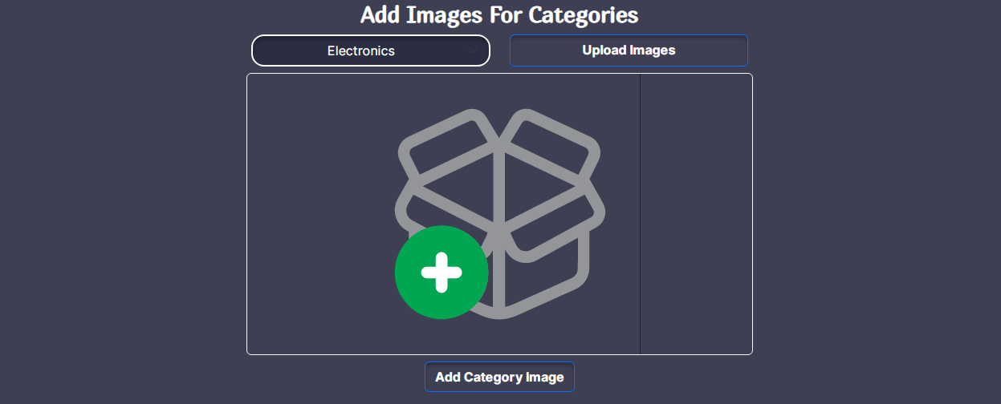

After adding the new category name, an image can be selected to view in the home page under categories from here.

<?php

session_start();

require "connection.php";

$email = $_SESSION["aduser"]["email"];

$category = $_POST["category"];

if ($category == "0") {

echo ("Please select a category");

} else {

$length = sizeof($_FILES); //We can get a length of array using sizeof

if ($length <= 1 && $length > 0) {

$allowed_img_extension = array("image/jpeg", "image/jpg", "image/png", "image/svg+xml");

for ($x = 0; $x < $length; $x++) {

if (isset($_FILES["img" . $x])) {

$image_file = $_FILES["img" . $x];

$file_ex = $image_file["type"];

if (in_array($file_ex, $allowed_img_extension)) {

$new_img_ex;

if ($file_ex == "image/jpg") {

$new_img_ex = ".jpg";

} else if ($file_ex == "image/jpeg") {

$new_img_ex = ".jpeg";

} else if ($file_ex == "image/png") {

$new_img_ex = ".png";

} else if ($file_ex == "image/svg+xml") {

$new_img_ex = ".svg";

}

$file_name = "category//" . $x . "_" . uniqid() . $new_img_ex;

move_uploaded_file($image_file["tmp_name"], $file_name);

Database::insUpdelete("UPDATE `category` SET `path` = '" . $file_name . "' WHERE `c_id` = '" . $category. "'");

} else {

echo ("invalid Image type"); } } }

echo ("Category Saved Successfully");

} else {

echo ("Invalid Image count");

} }

**JavaScript Function**

function addCatImg() {

var category = document.getElementById("category1");

var image = document.getElementById("imageuploder");var form = new FormData();

form.append("category", category.value);

var file_count = image.files.length;

for (var x = 0; x < file_count; x++) {

form.append("img" + x, image.files[x]);

}

var request = new XMLHttpRequest();

request.onreadystatechange = function () {

if (request.readyState == 4) {

var text7 = request.responseText;

if (text7 == "Product Saved Successfully") {

document.getElementById("addmsg").innerHTML = text7;

document.getElementById("addmsg").className =

"bi bi-x-octagon-fill fs-5";

document.getElementById("addalertdiv").className = "alert alert-danger";

document.getElementById("addmsgdiv").className = "d-block";

} else {

window.location.reload();

document.getElementById("addmsg").innerHTML = text7;

document.getElementById("addmsg").className =

"bi bi-check2-circle fs-5";

document.getElementById("addalertdiv").className =

"alert alert-success";

document.getElementById("addmsgdiv").className = "d-block"; } }

};

request.open("POST", "AddCatImg.php", true);

request.send(form);

}

1. Chatapp (Chat with your customers)

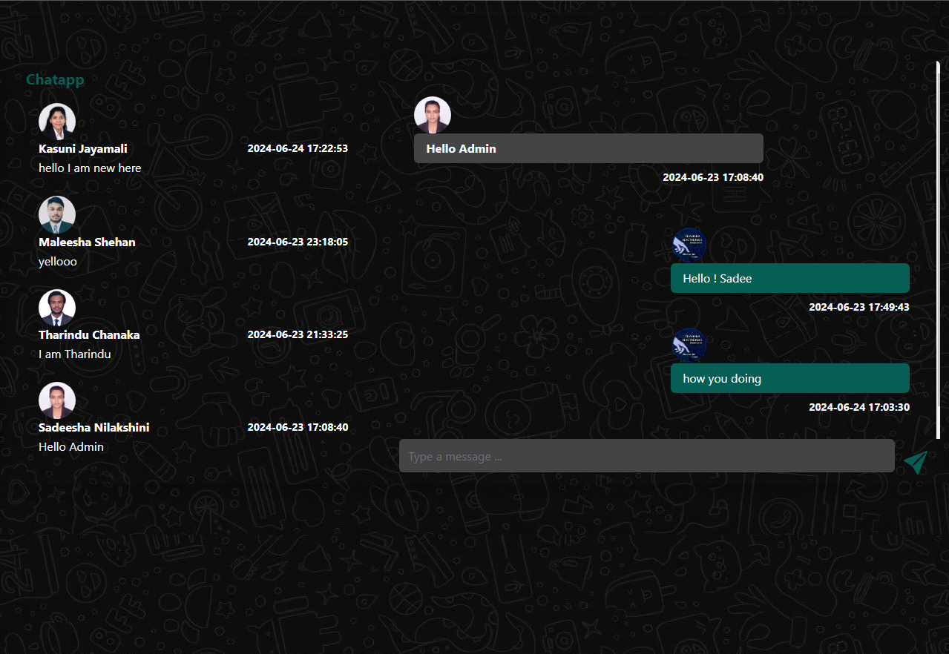

There you can chat with customers and gain business relationship

**Chatapp UI code**

!DOCTYPE html>

<html>

<head>

<meta charset="UTF-8">

<meta name="viewport" content="width=device-width, initial-scale=1.0">

<title>Chatapp | Chanaka Electronics</title>

<link rel="stylesheet" href="bootstrap.css" />

<link rel="stylesheet" href="https://cdn.jsdelivr.net/npm/bootstrap-icons@1.9.1/font/bootstrap-icons.css">

<link rel="stylesheet" href="style.css" />

<link rel="icon" href="resources/logo.png" />

</head>

<body style="background-image:url('resources/0a755a111030c39fca13d9fa38931f20.jpg');">

<div class="container-fluid">

<div class="row">

<?php include "connection.php";

session_start();

if (isset($_SESSION["aduser"])) {

$mail = $_SESSION["aduser"]["email"];

?>

<div class="col-12">

<hr />

</div>

<div class="col-12 py-5 px-4">

<div class="row overflow-hidden shadow rounded">

<div class="col-12 col-lg-5 px-0">

<div class="bg-transparent">

<div class="bg-transparent px-4 py-2">

<div class="col-12">

<h5 class="mb-0 py-1 fw-bold" style="color: #075E54;">Chatapp</h5>

</div>

<div class="col-12">

<?php

$msg_rs = Database::search("SELECT DISTINCT * FROM `chat` WHERE `toadmin`='chanakaelectro@gmail.com' ORDER BY `datetime` DESC");

$msg_num = $msg_rs->num_rows;

?>

<ul class="nav nav-tabs" id="myTab" role="tablist">

<li class="nav-item" role="presentation">

<button class="nav-link active" id="home-tab" data-bs-toggle="tab" data-bs-target="#home" type="button" role="tab" aria-controls="home" aria-selected="true">Received</button></li>

<li class="nav-item" role="presentation">

<button class="nav-link" id="profile-tab" data-bs-toggle="tab" data-bs-target="#profile" type="button" role="tab" aria-controls="profile" aria-selected="false">Sent</button></li></ul>

<div class="tab-content" id="myTabContent">

<div class="tab-pane fade show active" id="home" role="tabpanel" aria-labelledby="home-tab">

<div class="message_box" id="message_box">

<?php

for ($x = 0; $x < $msg_num; $x++) {

$msg_data = $msg_rs->fetch_assoc();

$sender = $msg_data["fromuser"];

$user_rs = Database::search("SELECT * FROM `user` WHERE `email`='" . $sender . "'");

$img_rs = Database::search("SELECT * FROM `profile_image` WHERE `user_email`='" . $sender . "'");

$user_data = $user_rs->fetch_assoc();

$img_data = $img_rs->fetch_assoc();

if ($msg_data["status"] == 0) {

?>

<div class="list-group rounded-0" onclick="viewMessage('<?php echo $sender; ?>');">

<a href="#" class="list-group-item list-group-item-action text-white rounded-5 mt-2" style="background-color: #075E54;">

<div class="media">

<?php

if (isset($img_data["path"])) {

?>

<img src="<?php echo $img_data["path"]; ?>" width="50px" class="rounded-circle">

<?php

} else {

?>

<img src="resources/user.png" width="50px" class="rounded-circle">

<?php } ?>

<div class="me-4">

<div class="d-flex align-items-center justify-content-between mb-1 ">

<h6 class="mb-0 fw-bold"><?php echo $user_data["fname"] . " " . $user_data["lname"]; ?></h6>

<small class="small fw-bold"><?php echo $msg_data["datetime"]; ?></small>

</div>

<p class="mb-0"><?php echo $msg_data["message"]; ?></p>

</div></div></a>

</div>

<?php } else { ?>

<div class="list-group rounded-0" onclick="viewMessage('<?php echo $sender; ?>');">

<a href="#" class="list-group-item list-group-item-action text-white rounded-5 mt-2" style="background-color: transparent;">

<div class="media">

<?php

if (isset($img_data["path"])) {

?>

<img src="<?php echo $img_data["path"]; ?>" width="50px" class="rounded-circle">

<?php } else { ?>

<img src="resources/user.png" width="50px" class="rounded-circle">

<?php } ?>

<div class="me-4">

<div class="d-flex align-items-center justify-content-between mb-1">

<h6 class="mb-0 fw-bold"><?php echo $user_data["fname"] . " " . $user_data["lname"]; ?></h6>

<small class="small fw-bold"><?php echo $msg_data["datetime"]; ?></small>

</div>

<p class="mb-0 text-light"><?php echo $msg_data["message"]; ?></p>

</div>

</div>

</a>

</div>

<?php } }

?>

</div>

</div>

<div class="tab-pane fade" id="profile" role="tabpanel" aria-labelledby="profile-tab">

<div class="message_box" id="message_box">

<?php

$msg_rs2 = Database::search("SELECT DISTINCT * FROM `chat2` WHERE `Fromadmin` = 'chanakaelectro@gmail.com' ORDER BY `datetime` DESC");

$msg_num2 = $msg_rs2->num_rows;

for ($y = 0; $y < $msg_num2; $y++) {

$msg_data2 = $msg_rs2->fetch_assoc();

$receiver = $msg_data2["touser"];

?>

<div class="list-group rounded-0" onclick="viewMessage('<?php echo $receiver; ?>');">

<a href="#" class="list-group-item list-group-item-action text-black rounded-0" style="background-color: #075E54;">

<div class="media">

<img src="resources/user.png" width="50px" class="rounded-circle">

<div class="me-4">

<div class="d-flex align-items-center justify-content-between mb-1 ">

<h6 class="mb-0 fw-bold"> me</h6>

<small class="small fw-bold"><?php echo $msg_data2["datetime"]; ?></small>

</div>

<p class="mb-0"><?php echo $msg_data2["message"]; ?></p>

</div></div>

</a>

</div>

<?php } ?>

</div></div>

</div></div>

</div></div>

</div>

<div class="col-12 col-lg-7 px-0">

<div class="row px-4 py-5 text-white chat_box" id="chat_box">

</div>

<!-- txt -->

<div class="col-12 px-1">

<div class="row">

<div class="input-group mb-3">

<input type="text" class="form-control rounded border-0 py-1 text-light" style="background-color: #444444; height: 45px;" placeholder="Type a message ..." id="msg_txt" />

<button class="btn fs-3" style="height: 45px;" onclick="SEndAdminMsg('<?php echo $receiver; ?>');"><i class="bi bi-send-fill fs-2" style="color: #075E54;"></i></button>

</div></div>

</div></div>

</div></div>

</div></div>

<script src="bootstrap.bundle.js"></script>

<script src="script.js"></script>

</body>

</html>

<?php } else {

header("location:html/index.php");

}

?>

**View Message process**

<?php

session_start();

include "connection.php";

$receiver_email = $_SESSION["aduser"]["email"];

$sender_email = $_GET["e"];

$msg_rs = Database::search("SELECT * FROM `chat` WHERE `fromuser`='" . $sender_email . "' OR `toadmin`='chanakaelectro@gmail.com'");

$msg_num = $msg_rs->num_rows;

for ($x = 0; $x < $msg_num; $x++) {

$msg_data = $msg_rs->fetch_assoc();

if ($msg_data["fromuser"] == $sender_email && $msg_data["toadmin"] == 'chanakaelectro@gmail.com') {

$user_rs = Database::search("SELECT * FROM `user` INNER JOIN `profile_image` ON

user.email=profile_image.user_email WHERE `email`='" . $msg_data["fromuser"] . "'");

$user_data = $user_rs->fetch_assoc();?>

<div class="media w-75">

<?php

if (isset($user_data["path"])) {?>

<img src="<?php echo $user_data["path"]; ?>" width="50px" class="rounded-circle" />

<?php } else { ?>

<img src="resources/user.png" width="50px" class="rounded-circle" />

<?php } ?>

<div class="media-body me-4">

<div class="rounded py-2 px-3 mb-2" style="background-color: #444444;">

<p class="mb-0 fw-bold text-light"><?php echo $msg_data["message"]; ?></p>

</div>

<p class="small fw-bold text-light text-end"><?php echo $msg_data["datetime"]; ?></p>

<p class="invisible" id="rmail"><?php echo $msg_data["fromuser"]; ?></p>

</div></div>

<!-- sender -->

<?php }

if ($msg_data["status"] == 0) {

Database::insUpdelete("UPDATE `chat` SET `status`='1' WHERE `chat_id`='" . $msg_data["chat_id"] . "'");

} } ?>

<?php

$msg_rs2 = Database::search("SELECT * FROM `chat2` WHERE `touser`='" . $sender_email . "' OR `Fromadmin`='chanakaelectro@gmail.com'");

$msg_num2 = $msg_rs2->num_rows;

for ($x = 0; $x < $msg_num2; $x++) {

$msg_data2 = $msg_rs2->fetch_assoc();

if ($msg_data2["Fromadmin"] == "chanakaelectro@gmail.com" && $msg_data2["touser"] == $sender_email) { ?>

<div class="offset-6 col-6 media text-stat justify-content-end align-items-end">

<img src="resources/logo.png" width="50px" class="rounded-circle" />

<div class="media-body">

<div class="rounded py-2 px-3 mb-2" style="background-color: #075E54;">

<p class="mb-0 text-white"><?php echo $msg_data2["message"]; ?></p>

</div>

<p class="small fw-bold text-light text-end"><?php echo $msg_data2["datetime"]; ?></p>

</div></div>

<?php }

if ($msg_data["status"] == 0) {

Database::insUpdelete("UPDATE `chat2` SET `status`='1' WHERE `chat2_id`='" . $msg_data2["chat2_id"] . "'");

} } ?>

**Send Message process**

<?php

session_start();

include "connection.php";

if (isset($_SESSION["aduser"])) {

$mail = $_POST["email"];

$msg = $_POST["f"];

$d = new DateTime();

$tz = new DateTimeZone("Asia/Colombo");

$d->setTimezone($tz);

$date = $d->format("Y-m-d H:i:s");

Database::insUpdelete("INSERT INTO `chat2`(`message`,`datetime`,`status`,`Fromadmin`,`touser`) VALUES

('" . $msg . "','" . $date . "','1','chanakaelectro@gmail.com','" . $mail . "')");

echo ("Message Added Successfully");

}

**JavaScript Functions**

function SEndAdminMsg(email1) {

var stxt = document.getElementById("msg_txt");

var form = new FormData();

form.append("email", email1);

form.append("f", stxt.value);

var request = new XMLHttpRequest();

request.onreadystatechange = function () {

if ((request.status == 200) & (request.readyState == 4)) {

var response = request.responseText;

if (response == "Message Added Successfully") {

window.location.reload();

} else {

alert(response);

}}};

request.open("POST", "sendMsgProcess.php", true);

request.send(form);

}

function viewMessage(email) {

var request = new XMLHttpRequest();

request.onreadystatechange = function () {

if (request.status == 200 & request.readyState == 4) {

var response = request.responseText;

document.getElementById("chat_box").innerHTML=response;

// alert (response);

}}

request.open("GET", "viewMsgProcess.php?e=" + email, true);

request.send();

}

var av;

**E commerce web application Charts**

1. Doughnut Charts

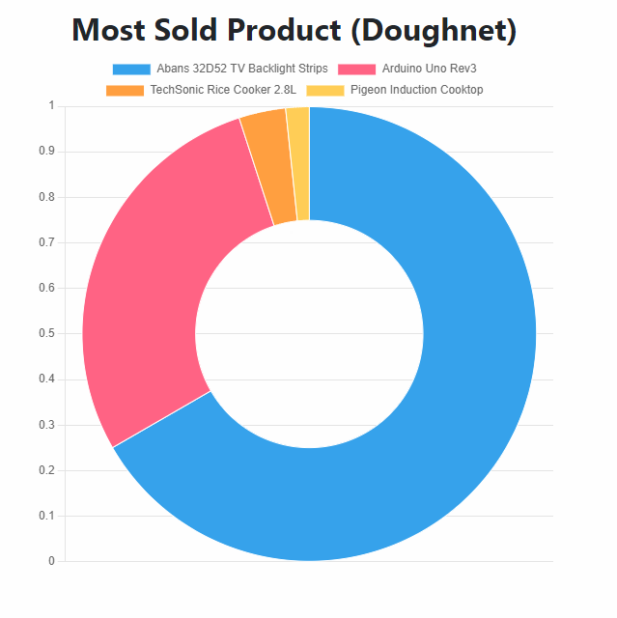

This is the Doughnet chart that has been created to view the most sold products. In this chart we can get a clear idea about selling products.

<!DOCTYPE html>

<html lang="en">

<?php

session_start();

require "../connection.php";

if (isset($_SESSION["aduser"])) {

$email = $_SESSION["aduser"]["email"];

?>

<head>

<meta charset="UTF-8">

<meta name="viewport" content="width=device-width, initial-scale=1.0">

<title>Doughnet Chart | Business Charts</title>

<link href="https://fonts.googleapis.com/css?family=Montserrat:400,500,700" rel="stylesheet">

<link type="text/css" rel="stylesheet" href="css/bootstrap.min.css" />

<link type="text/css" rel="stylesheet" href="css/slick.css" />

<link type="text/css" rel="stylesheet" href="css/slick-theme.css" />

<link type="text/css" rel="stylesheet" href="css/nouislider.min.css" />

<link rel="stylesheet" href="css/font-awesome.min.css">

<link type="text/css" rel="stylesheet" href="css/style.css" />

<link rel="stylesheet" href="../bootstrap.css" />

<link rel="stylesheet" href="https://cdn.jsdelivr.net/npm/bootstrap-icons@1.9.1/font/bootstrap-icons.css" />

<link rel="stylesheet" href="../style.css" />

<link rel="icon" href="../resources/logo.png" />

</head>

<body onload="loadDChart();" class="body2">

<!-- empty view -->

<div class="col-12 d-flex justify-content-center align-items-center" style="margin-top: 20px;">

<div class="row">

<div class="col-12" style="width: 560px;">

<h2 class="text-center text-dark fw-bold">Most Sold Product (Doughnet)</h2>

<canvas id="myChart"></canvas>

</div>

</div>

</div>

<!-- empty view -->

<script src="https://cdn.jsdelivr.net/npm/chart.js"></script>

<!-- <script src="script.js"></script> -->

<script>

function loadDChart() {

var ctx = document.getElementById("myChart");

var request = new XMLHttpRequest();

request.onreadystatechange = function() {

if ((request.readyState == 4) & (request.status == 200)) {

var response = request.responseText;

var data = JSON.parse(response);

new Chart(ctx, {

type: 'doughnut',

data: {

labels: data.labels,

datasets: [{

labels: data,

data: data.data,

borderWidth: 1

}] },

options: {

scales: {

y: {

beginAtZero: true } } }

}); } };

request.open("POST", "../chartProcess/loadMostSellProcess.php", true);

request.send(); }

</script>

<script src="../bootstrap.bundle.js"></script>

</body>

</html>

<?php } else {

header("location:html/index.php"); } ?>

1. Pie Charts

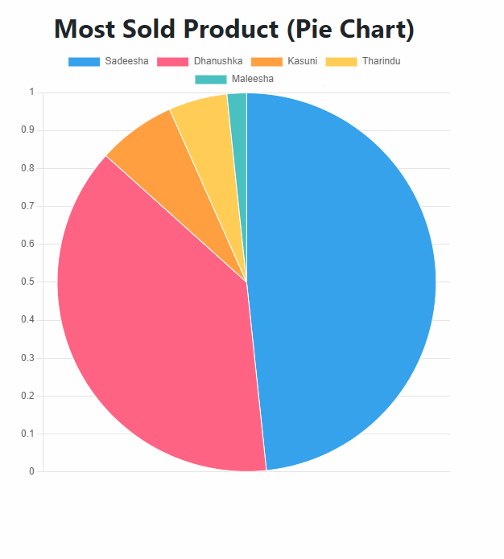

<!DOCTYPE html>

<html lang="en">

<?php

session_start();

require "../connection.php";

if (isset($_SESSION["aduser"])) {

$email = $_SESSION["aduser"]["email"];

$pageno;

?>

<head>

<meta charset="UTF-8">

<meta name="viewport" content="width=device-width, initial-scale=1.0">

<title>Pie Chart | Business Charts</title>

// css linked files here

<link rel="icon" href="../resources/logo.png" />

</head>

<body onload="loadDChart();" class="body2">

<!-- empty view -->

<div class="col-12 d-flex justify-content-center align-items-center" style="margin-top: 20px;">

<div class="row">

<div class="col-12" style="width: 560px;">

<h2 class="text-center text-dark fw-bold">Most Sold Product (Pie Chart)</h2>

<canvas id="myChart"></canvas>

</div></div>

</div>

<!-- empty view -->

<script src="https://cdn.jsdelivr.net/npm/chart.js"></script>

<!-- <script src="script.js"></script> -->

<script>

function loadDChart() {

var ctx = document.getElementById("myChart");

var request = new XMLHttpRequest();

request.onreadystatechange = function() {

if ((request.readyState == 4) & (request.status == 200)) {

var response = request.responseText;

var data = JSON.parse(response);

new Chart(ctx, {

type: 'pie',

data: {

labels: data.labels,

datasets: [{

labels: data,

data: data.data,

borderWidth: 1

}] },

options: {

scales: {

y: {

beginAtZero: true

} } }

});

} };

request.open("POST", "../chartProcess/loadMostFamprocess.php", true);

request.send(); }

</script>

<script src="../bootstrap.bundle.js"></script>

</body>

</html>

<?php

} else {

header("location:html/index.php"); } ?>

1. Bar Charts

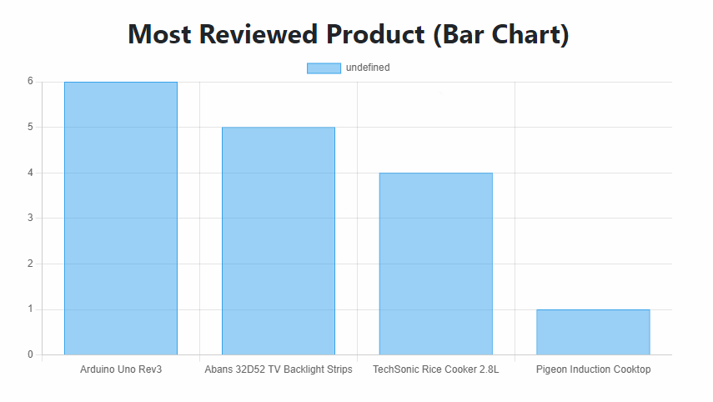

<!DOCTYPE html>

<html lang="en">

<?php

session_start();

require "../connection.php";

if (isset($_SESSION["aduser"])) {

$email = $_SESSION["aduser"]["email"];

$pageno;

?>

<head>

<meta charset="UTF-8">

<meta name="viewport" content="width=device-width, initial-scale=1.0">

<title>Bar Chart | Business Charts</title>

//css linked file here

<link rel="icon" href="../resources/logo.png" />

</head>

<body onload="loadDChart();" class="body2">

<!-- empty view -->

<div class="col-12 d-flex justify-content-center align-items-center" style="margin-top: 20px;">

<div class="row">

<div class="col-12" style="width: 800px;">

<h2 class="text-center text-dark fw-bold">Most Reviewed Product (Bar Chart)</h2>

<canvas id="myChart"></canvas>

</div> </div>

</div>

<script src="https://cdn.jsdelivr.net/npm/chart.js"></script>

<!-- <script src="script.js"></script> -->

<script>

function loadDChart() {

var ctx = document.getElementById("myChart");

var request = new XMLHttpRequest();

request.onreadystatechange = function() {

if ((request.readyState == 4) & (request.status == 200)) {

var response = request.responseText;

var data = JSON.parse(response);

new Chart(ctx, {

type: 'bar',

data: {

labels: data.labels,

datasets: [{

labels: data,

data: data.data,

borderWidth: 1

}]},

options: {

scales: {

y: {

beginAtZero: true

} } }

});

} };

request.open("POST", "../chartProcess/loadMostReviewed.php", true);

request.send();

}

</script>

<script src="../bootstrap.bundle.js"></script>

</body>

</html>

<?php

} else {

header("location:html/index.php");

}?>

1. Line Charts

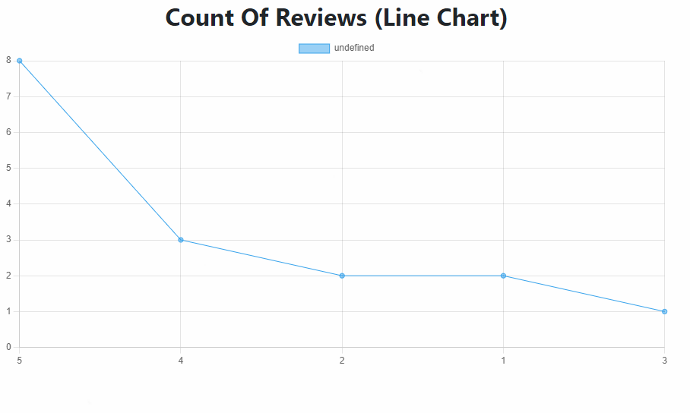

<!DOCTYPE html>

<html lang="en">

<?php

session_start();

require "../connection.php";

if (isset($_SESSION["aduser"])) {

$email = $_SESSION["aduser"]["email"];

?>

<head>

<meta charset="UTF-8">

<meta name="viewport" content="width=device-width, initial-scale=1.0">

<title>Line Chart | Business Charts</title>

//css linked files here

<link rel="icon" href="../resources/logo.png" />

</head>

<body onload="loadDChart();" class="body2">

<!-- empty view -->

<div class="col-12 d-flex justify-content-center align-items-center" style="margin-top: 20px;">

<div class="row">

<div class="col-12" style="width: 900px;">

<h2 class="text-center text-dark fw-bold">Count Of Reviews (Line Chart)</h2>

<canvas id="myChart"></canvas>

</div></div>

</div>

<script src="https://cdn.jsdelivr.net/npm/chart.js"></script>

<!-- <script src="script.js"></script> -->

<script>

function loadDChart() {

var ctx = document.getElementById("myChart");

var request = new XMLHttpRequest();

request.onreadystatechange = function() {

if ((request.readyState == 4) & (request.status == 200)) {

var response = request.responseText;

var data = JSON.parse(response);

new Chart(ctx, {

type: 'line',

data: {

labels: data.labels,

datasets: [{

labels: data,

data: data.data,

borderWidth: 1

}] },

options: {

scales: {

y: {

beginAtZero: true

} } }

});

} };

request.open("POST", "../chartProcess/loadMostRecProcess.php", true);

request.send(); }

</script>

<script src="../bootstrap.bundle.js"></script>

</body>

</html>

<?php

} else {

header("location:html/index.php"); } ?>

1. Polar Charts

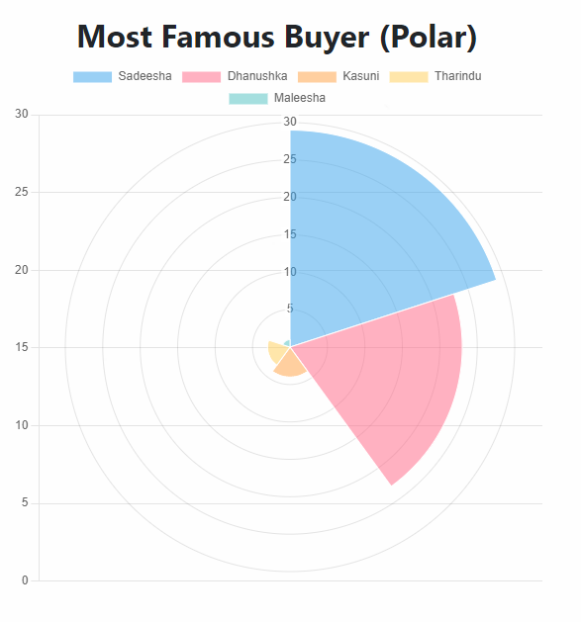

<!DOCTYPE html>

<html lang="en">

<?php

session_start();

require "../connection.php";

if (isset($_SESSION["aduser"])) {

$email = $_SESSION["aduser"]["email"]; ?>

<head>

<meta charset="UTF-8">

<meta name="viewport" content="width=device-width, initial-scale=1.0">

<title>Polar Area Chart | Business Charts</title>

//css

<link rel="icon" href="../resources/logo.png" />

</head>

<body onload="loadpAChart();" class="body2">

<!-- empty view -->

<div class="col-12 d-flex justify-content-center align-items-center" style="margin-top: 20px;">

<div class="row">

<div class="col-12" style="width: 560px;">

<h2 class="text-center text-dark fw-bold">Most Prefered Product (Polar)</h2>

<canvas id="myChart"></canvas>

</div></div>

</div>

<script src="https://cdn.jsdelivr.net/npm/chart.js"></script>

<script>

function loadpAChart() {

var ctx = document.getElementById("myChart");

var request = new XMLHttpRequest();

request.onreadystatechange = function() {

if ((request.readyState == 4) & (request.status == 200)) {

var response = request.responseText;

var data = JSON.parse(response);

new Chart(ctx, {

type: 'polarArea',

data: {

labels: data.labels,

datasets: [{

labels: data,

data: data.data,

borderWidth: 1

}] },

options: {

scales: {

y: {

beginAtZero: true

} } }

}); } };

request.open("POST", "../chartProcess/loadWishlistprocess.php", true);

request.send(); }

</script>

<script src="../bootstrap.bundle.js"></script>

</body>

</html>

<?php

} else {

header("location:html/index.php"); } ?>

1. Radar Charts

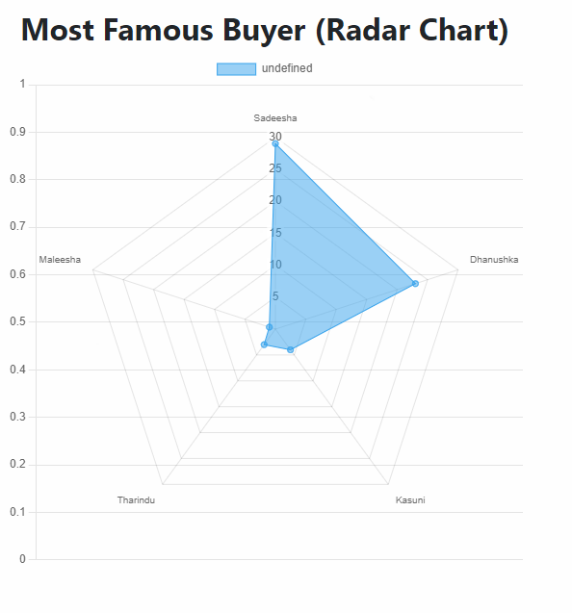

<!DOCTYPE html>

<html lang="en">

<?php

session_start();

require "../connection.php";

if (isset($_SESSION["aduser"])) {

$email = $_SESSION["aduser"]["email"];

?>

<head>

<meta charset="UTF-8">

<meta name="viewport" content="width=device-width, initial-scale=1.0">

<title>Radar Chart | Business Charts</title>

<link href="https://fonts.googleapis.com/css?family=Montserrat:400,500,700" rel="stylesheet">

<link type="text/css" rel="stylesheet" href="css/bootstrap.min.css" />

<link type="text/css" rel="stylesheet" href="css/slick.css" />

<link type="text/css" rel="stylesheet" href="css/slick-theme.css" />

<link type="text/css" rel="stylesheet" href="css/nouislider.min.css" />

<link rel="stylesheet" href="css/font-awesome.min.css">

<link type="text/css" rel="stylesheet" href="css/style.css" />

<link rel="stylesheet" href="../bootstrap.css" />

<link rel="stylesheet" href="https://cdn.jsdelivr.net/npm/bootstrap-icons@1.9.1/font/bootstrap-icons.css" />

<link rel="stylesheet" href="../style.css" />

<link rel="icon" href="../resources/logo.png" />

</head>

<body onload="loadRChart();" class="body2">

<!-- empty view -->

<div class="col-12 d-flex justify-content-center align-items-center" style="margin-top: 20px;">

<div class="row">

<div class="col-12" style="width: 560px;">

<h2 class="text-center text-dark fw-bold">Most Reviewed Product (Radar Chart)</h2>

<canvas id="myChart"></canvas>

</div> </div>

</div>

<script src="https://cdn.jsdelivr.net/npm/chart.js"></script>

<script>

function loadRChart() {

var ctx = document.getElementById("myChart");

var request = new XMLHttpRequest();

request.onreadystatechange = function() {

if ((request.readyState == 4) & (request.status == 200)) {

var response = request.responseText;

var data = JSON.parse(response);

new Chart(ctx, {

type: "radar",

data: {

labels: data.labels,

datasets: [{

labels: data,

data: data.data,

borderWidth: 1, }, ],

},

options: {

scales: {

y: {

beginAtZero: true,

},

},

elements: {

line: {

borderWidth: 3,

}, },

}, });

} };

request.open("POST", "../chartProcess/loadMostReviewed.php", true);

request.send(); }

</script>

<script src="../bootstrap.bundle.js"></script>

</body>

</html>

<?php

} else {

header("location:html/index.php"); } ?>

1. Chart Processes

**Most Selling Product Chart Process**

<?php

include "../connection.php";

$resultSet = Database::search("SELECT `product`.`id`,`product`.`title`, SUM(`invoice`.`iqty`)AS `total_sold` FROM `invoice`

INNER JOIN `product` ON `invoice`.`product_id` = `product`.`id`

GROUP BY `product`.`id`,`product`.`title`

ORDER BY `total_sold` DESC");

$num = $resultSet ->num_rows;

$labels = array();

$data = array();

for($i = 0; $i <$num; $i++){

$d = $resultSet->fetch_assoc();

$labels[] = $d["title"];

$data [] = $d ["total_sold"]; }

$json = array();

$json["labels"] = $labels;

$json["data"] = $data;

echo json_encode($json);

**Most Famous Buyer Chart Process**

<?php

include "../connection.php";

$resultSet = Database::search("SELECT `user`.`email`,`user`.`fname`, SUM(`invoice`.`iqty`)AS `total_sold` FROM `invoice`

INNER JOIN `user` ON `invoice`.`user_email` = `user`.`email`

GROUP BY `user`.`email`,`user`.`fname`

ORDER BY `total_sold` DESC");

$num = $resultSet ->num_rows;

$labels = array();

$data = array();

for($i = 0; $i <$num; $i++){

$d = $resultSet->fetch_assoc();

$labels[] = $d["fname"];

$data [] = $d ["total_sold"]; }

$json = array();

$json["labels"] = $labels;

$json["data"] = $data;

echo json_encode($json);

**Most Reviewed Product Chart Process**

<?php

include "../connection.php";

$resultSet = Database::search("SELECT `product`.`id`,`product`.`title`, COUNT(`feedback`.`feed_id`)AS `total_review` FROM `feedback`

INNER JOIN `product` ON `feedback`.`product_id` = `product`.`id`

GROUP BY `product`.`id`,`product`.`title`

ORDER BY `total_review` DESC");

$num = $resultSet ->num_rows;

$labels = array();

$data = array();

for($i = 0; $i <$num; $i++){

$d = $resultSet->fetch_assoc();

$labels[] = $d["title"];

$data [] = $d ["total_review"]; }

$json = array();

$json["labels"] = $labels;

$json["data"] = $data;

echo json_encode($json);

**Most Reviewed Product Chart Process**

<?php

include "../connection.php";

$resultSet = Database::search("SELECT `product`.`id`,`product`.`title`, COUNT(`feedback`.`feed_id`)AS `total_review` FROM `feedback`

INNER JOIN `product` ON `feedback`.`product_id` = `product`.`id`

GROUP BY `product`.`id`,`product`.`title`

ORDER BY `total_review` DESC");

$num = $resultSet ->num_rows;

$labels = array();

$data = array();

for($i = 0; $i <$num; $i++){

$d = $resultSet->fetch_assoc();

$labels[] = $d["title"];

$data [] = $d ["total_review"]; }

$json = array();

$json["labels"] = $labels;

$json["data"] = $data;

echo json_encode($json);

**Highly Recommended Product Chart Process**

<?php

include "../connection.php";

$resultSet = Database::search("SELECT `feedback`.`type`, COUNT(`feedback`.`feed_id`)AS `total_review` FROM `feedback`

INNER JOIN `product` ON `feedback`.`product_id` = `product`.`id`

WHERE `feedback`.`type` IN(5,4,3,2,1) GROUP BY `feedback`.`type` ORDER BY `total_review` DESC");

$num = $resultSet ->num_rows;

$labels = array();

$data = array();

for($i = 0; $i <$num; $i++){

$d = $resultSet->fetch_assoc();

$labels[] = $d["type"];

$data [] = $d ["total_review"]; }

$json = array();

$json["labels"] = $labels;

$json["data"] = $data;

echo json_encode($json);

**Customer Preferences Chart Process**

<?php

include "../connection.php";

$resultSet = Database::search("SELECT `product`.`id`,`product`.`title`, COUNT(`recent`.`id`)AS `wishlists` FROM `recent`

INNER JOIN `product` ON `recent`.`product_id` = `product`.`id`

GROUP BY `product`.`id`,`product`.`title`

ORDER BY `wishlists` DESC");

$num = $resultSet ->num_rows;

$labels = array();

$data = array();

for($i = 0; $i <$num; $i++){

$d = $resultSet->fetch_assoc();

$labels[] = $d["title"];

$data [] = $d ["wishlists"]; }

$json = array();

$json["labels"] = $labels;

$json["data"] = $data;

echo json_encode($json);

1. ER Diagram

ER Diagram PDF is inside the project

ER Diagram Model

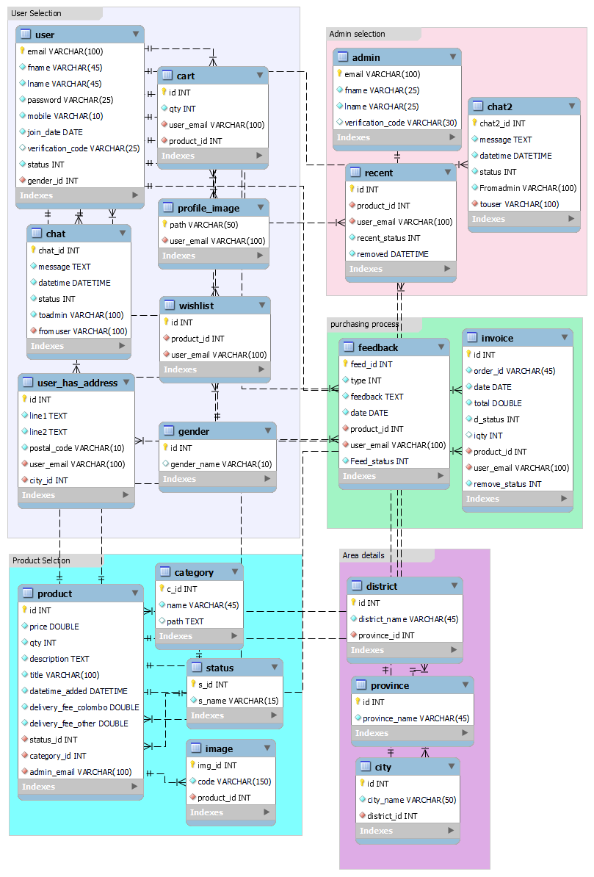

Mobile Views (Responsive Proofs)

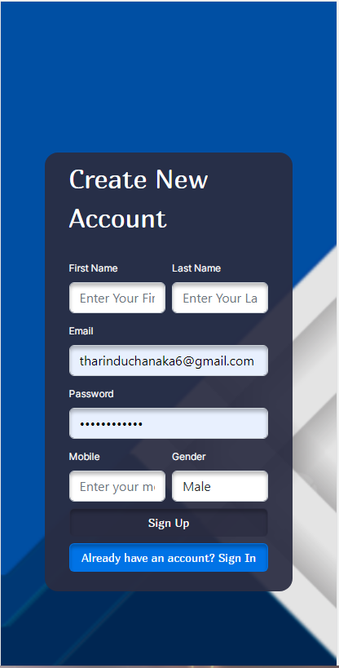 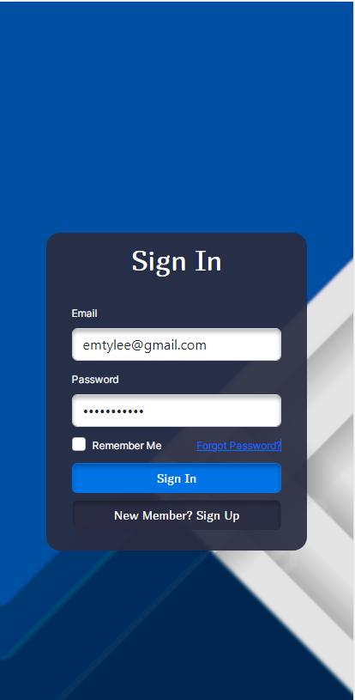 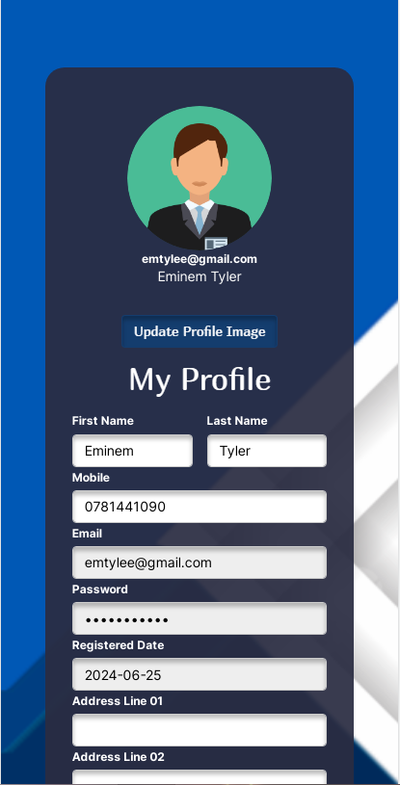

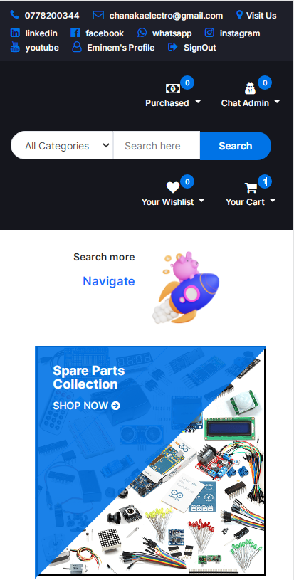 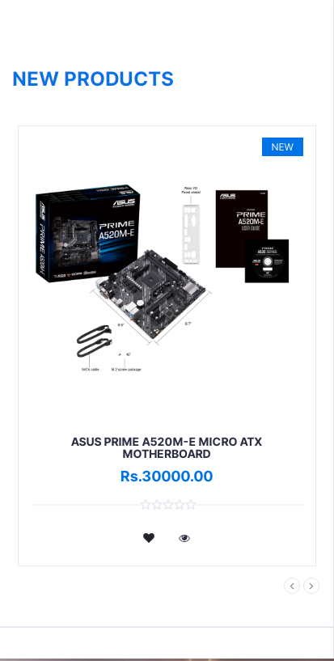 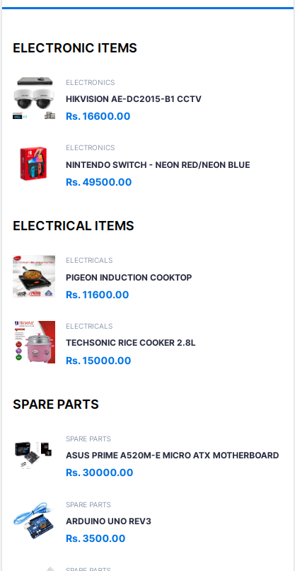

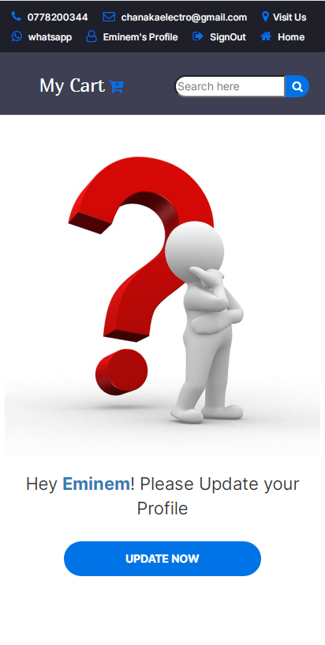 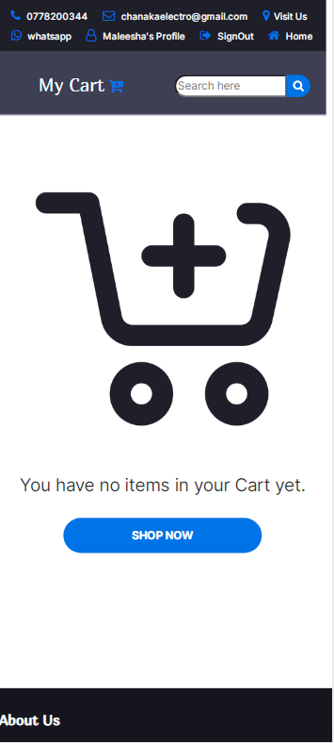 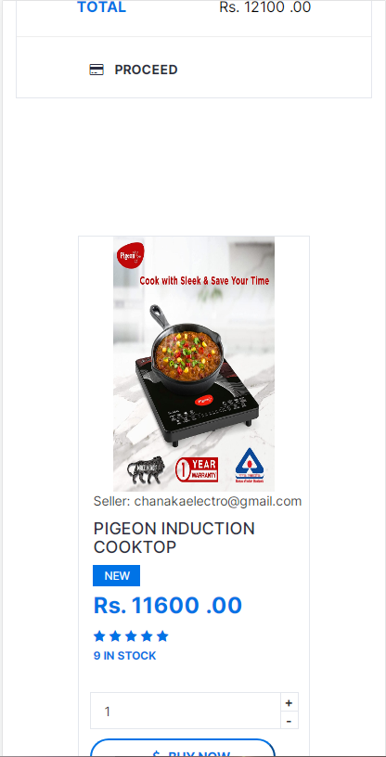

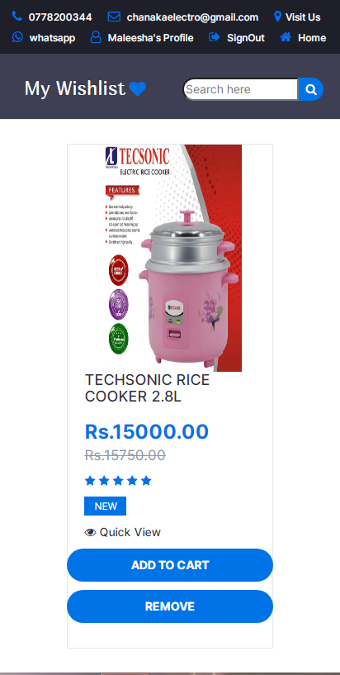  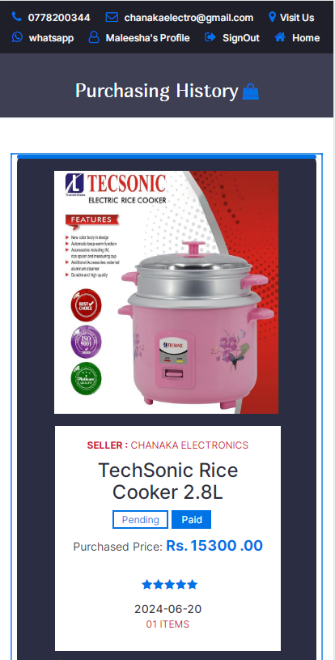

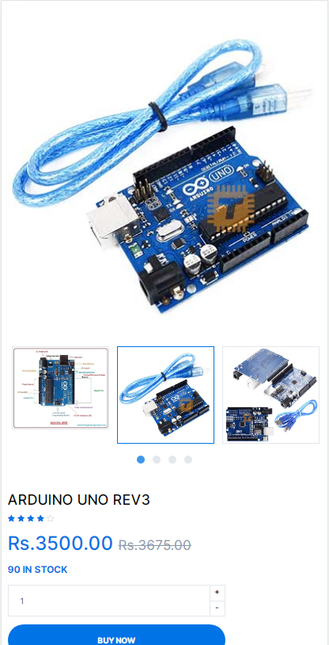 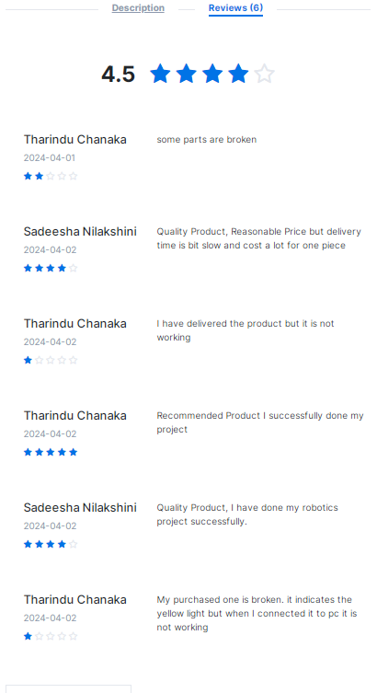 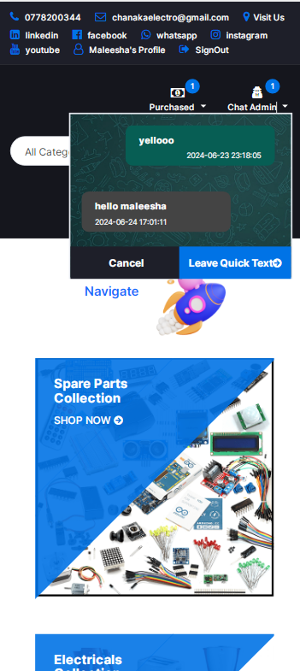

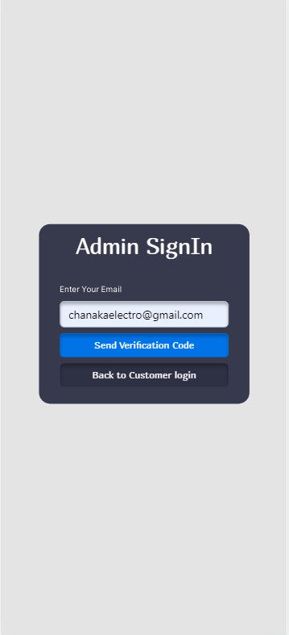 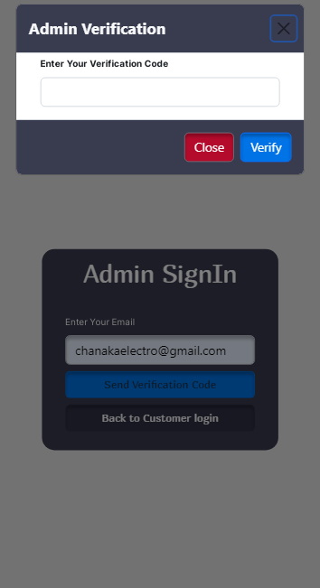 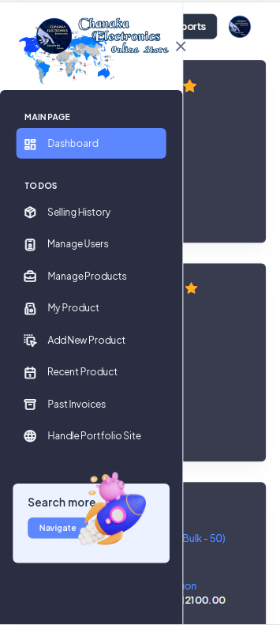

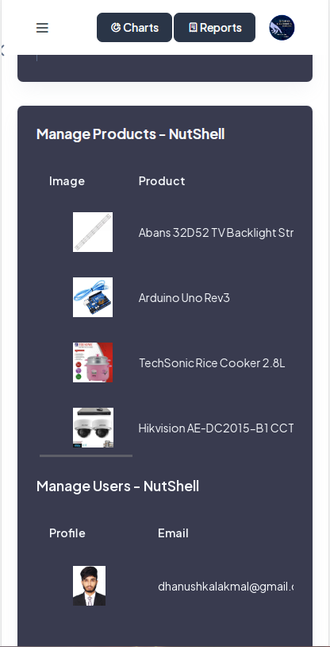 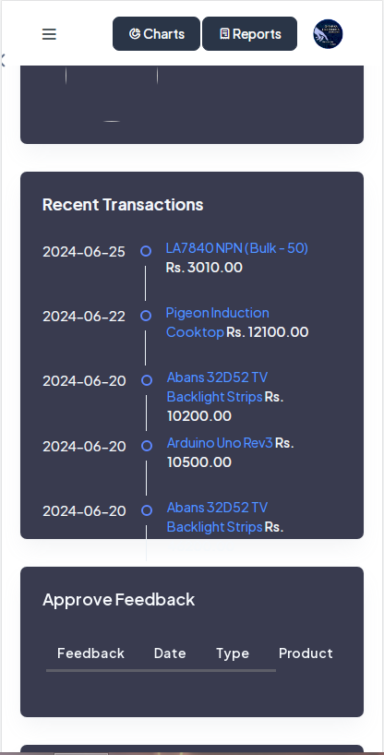 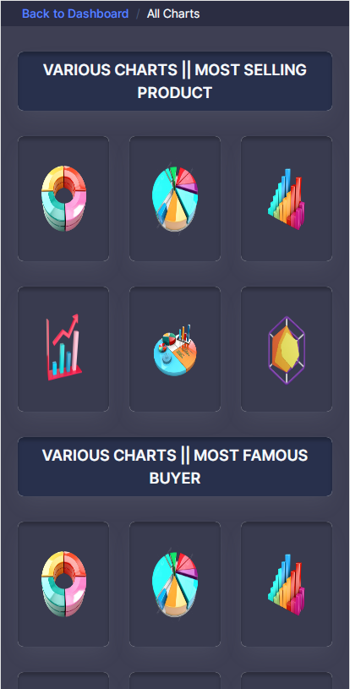

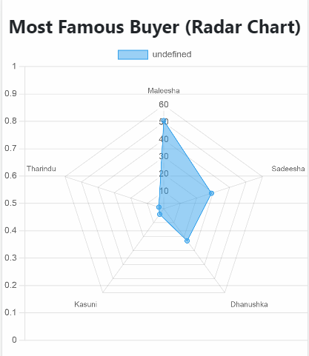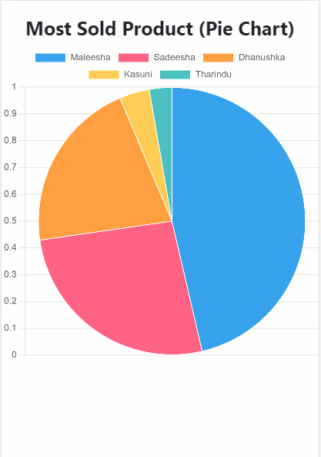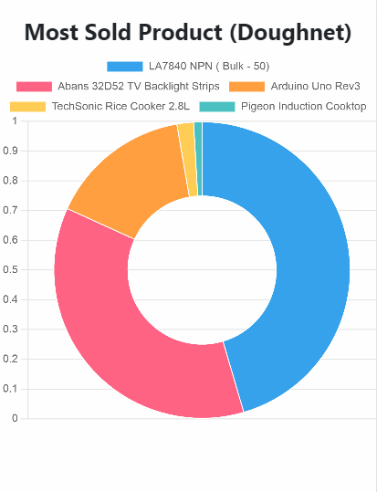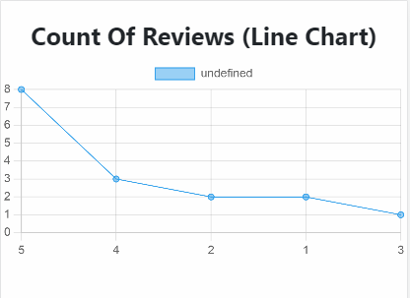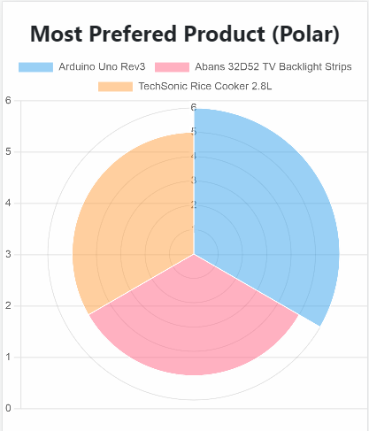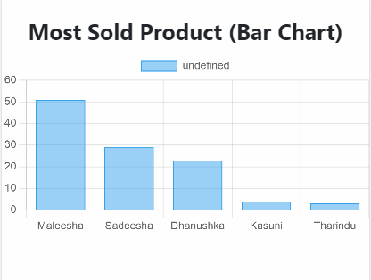

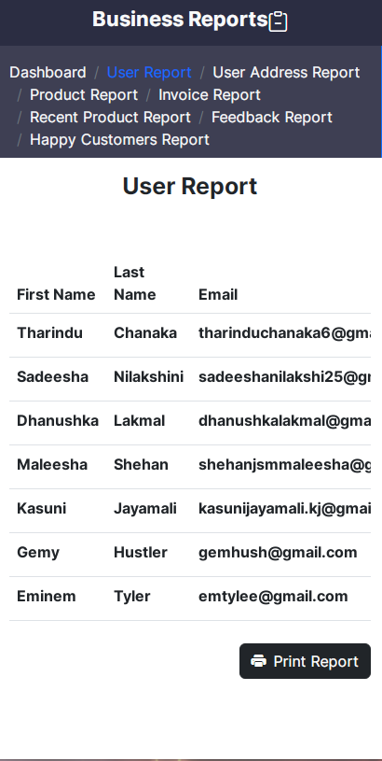 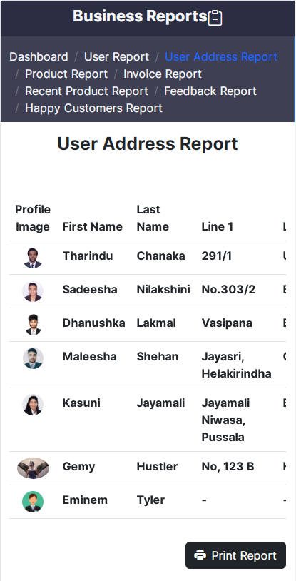 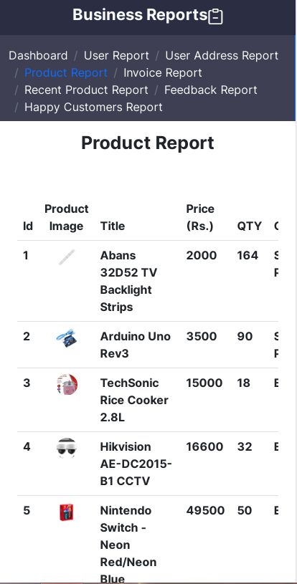

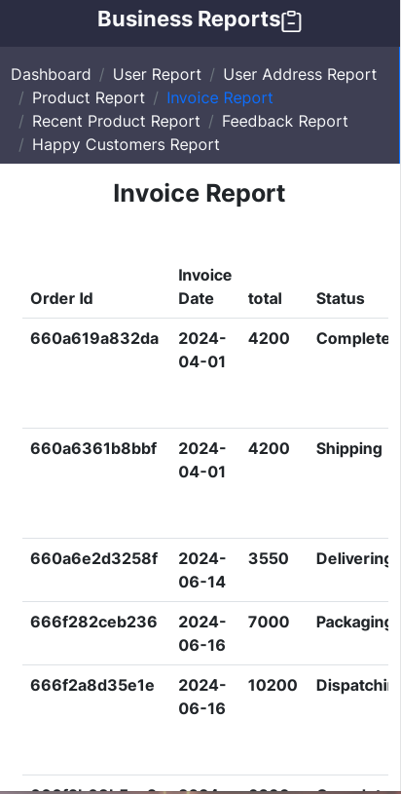 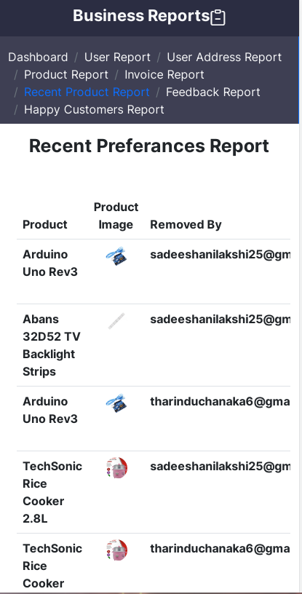 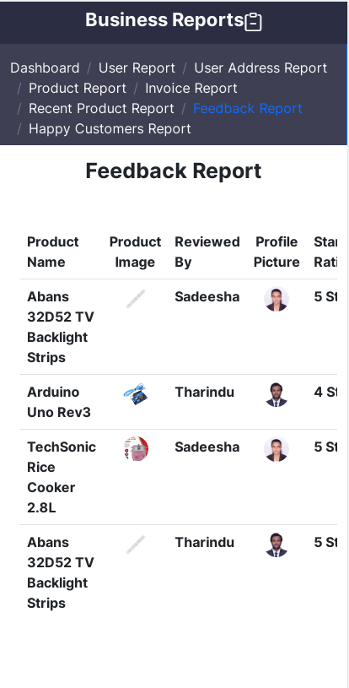

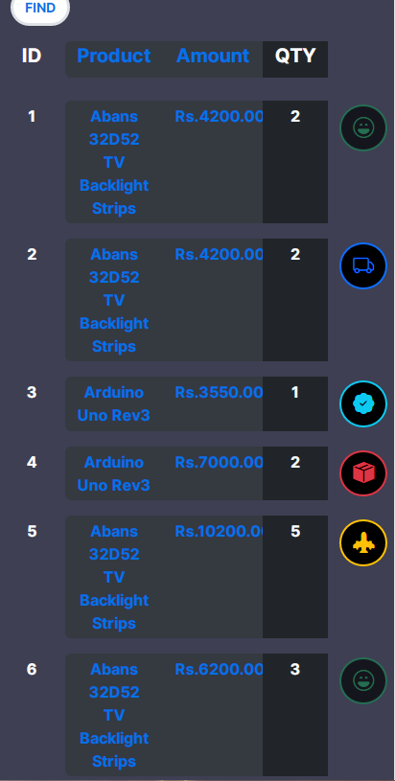 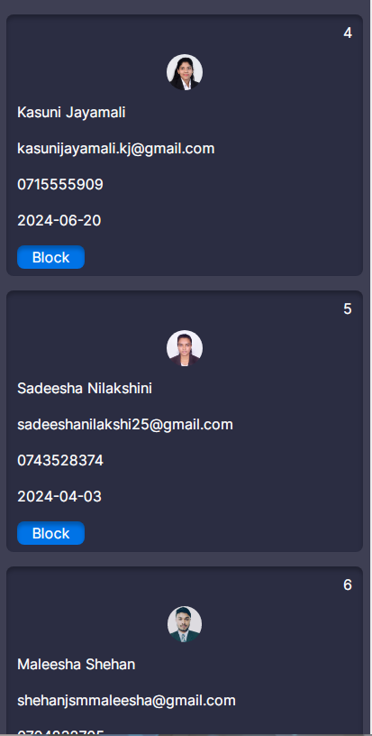 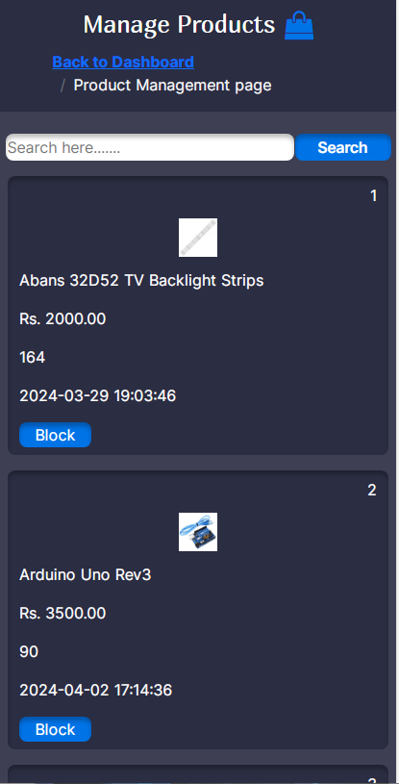

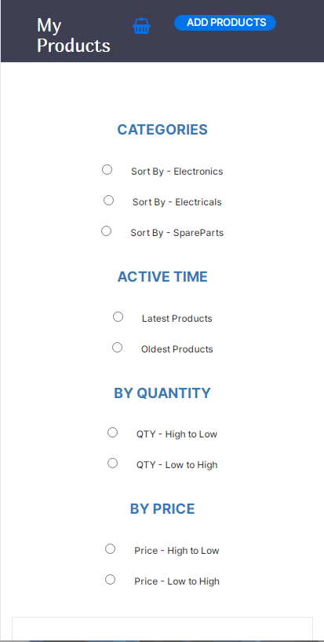 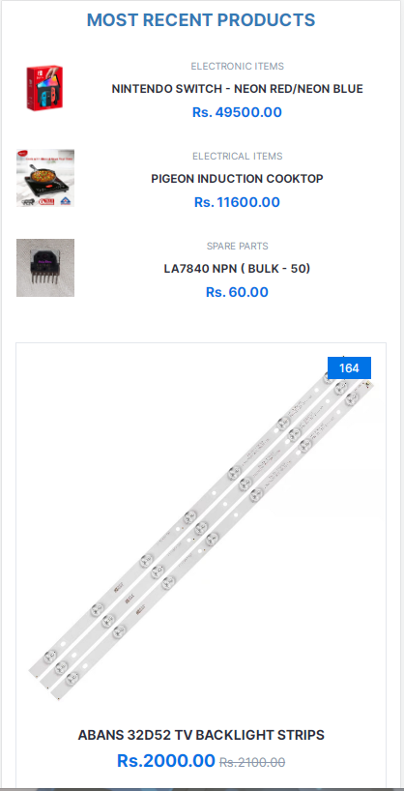 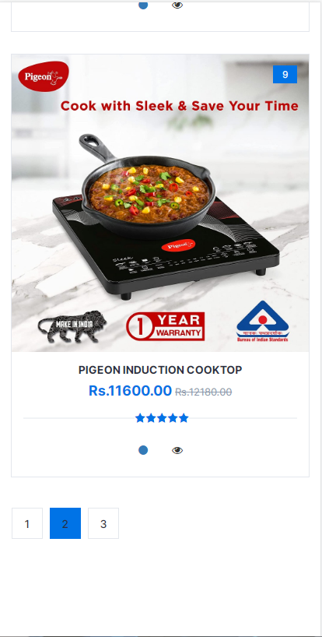

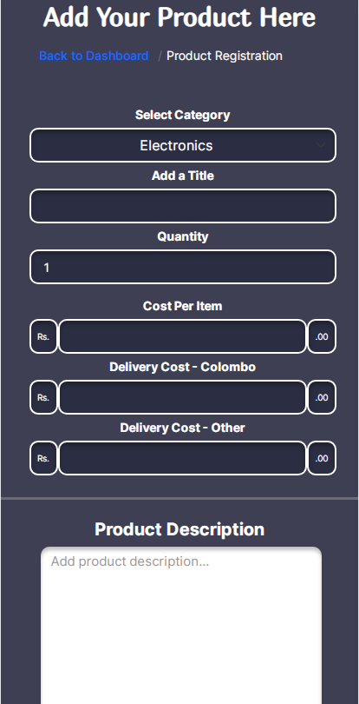 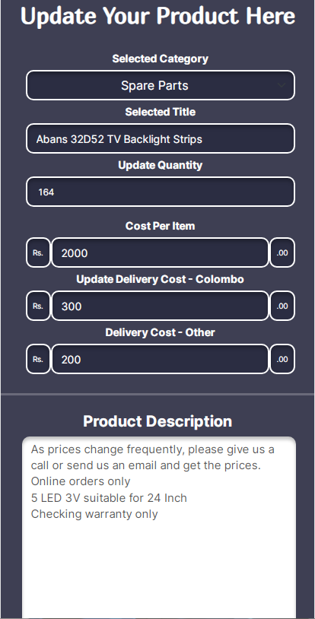 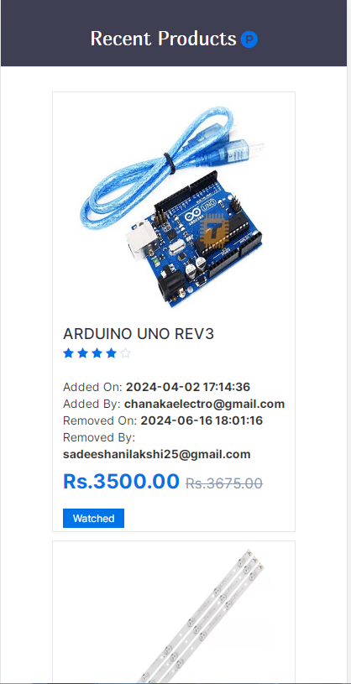

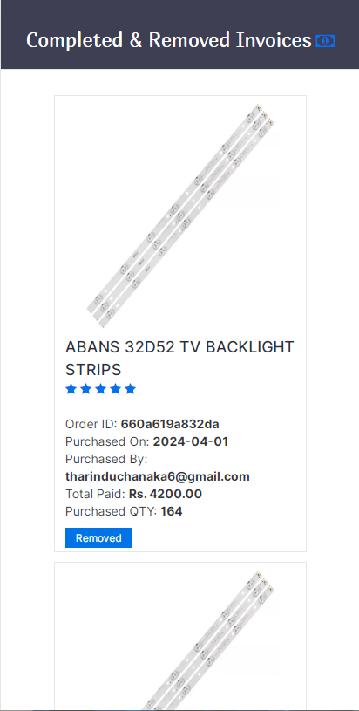 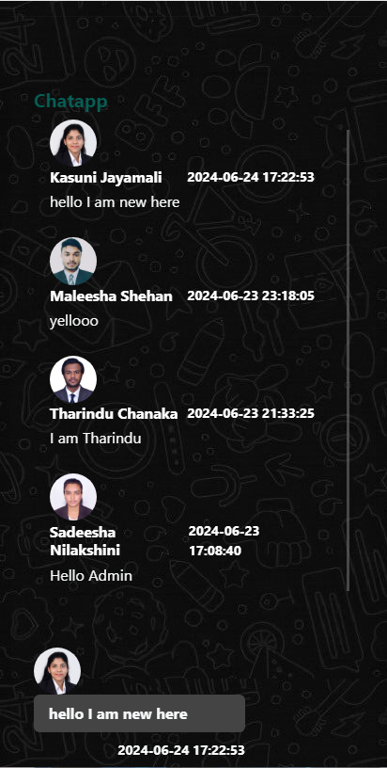 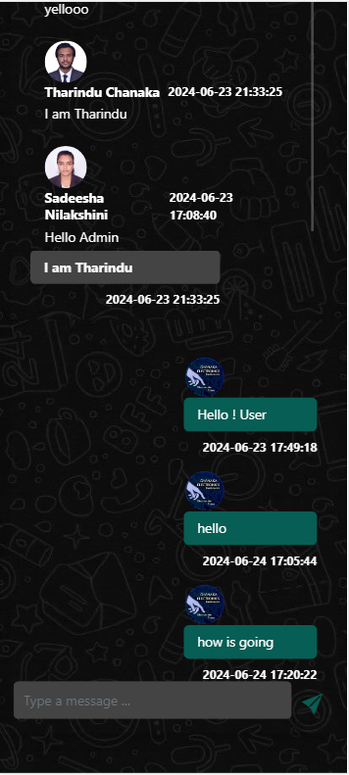

Further Modifications

Customers don’t have the ability to delete order until it becomes to completed stage

<?php

if ($invoice_data["d_status"] == 5) {

?>

<div class="product-body" style="background-color:transparent; border-radius: 400px; justify-content: center; align-items: center; display: flex;">

<div class="product-btns" style="background-color:white; border-radius: 20px;">

<button class="quick-view" onclick="removeFromPurchasingHistory('<?php echo $invoice_data['id']; ?>');"><i class="fa fa-trash"></i><span class="tooltipp">Remove Item</span></button>

</div>

</div>

<?php

} else {

?>

<div class="product-body" style="background-color:transparent; border-radius: 400px; justify-content: center; align-items: center; display: flex;">

<div class="product-btns" style="background-color:white; border-radius: 20px;">

<button class="quick-view" disabled><i class="fa fa-trash"></i><span class="tooltipp">Incomplete Order</span></button>

</div>

</div>

<?php } ?>